ARVC - what are the types of arrhythmias, how do you treat them?
ATE - pathophysiology and treatment options
Pericardial effusion - how does it affect hemodynamics

ARVC – arrhythmogenic right ventricular cardiomyopathy
- Boxers have a genetic predisposition for ARVC, commonly referred to as boxer ARVC or boxer cardiomyopathy
  - Inherited autosomal dominant trait
  - Mean age 8.5yo but can appear at any age
- Myocardial histologic changes include myofiber atrophy, fibrosis, and fatty infiltration of right ventricle
  - Can see focal areas of necrosis, hemorrhage, myocytolysis, mononuclear cell infilitration
  - Right ventricular enlargement seen in only 30% of cases with normal thickness of RV wall
- Clinical signs
  - 1) asymptomatic dogs with ventricular arrhythmia
    - Can be single right sided VPCs to malignant sustained ventricular tachycardia
  - 2) dogs with normal heart size and LV function, but have syncope and weakness from paroxysmal or sustained ventricular tachycardia
    - rates can be as high as 400bpm, which decreases cardiac output due to inadequate filling time of ventricle
  - 3) poor myocardial function and CHF with ventricular tachycardia
    - very poor prognosis
  - Sometimes can cause sudden death
- ECG
  - Ventricular complexes appear upright in leads I, II, III and aVF, suggesting RV origin
  - Some boxers have multiform VPCs
  - Recommendation is 24 holter monitor for screening of this disease as well as evaluate antiarrhythmic drug efficacy
    - For screening purposes, threshold of >100 VPCs in 24 hr period lends to presumptive diagnosis of ARVC unless there is evidence of another disease
  - Frequent VPCs and ventricular tachycardia signal increased risk of syncope and sudden death
  - Can sometimes have other supraventricular tachyarrhythmias
  - ACTA myologica “ARVC in boxer dogs: the diagnosis as a link to human disease” 9/2017
    - Criteria for ARVC diagnosis in boxers require 2 of 3 following in 24 hr holter
      - ≥100 VPCs
      - presence of couplets
      - presence or R-on-T phenomenon

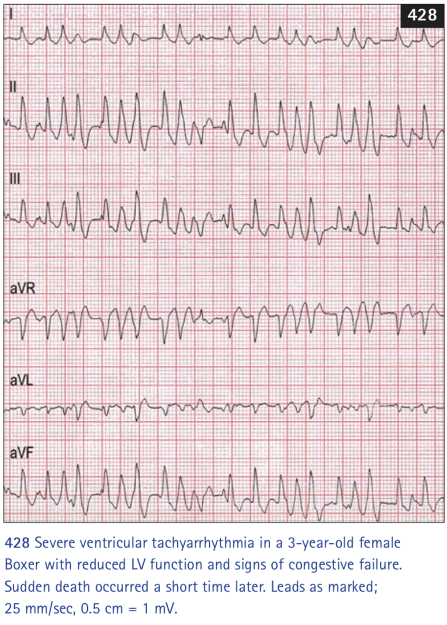

- Echo
  - Can be normal cardiac size and function
  - Can progress to chamber dilation with poor fractional shortening
- Treatment
  - Treat for CHF if indicated
  - Sotalol (40-120 mg BID PO) or mexiletine (5-8mg/kg TID) with atenolol (12.5mg PO BID) for antiarrhythmic therapy
    - Holter monitor rechecked 2-3 weeks after starting therapy
- Prognosis
  - Guarded to good.
  - Risk of sudden death should be mentioned to owners
  - Many affected dogs can live years without treatment and with treatment
  - Small percentage that develops DCM and heart failure guarded to poor prognosis

Arterial thromboembolism:
- Etiology:
  - Most common cause of arterial thromboembolism in cats is cardiomyopathy of any type (90%)
  - Male cats at higher risk for ATE due to prevalence of HCM
  - Hyperthyrodism may be a risk factor for TE in cats independent from cardiac effects
  - Neoplastic or systemic inflammatory disease or no cause identified
  - Arterial TE in dogs relatively uncommon compared to cats
    - PLN, hyperadrenocorticism, neoplasia, chronic interstitial nephritis, dirofilariasis, hypothyroidism, GDV, pancreatitis, CV diseases
- Pathophysiology
  - Thrombus is aggregation of platelets and fibrin with entrapped blood cells
  - In cats, thrombi initially form in left heart (most commonly left atrium/left auricle) and can become quite large, breaks loose to become an embolus that travels to distal region of systemic circulation
  - Marked LA enlargement may magnify the risk
    - Mechanism involves poor intracardiac blood flow within LA, altered blood coagulability, local tissue or blood vessel injury, or combination
    - Normal to low blood flow through enlarged chamber results in lower than normal blood flow velocity
    - When slow to certain velocity, red cells and other blood factors clump together
      - Spontaneous echocardiographic contrast (“smoke”)
      - Statsis of blood also allows activation of coagulation factors to accumulate and intermittent movement of viscous blood may induce platelet activation
  - Abnormal turbulence may be a factor with MR
  - Systemic arterial emboli usually lodge at aortic trifurcation (“saddle thrombus”) (~90%)
    - Thrombi usually extend down external iliac arteries, giving appearance of saddle
    - Other places iliac, femoral, renal, brachial, or other arteries
    - Small emboli clinically “silent”
  - After obstructing flow to affected artery, thromboemboli (platelets) release vasoactive substances (thromboxane A2 and serotonin)
    - Cause vasoconstriction and compromise collateral blood flow development around obstructed vessel
      - Kittleson referenced paper with aortic ligation that exhibited no pain and walk following surgery with femoral pulses absent and caudal limb blood flow only 30% of baseline. After 72 hours, caudal limb blood flow becomes closer to 90% baseline. This is due to collateral blood flow through lumbar vertebral arteries and cranial/caudal epigastric arteries
      - Experimentally, antiseratonin agents (cyproheptadine) and indomethacin prevent vasoconstriction distal to TE when administered before producing experimental thrombus. Agests after thromboembolus had not effect
  - Ischemic neuromyopathy occurs in affected limb(s)
    - Peripheral nerve dysfunction and degeneration as well as pathologic changes in associated muscle tissue
- Clinical presentation:
  - Arterial TE dz in cats usually acute dramatic clinical signs secondary to tissue ischemia
  - Clinical signs depend primarily on site occluded by TE, total versus partial occlusion, and amount of collateral circulation
  - “Saddle thrombus” acute hindlimb paresis/paralysis without palpable femoral pulses
  - Sensation and reflexes are lost over time
  - Pain, poor systemic perfusion, hypothermia
  - Tachypnea and open mouth breathing
    - Pain response
    - CHF (Increased pulmonary venous pressure)
  - Affected limb characteristic
    - Motor function minimal to absent (may be able to flex/extend hip)
    - Sensation to lower limb poor to absent
    - One side may show greater deficit than other
    - Cyanotic/pale paw pads
  - PE: auscultation may have heart murmur or gallop
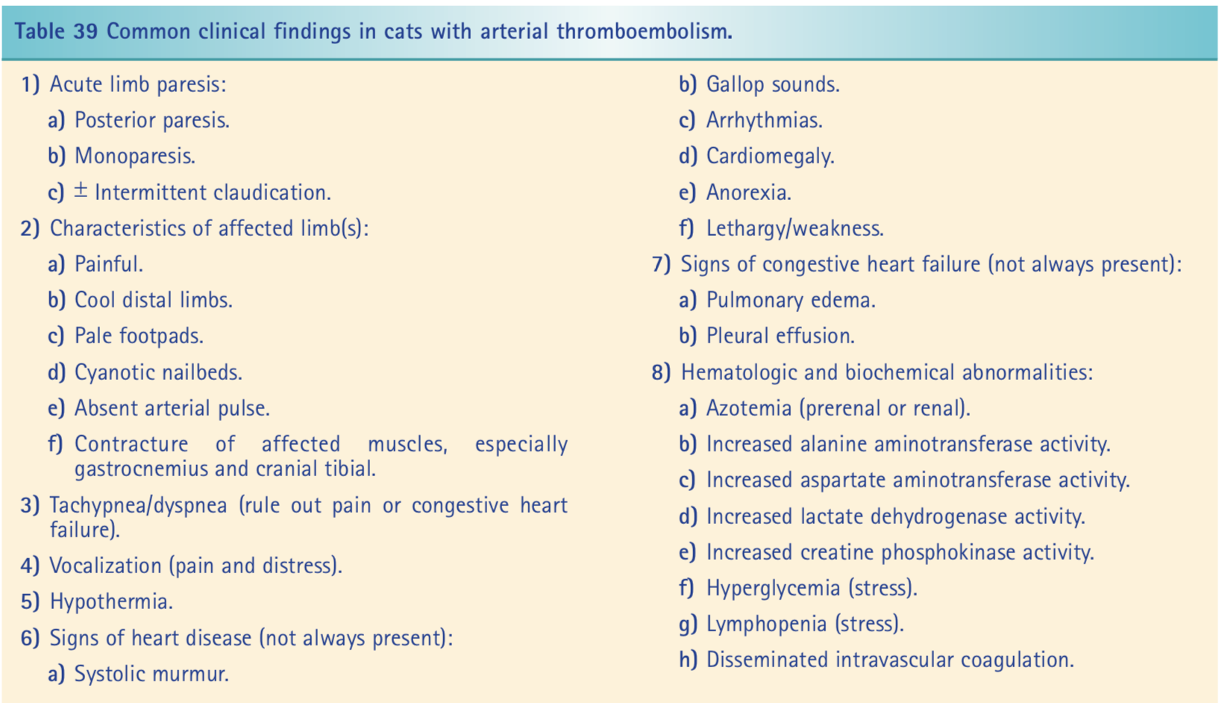

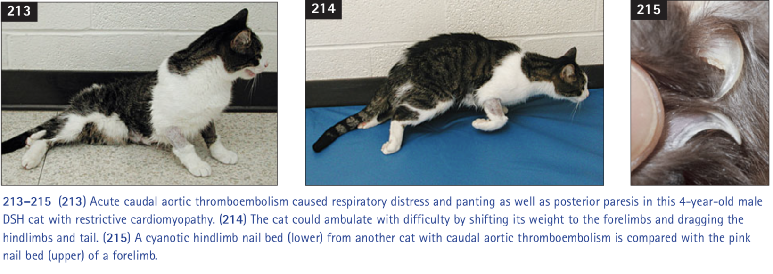
- Diagnostics
  - Doppler blood flow detection to identify presence or absence of blood flow at distal artery
  - Nail can be cut back to “quick” to determine whether bleeding occurs
  - Imaging of affected regional vessels by IV or intrarterial angiography or nuclear tracers for definitive diagnosis
  - Ultrasound may be able to see TE in terminal aorta, color flow Doppler may show lack of flow or compromised flow
  - CXR: cardiomegaly in 90% of cats with ATE, and 70% CHF
  - ECG: signs of left ventricular enlargement, conduction system abnormalities. Most are normal sinus rhythm and sinus tachycardia
  - Echo: identify underlying cardiac disease (60% HCM, 25% unclassified cardiomyopathy, rest DCM, RCM, or hyperthyroidism
  - Chemistry: increased ALT, AST, glucose

- Treatment:
  - CURATIVE guideline
    - Antiplatelet agents recommended for prevention of ATE in cats
      - The FATCAT study (LOE 1, Good) enrolled 75 cats following a cardiogenic thromboembolism and randomized them to receive either oral clopidogrel 18.75 mg once daily or oral aspirin 81 mg every 72 hours. There was a recurrence of ATE in 75% (27/36) of cats receiving aspirin in the first year compared to 36% (14/39) for those receiving clopidogrel. The median time to a primary event (recurrence of ATE) was 346 days for clopidogrel treated cats compared to 128 days for those receiving aspirin.
      - A single experimental study (LOE 3, Fair) evaluating the effects of abciximab on thrombus formation in cats was identified. That study used a feline model of arterial injury and compared the efficacy of aspirin alone with a combination of aspirin and abciximab. Cats that received aspirin and abciximab had signifi- cantly less thrombus formation compared to those receiving aspirin alone, but at the expense of significantly longer mucosal bleeding times.
    - No evidence-based recommendations can be made for use of anticoagulants for ATE in cats
      - An ongoing study comparing rivaroxaban to clopidogrel in cats may help determine if a direct Xa inhibitor can be, or should be, used in place of clopidogrel for ATE prevention in cats.
    - LMWH in preference to UFH because of documented efficacy of LMWH in cats and positive safety profile of LMWH
      - No articles directly addressed LMWH vs UFH
      - One study (LOE 3, Fair) demonstrated an antithrombotic effect of enoxaparin in a feline venous stasis model, while another study (LOE 5, Good) retrospectively reported safe use of dalteparin in cats, but neither compared LMWH with UFH.
    - Reolitic thrombectomy
    - tPA catheter specific thrombolysis
- Prognosis
  - In general, the prognosis is poor in both dogs and cats with arterial TE disease. Historically, only a third of cats survive the initial episode; however, survival statistics improve when cats euthanized without therapy are excluded or when only cases from recent years are analyzed
  - Survival is better if only one limb is involved and/or if some motor function is preserved at presentation
  - Hypothermia and CHF at presentation are both associated with poor survival in cats

Pericardial diseases:
- Pathophysiology of cardiac tamponade:
  - Normal pericardium helps balance output of right and left ventricles, limits acute distention of heart, maintains normal cardiac position within chest, barrier to infection or inflammation of surrounding structures
  - Normal pericardium contain only 2.5-15mL of fluid (~0.25mL/kg) serves as lubricant and can accommodate rapid accumulation of 50-150mL (20kg dog) of fluid w/o significant increase in intrapericardial pressure or decline in systemic arterial pressure
    - Under chronic conditions, pericardium hypertrophies and stretches to accommodate several hundred mL of fluid w/o clinically significant increase in pressure (cardiac filling and output remain normal)

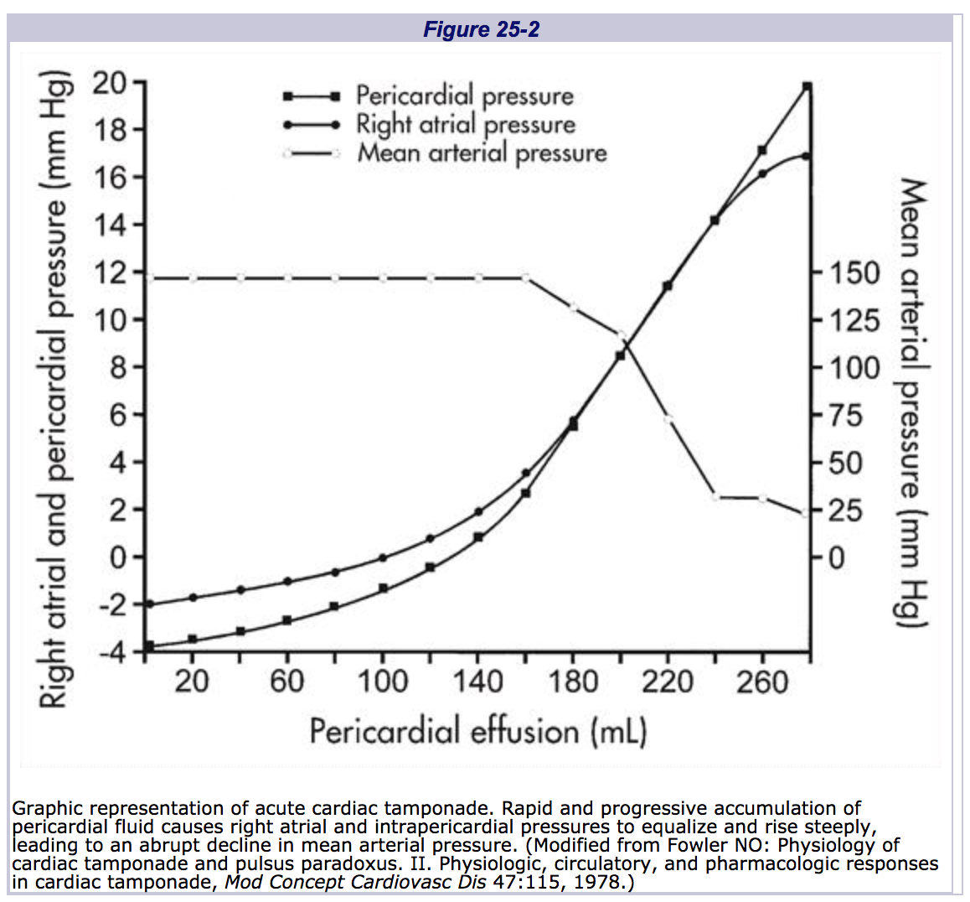
  - Increased intrapericardial pressure caused by accumulation of fluid within pericardial cavity leads to impairment of ventricular filling
  - When intrapericardial pressure equilibrates with right atrial and right ventricular diastolic pressure, transmural distending pressure becomes zero and cardiac tamponade begins
  - Elevation of intracardiac diastolic pressures (congestive heart failure)
    - Because systemic capillaries leak badly at pressures between 10 and 15 mm Hg and pulmonary capillaries do not leak badly until the pressure is approximately 30 mm Hg, patients with chronic cardiac tamponade always present with right heart failure (most commonly ascites) rather than left heart failure.
    - Predominates in chronic cardiac tamponade
  - Progressive limitation of ventricular filling leading to reduction in stroke volume and cardiac output (forward/low-output heart failure)
    - Acute tamponade
      - Usually caused by trauma and bleeding into pericardial space
  - Cardiac tamponade alters the dynamics of systemic venous return and cardiac filling. (Increased CVP)
    - Normally, one surge of venous flow occurs during ventricular systole coincident with the x decent of the venous pressure pulse, and a second surge occurs during right atrial emptying with the opening of the tricuspid valve, coincident with the y descent.
    - Cardiac tamponade results in compression of the heart throughout the cardiac cycle. This prevents rapid emptying of the right atrium when the tricuspid valve opens. During ventricular ejection, total intracardiac volume decreases, resulting in a transient fall in intrapericardial and right atrial pressures. This is accompanied by a surge of systemic venous return. However, in early diastole the total volume within the pericardial space remains elevated despite opening of the tricuspid valve. During this phase of the cardiac cycle, intrapericardial pressure remains elevated and is equal to or exceeds right atrial pressure, so that transmural distending pressure is zero or even negative.
    - As a result, the normal surge of systemic venous return during early ventricular diastole is attenuated, right atrial emptying is impeded, and the right atrium is compressed or even collapsed during diastole.
    - These events are reflected in right atrial or systemic venous pressure tracings as an increase in mean pressure, a prominent systolic x descent, and an attenuated or absent diastolic y descent
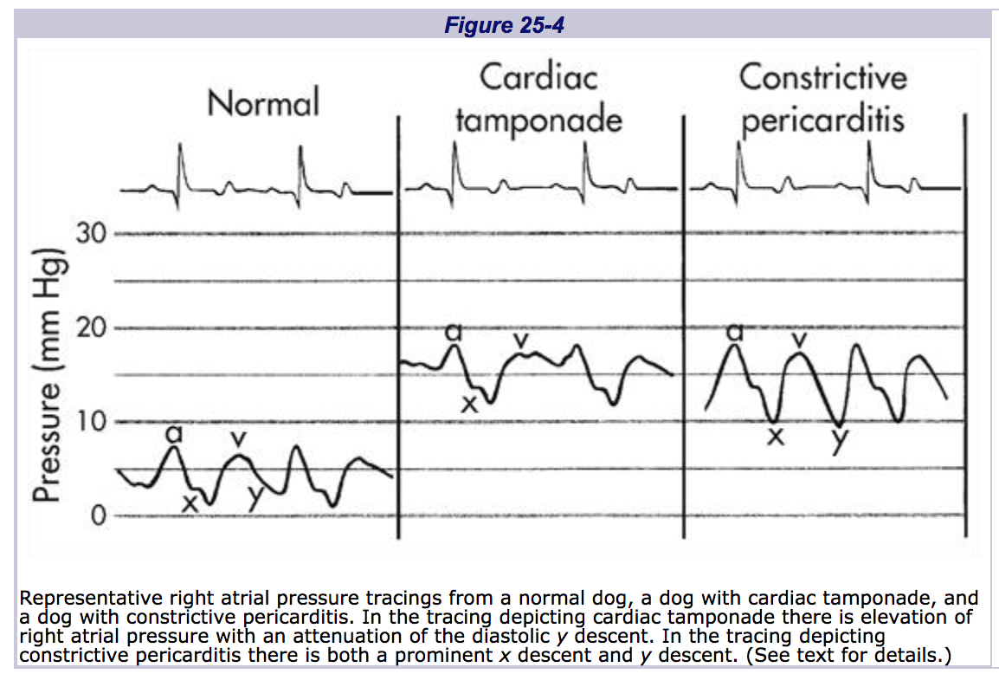

  - Cyclic alterations in systemic arterial pressure are also characteristic of cardiac tamponade.
    - Normally there is a slight decline (less than 10 mm Hg) in systemic arterial pressure during inspiration.
    - In patients with cardiac tamponade, inspiration lowers intrapericardial and right atrial pressures which facilitates right heart filling and pulmonary blood flow. At same time, left heart filling is reduced as more blood held in lungs and IVS bulges leftward from the inspiratory increase in RV filling. This decrease left ventricular stroke volume and systemic arterial pressure decreases during inspiration
    - Pulses paradoxicus produces a more dramatic decline (greater than 10 mm Hg) in systolic arterial blood pressure
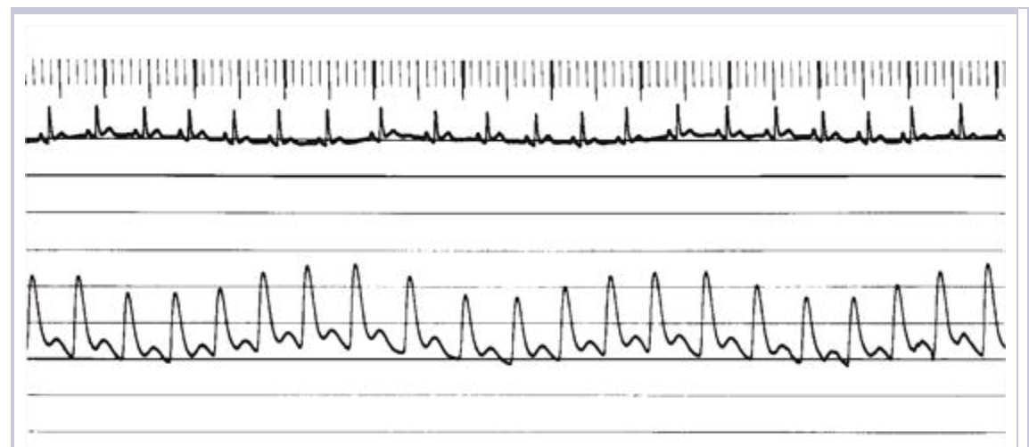
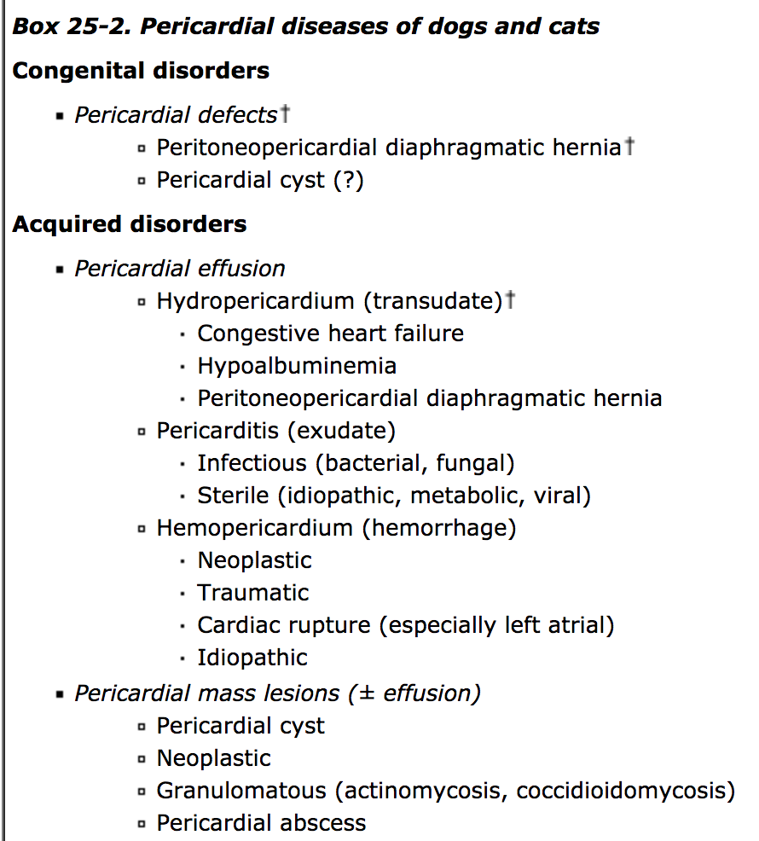

- Etiology
  - More than 90% of dogs with pericardial effusion have either idiopathic (hemorrhagic) pericardial effusion or cardiac or pericardial neoplasia.
  - Most pericardial effusions are serosanguinous to sanguinous with transudates, modified transudates, and exudates found occasionally
  - Hemorrhagic effusions
    - Normally do not clot unless hemorrhage was recent
  - Cardiac neoplasia
    - Middle aged to geriatric
    - Hemangiosarcoma right atrium
      - German shepherd, golden retrievers (other larger breed dogs)
      - High rate of metastatic disease
    - Heart based tumors
      - Typically around perimeter of proximal ascending aorta between aorta and pulmonary artery
      - Chemodectoma or ectopic thyroid carcinoma
        - Chemodectomas arise from chemoreceptor cells at base of aorta
      - Brachycephalic breeds, more commonly males
      - Locally invasive but slow to metastasize
    - Cats lymphosarcoma
  - Left atrial rupture
    - Infrequent complication of severe chronic degenerative mitral valve disease
    - Typically in small breed dogs predisposed to MVD, male poodles, dachshunds, cocker spaniels
- History PE
  - Vague clinical signs of lethargy, weakness, anorexia, abdominal enlargement, collapse
  - With severe R CHF, potential for tachypenea or dyspnea from severe pleural or peritoneal effusion
  - With large pericardial effusion, jugular venous distention, weak variable femoral pulses (pulses paradoxicus), muffled heart sounds
  - Cardiac arrhythmias or sinus tachycardia may be present
  - Lung sounds muffled with pleural effusion, abdominal distention with ascites
  - JVECC 2017 high prevalence of vomiting in dogs with pericardial effusion
- ECG
  - Electrical alternans
    - Beat-to-beat variation of QRS height
    - Not highly sensitive, but quite specific to pericardial effusion

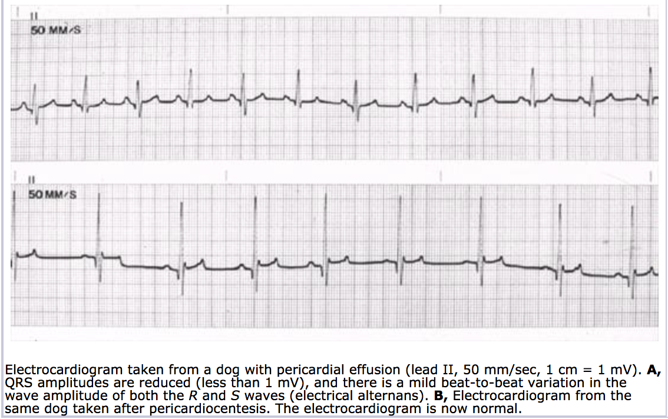

  - Sinus tachycardia
  - Ventricular or supraventricular arrhythmias may occur up to 40% of cases

- Radiographs
  - Generalized cardiac enlargement leading to globoid cardiac silhouette
  - Some heart based tumors cause deviation of trachea or soft tissue mass effect
  - Metastatic lung lesions common in dogs with HSA
  - Pleural effusion, caudal vena cava distention, hepatomegaly, ascites for R CHF

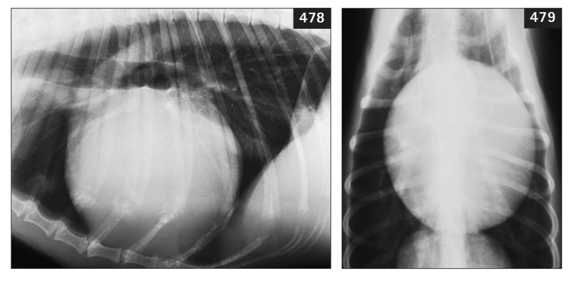

- Echocardiography
  - Most sensitive diagnostic technique for detecting pericardial effusion
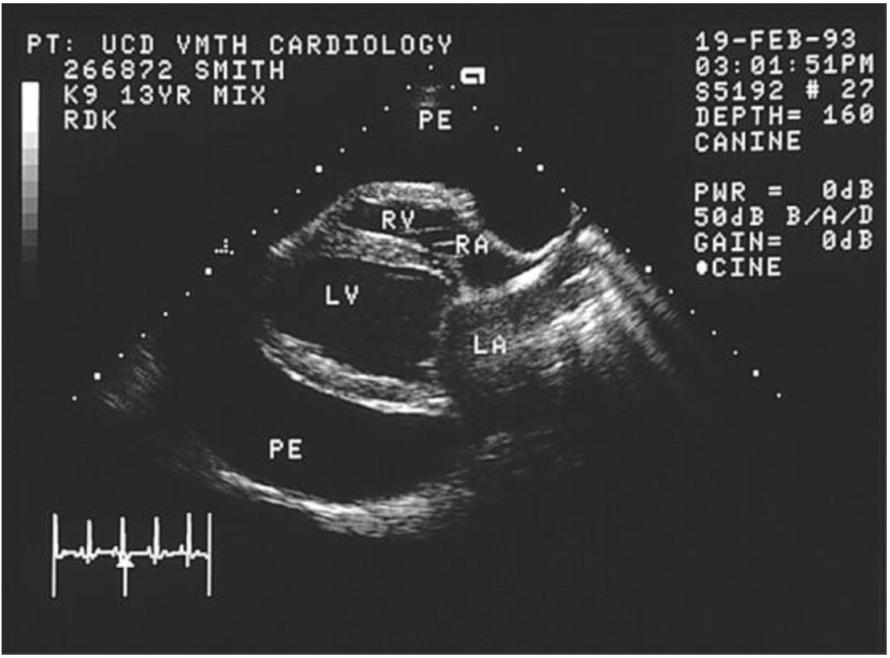

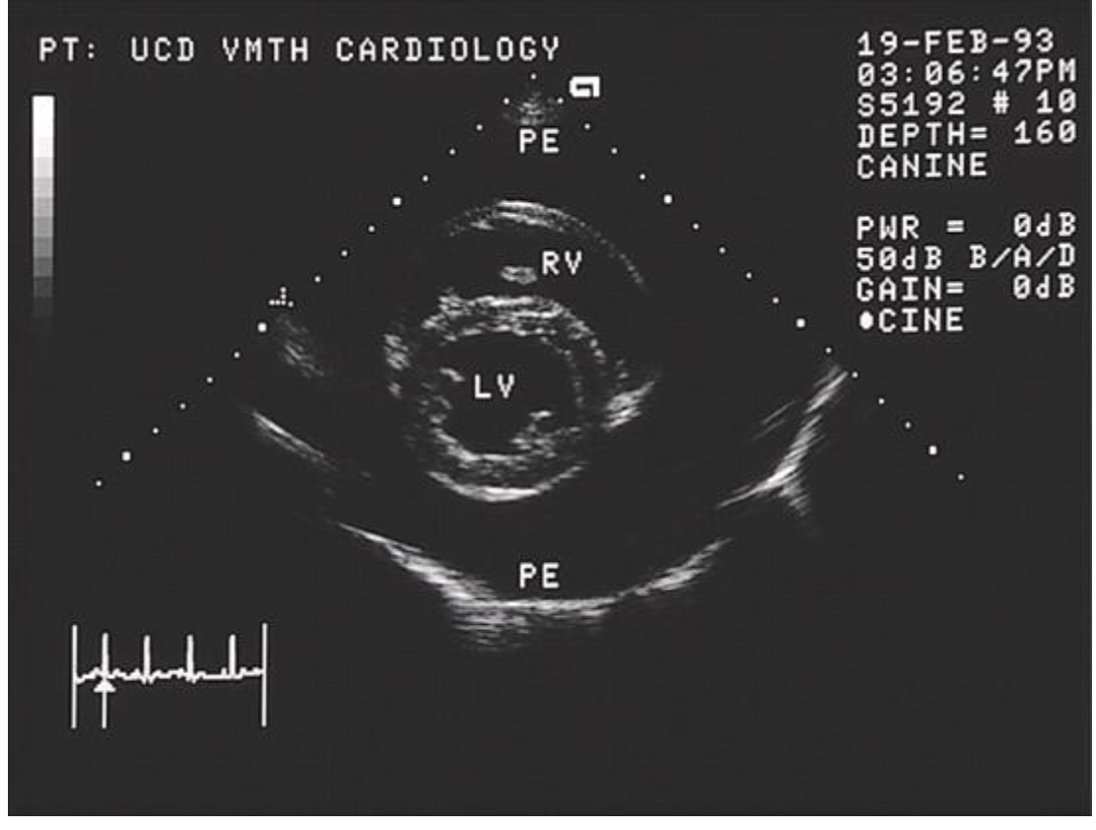

  - Cardiac tamponade recognized using 2d echo as early diastolic or systolic collapse of right atrium or right ventricular walls
  - 2d echo most accurate technique available for detection and localization of cardiac and pericardial masses
    - if possible, a complete echo should be performed prior to pericardiocentesis as small masses may be harder to identify without contrast of pericardial effusion around the heart
    - Right atrial masses may arise from right auricle, right atrial lateral wall, or junction between right atrium and right ventricle

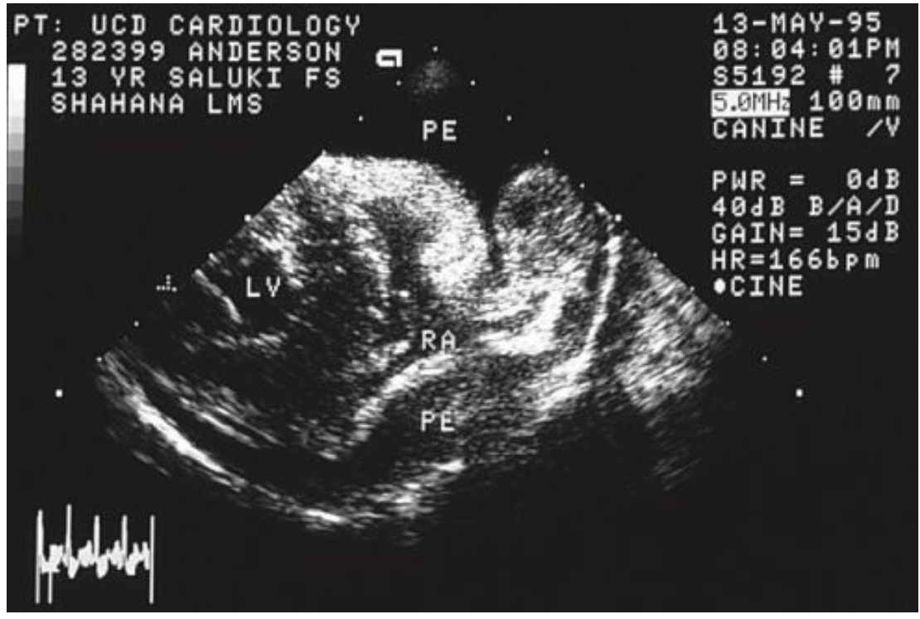

- Troponin
  - With myocardial necrosis, troponins can be released into circulation. This is also seen when tumors invade myocardium (HSA)
  - With pericardial effusion, in one small study, if troponin I > 0.25ng/mL, there was 81% sensitivity and 100% specificity for HAS
    - In other words, 19% of dogs with pericardial effusion due to HSA did not have a troponin I concentration >0.25 ng/ml and all dogs with an elevation >0.25 ng/ml had HSA rather than idiopathic pericarditis, heart base tumor, or mesothelioma.
- Treatment
  - Pericardiocentesis
    - Diagnostic and therapeutic
      - Provides fluid sample for analysis, reduces pericardial pressure, improves cardiac filling, relieves clinical signs temporarily
      - Most patients show dramatic clinical improvement following pericardiocentesis with reduction in jugular distention, increased arterial pulse quality, reduction in heart rate
    - 14g-16g catheter, 5-6 inch, over-the-needle
      - extra side holes can be cut using no 11 blade, taking care not to leave burrs on the holes cut near the tip
    - Patient placed in sternal recumbency or left lateral recumbency, right side shaved and prepped from 3rd to 7th intercostal space
    - Local anesthetic can be administered as well as mild sedation with butorphanol
    - ECG monitoring during procedure
    - Right side between intercostals 4-6 due to larger cardiac notch to avoid trauma to lung tissue as well as avoid laceration of cardiac coronary vessels on left side
    - Catheter needle is inserted through skin and slowly advanced into thorax until penetration into pericardium. When fluid is obtained, the catheter is fully advanced over the needle into the pericardial space, the needle is removed, and the extension and stopcock with syringe is connected directly to the catheter.
    - Complications include cardiac puncture (right heart wall thinner than left), hemorrhage, arrhythmias, tumor laceration, dissemination of neoplasia or infection throughout thorax
      - Ventricular arrhythmias are commonly seen due to catheter contact with ventricular wall or epicardium. Antiarrhythmic medications and repositioning of catheter usually resolves arrhythmias
      - Immediately place a sample in glass tube to look for clotting of fluid which would be an indication of cardiac puncture into right ventricle
  - Medical management
    - Important to distinguish cardiac tamponade from other causes of RCHF because treatment different
    - Diuretics and vasodilators will further decrease cardiac output and exacerbate hypotension by reducing cardiac filling pressure
      - Diuretic may be useful post-pericardiocentesis for RCHF
    - Positive inotropic drugs do not improve cardiac output because underlying pathophysiology is impaired cardiac filling and not poor contractility
  - Exploratory thoracotomy pericardectomy +/- mass resection
    - Curative for nonneoplastic masses
      - Re-effusion occurs up to 64% of idiopathic cases
    - Palliative for heart based tumors of several months to 1-2 years symptom free
      - Heart based tumors slow growing, metastasize late, and do not bleed
    - Prognosis and outcome not changed for atrial HSA
      - Usually already metastasis by time of diagnosis
      - Subtotal pericardiectomy may be contraindicated due to direct spread of tumor
      - May consider chemotherapy for improved survival time of only a couple months with overall survival less than 1 year

