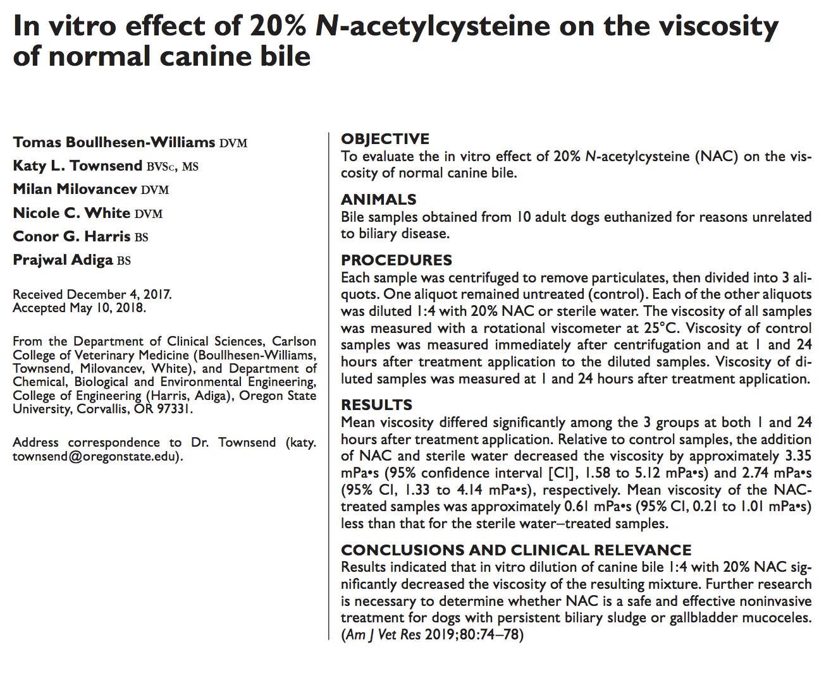
- In vitro study using NAC with normal bile extracted from gall bladder to 10 adult dogs that were euthanized
- NAC decreased viscosity of the bile with diluted 1:4 with 20% NAC
- Human infants have similar disease called bile-plug syndrome forming bile sludge, treatment is that NAC is given via cholangiogram catheter.
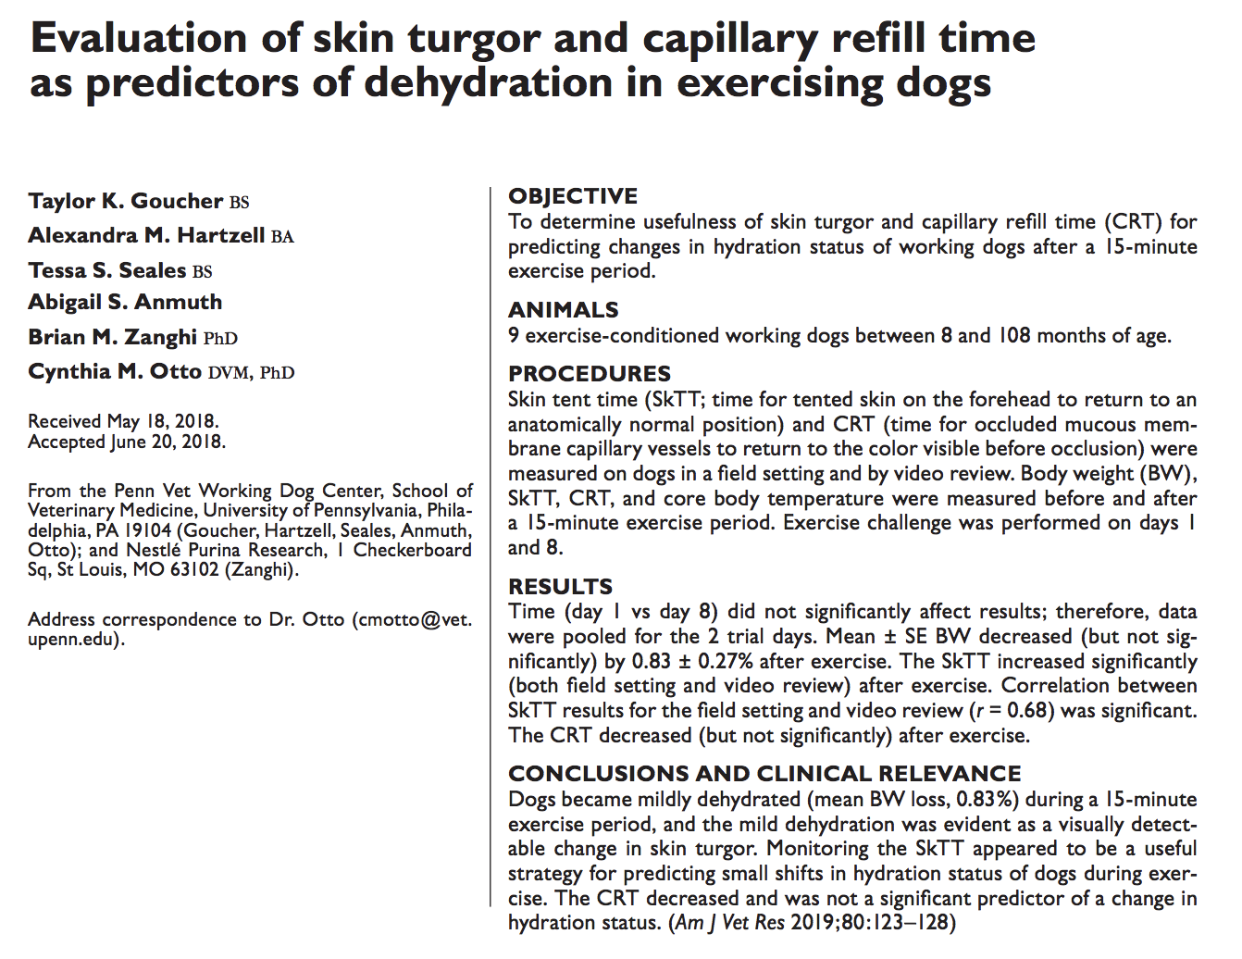
- 15 min exercise period, body weight slightly decreased indicating dehydration, skin tent time increased, CRT decreased.
- Skin tent time was checked on forehead, pinching raised for three seconds before released
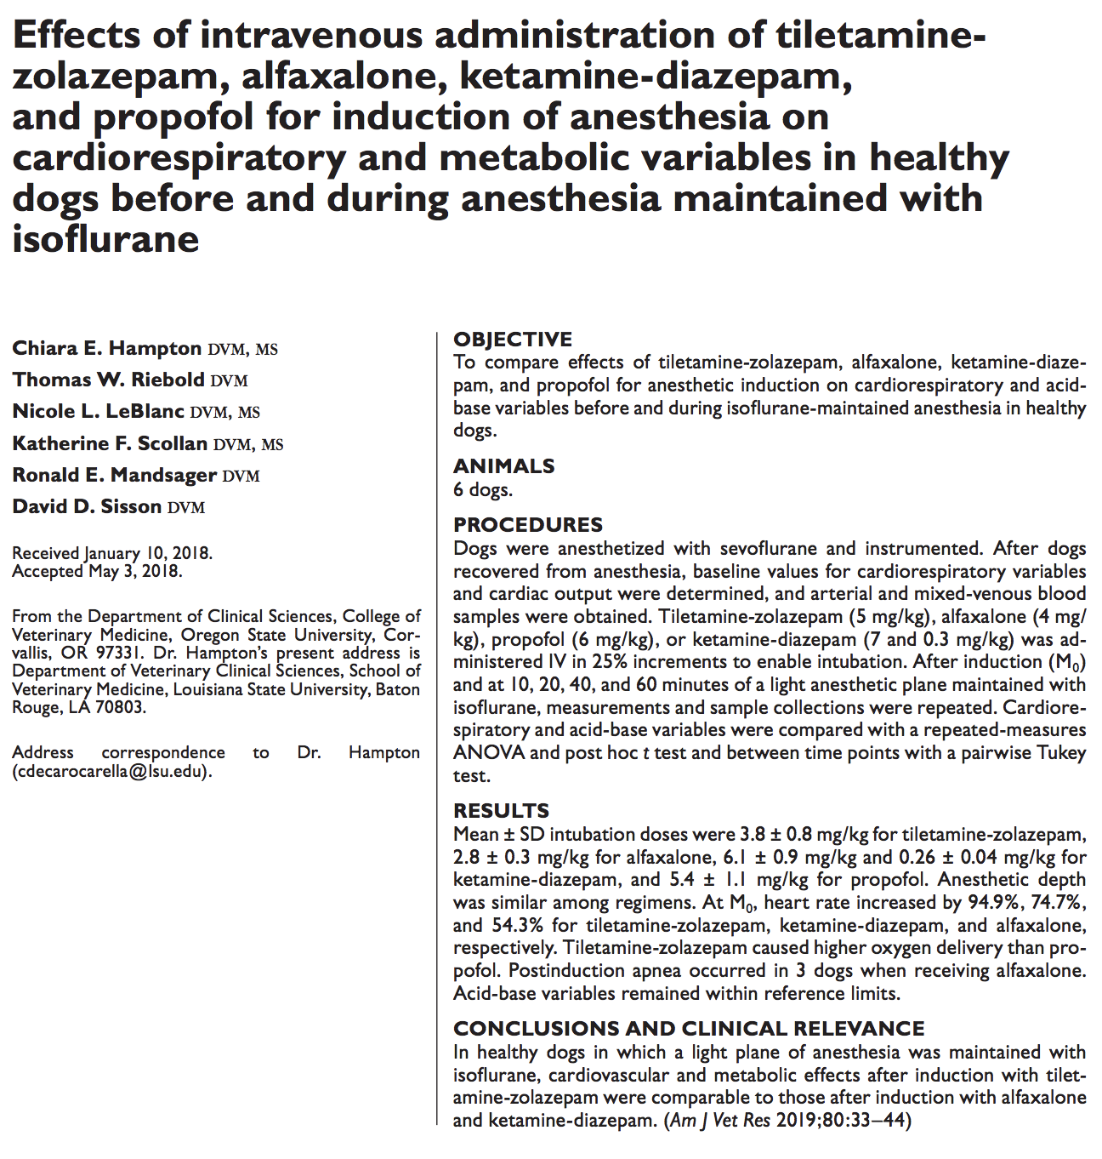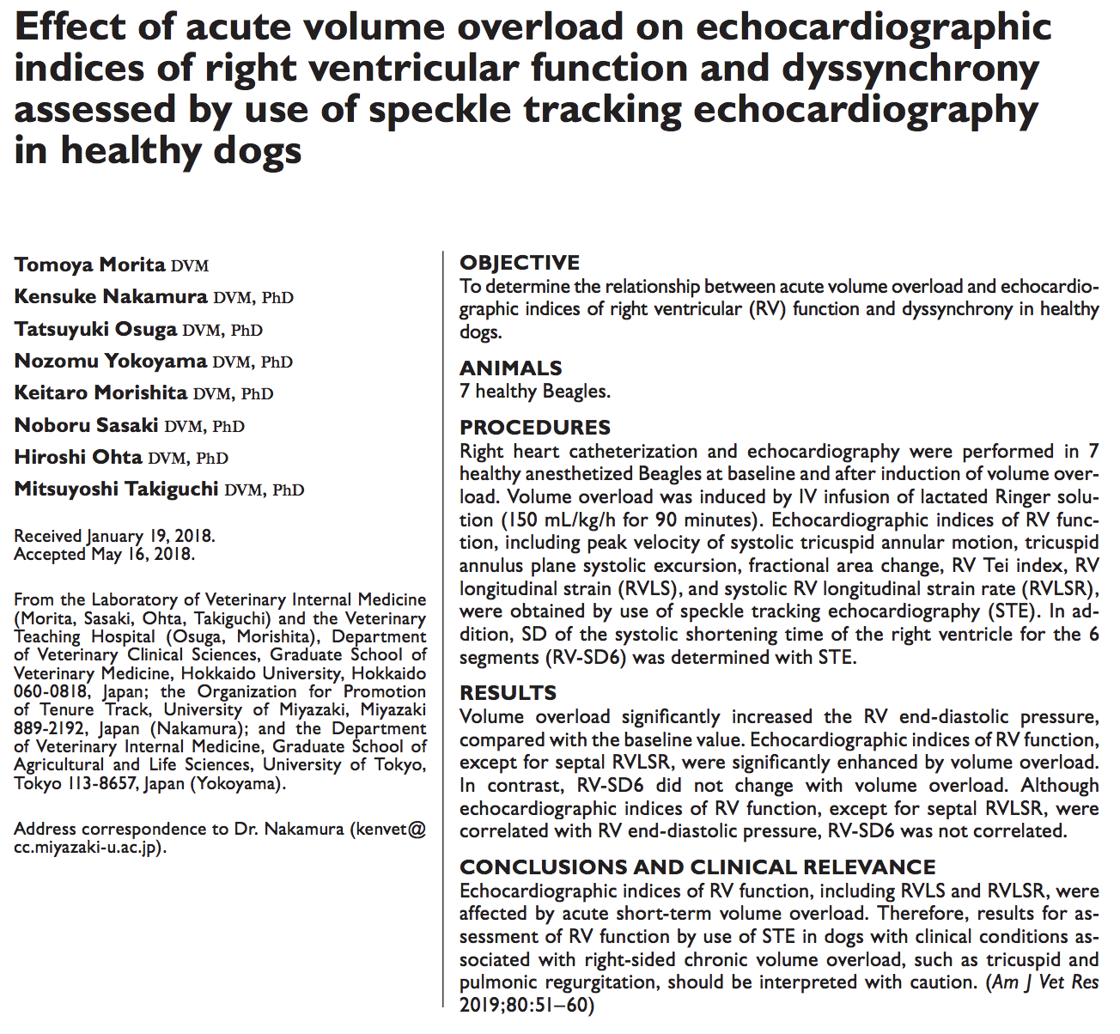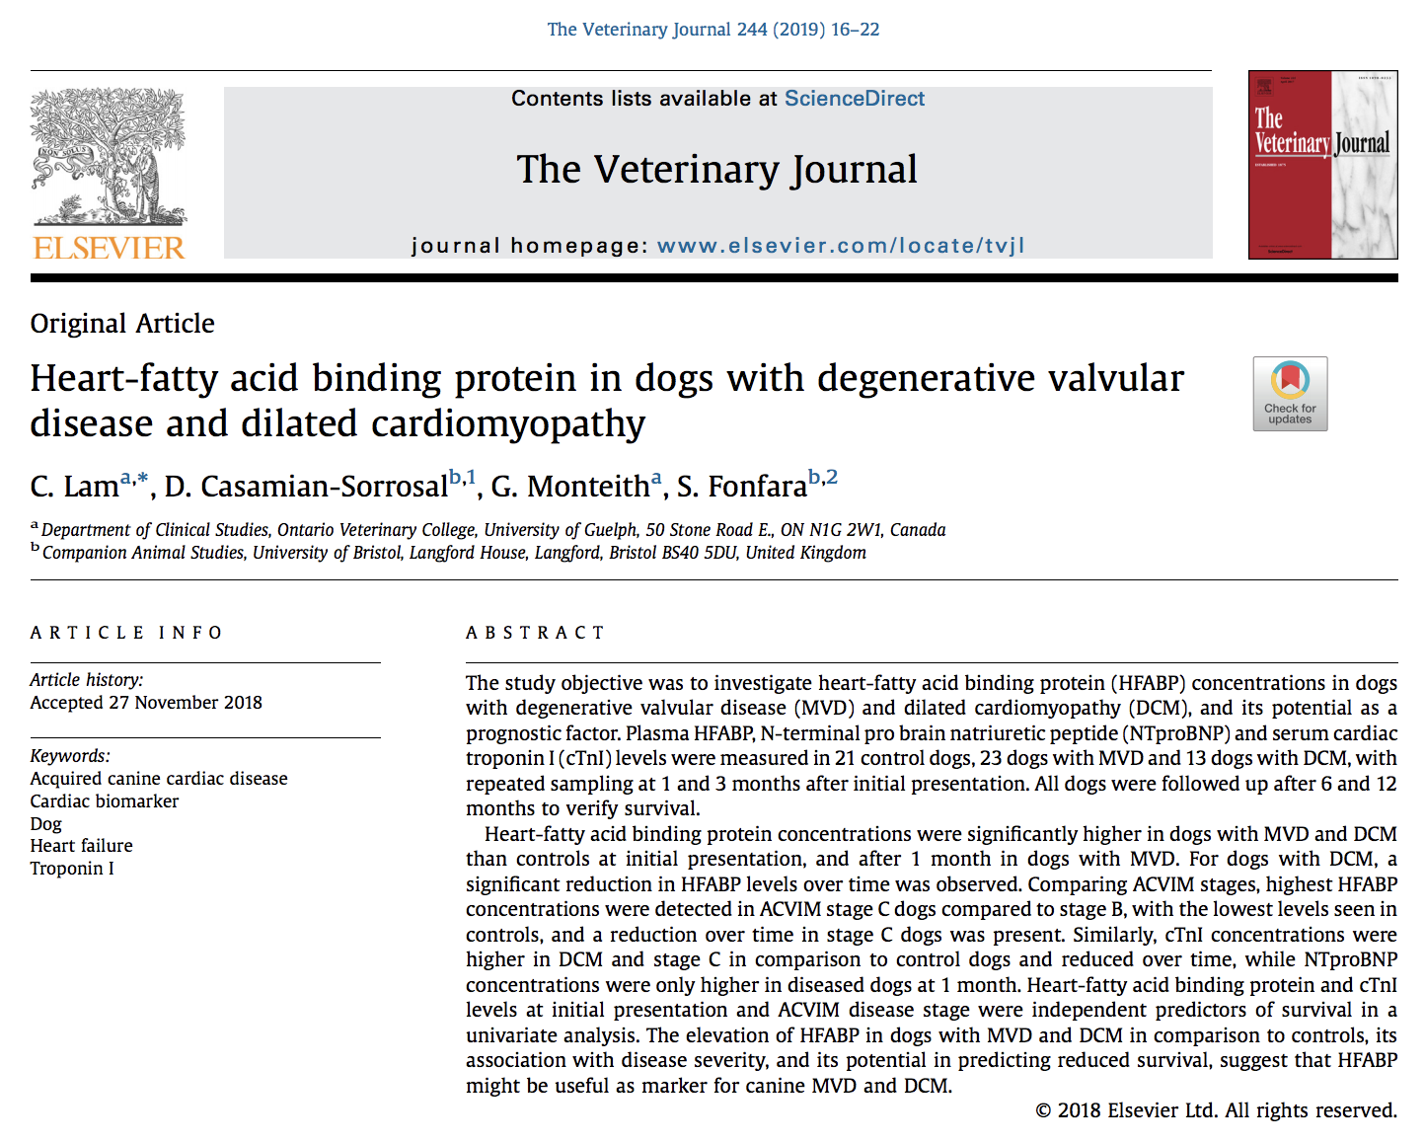
- Heart-fatty acid binding protein (HFABP) novel biomarker in human with ischemic heart disease and heart failure
  - Small 15kD low molecular weight cytoplasmic protein abundantly expressed in myocardial cells
  - Function is fatty acid transport and metabolism, which can be impaired early stages of heart failure and can be rapidly released during myocardial damage
  - More sensitive (but not more specific) than cardiac troponin I
- Results: HFABP present in normal dogs, but higher in MVD and DCM. HFABP higher in MVD stage C than stage B. NTproBNP and cTnI did not have any difference between stage B and normal dogs. With treatment, there was a decreased in HFABP in DCM and MVD stage C at 1mo and 3mo
- Persistent HFABP over time can be a marker of predicting reduced survival
- HFABP potentially can be a marker of disease severity as well

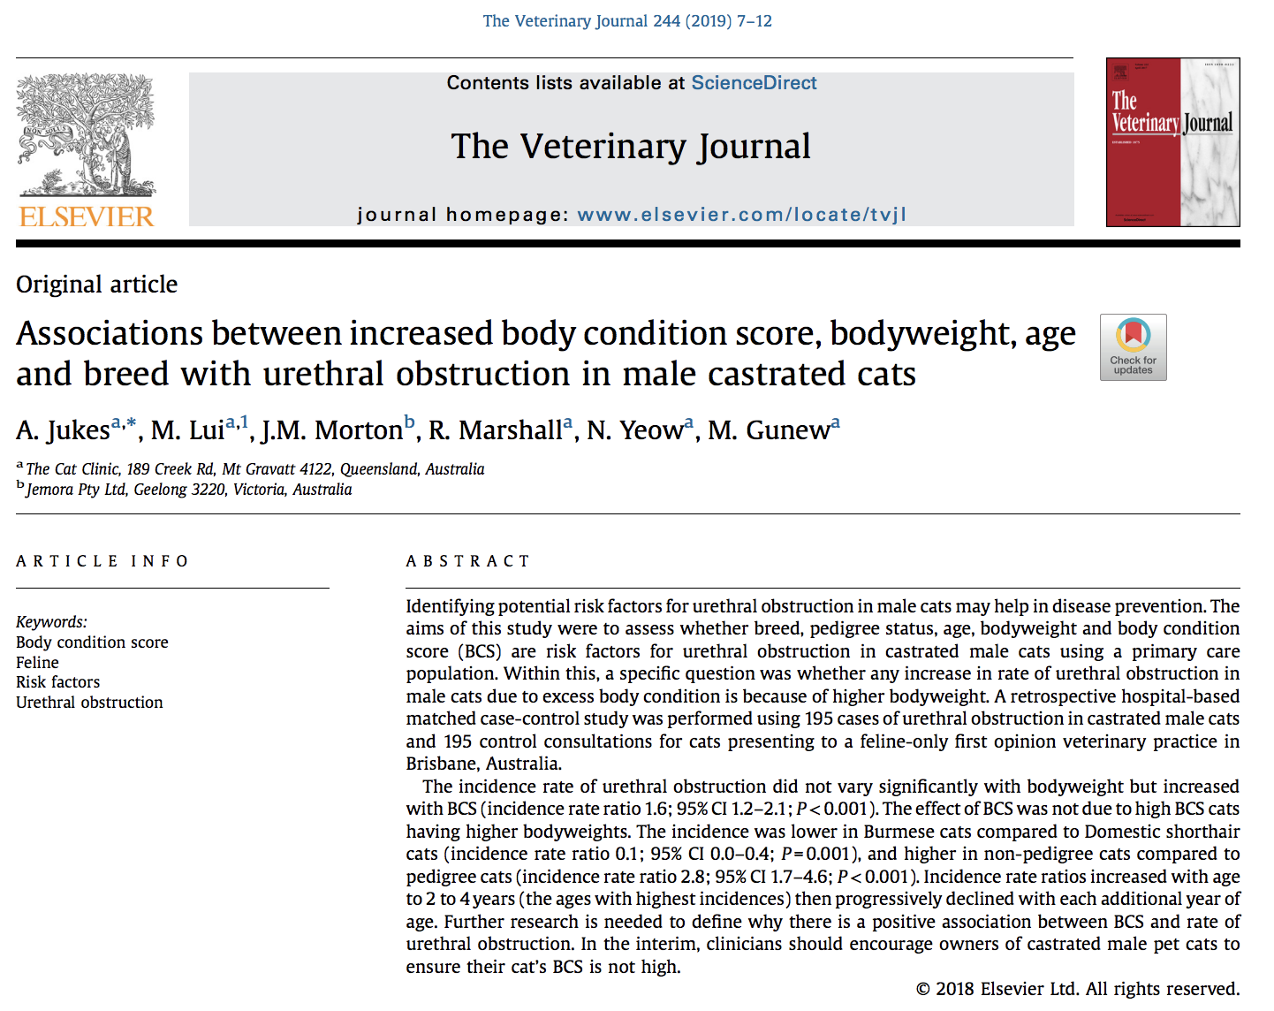
- Increased body weight has been identified as risk factor for UO, author hypothesizes that it is more related to adiposity and that body condition score more accurately reflects body fat
- Results showed that increased BCS had higher incidence of UO, not body weight
- Incidence rate ratios also increased with age 2-4, then declined each additional year
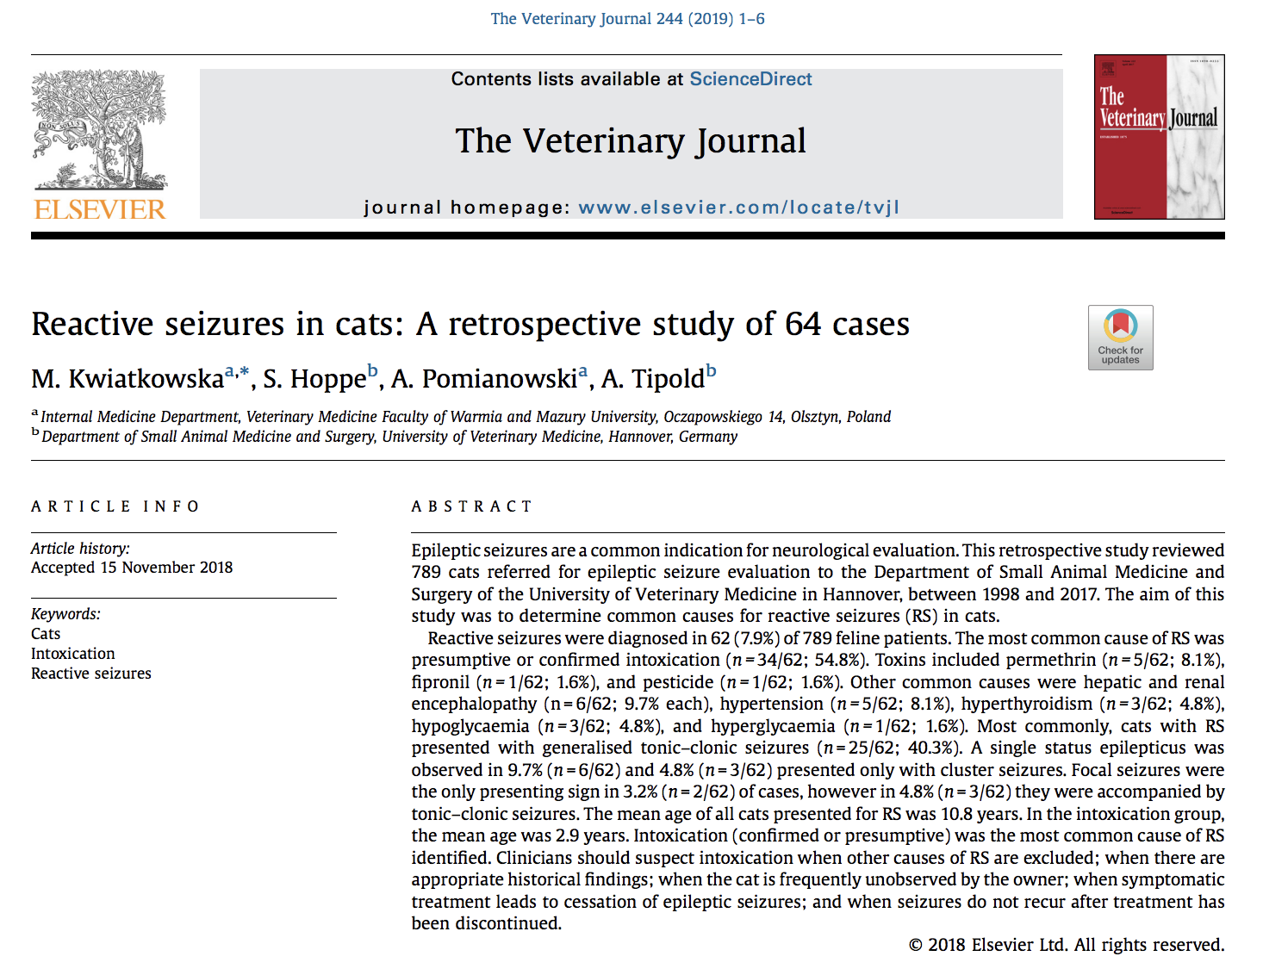

- When animals develop sudden onset seizures, divide into idiopathic epilepsy, structural epilepsy, or reactive seizures
- In this retrospective study, 64 of 789 cats were diagnosed with RS; most common cause was presumptive or confirmed intoxication (permethrin, fipronil, pesticide), other common common causes were hepatic and renal encephalopathy, hypertention, hyperthyroidism, hypoglycemia, hyperglycemia
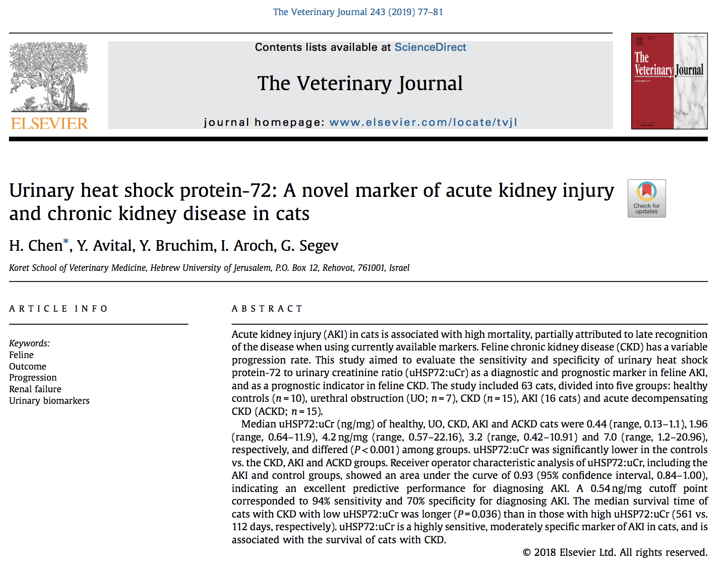

- Heat shock protein-72 is a stress-induced cytoprotective protein which increase under variety of cellular insults and stress conditions, including kidney damage
- 63 cats devided in healthy, UO, CKD, AKI, acute decompensating CKD (ACKD)
- In this study, uHSP72:uCr ratio was significantly higher in UO, CKD, AKI, ACKD in comparison to healthy cats. A 0.53 cutoff point corresponded to 94% sensitivity and 70% specificity in diagnosing AKI
- Low uHSP72:uCr had a better median survival time thank high in CKD cats
- Small sample size of only ~10-15 in each group
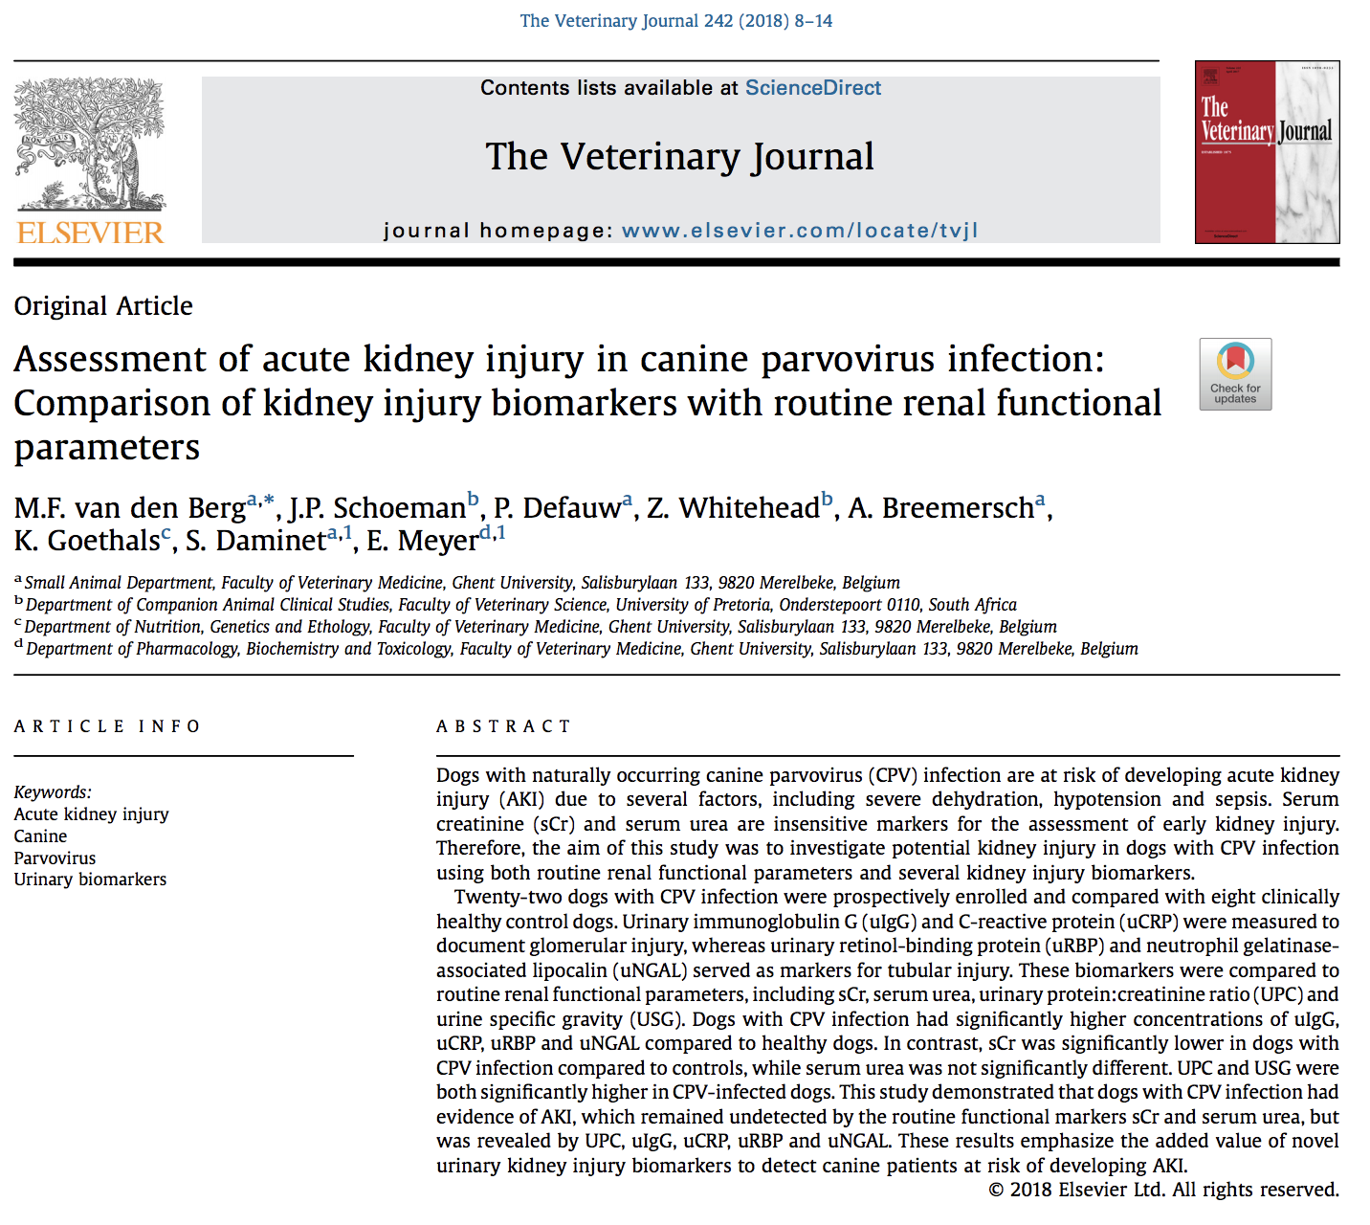

- 22 parvo dogs compared to 8 healthy control dogs
- measured urinary immunoglobulin G (ulgG) and urinary c-reactive protein (uCRP) to document glomerular injury
  - relatively high MW proteins that are normally not filtered through the glomerular filtration barrier
- urinary retinol-binding protein (uRBP) and neutrophil gelatinase-associated lipocalin (uNGAL) to document tubular injury
  - retinol binding protein is a protein of low MW (21 kDa), which is freely filtered through the glomerulus and reabsorbed by the proximal tubules under physiological circumstances. Its detection in urine reflects tubular damage and has been described in various kidney diseases and naturally occurring AKI
  - Neutrophil gelatinase-associated lipocalin (NGAL, MW 25 kDa) is a neutrophil-derived protein that is normally expressed at low concentrations at the level of the kidney, but markedly increases with renal tubular cell injury at an early stage. Plasma NGAL (pNGAL) and urinary NGAL (uNGAL) are used as early markers of AKI in human medicine. Studies have been shown that it is a sensitive biomarker for AKI in dogs
- Also looked at routine renal functional parameters like USG, BUN, sCreat, UPC
- Results: parvo dogs had higher uIgG, uCRP, uRBP, uNGAL compared to healthy dogs; BUN same creat lower, UPC and USG higher in CPV dogs
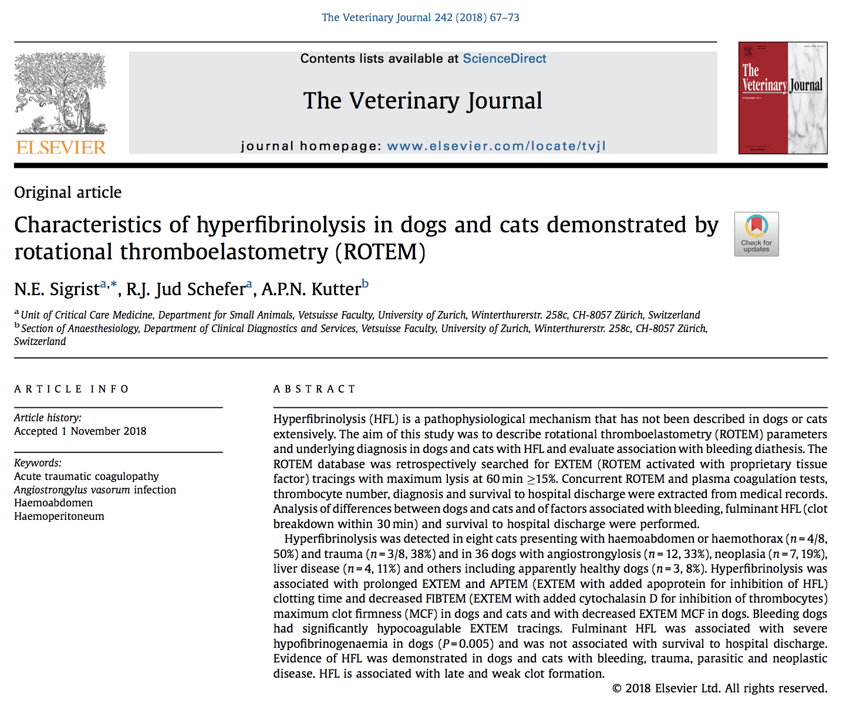
- The purpose of this retrospective study was to identify diseases associated with HFL in dogs and cats, to characterize concurrent coagulation abnormalities described by viscoelastic and plasma coagulation tests and to compare dogs and cats. An additional goal was to compare parameters between dogs with and without clinical signs of bleeding. The hypothesis was that ROTEM parameters of dogs with HFL and clinical signs of bleeding significantly differ from those of dogs with HFL without clinical signs of bleeding.
- Retrospective, of the 995 canine and feline EXTEM (ROTEM activated with proprietary tissue factor), 44 showed HFL (36 dogs, 8 cats)
- In cats, those with HFL had hemoabdomen and trauma
- In dogs, A. vasorum lungworm infestation, liver disease, neoplasia with and without hemoabdomen, septic abdomen, GI bleed, and others
- In dogs, HFL in combination with EXTEM hypocoagulability was significantly associated with bleeding.

