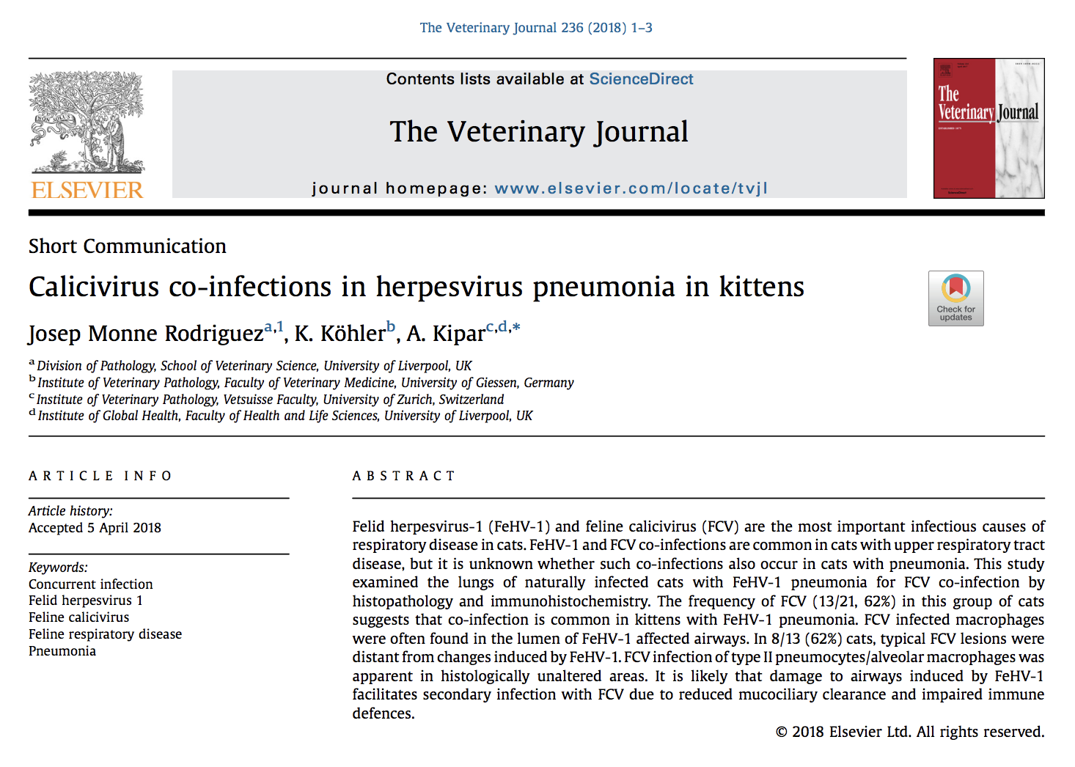

21 naturally infected FeHV-1 pneumonia cats had histopathology and 13 of 21 had co-infection with feline calicivirus
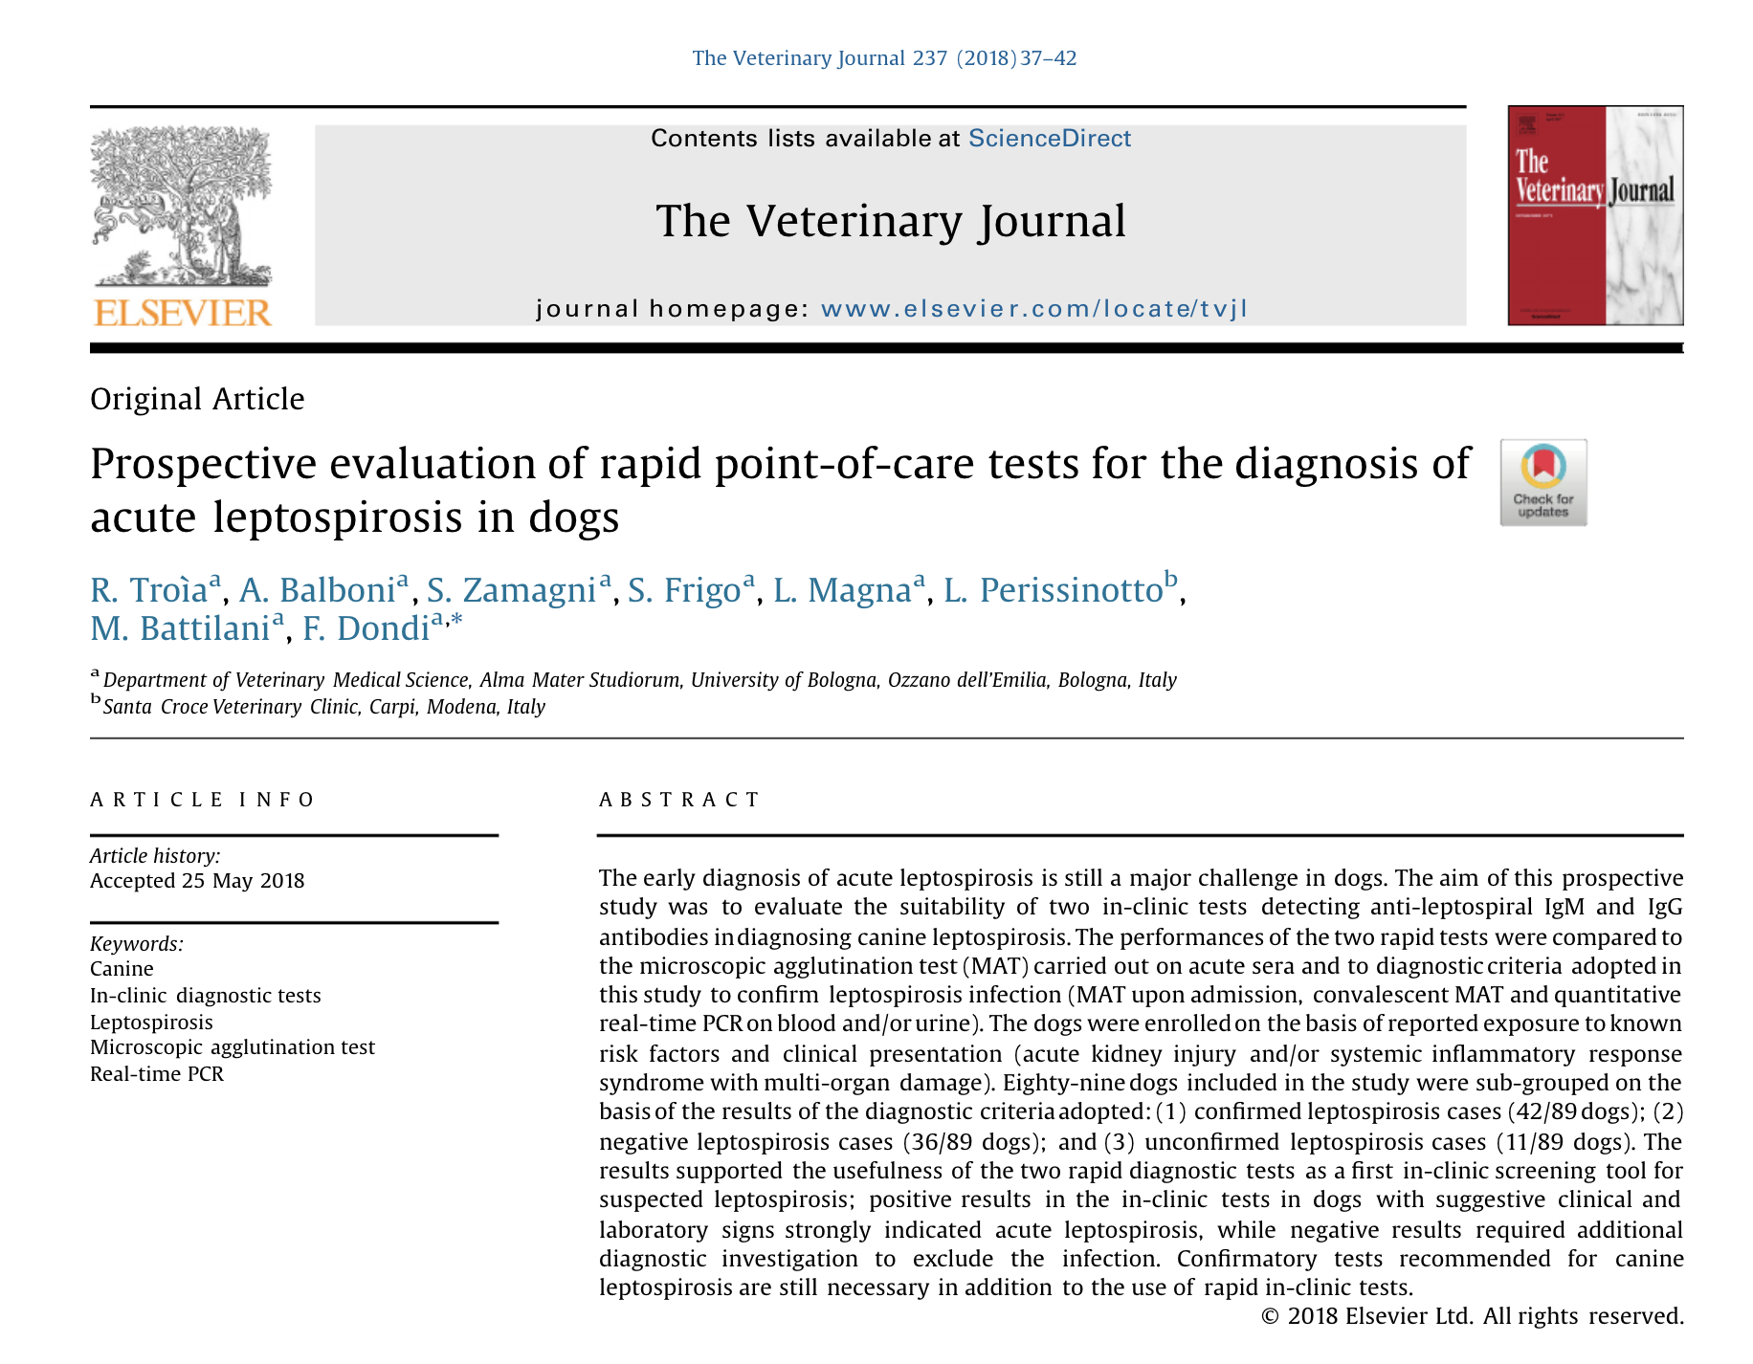

Prospective study evaluating two rapid in-clinic tests detecting anti-leptospiral IgM and IgG antibodies; compared to microscopic agglutination test (MAT)
89 dogs
- 42/89 were confirmed leptospirosis cases
- 36/89 were negative
- 11/89 were unconfirmed cases
Positive tests with clinical and lab signs strongly indicative of lepto, negative test does not rule out. Additional confirmatory tests are still recommended beyond this.

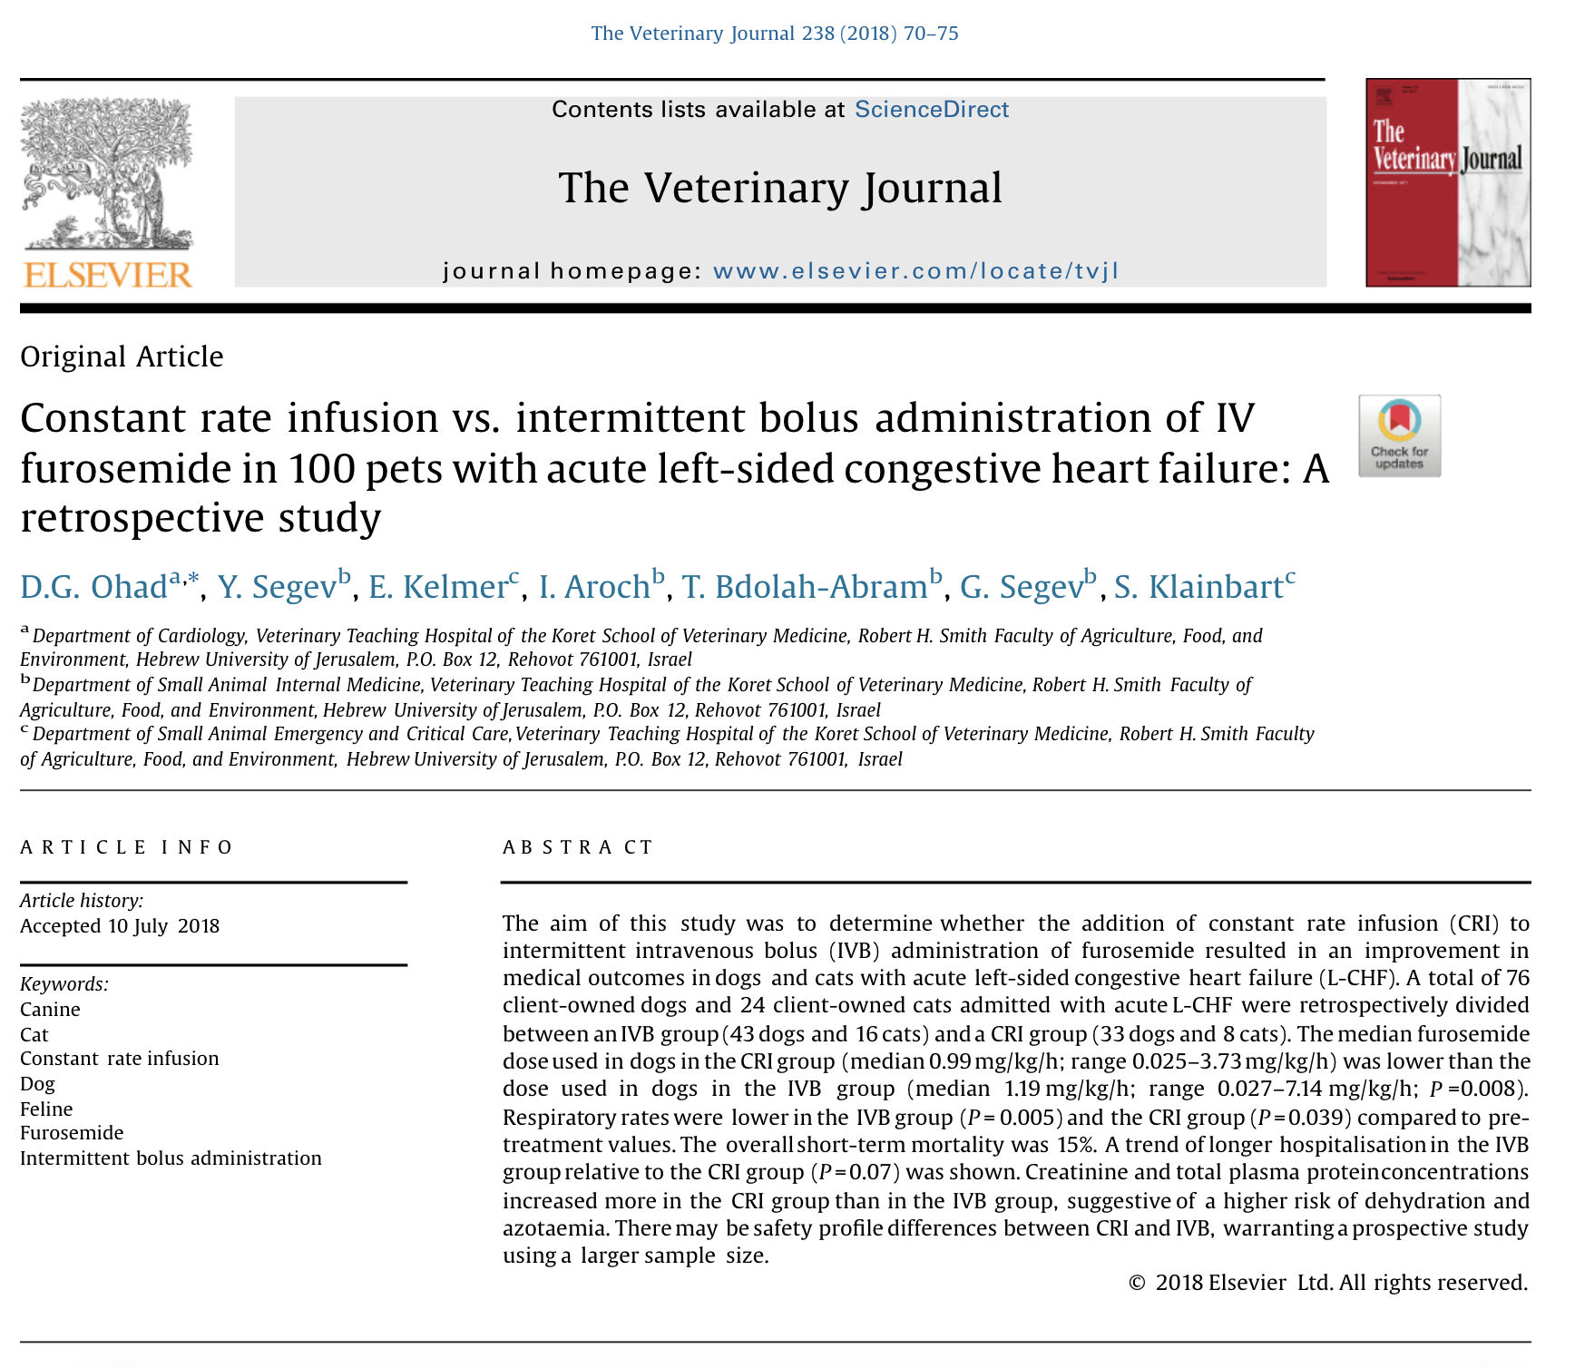

Retrospective study.
Total of 76 client-owned dogs and 24 client-owned cats admitted with acute L-CHF, divided to:
- 43 dogs and 16 cats in IV bolus group
- 33 dogs and 8 cats in CRI group
Results
- median amount used was lower in CRI than IVB
- Resp rates were lower in IVB than CRI
- Trend for longer hospitalization in IVB than CRI
- Creatinine and total plasma protein concentration increased in CRI than IVB group suggesting higher risk of dehydration and azotemia

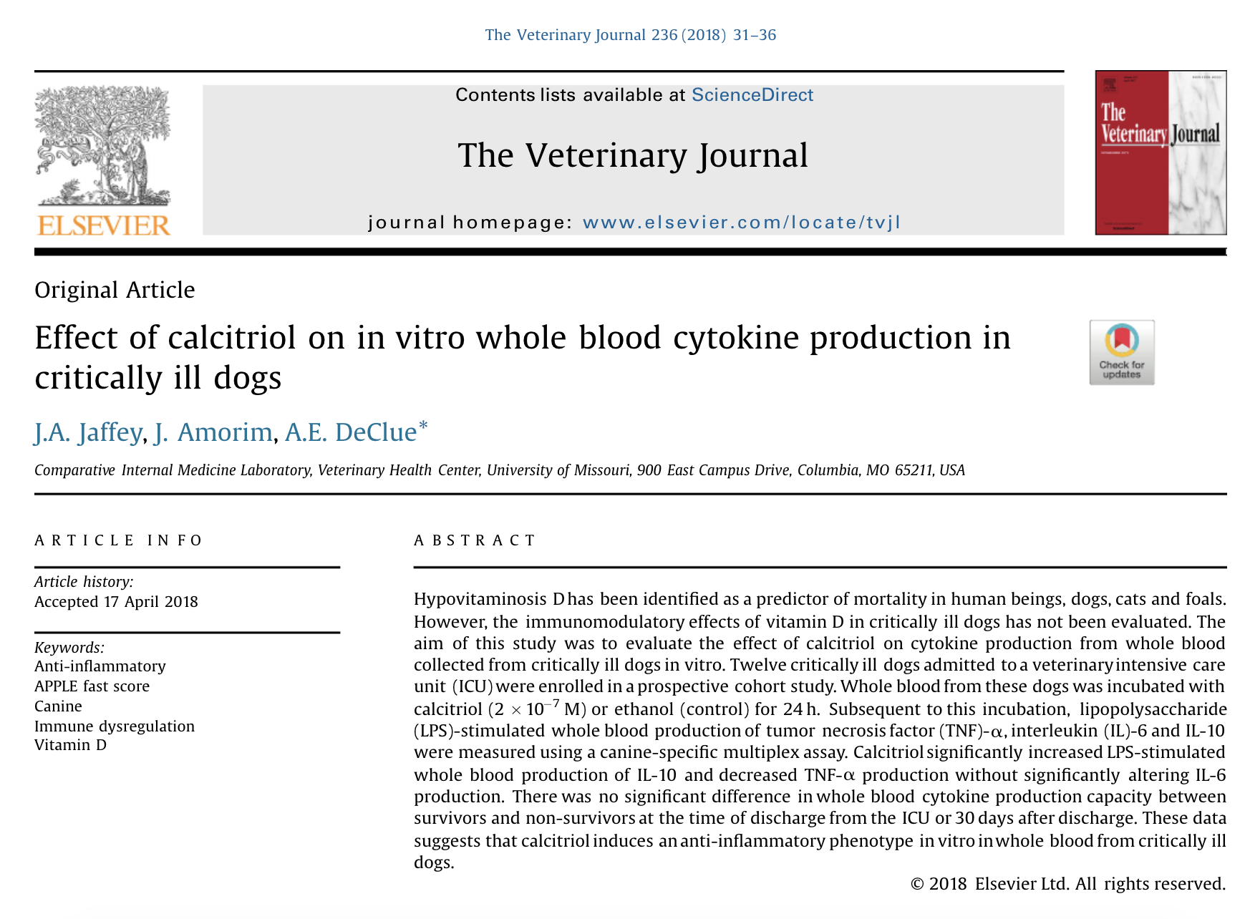

Prospective cohort study
12 critically ill dogs had whole blood collected and incubated with calcitriol or ethanol (control)
Calcitriol in vitro had increased LPS-stimulated production of IL-10 and decreased TNF-alpha production without alterint IL-6 production
Suggests that calcitriol induces an anti-inflammatory phenotype in vitro in whole blood from critically ill dogs

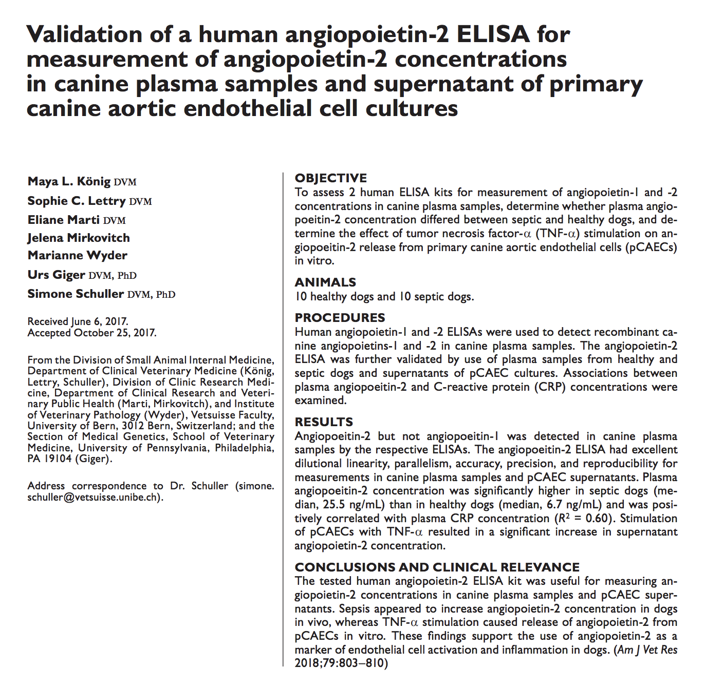

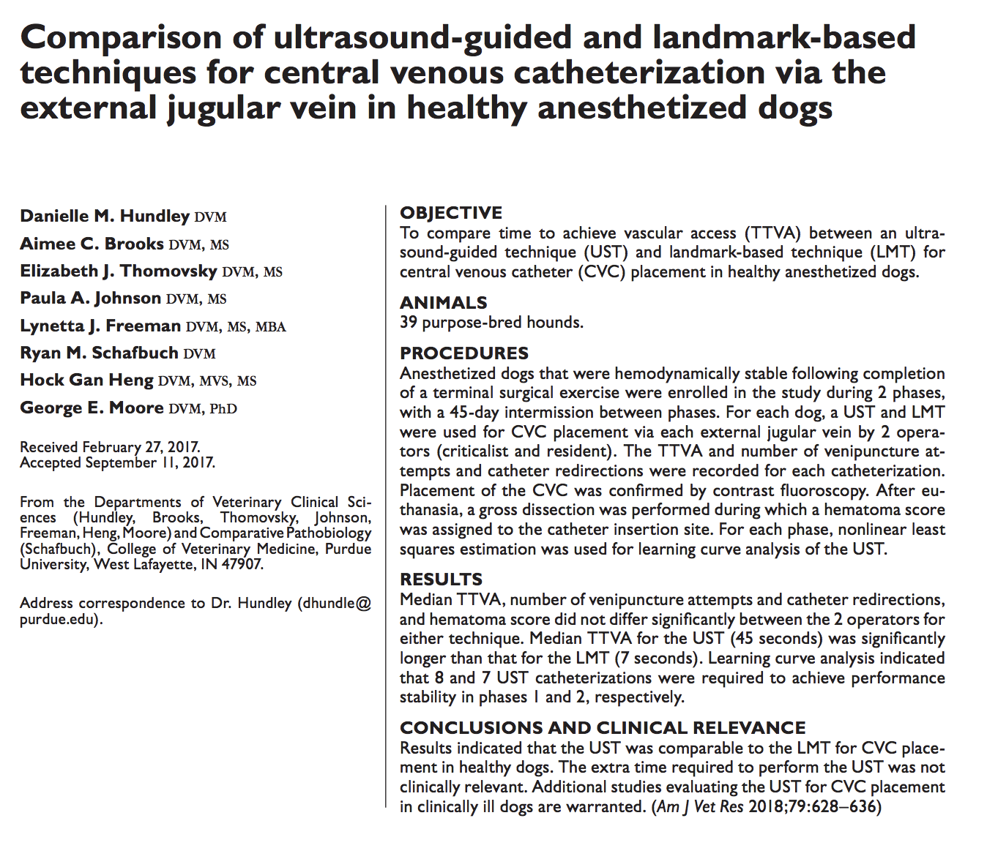

- Prospective, 39 anesthetized hounds that were hemodynamically stable.
- For each dog, ultrasound guided technique and landmark-based technique for central venous catheterization were performed 45 days apart
- Recorded time to achieve vascular access (TTVA) as well as number of venipuncture attempts and catheter redirection. Placement confirmed with contrast fluoro
- Results UST and LMT relatively comparable but UST took longer (45 seconds). However it did not seem to be clinically relevant.
- In conclusion section, talking about limitations of study, they mentioned that additional studies evaluating this in clinically ill dogs is warranted as well as comparing novice to experienced people

