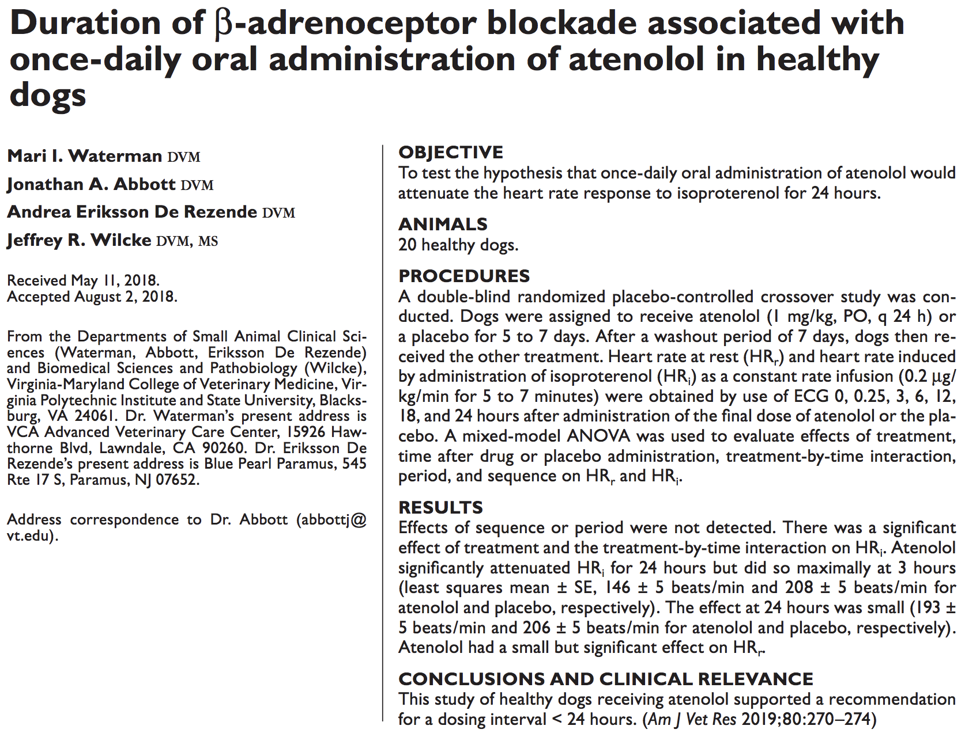

- Atenolol as a selective beta1-adrenergic receptor antagonist
  - Limits myocardial oxygen consumption and preserve myocardial function via decreasing heart rate and contractility
- Typically dosed at q12 or q24 interval but elimination half life is 3-7 hours in dogs with peak plasma concentration at 1-2 hours post oral administration
- Prospective double blinded randomized placebo controlled crossover study
- 20 healthy dogs
- Received atenolol 1 mg/kg PO q24 or placebo for 5-7 days, 7 day wash out period, then dogs receive other treatment
- HR at rest and HR induced by administration of isoproterenol at CRI 0.2ug/kg/min obtained looking at ECG 0, 0.25, 3, 6, 12, 18, 24 hours
- Atenolol significantly attenuated heart rate up to 24 hours, maximally at 3 hours, minimally at 18 and 24 hours

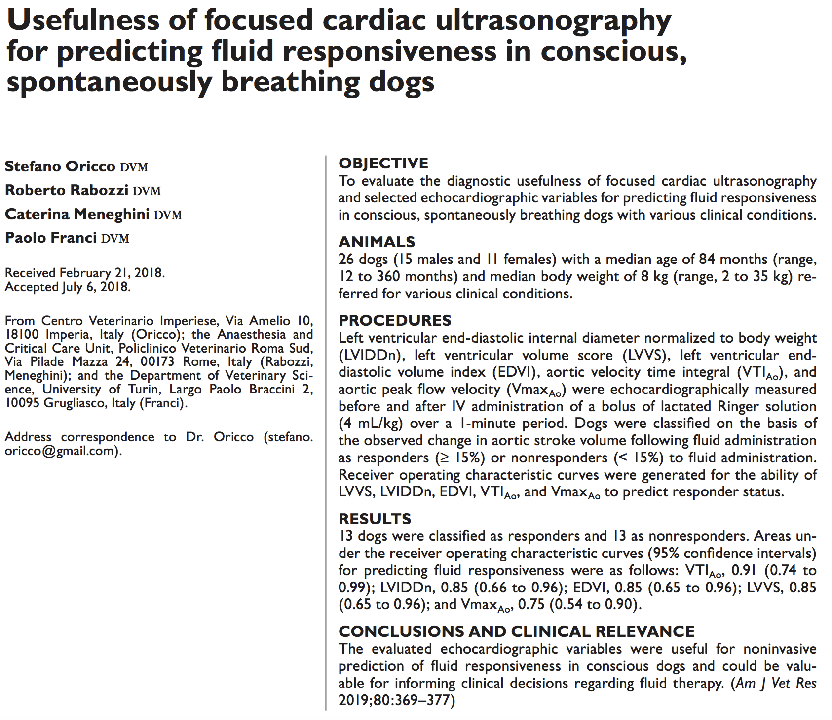

- Fluid responsiveness is ability for individual to increase stroke volume by 10-15% after receiving appropriate fluid bolus
- The purpose of the study reported here was to assess the discriminatory power of FoCUD and selected echocardiographic indices to predict FR in spontaneously breathing dogs. Specifically, LVIDDn, left ventricular EDVI, VTIAo, and VmaxAo were explored as independent predictors of FR in a heterogeneous group of conscious, critically ill dogs.
- All echographic indices evaluated in the present study were good to excellent predictors of FR (as defined) in a heterogeneous group of conscious dogs with various clinical conditions. The optimal cutoffs for discriminating responders to bolus fluid administration from nonresponders had 100% specificity for EDVI, LVIDDn, LVVS, and VTIAo. This finding suggested the high accuracy of the test in terms of specificity and the ability to classify dogs as responders without false-positive results

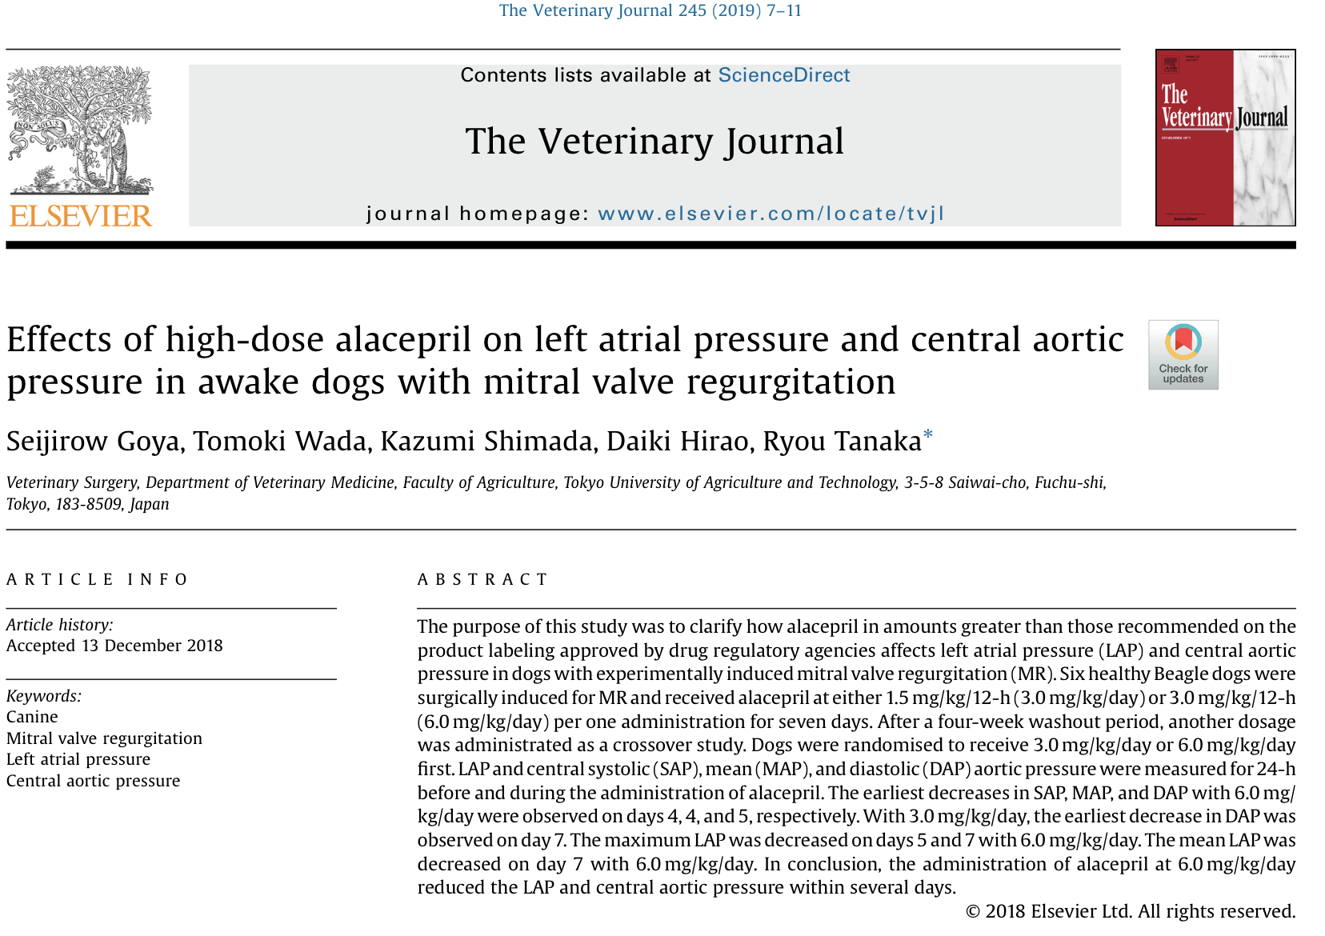
- 6 healthy beagle dogs
- MR was surgically induced, radiotransmitter catheter was placed in left atrium and aorta, and then animal was rested for 4 weeks before alacepril was administered 1.5mg/kg q12 for 7 days or 3mg/kg q12 for 7 days. After another 4 week washout period, animal was then randomized to receive 3mg/kg/day or 6mg/kg/day for 7 days.
- HR, LAP and central aortic pressure was measured for 24 hours before administration and every day after administration
- Alacepril at 6.0mg/kg/day had significant decrease in LAP and central aortic pressure within 7 days (as early as day 4 or 5)

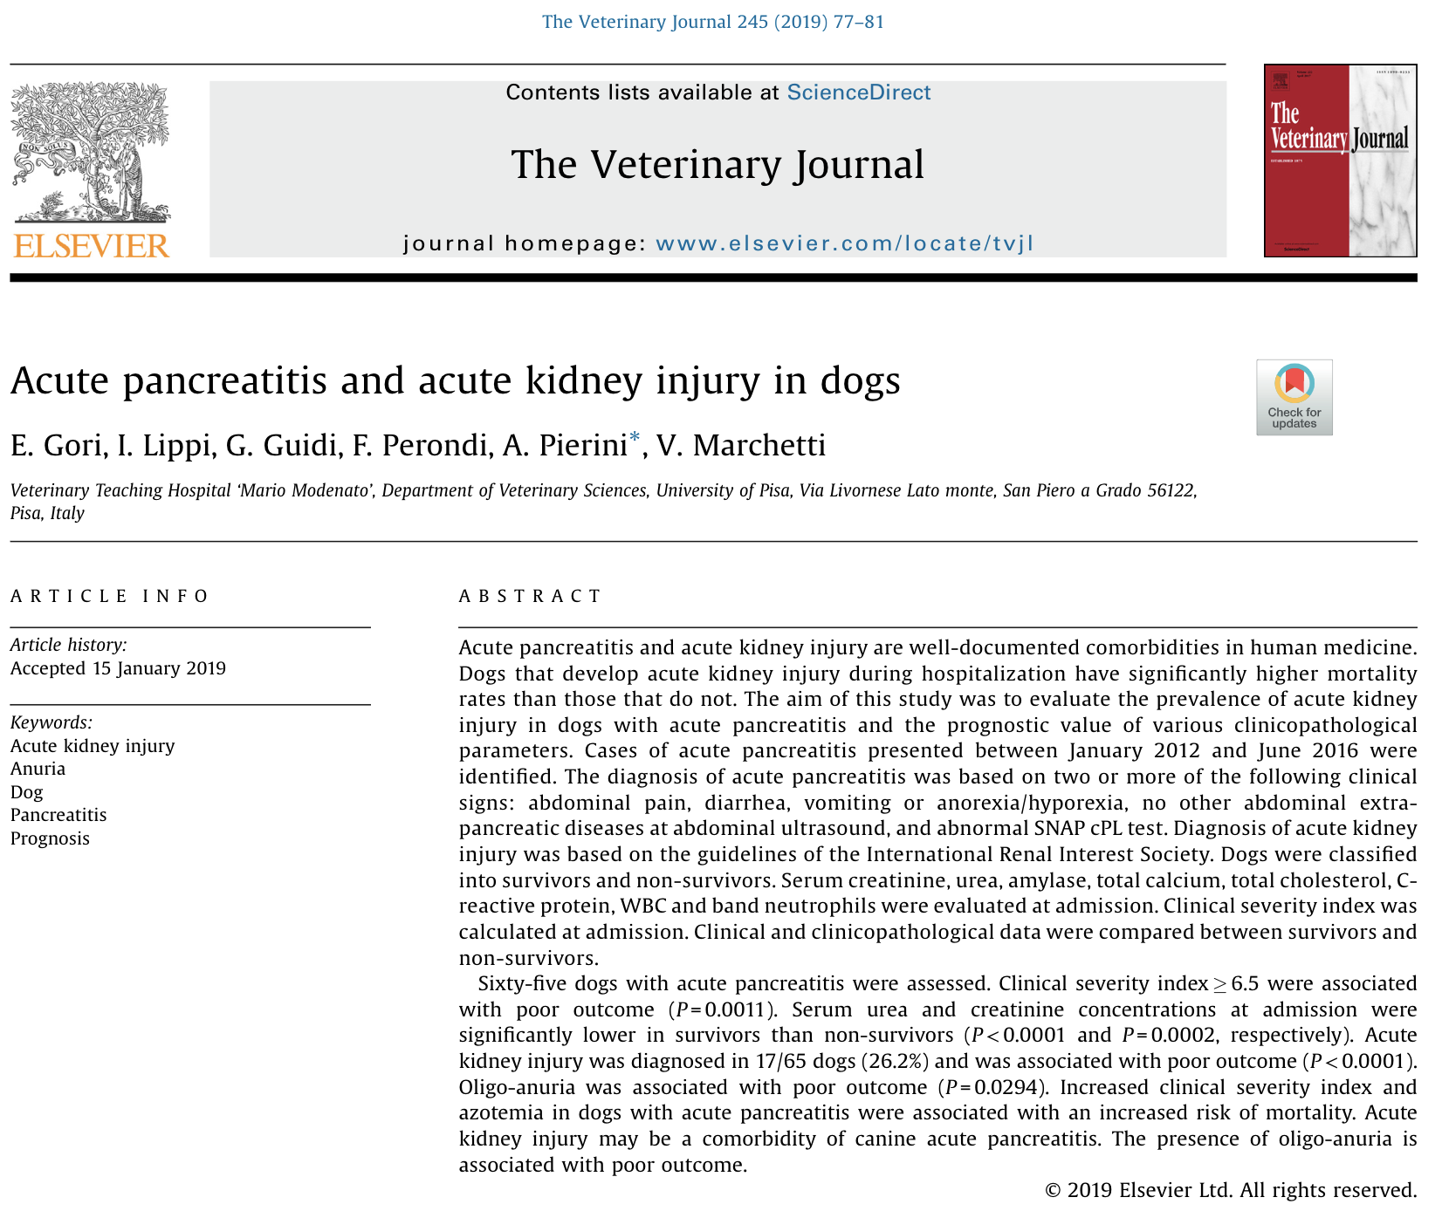
- In human medicine, AKI and AP are common comorbidities. AP leads to AKI via hypovolemia, cytokine-induced ischemia, inflammation, and oxidative stress
- Retrospective study looking at 65 dogs with AP to evaluate prevalence of AKI and determine prognostic value of various clinicopathological parameters
- Diagnosis of AP based on 1) two or more of following clinical signs: V+/D+/anorexia, abdominal pain 2) presence of AUS without other signs of extra-pancreatic disease 3) abnormal SNAP cPL
- Results/discussion: Clinical severity index ≥ 6.5 associated with poor outcome, significant association between azotemia and increased risk of mortality, oligo-anuria associated with poor outcome

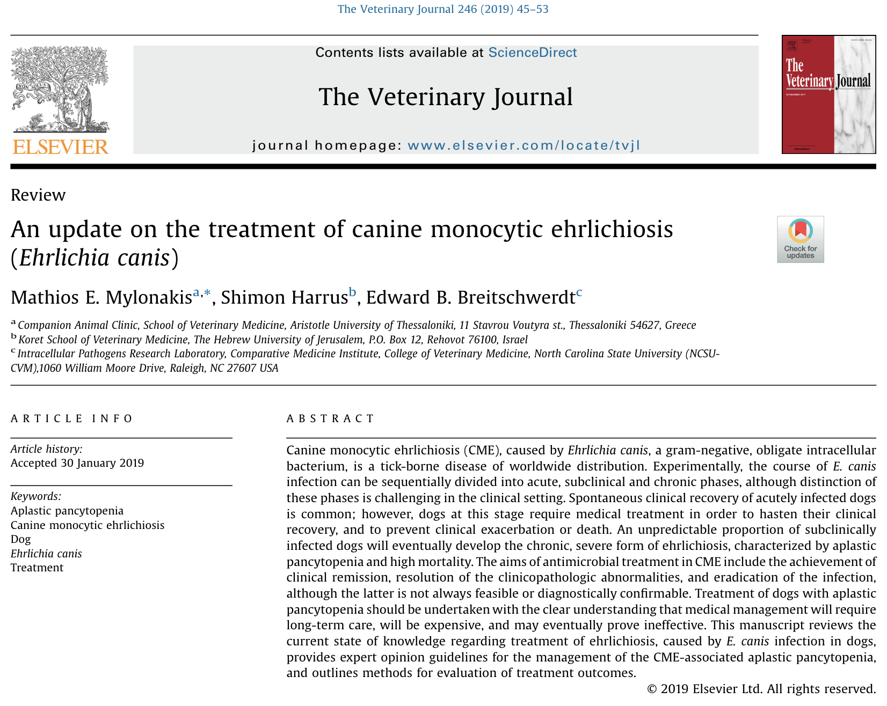
- Ehrlichia canis infection from blood transfusion or tick attachment
- Experimental setting divides into acute (2-4 wks), subclinical (months to years) and chronic phase but distinction not as straightforward in dogs with naturally occurring disease
- Clinical signs of fever, depression/lethargy, anorexia, generalized lymphadenopathy, splenomegaly, mucosal pallor, bleeding tendency
  - Acute likely infested with ticks with ulcerative stomatitis, necrotic glossitis, hindlim and/or scrotal edema
  - Chronic signs of CNS signs, cervical pain, bleeding diathesis (petechiae, ecchymoses, epistaxis, melena, hematuria
- Tetracycline broad spectrum antibacterial agenst that act by inhibiting attachment of aminoacyl-tRNA to bacterial ribosome during protein synthesis
  - Only doxycycline, semi-synthetic tetracycline time-dependent, has been critically evaluated in vitro or in association with E. canis infections
  - Consensus statement from ACVIM is doxycycline 10mg/kg PO q24 for 4 weeks
  - Typically given q12, but MIC for E.canis so low that q24 adminstration still has MIC above threshold
- Talks about experimental rifampicin potentially efficacious, imidocarb dipropionate no longer recommended, enrofloxacin ineffective, corticosteroids for immune-mediated cytopenias

