

- 424 canine urine culture with 46% positive for bacterial cystitis
- Sex, age, hematuria, pollakiuria were predictive for bacterial cystitis
  - Sex: Intact females
  - Age: increases with age
- There is no global agreement on the level of predictivity that qualifies empiric antibiotic treatment or characterizes a good clinical rule. An AUC of 0.70-0.80 is usually considered acceptable with regard to diagnostic accuracy and empiric antibiotic prescription is regarded as acceptable if the probability of bacterial cystitisis >70%
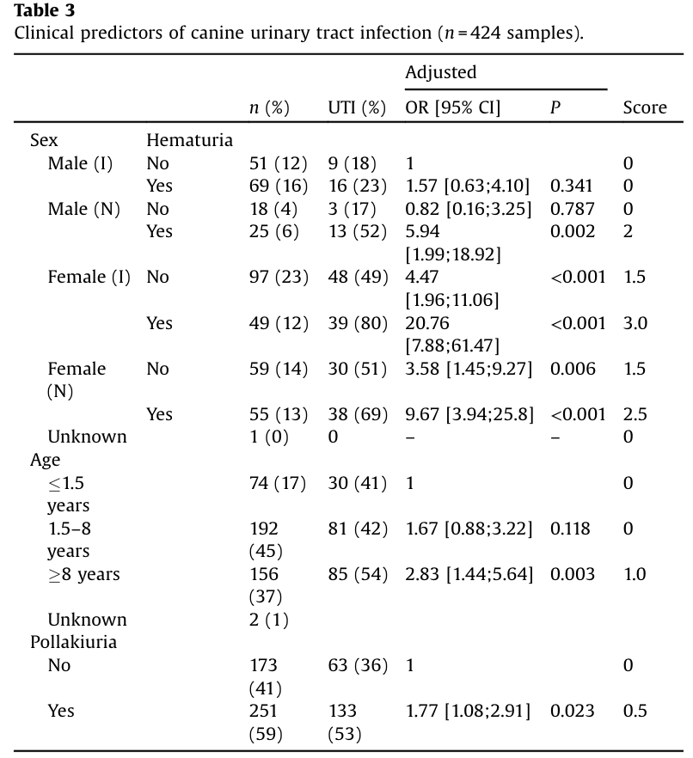

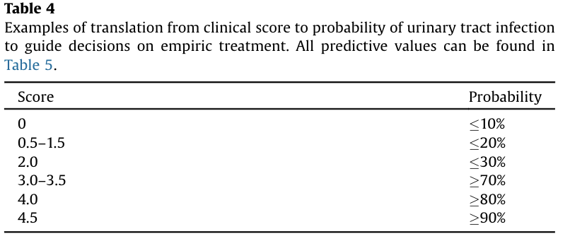
- Derived clinical decision rule had only modest predictive value in this study. Other variables or point-of-care test results should be included in future clinical rules in order to achieve higher overall precision.


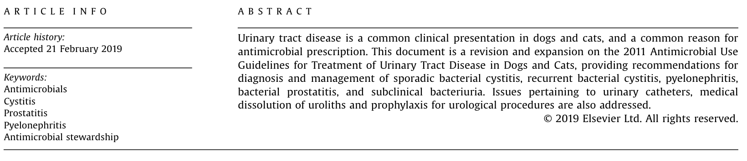

- Goes through classification, diagnosis, treatment, follow up recommendations for: sporadic bacterial cystitis, recurrent bacterial cystitis, upper urinary tract infection (pyelonephritis), bacterial prostatitis, subclinical bacteriuria
- Recommendations with urinary catheters
- Urological surgery, MIS urological procedures and urologic implants
- Medical dissolution of uroliths

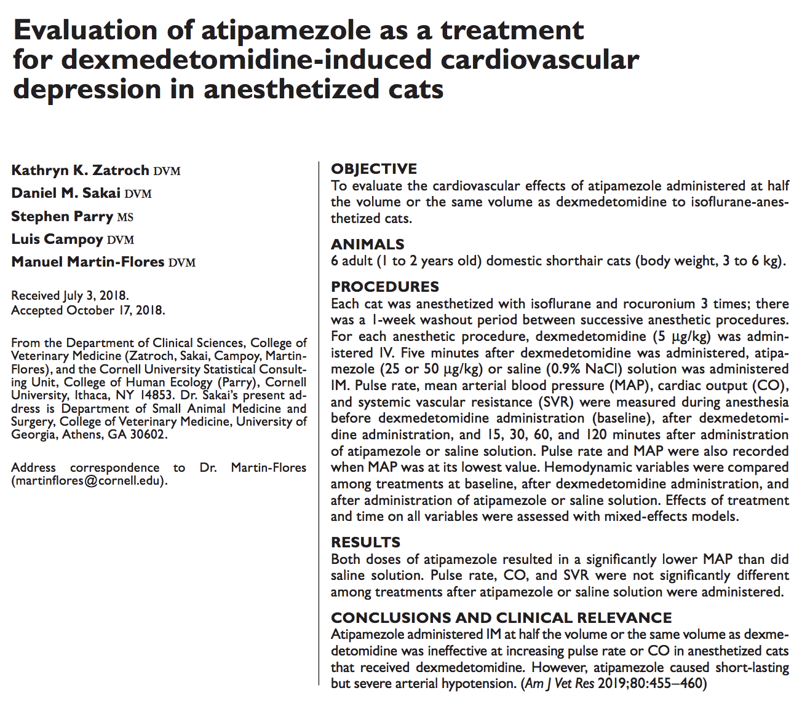
- Dexmedetomidine is known to have cardiovascular effects that decrease pulse rate, cardiac output and increase systemic vascular resistance and arterial blood pressure.
- This study hypothesized that atipamezole administered IM to cats that received dexdomitor and are under general anesthesia with isofluorane would restore pulse rate and decrease MAP compared to those administered just saline solution
- Results showed that pulse rate, cardiac output, systemic vascular resistence were not significantly different between atipamezole and saline treatment
  - Atipamezole resulted in significantly lower MAP, leading to severe hypotension MAP <60mmHg in 2 of the 6 cats for about 15 min
    - Suspected due to inhalation agents causing vasodilation and blunt the baroreceptor reflexes
- Currently atipamezole is not labeled for use in cats
  - This study used two different volumes (equal volume IM vs 0.5 volume IM) with no real difference between the two

