Chemistry Drupal training visuals

Login URLs (use your netID and password):
https://chemdev.as.cornell.edu/saml_login
*Bookmark it for now, but it will change when the site launches.

User page
When you are logged in you will see the basic Drupal interface (black menu options at the very top, and the grey buttons at the bottom right). To access the homepage, click the department name next to the Cornell seal.
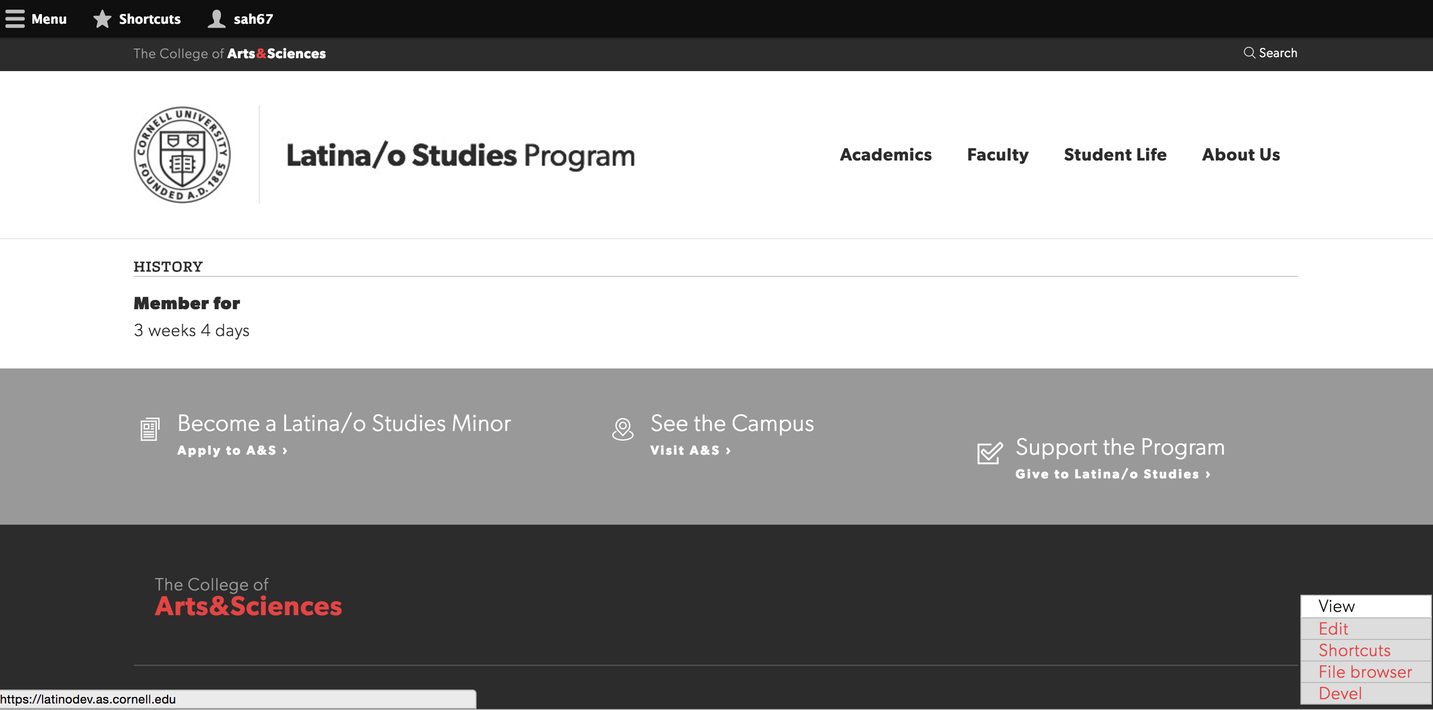

Editing a page
When you are logged in, all pages that you can edit will have a gray edit link in the bottom right. Clicking it will take you to the edit form for that specific page. Landing pages and the homepage are “blocks” and so you’ll see “Edit Block”, while basic and modal pages will just say “Edit”.
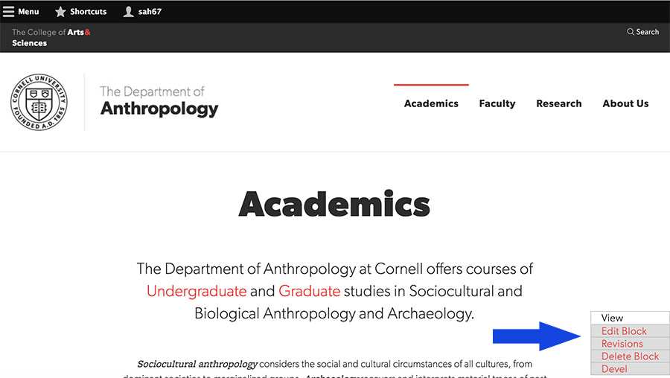
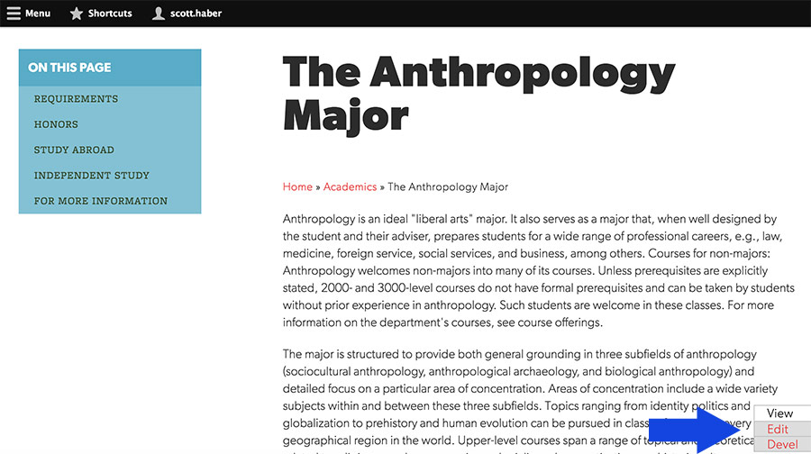

Finding content to edit
To get to the administrative content search form click on the “Manage” drop-down at the top right, and then “Content.”

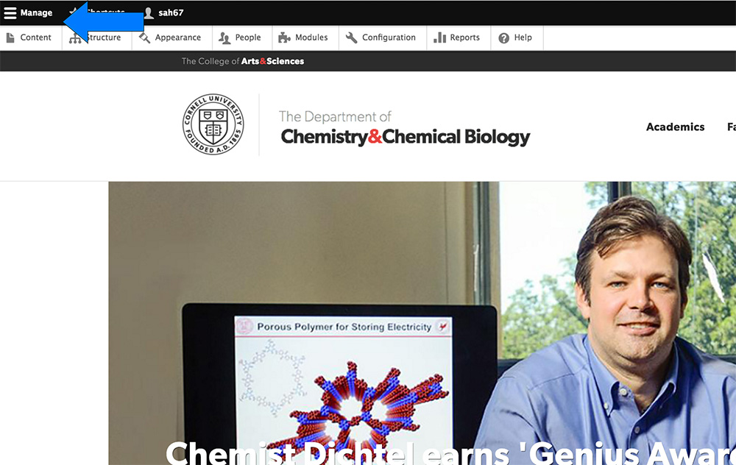

Content search in Drupal
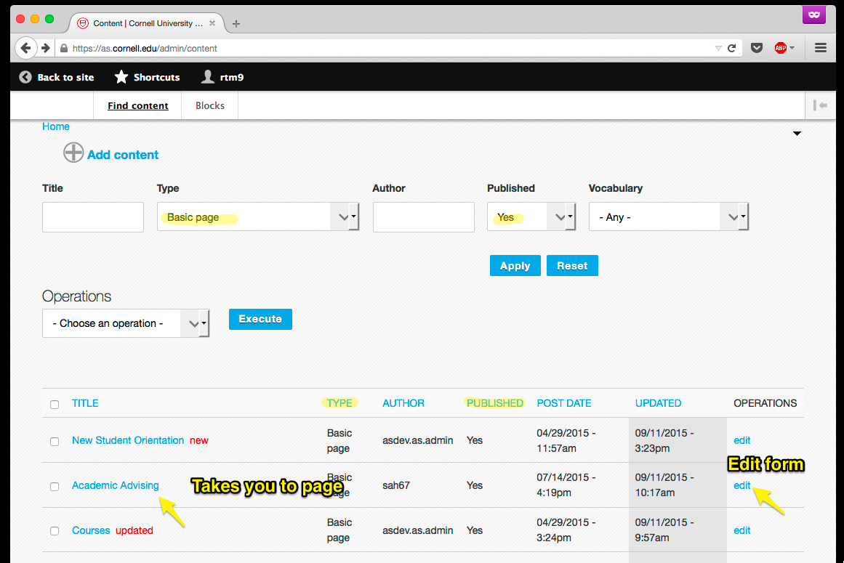
Search by:
- title
- type of content
- author
- is this page published
- taxonomy terms

Stripping Formatting:
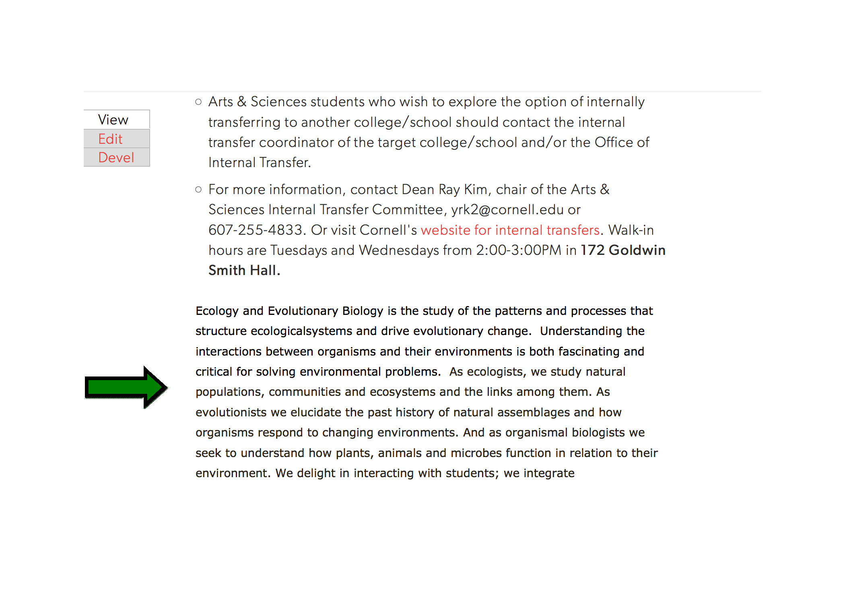
Be careful when copying and pasting text from an email or a Word/PDF document into Drupal. Those programs attach special formatting behind the scenes that messes up the fonts/spacing/colors we established in Drupal. To remove the formatting, highlight the pasted text and click the “Remove Format” symbol:
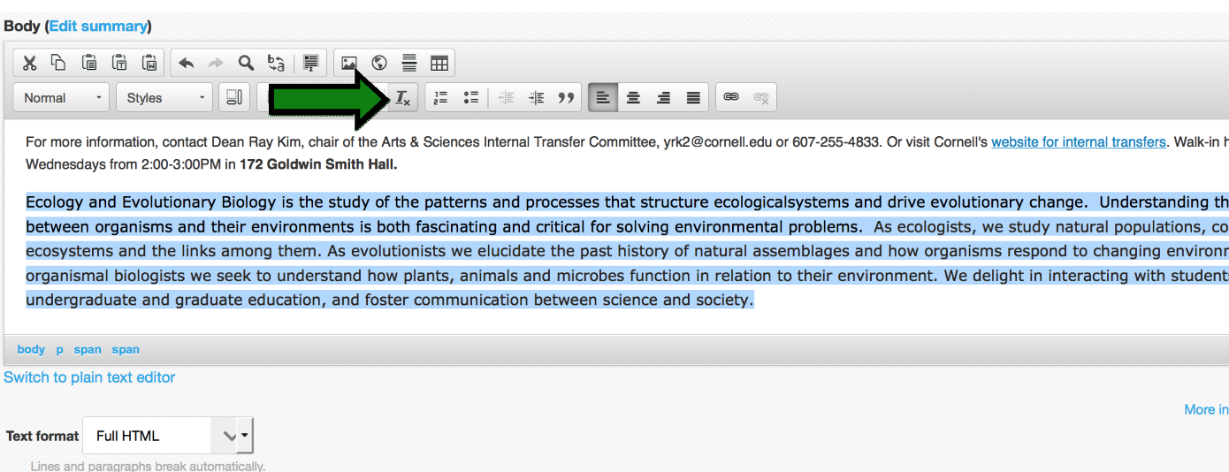
Linking to documents:
-Highlight the text you want to use for the link and click the chain-link icon: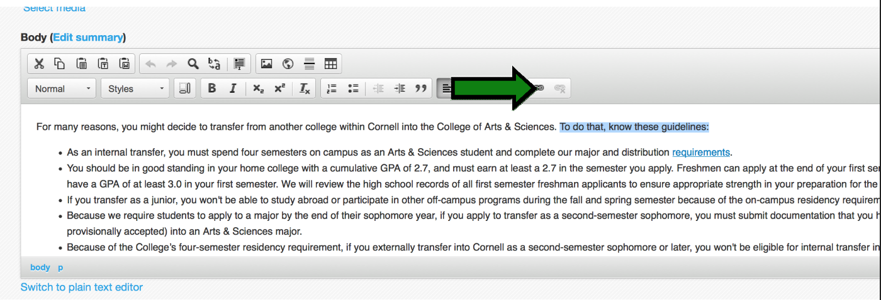
On the link menu, click “Browse Server”: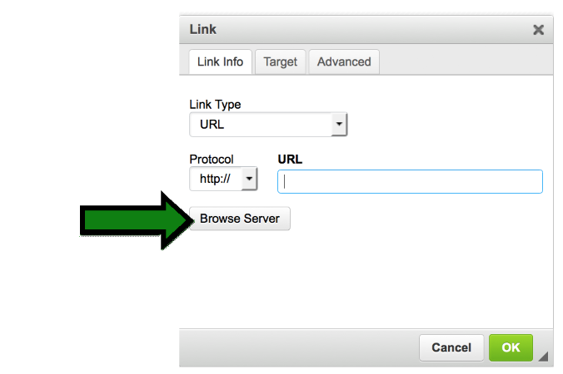
In the file browser window that opens, click “Upload” at the top left, and then “Browse” to locate the document on your computer. After selecting the document, click the larger “Upload” button that appears in the dialog box. Your uploaded file will appear in the list on the right highlighted in blue…to finish: click “Insert File” (next to the green checkmark) on the top menu.
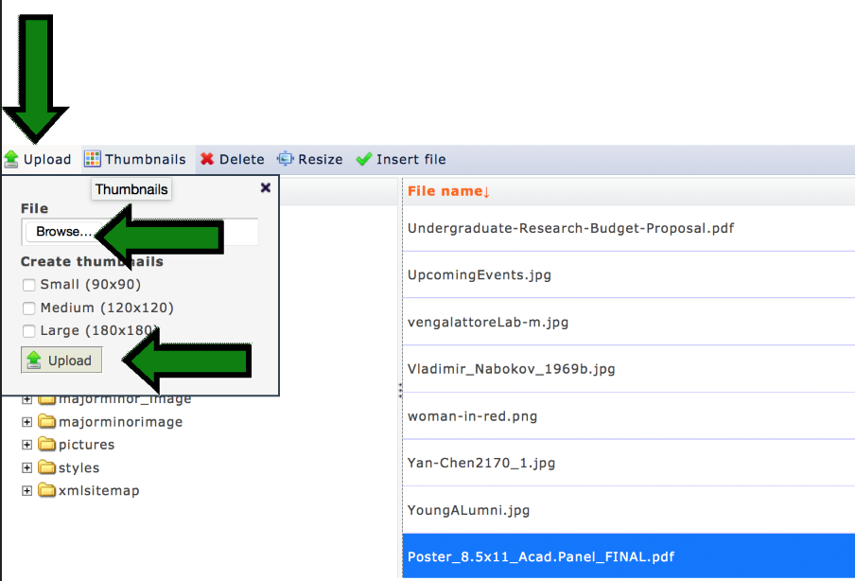
To reorganize sections of a modal page, click and hold on the small arrow to the left of the text box and then drag up or down.
To delete a section of a modal page, click the blue “remove” button at the bottom of the section.
To change the name of a section on a modal page (appears in the green box of links) on the left side of the page, edit the text in the “Section Title” field.

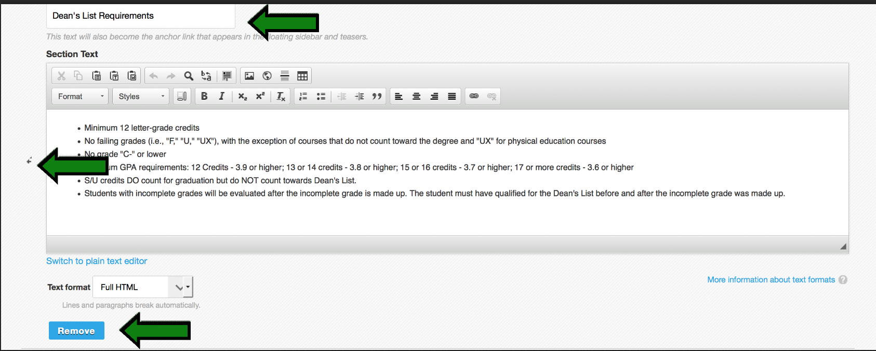

Links:
- If you want to link to a specific section on a modal page, you can include the “#” portion in the URL, i.e., to link to the Honors section of the Africana Undergraduate page, the URL would be “http://africanadev.as.cornell.edu/undergraduate#honors”

Photo sizing guidelines
- Pano images for basic pages or feature stories: 1440 x 525
- Regular story images: 450 x 517
- Images to accompany phototext blocks on homepage/landing pages: 600 x 400
- Images to accompany quotes on landing pages/homepage: 500 x 500
- When adding photos to the body of a page, use your own discretion when it comes to cropping/sizing, but feel free to ask Scott for advice.

