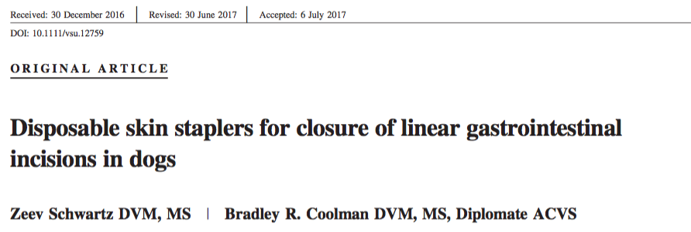

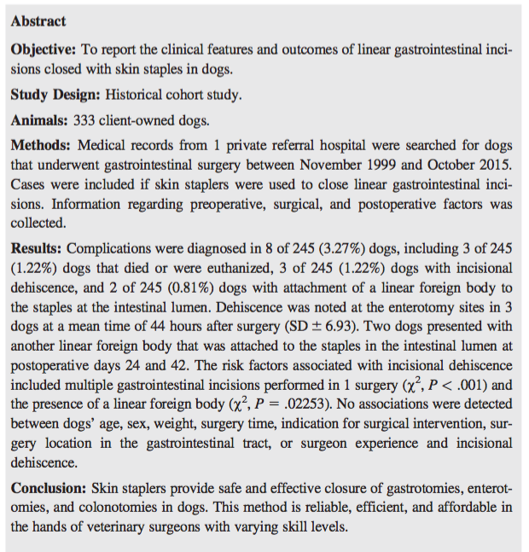
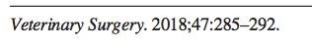

- Linear stapling devices are widely accepted in human and veterinary medicine
  - More efficient, decreased inflammation, preservation of blood supply
  - More limited use in vet med due to cost of equipment and lack availability
- Military human surgeons described use of skin staplers for intestinal anastomosis in 1990s
- Healing patterns between skin staples and sutures for anastomosis in dogs is similar; clinical use has been previously described for a handful of dogs for enterotomies
- Methods
  - Retrospective
  - 242 dogs undergoing 252 independent surgeries requiring linear GI incision closed with skin staplers
  - Single private referral hospital
  - Regular dimension skin staplers for enterotomies, wide dimension for enterotomies
  - Gastrotomies closed in 2 layers – mucosa and submucosa with continuous pattern and seromuscular layers with skin staplers
  - 10 different surgeons with varying skill levels
- Results
  - No dogs had pre-op septic peritonitis
  - 5 dogs had post-op septic peritonitis- 3 of which had dehiscence (all were linear foreign bodies requiring multiple enterotomies)
  - 2 cases in which a subsequent linear foreign body attached to the stables within the intestinal lumen
- Conclusion: skin staplers are a reliable method of closure of GI incisions in dogs
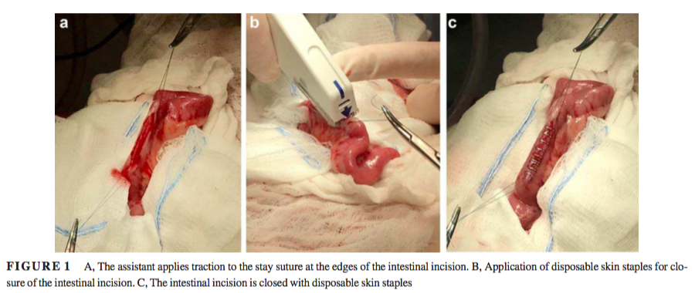
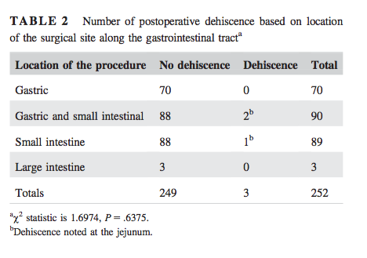

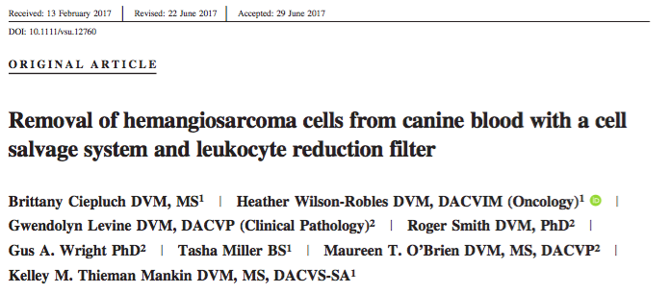

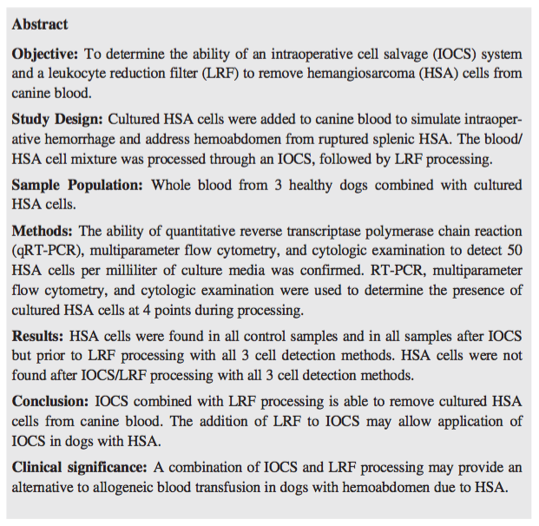
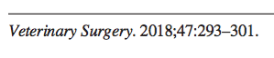

  - Intraoperative cell salvage system for autotransfusion used in a variety of human oncologic surgeries
    - Recovery of blood with a standard suction tip during surgery
    - Empties into tubing with heparinized saline
    - Passes into sterile reservoir through 140-um filter to remove gross debris
    - Then pumped into bowl, where it is centrifuged
    - Supernatant is removed – plasma, some WBCs, platelets, free hemoglobin, cell debris, medications, wash fluid, activated clotting factors
    - PCV reaches 60%
    - Washed with saline and pumped into a blood bag
    - Passed through leukocyte reduction filter and given to patient
  - Methods
    - Cultured HSA cells added to canine blood from healthy dogs
    - Processed though intraoperative cell salvage system and leukocyte reduction filter
    - PCR, flow cytometry and cytological exam used to look for HSA cells at 4 points during processing
  - Results
    - HSA cells not found in any samples following cell salvage system and leukocyte reduction
    - Combination was required – filter for IOCS is not adequate alone
  - Conclusions – IOCS and LRF useful for blood transfusion of dogs with hemoabdomen?
    - LRF removes tumor cells
    - Allogenic transfusions sometimes avoided in human cancer patients due to transfusion related immunomodulation – IOCS preferred
      - Improved survival times in certain groups

