Brachycephalic Obstructive Airway Syndrome (BAS)

Breeds
- English Bulldog, French Bulldog, Pug, Boston Terrier; less commonly in Pekingese, CKCS, Shih Tzu, Lhasa Apso, Boxer and Shar-Pei

Anatomic abnormalities
- Skull conformation is short and wide, causing compression of the nasal passage and abnormal pharyngeal anatomy
  - Pugs – dorsal rotation of the maxillary bone; miniscule or absent frontal sinuses
- Nasal cavity
  - Stenotic nares
  - Compressed nasal cavity - Marked contact between turbinate lamellae, creating contact between the mucosal surfaces and no room for air to flow
  - Aberrant nasopharyngeal turbinates (rostral and caudal)
- Pharynx
  - Soft palpate hyperplasia (elongation and thickening) staphylectomy
  - Macroglossia (overlong and thickening tongue)
- Larynx
  - Everted laryngeal saccules (stage 1 of laryngeal collapse)
- Trachea
  - Tracheal hypoplasia (tracheal diameter: thoracic inlet <0.2 in non-brachycephalic breeds and <0.16 brachycephalic)
    - ~13% of BAS dogs with a higher incidence in English Bulldog
- Bronchi
  - Bronchial collapse and chrondromalacia
  - Significantly correlated with severity of laryngeal collapse
  - Pugs most severely affected

Pathophysiology
- Compressed anatomy creates increased resistance increased inspiratory effort increased negative pressure on inspiration pulls soft tissues into the lumen collapse of the upper airway obstruction
- Secondary components: everted laryngeal saccules, laryngeal collapse, everted tonsils further airway turbulence, edematous tissues and inc insp effort
- Severe upper airway obstruction pulmonary edema due to decreased intrathoracic pressure
- Uncertain which component is the greatest contributor
  - Nose is the greatest source of airway resistance in all dogs; and is higher in brachycephalic dogs than others; however space dorsal to the soft palpate is the smallest airway space (based on CT) in pugs and Frenchies

Rancan L, Romussi S et al. Assessment of circulating concentrations of proinflammatory and anti-inflammatory cytokines and nitric oxide in dogs with brachycephalic airway obstruction syndrome. J Vet Res 2013; 74; 156-160
- Is a proinflammatory condition related to pathogenesis and progression of BAS? What molecular mediators are involved in this syndrome?
- 17 dogs (12 Bulldogs) with BAS and 10 controls (Beagles); graded 1-3 based on severity; those with systemic illness were excluded
- 13 were treated medically and 4 were treated surgically
- Plasma concentrations of proinflammatory (IL-1B, TNF-a, IL-6, IL-17A) and anti-inflammatory (IL-10 and IL-13) cytokines measured by ELISA and NO concentration measured by Griess test
- TNF-a, IL-10, IL-13 and NO were significantly higher in brachycephalic dogs and moreso for dogs that required surgery (association with disease severity?)
  - TNF-a -> directly induce cell injury through apoptosis, upregulates other inflammatory mediators (triggering cytokines and angiogenic factors) causing endothelial changes initially within the lung parenchyma, likely contributes to maintence of a chronic inflammatory process
    - changes of pulmonary parenchyma that may encourage pulmonary hypertension, respiratory failure or cardiac disease
  - IL-10 and IL-13 are immunosuppressive that act on macrophages and monocytes, respectively, to suppress the secretion of pro-inflammatory cytokines and stimulate production of cytokine inhibitors; ultimately contributing to reduction in airway inflammation
    - IL-10 used in human medicine as a marker for monitoring COPD and used in treatment
    - Direct association between degree of COPD and concentration of IL-13
  - Excessive NO production by inducible NO synthase may have an important role in tissue injury
- IL-17A higher in severely affected brachycephalic dogs or those that required immediate surgical treatment than non-clinical or moderately affected brachycephalic dogs or controls
  - IL-17A is a proinflammtory cytokine that may be important in the latter stage of disease
  - In human asthma, IL-17A and IL-17F are involved in subepithelial fibrosis leading to airway remodeling that alters severity of disease
- IL-1B and IL-6 concentrations did not differ
- No difference between small and large brachycephalic dogs
- Indication that local changes results in systemic changes; may help in identification of dogs at risk for disease progression

Clinical signs
- Stertor or stridor, inspiratory dyspnea, heat/stress/exercise intolerance, cyanosis, syncopal episodes, sleep apnea
- Association with GI signs – dysphagia, regurgitation, vomiting

Crane C, Rozanski EA, Abelson AL, DeLaforcade A. Severe brachycephalic obstructive airway syndrome is associated with hypercoaguability in dogs. Journal of Veterinary Diagnostic Investigation. 2017; 29:570-573.
- Humans with obstructive sleep apnea are hypercoaguable
- TEG performed on 5 dogs with grade 3 BAS and 5 healthy labs
- BAS were hypercoaguable compared to the controls
  - shortened clotting time with increased angle, maximal amplitude, and clot rigidity
  - evidence of delayed fibrinolysis

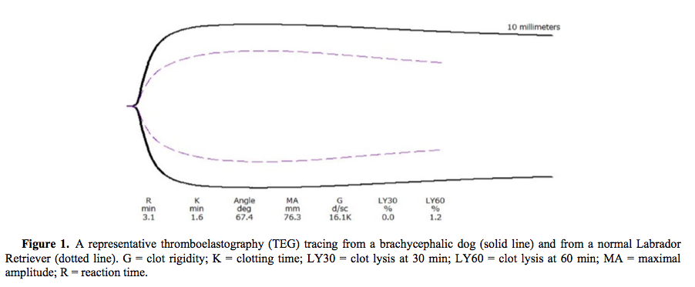

Fasanella FJ, Shivley JM, Wardlaw JL, and Givaruangsawat S. Brachycephalic airway obstructive syndrome in dogs: 90 cases (1991-2008). J Am Vet Med Assoc 201; 237: 1048-1051
- Retrospective study at Mississippi State – assessing 90 dogs with at least one component of BAS identified on laryngospic exam; 92% underwent corrective surgery
- 94% had elongated soft palate, 77% had stenotic nares, 66% everted laryngeal saccules, 56% everted tonsils, 39% (of 41 dogs with CXR) hypoplastic trachea
- Dogs with stenotic nares were more likely to have everted laryngeal saccules; and dogs with everted laryngeal saccules were more likely to have everted tonsils
- 12% dogs had post-operative complications (4 with severe dyspnea or death; 6 with excessive respiratory noise, dehiscence or regurgitation). No correlation with patient age or number of BAS components. Only one dog was in the older age group (>3 yrs), suggesting that more severely affected dogs are evaluated at a younger age

Diagnosis
- radiographs, CT, rhinospcopy/ laryngoscopy

Medical therapy
- Active cooling, sedatives, oxygen therapy, anti-inflammatories

Surgical therapy
- Alaplasty
- Endoscopic laser assisted turbinectomy (LATE) – 55% decreased in intanasal resistance 3-6 months following surgery. Partial regowth of turbinates but with less mucosal contact points. Long-term benefits and effect on thermoregulatory abilities is unknown.
- Stapylectomy by resection, cautery, laser or Ligasure (resection to level of the palantine tonsils)
- Folded flap palatoplasty
- Sacculoectomy
- Laryngeal surgery – only consider after treatment of proximal airway. Aryntenoid lateralization likely only acceptable if cartilages are well mineralized/ no chrondromalacia
- Tracheostomy

Post-operative care
- Often patients are kept intubated as long as possible after anesthesia, are provided supplemental oxygen, temporary tracheostomy, re-intubation and intensive post-operative monitoring

Senn D, Sigrist N, Forterre F et al. Retrospective evaluation of postoperative nasotracheal tubes for oxygen supplementation in dogs following surgery for brachycephalic syndrome: 36 cases (2003-2007). J Vet Emerg Crit Care 2011; 21(3): 261-267
- 36 dogs that underwent surgery for brachycephalic syndrome
- 20 dogs had nasotracheal tube (NTT) placed at the end of surgery, 8 dogs received other forms of oxygen supplementation (nasal insufflation, tracheostomy, oxygen cage, oxygen collar), 8 dogs received no oxygen supplementation
- Tube placement is easy and non-invasive, and may offer benefit
- Placement technique
  - 5-10 Fr NG feeding tube passed from nose to thoracic inlet
  - Visualized by oral inspection pass the soft palate
  - Tip of tube grasped with long forceps and exteriorized through the mouth
  - Patient extubated and the tip of tube advanced into trachea
  - Patient re-intubated without inflation of the cuff and NTT sutured into place
  - Patient recovered with careful extubation
  - O2 provided at 1-2 L/min
  - Most tubes removed before 24 hours
- All dogs received opioids post-op; 18/20 dogs and 11/16 dogs received dexamethasone injection
- Respiratory distress (tachypnea with increased effort, SaO2 <90%, or PaO2 <80 mmHg) was observed in 5 dogs without NTT but not observed in any dogs with NTT
- Post-op complications was similar (8/20 and 7/16) between groups; one dog from each group died
- Coughing observed more frequently in NTT
- No appreciable effect on long-term outcome, but potentially beneficial in post-op recovery

Ellis J, Leece EA. Nebulized adrenaline in the post-operative management of brachycephalic obstructive airway syndrome in a pug. J Am Anim Hosp Assoc 2017; 53: 107-110.
- 7 yo F/S Pug underwent airway surgery; became dyspneic after extubation
- Administered nebulized phenylephrine and IV dexmedetomidine; caused some transient improvement
- Adrenaline 0.3 mg nebulized for 10 mins (repeated q6) and dexmedetomidine CRI started
- Binds to alpha-adrenergic receptors on vascular smooth muscle, causing vasoconstriction and decreased blood flow; may also stimulate B receptors causing bronchiolar relaxation
- Minimal systemic effects in children

Liu NC, Adams VJ, Kalmar L et al. Whole-body barometric plethysmography characterizes upper airway obstruction in 3 brachycephalic breeds of dogs. J Vet Intern Med 2016;30:853-865
- Establishment of a non-invasive and objective diagnostic test for BAS
- Prospective study of 266 brachycephalic dogs (100 pugs, 100 Frenchies, 66 bulldogs; 46 were “clinical”) and 28 normal dogs
- Exercise tolerance tests with respiratory functional grading (grade 1-3) and whole-body barometric plethysmography were performed on all dogs
  - Barometric chamber with balanced flow of room air
  - Measurement of pressure difference represent flow
  - Measured RR, insp time, exp time, TV, minute volume, peak insp flow rate, peak expiratory flow rate, relaxation time
  - BAS index of 0-100% was calculated for each dog
- Respiratory characteristics are different among types of brachycephalic dogs
- Obesity and stenotic nares are associated with BAS
- BAS index can distinguish affected from clinically healthy dogs
- Minute volume significantly decreased in asymptomatic pugs, French Bulldogs, and Bulldogs in comparison to controls
- Grade 0 bulldogs showed patterns consistent with upper airway restriction and dynamic obstructions; lower minute volume and slower flow rate when adjusted for weight
- Grade 2 and 3 dogs breathing patterns were more chaotic and required continuous adjustment

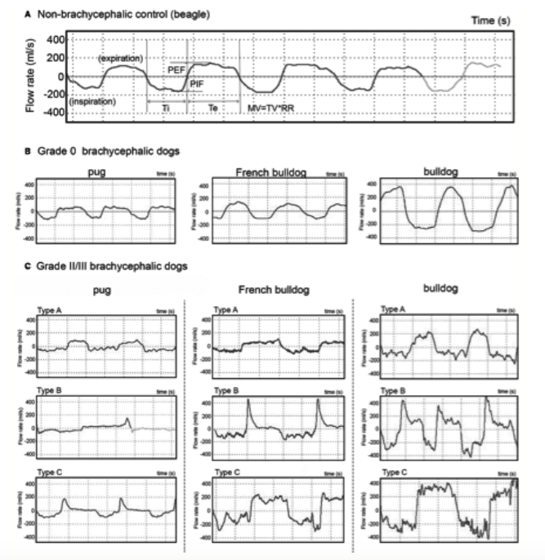

Canine Tracheal Collapse

Signalment – small or toy breed dogs
- Yorkshire Terriers represents ~1-2/3 of affected dogs; also commonly affected are Miniature Poodles, Pugs, Maltese, Chihuahuas and Pomeranians
- No gender predisposition
- Clinical signs may develop at any age; often middle-age

Pathophysiology
- Exact cause is not well understood
- Reduced glycosaminoglycan, glycoprotein and chondroitin sulphate content of the hyaline tracheal rings softening of the cartilage/ reduced rigidity laxity of the dorsal tracheal membrane causing increased upper airway resistance
- Likely both congenital and degenerative factors at play
- Secondary factors: airway irritants, chronic bronchitis, laryngeal paralysis, respiratory tract infection, obesity, tracheal intubation
- Once symptomatic, dynamic collapse creates a cycle of chronic inflammation and fibrosis within the tracheal mucosa decreased in normal ciliary clearance coughing

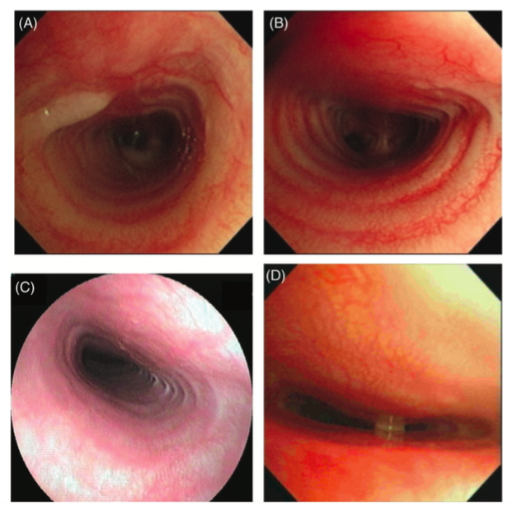

Clinical signs/ PE
- Varies from mild airway irritation and goose-honking cough, progressing to dyspnea or resp distress
- Cough often precipitated by heat, excitement, stress or concurrent respiratory disease
- Extrathoracic tracheal collapse inspiratory effort
- Intrathoracic tracheal collapse +/- bronchomalacia expiratory effort
- Tracheal sensitivity; may palpate flattened tracheal rings

Bronchomalacia
- Tracheomalacia is described in humans; and if the bronchi are involved than this is termed tracheobronchomalacia
  - Diagnosed by bronchoscopy with >50% collapse observed
  - Incidence <5% adults; <34% congenital (children)
  - 45-85% of cases affect the right middle and left cranial bronchi

Johnson LR and Pollard RE. Tracheal collapse and bronchomalacia in dogs: 58 cases (7/2001 – 1/2008). J Vet Intern Med (2010) 24, 298-305.
- Bronchoscopy and BAL performed on 115 dogs (86% presented for a cough)
  - 58 (50%) had some form of airway collapse
    - 41% had tracheal collapse +/- bronchial collapse; 59% had bronchial collapse without tracheal collapse
    - 83% dogs with cervical tracheal collapse also had lobar collapse
  - Dogs with airway collapse were significantly older, had a lower body weight and had a higher BCS than dogs without airway collapse
  - Of the airway collapse dogs, dogs with tracheal collapse had a lower body weight (no difference in BCS)
- Tracheal sensitivity did not differ between groups
- Mitral regurgitation and cardiomegaly was significantly associated with dogs with airway collapse
  - follow-up study in 2012 failed to identify association between left atrial enlargement and left bronchus collapse; suggesting that LA enlargement is not the cause of cough
- Static collapse of the left principle bronchus in 29%; and right principle bronchus in 9%
- Bronchomalacia most commonly affected median 2.5 lobes with the right middle and left cranial lobar bronchus most commonly affected
- Collapse of smaller airways without lobar collapse occurred in 10% of dogs – alteration in transpulmonary pressure?
- Inflammation (without infection) was found equally in both dogs with and without collapse indicating that inflammation is not a risk factor for airway collapse
- Airway infection identified more often in dogs without collapse than those with, which is in contrast to human bronchomalacia where there is through to be an increased likelihood of infection because of trapping of secretions and reduced mucociliary clearance
- Conclusions: bronchoscopy should be used as a diagnostic tool to evaluate the lower airways as radiographs underestimate this incidence, particularly if considering stent placement

Diagnosis
- Fluoroscopy – superior to radiographs as dynamic process (radiographs will underdiagnosis the frequency and degree of collapse)
- Ultrasound had been used by assessing changes in the tracheal air shadowing
- Bronchoscopy –gold standard for dynamic airway disease in humans

Medical management
- Acute: stabilization with oxygen, cool environment, sedation, +/- intubation surgery
- Chronic:
  - 71-93% of dogs respond well to medical management for a period longer than12 months, with 50% gradually able to have medication withdrawn (White 1994)
  - Weight control
  - Use of harness
  - Removal of environmental irritants
  - Management of upper airway disease that increases intrathoracic pressure gradients
  - Cough suppressants – Lomotil (diphenoxylate hydrochloride), hydrocodone, codeine, butorphanol
- Anti-inflammtories - steroids (short-course at lowest dose possible)
  - Stanozolol –anabolic androgenic steroid (enhance protein synthesis, increased collagen synthesis and chrondroitin sulphate content?) (Adamama-Moraitou et al. 2011)
  - Bronchodilators – reduced intrathoracic pressure during expiration to reduce expiratory tracheal collapse

Surgical management
- Patients with severe collapse (usually grade 3 or 4) that have failed medical management
- Extraluminal ring prostheses - “C”-shaped prosthesis placed at every second to third tracheal ring
  - Pros:
    - restores tracheal diameter and does not interfere with mucociliary function
    - (White 1995) showing 72% of dogs no longer needing medication and returned to normal exercise tolerance with 6-36 month follow-up
    - (Becker et al. 2012) MST 4 years and 6 months
  - Cons:
    - (Buback et al 1996) 5% perioperative mortality; up to 20% of dogs requiring tracheostomy. ~31% coughing, dyspnea and lar par after a month and 56% at some point. 23% dogs died from resp complication with a MST 25 months
    - Laryngeal paralysis 11-21% cases in immediate post-op period (damage to recurrent laryngeal nerves); small proportion develop this as a late complication (contact with the prosthesis or granulation tissue formation)
    - Other complications: vascular damage to the trachea resulting in necrosis (earlier studies), ring migration (one dog)
  - Generally fallen out of favour but still considered a valid option for tracheal collapse, especially if patient has cervical collapse alone
- Intraluminal stent - balloon expandables or self-expanding stainless steel stents placed with fluoroscopic guidance
  - 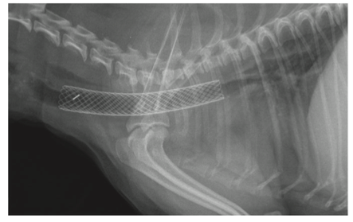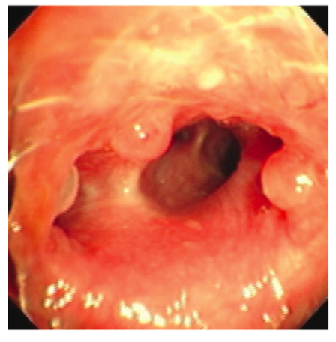
  - Pros
    - Minimally invasive with short anesthetic time
    - Rapid post-operative improvement in most cases (Weisse 2015)
    - Improvement in 75-90% of dogs
  - Cons
    - Appropriate sizing is very important - if too small, stent will migrate or shorten; if too large can cause pressure necrosis
    - 11% patients die within the first 60 days, and 25% die within 6 months of stent placement
    - In one case series, relatively high rates of stent fractures (~21-41%) which then requires placement of a second stent within the lumen of the first
    - May lead to creation of excessive inflammatory tissue within the trachea (~28-33%), which leads to coughing and reduced tracheal diameter
    - Other complications: stent migration, tracheitis, pneumonia, persistant coughing
    - Case report of right atrial thrombus dislodgement following stent deployment (Preston JVECC 2016)
  - 89% of stents will shorten over time

Rosenheck S, Davis G, Sammarco CD, Bastian R. Effect of variations in stent placement on outcome of endoluminal stenting for canine tracheal collapse. J Am Anim Hosp Assoc; 53: 150-158.
- 27 patients treated with endoluminal stents at a private practice (Red Bank Veterinary Hospital) from Feb 2005 to Oct 2013
- MST was 502 days (range of 3 to 1558 days)
  - 5 (18%) died within first month after stent placement
  - 27 (78%) survived at least 6 months, 16/27 (60%) survived >1 year, 7/27 (26%) survive > 2 years
  - 48% died of respiratory disease
  - If complication occurred, MST of 208 days
  - 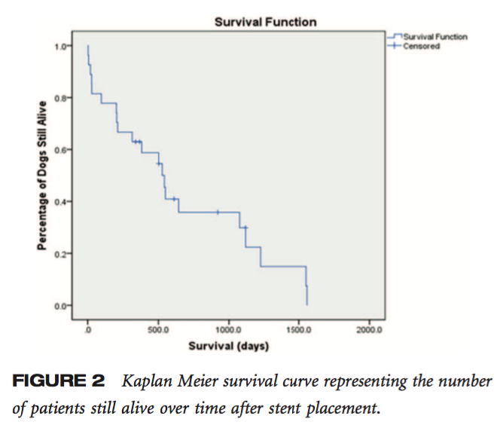
- Complications (37%)
  - Granuloma formation – 5/27
  - Pneumonia – 4/27
  - Stent deformation – 1/27
  - Stent fracture – 1/27
  - Stent migration – 1/27
- Degree of tracheal coverage, exact location of the stent and stent shortening/ lengthening at follow-up was not associated with occurrence of complications of survival

Additional references
Dupre G and Heidenreich D. Brachycephalic syndrome. Vet Clin Small Anim 46 (2016) 691-707
Tappin SW. Canine tracheal collapse. Journal of Small Animal Practice (2016) 57, 9-17

