Questions
What are the 3 categories of the modified Glasgow coma scale

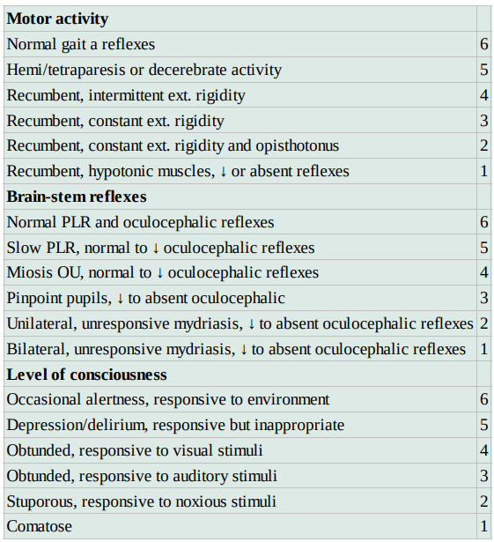

What neurotransmitter is most important in the development of secondary brain injury?

Glutamate

How are ROS involved in the development of secondary TBI?

Due to local acidosis, hypoperfusion
Brian is lipid rich making it more susceptible to oxidative injury
Iron release in hemorrhage favors Habe-Weiss reaction of the xanthine oxidase pathway
Leads to hydroxyl radical formation

Explain what happens to the pupils (and why) as severe TBI progresses to transtentorial herniation of the brain

- Normal = adequate function of:
    - Rostral brainstem
    - Optic chiasm
    - Optic nerves
    - Retinae
  - Miotic pupils
    - Diffuse forebrain injury
  - Progression to mydriatic pupils
    - Herniation
      - Transtentorial herniation puts pressure on CN III, removing parasympathetic input to the eye
      - If herniation is enough to compress brainstem pupils become midrange, fixed and unresponsive
        - Impending death

Give 2 arguments for and against aggressive glycemic control for TBI

Against
Hypoglycemia
Does not improve outcomes

For
Hyperglycemia can lead to increased free radical production, excitatory amino acid release, cerebral edema, cerebral acidosis, alters cerebral vasculature

Traumatic Brain Injury
Pathophysiology
- Primary injury
  - Immediately as a result of the direct mechanical damage at the time of trauma
  - Physical disruption of tissues
    - Contusions, hematomas, lacerations, axonal injury, vascular damage
      - Hemorrhage and vasogenic edema
    - Extraaxial hemorrhage occurs in ~10% of mild head trauma, >80% in severe injury
  - Nothing we can do about it
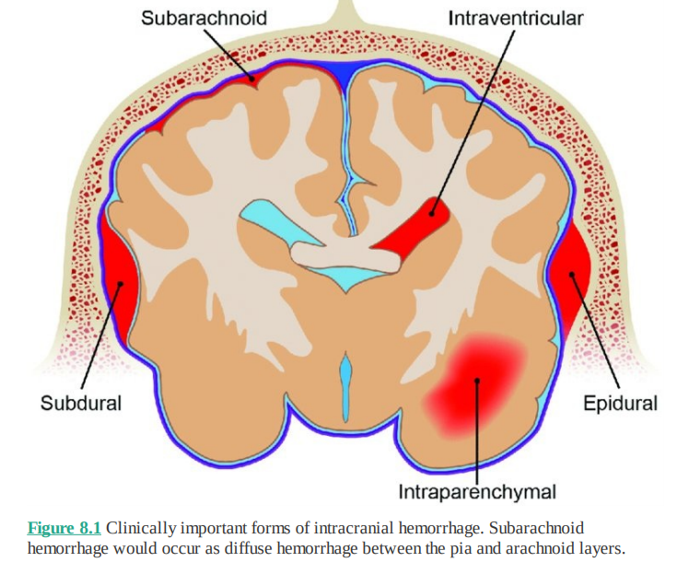
- Secondary injury
  - Minutes to days following injury
  - Enhanced activity of neurotransmitters
    - Glutamate predominantly
    - Excessive metabolic activity
    - ATP depletion
    - Increases in cellular sodium and calcium influx
    - Cytotoxic edema
  - ROS
    - Due to local acidosis, hypoperfusion
    - Brian is lipid rich making it more susceptible to oxidative injury
    - Iron release in hemorrhage favors Habe-Weiss reaction of the xanthine oxidase pathway
      - Leads to hydroxyl radical formation
  - Systemic inflammatory cytokines
    - Arachidonic acid
    - Stimulation of coagulation
    - Disruption of BBB
    - NO production
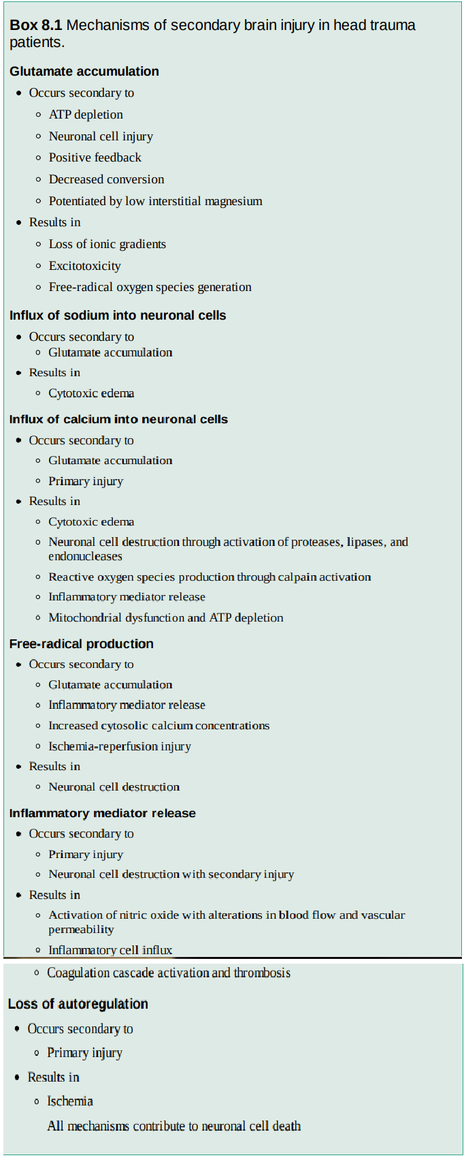
- Intracranial Pressure
  - Brain contains parenchyma, arterial/venous blood, CSF
    - Increases in one leads to a decrease in the others or an increase in ICP
      - ‘Intracranial compliance’
    - Severe increases induce “Cerebral ischemic response reflex” (Cushing)
      - Increased ICP -> ^CO2 -> stimulation of local vasomotor center -> ^Sympathetic tone -> ^MAP -> stimulation of baroreceptors in carotid arteries and aortic arch -> ^vagal stimulation -> bradycardia
  - Normal brain can autoregulate between MAPs of 50-150mmHg
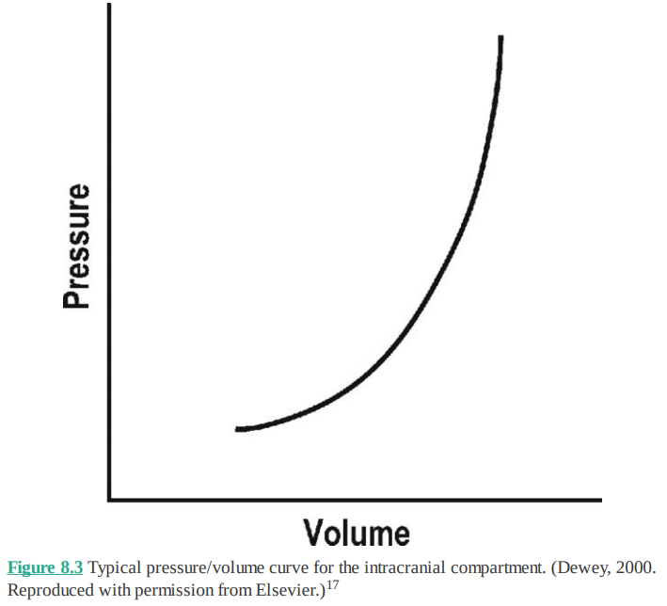

Assessment
- In humans – 60% of TBI have other concurrent injuries to major organs
- Minimun database, especially BG
  - Correlates to severity of injury
- Neuro assessment
  - Consciousness, breathing pattern, pupils, ocular position and movements, skeletal motor responses
  - MGCS
    - 3 Categories
      - Level of consciousness
      - Motor Activity
      - Brainstem reflexes
    - Higher scores correlate to better prognosis
      - May be better as objective assessment of progression
  - Consciousness
    - Provides evaluation of the cerebral cortex and RAS
    - Coma = likely bilateral or global cerebral abnormalities or severe brain stem injury
      - Guarded prognosis
  - Decerebrate rigidity
    - Opisthotinus and hyperextension off all limbs WITH altered mentation
    - Indicates cerebral injury
    - Grave prognosis
  - Decerebellate rigidity
    - Variable flexion and extention of hind limbs WITHOUT altered mentation
    - Cerebellar injury
  - PLRs
    - Normal = adequate function of:
      - Rostral brainstem
      - Optic chiasm
      - Optic nerves
      - Retinae
    - Miotic pupils
      - Diffuse forebrain injury
    - Progression to mydriatic pupils
      - Herniation
        - Transtentorial herniation puts pressure on CN III, removing parasympathetic input to the eye
        - If herniation is enough to compress brainstem pupils become midrange, fixed and unresponsive
          - Impending death
Treatment
- Fluids
  - Rapid restoration of intravascular volume
    - Concerns regarding exacerbation of brain edema appear to have limited supporting data
    - Hypotension in people associated with 2.5x increase in mortality
  - Brain is relatively impermeable to colloids, so it is osmolality of fluid that is most important
    - Except in diseased states like trauma
  - Hypertonic saline
- Oxygen
  - Hypoxia after injury doubles mortality in people
  - Hyperoxemia may induce additional ROS damage
- CO2
  - Hypercapnia results in cerebrovascular dilation and increased ICP
  - Hypocapnia <34mmHg will lead to vasoconstriction and decreased cerebral blood flow
    - Brief hyperventilation between 30-34mmHg can be helpful if there is risk of herniation. Never a reason to go below 30mmHg, even with brain herniation.
- Other therapies
  - Elevation of head/body at 15-30’ angle
    - Increases venous drainage without deleterious changes to oxygenation
  - Mannitol
    - Increase blood volume AND decrease blood viscosity
      - Results in vasoconstriction (decreases ICP) but maintenance of CBF
    - Also favors fluid shift from intracellular and interstitial spaces of brain into vasculature
      - Peak effect is after 1 hour and persists for 6-8h
    - Free radical scavenging effects
    - Contraindicated in hypovolemic patients due to diuretic effects
    - In situations of prolonged contact (multiple bolus doses or continuous infusions) mannitol can accumulate in the extravascular compartment exceeding the intravascular concentration and leading to brain edema and an increase in ICP
      - Reverse osmotic shift
  - Hypertonic saline
    - Intact BBB relatively impermeable to Na and Cl which allows set-up of an osmotic gradient
    - Promotes reuptake of glutamate (and other amino acids), reducing excitotoxicity
    - Reduce PMN adhesion and infiltration to brain
  - Glycemic control
    - Hyperglycemia can increase excitatory neurotransmitter release, and increased free-radical production
    - Degree of hyperglycemia is associated with severity of trauma, but NOT with prognosis
      - However, hyperglycemia cause increased free radical production, excitatory amino acid release, cerebral edema, cerebral acidosis, alters cerebral vasculature
  - Hypothermia
    - Not currently panning out as therapy
    - Pros
      - Decreased cerebral metabolic oxygen demand
      - Decresaed imflammation
      - Decreased release of excitatory neurotransmitters
    - Cons
      - Coaguloapthy
      - Decreased immunity
      - Hypotension
      - Bradycardia
      - Arrhythmias
  - Pain control
    - Opioids relatively safe
  - Anticonvulsants
    - Seizures occur in 4-42% of severe TBI in humans
    - Prophylactic anticonvulsants in humans reduce occurrence of seizures post TBI for 1 week, but not longer. Does not improve outcome
  - Barbiturates
    - Lower O2 demand by neuronal tissue
    - Prophylactic barbiturates in humans may worsen outcomes
      - Except when used as last resort for elevated ICP
      - Pentobarbital if possible – need to induce coma, so ventilation will likely be required
  - Corticosteroids
    - Increase mortality in head trauma in humans
      - Hyperglycemia, immunosuppression, delayed wound healing, gastric ulceration, catabolic state
  - GI protectants
    - CNS injuries associated independently with risk of ulcers in humans
      - Treatment currently recommended in veterinary medicine
    - PPIs
      - Omeprazole preferred, as may reduce CSF production
  - Prokinetics
    - Questionable efficacy in TBI, but still recommended
  - Nutrition
    - Enteral if patient has gag reflex and can protect airway
    - Parenteral if patient cannot protect airway
Imagining
- CT is modality of choice
  - Increased ICP associated with
    - Subdural hematomas, subarachnoid hemorrhage, intracerebral hematomas, cerebral infarcts, diffuse brain injury, generalized cerebral edema, midline shifts, ventricular compression
- MRI
  - Better associated with prognosis
  - Midline shift and ventricular obliteration indicated poor prognosis

Surgery
- Patients with ICP elevations refractory to medical management
- No consensus one when to pursue
- Indications
  - Open or depressed skill fracture
  - Ongoing hemorrhage
  - Foreign body or hematoma removal
  - Declining neuro signs despite aggressive medical management

Long Term
- Complications
  - Central DI (transient or permanent), Seizures, coma
Prognosis
- Humans
  - Age, cause of injury, GCS motor score, pupil response to light, CT characteristics, hypotension, hypoxia, BG, prothrombin time,
- Veterinary
  - MGCS correlated with probability of survival in 1st 48 hours.
    - MGCS predicted 50% survival with 8/18
  - Gender, weight, age, skull fractures did NOT predict survival
    - Study was TBI ONLY
