Sepsis 2.0 definitions:
Sepsis = SIRS due to infectious cause
Sever Sepsis = Sepsis complicated by acute organ dysfunction
Septic Shock = Sepsis complicated by either hypotension that is refractory to fluid resuscitation or by hyperlactatemia
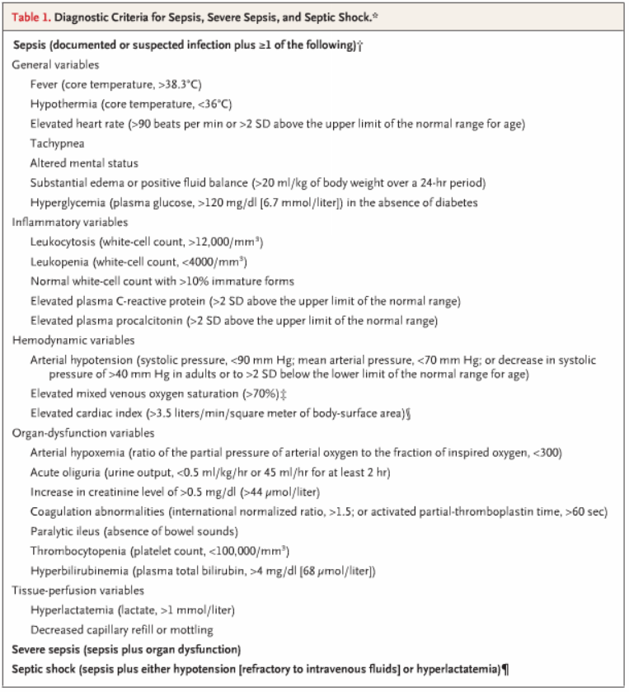

Human Medicine:
Pneumonia accounts for ~50% of severe sepsis. #2 = intraabdominal, #3 = urinary tract
Severe sepsis target organs = respiratory and cardiovascular system
Other common sequelae include AKI, altered mentation, paralytic ileus, elevated tranaminases, altered glycemic control, thrombocytopenia, DIC, adrenal dysfunction, euthyroid sick syndrome

Cultures
Blood cultures: Only positive in ~1/3 of cases
No positive cultures from anywhere in ~1/3 of case
Staph and strep most common Gram+. E. coli, klebsiella spp and pseudomonas are most common gram-
Gram neg ~62%, Gram pos ~47%, fungal ~19%

Pathophysiology
Host response
Initially thought to be just overly exuberant inflammation, with later thoughts of subsequent compensatory anti-inflammatory response syndrome (CARS).
Now thoughts that both occur simultaneously (MARS)
Septic Shock subtyples:
‘warm’ septic shock = hyperdynamic shock, characterized by high CO, lower peripheral vascular resistance, warm extremities.
‘cold’ septic shock = hypodynamic shock, low CO, poor peripheral perfusion, cool extremities, death

Response depends on causative pathogen (load and virulence) and host (genetics, coexisting illness)
Pathogen:
To adhere to epithelium and invade, pathogens must avoid: secretion of mucus, epithelial cell shedding, and secretion of enzymes such as lysozyme.
Bacteria as an infectious group (minimally infectious group called a quorum). Once quorum is reached, virulence factors are expressed.

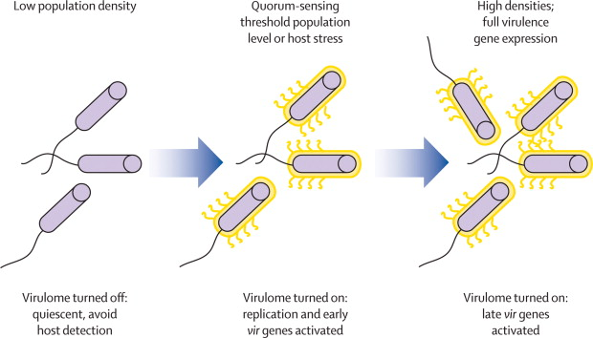
Virulence factors include:
Adherence Factors: Many pathogenic bacteria colonize mucosal sites by using pili (fimbriae) to adhere to cells.
Invasion Factors: Surface components that allow the bacterium to invade host cells can be encoded on plasmids, but more often are on the chromosome.
Capsules: Many bacteria are surrounded by capsules that protect them from opsonization and phagocytosis.
Endotoxins: The lipopolysaccharide endotoxins on Gram-negative bacteria cause fever, changes in blood pressure, inflammation, lethal shock, and many other toxic events.
Exotoxins: Exotoxins include several types of protein toxins and enzymes produced and/or secreted from pathogenic bacteria. Major categories include cytotoxins, neurotoxins, and enterotoxins.
Siderophores: Siderophores are iron-binding factors that allow some bacteria to compete with the host for iron, which is bound to hemoglobin, transferrin, and lactoferrin.

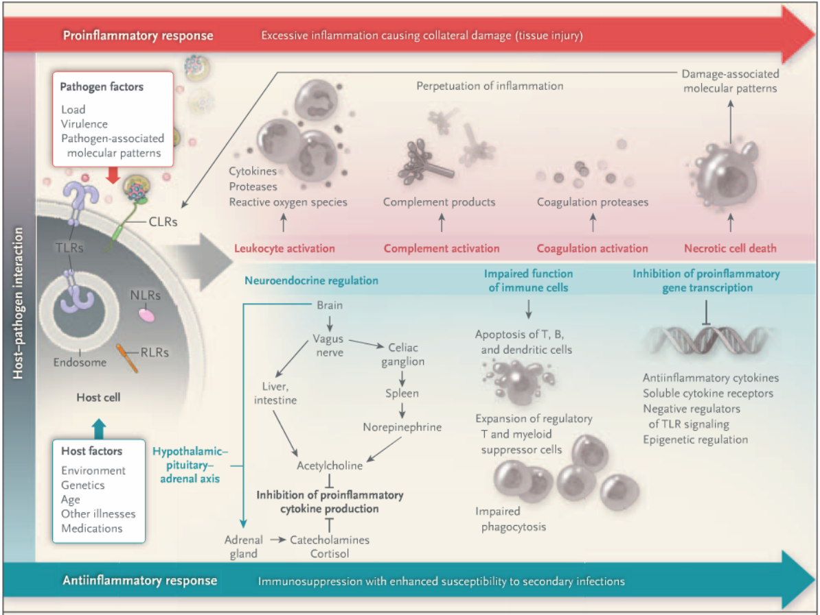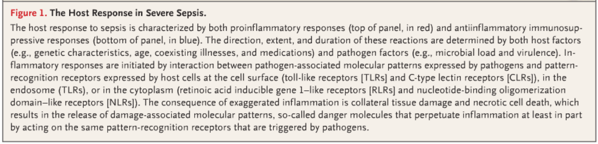
Four main receptors implicated in inflammatory response:
Toll-like receptors (TLRs)
C-type lectin receptors (CLRs)
Retinoic acid inducible gene 1-like receptors (RLRs)
Nucleotide-binding oligomerization domain-like receptors (NLRs)
Aimed at recognizing PAMPs and initiate innate immunity, and DAMPs and alarmins.

Coagulation abnormalities:
Increase TF expression leading to fibrin deposition (via coag cascade)
Decreased antithrombotic mechanisms (decreased protein C and antithrombin)
Decreased fibrinolysis (True in dogs or cats? They seem to have very different fibrinolysis)
NETs capturing platelets

Vasodilation
Normal response to low BP is profound vasoconstriction
Sepsis (Nitrogen intoxication and carbon monoxide intoxication as well) prevent normal vasoconstriction in response to hypotension
There is abundant catecholamine and RAAS activation, but lack of vasoconstriction due to failure or response by vascular smooth muscle
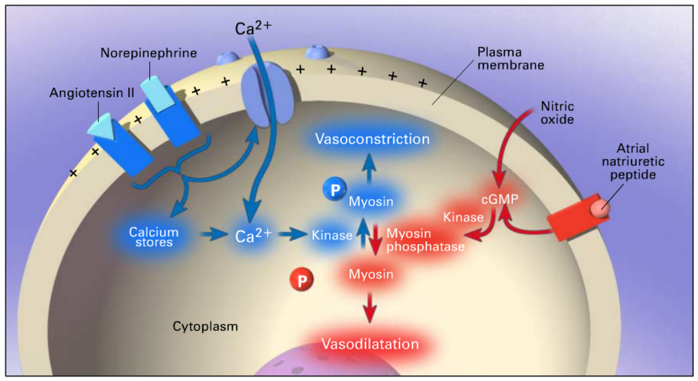
Normal smooth muscle contraction:
Increase in intracellular Ca++ (from hormonal or neurotransmitter binding), Ca++ and calmodulin complex formation, activation of kinase that phosphorylates myosin light chain, activation of myosin ATPase by actin, cycling of myosin cross-bridges along actin filaments

Causes Vasodilation in Septic Shock:
Activation of ATP-sensitive potassium channels (K_{ATP}) in the plasma membrane of vascular smooth muscle
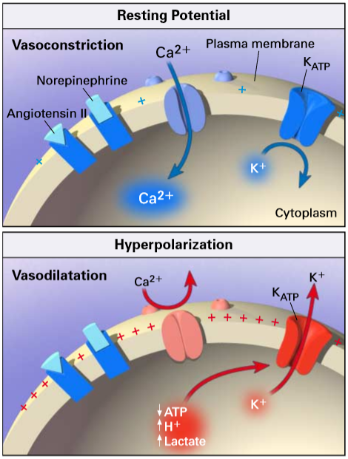
Hyperpolarization both decreases cytosolic release of stored Ca++ for initial constriction AND closes membrane channels preventing Ca++ influx required for longer term constriction, and prevents constriction in face of neurotransmitters or hormones
Causes of the opening of K_{ATP} may include ANP, calcitonin gene-related peptide, and adenosine, all of which are increased in septic shock!
Lactate and acidosis also open channels

*Side note*
Diazoxide activates the K_{ATP} channels as well causing vasodilation!

Activation of iNOS (inducible NO synthase)
Muscle relaxation by vasodilators (ANP, NO, etc…) which activates a kinase that dephosphorylates myosin, preventing cross-bridge formation. May also hyperpolarize cells by opening K channels (other, non KATP channels)
iNOS induced by IL-1, IL-6, TNF-α, interferon-γ, adenosine

Deficiency of vasopressin
Possibly due to the depletion of vasopressin stores in prolonged states of stimulation
Vasopressin is needed in very low concentrations for V-2 receptor activity in kidney (via increase in cGMP in distal tubular cells and principal cells of collecting ducts in kidney)
Multi-fold higher concentrations needed for V-1 mediated effects
Vasopressin binding to V-1 receptors causes opening of voltage gated calcium channels and closure of the K_{ATP} channels, resulting in vasoconstriction
Because of the large amount of vasopressin needed for V-1 activity, the hypothalamus and posterior pituitary deplete their stores quickly
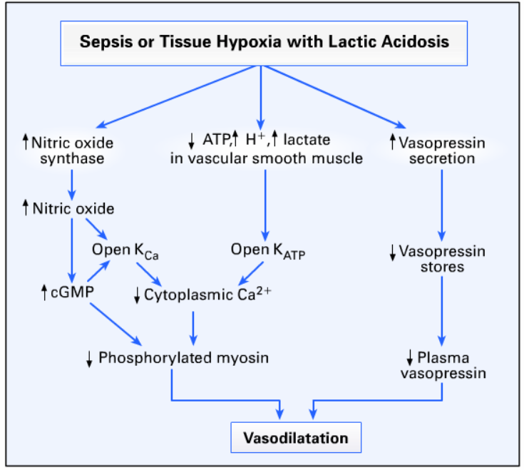

Review of cytokines in sepsis and septic shock
Anti-inflammatory mechanisms regulated by humoral and neurologic mechanisms.
Neuroinflammatory reflex = sensory input from afferent vagus fibers sent to brain and efferent vagal fibers activate splenic nerves resulting in norepi release in spleen and release of acetylcholine by CD4+ T cells, which induce proinflammatory cytokine release from macrophages.
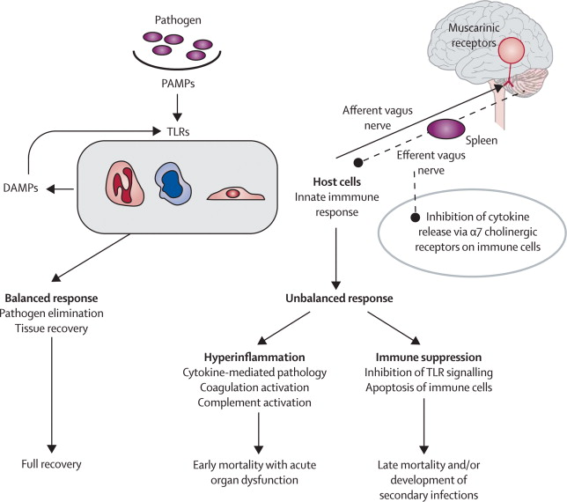
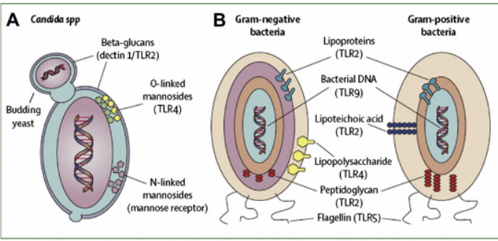
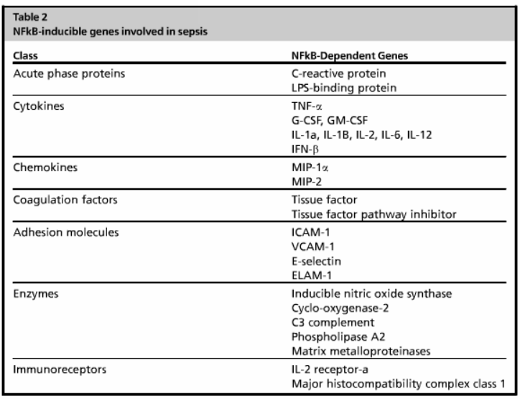

Cytokines most responsible for septic SHOCK

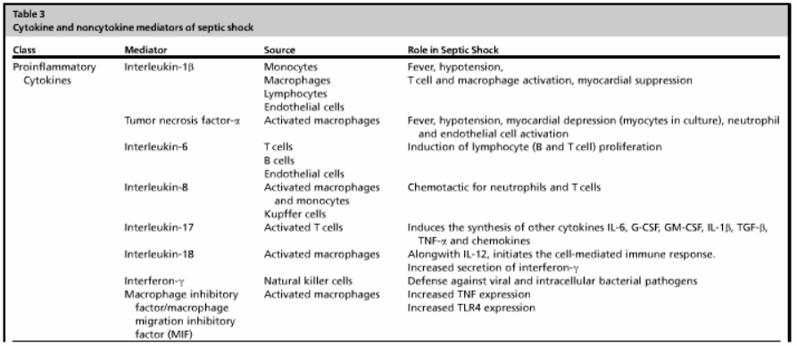
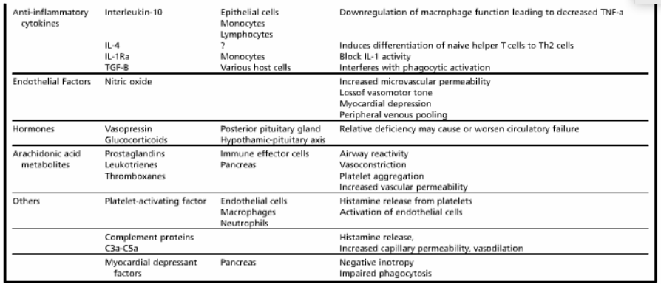

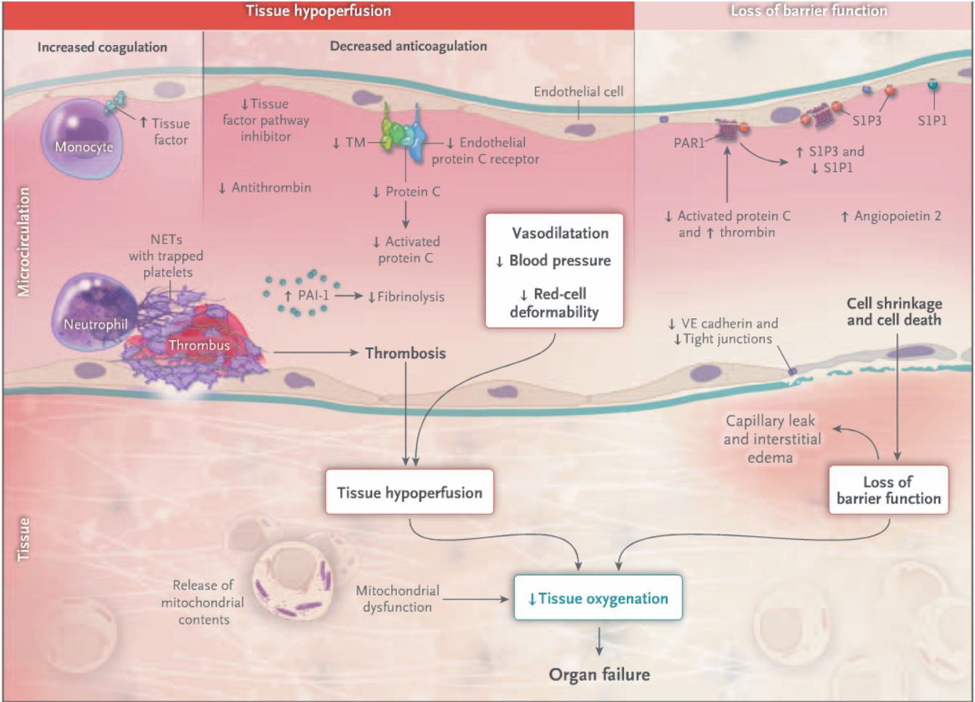
KNOW THIS DIAGRAM!!!
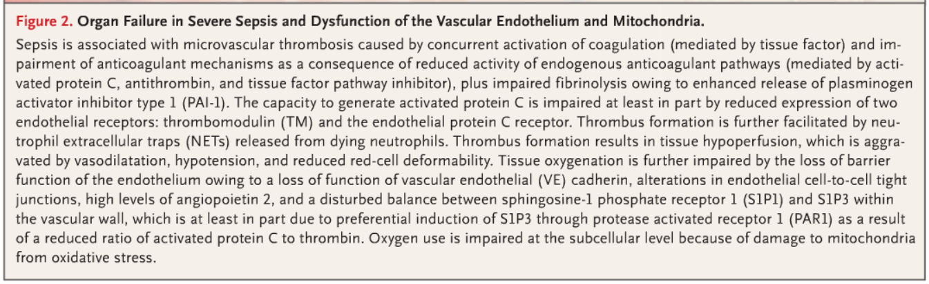
Cellular dysfunction in Sepsis
Neutrophils dysfunction
There is excessive activation and prolonged survival (greater than normal 7 hours in systemic circulation in humans) They injure endothelium, release inflammatory mediators and injure host organs
T-helper lymphocytes accelerated apoptotic death

Progressing from Sepsis to septic shock
Cardiac abnormalities:
Decreased right and left ventricular ejection fractions
Increased end-diastolic and end-systolic volumes
Normal stroke volume (when you combine both above)
Increased heart rate and cardiac output
Cardiac abnormalities are usually reversible 10 days after reversal of sepsis
TNF-α and IL-1 are associated with myocyte dysfunction
iNOS -> increased NO -> interference with myocyte calcium metabolism and impairs contractile function and increases reactive nitrogen spp. which damages cardiac myocytes.
Myocardial edema secondary to above also occurs
Human patients with cardiovascular dysfunction in sepsis had much higher mortality
Other causes:
Myocardial depressant factors (MDFs) such as TNF-α and IL-1β cause direct decrease in contractility (this may be in part due to downregulation of adrenergic response from downregulation of β-adrenergic receptors)
Global mitochondrial dysfunction in sepsis also affects the mitochondrial rich myocytes
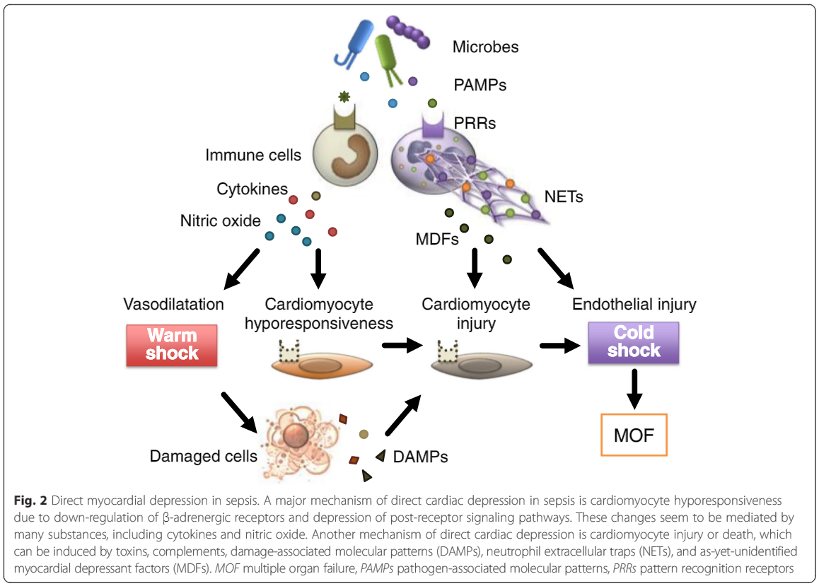
Vascular Abnormalities:
See above

Humoral system in current medicine refers to any body fluid or semifluid (think aqueous humor)
Humoral control is control of organ systems by molecules within extracellular fluid.
Humoral immunity involves cytokines, immunoglobulins, etc… that are circulating within extracellular fluid
Neurohumor are materials that are produced by neurons that get into extracellular fluid, of which the most talked about seem to be: epinephrine, norepinephrine, acetylcholine, +/- histamine, serotonin, GABA

