Biomarkers
DeClue et al, JVIM 2011: Evaluation of Serum NT-pCNP as a Diagnostic and Prognostic Biomarker for Sepsis in Dogs
BACKGROUND:
C-type Natriuretic Peptide:
- Expressed by vascular endothelium and macrophages
  - In response to inflammatory mediators,
  - In direct response to microbial products eg LPS
- Antimicrobial as inhibits growth and modifies pathogenicity of organisms
- NT is the amino-terminal of proCNP; more stable for assays
HYPOTHESIS:
- Dogs with sepsis would have greater levels than those with NSIRS or healthy controls
- Concentration would be sensitive and specific diagnostic and prognostic marker for sepsis in dogs
METHODS:
- Included dogs with SIRS score ≥ 2 and deemed ‘critically ill and required hospitalization’
- Septic patients were positive on cytology, culture, histopath and/or serology
- Control = staff/student owned
- Samples collected within 24hrs of hospitalization
RESULTS:
- 29 sepsis, 34 NSIRS, 49 controls
- No significant difference in SIRS score or degree of change in SIRS markers between groups
- NT-pCNP significantly greater in SIRS than NSIRS and healthy controls (11 vs 5.2 vs 6.4)
  - Sensitivity 65%, specificity 89%, cut off value 10.1
  - False positives included healthy dogs (but all ≤ 12.5)
  - , large number of false negatives were peritonitis
- peritoneal subgroup had significantly lower levels than all others
  - May have higher concentrations in peritoneum than blood?
  - If this group is removed sensitivity 94%, specificity 89%
- No difference in survival between sepsis/NSIRS, NT-pCNP not associated with survival

Floras et al 2014 JVIM: N-Terminal Pro-C-Natriuretic Peptide and Cytokine Kinetics in Dogs with Endotoxemia
- IV E. Coli endotoxin to healthy beagles; no change in CNP over 24hrs

Gueiu 2015 JVIM: Serial Evaluation of Abdominal Fluid and Serum Amino-terminal pro-C-type Natriuretic Peptide in Dogs with Septic Peritonitis

Patients with septic peritonitis

CNP in drains was lower than serum and remained lower than serum

DeClue 2012 JVIM: Plasma Inflammatory Mediator Concentrations at ICU Admission in Dogs with Naturally Developing Sepsis

TNFalpha, IL6, IL10, CXCL8 in healthy, sepsis and NSIRS

IL6 & TNFa increased in both

IL10 decreased in Sepsis

Poor sensitivity/specificity for differentiating, and for predicting outcome
Torrente 2015: Plasma iron, C-reactive protein, albumin, and plasma ﬁbrinogen concentrations in dogs with systemic inﬂammatory response syndrome
- 54 Sepsis/SIRS, 42 focal inflammation, 20 clinically healthy
- Iron (65 vs 89), CRP and albumin could differentiate between SIRS and focal infection on admission
- Admission values not useful for prognosis
- Survivors had greater increase in iron and decrease in CRP from admission to discharge (discharge levels similar to focal inflammation group)

Prognostic Indicators
Giunti et al JVECC 2015: Prospective evaluation of the acute patient physiologic and laboratory evaluation score and an extended clinicopathological profile in dogs with systemic inflammatory response syndrome
AIM: To examine the prognostic value of the APPLEfast score (5-variable model) and to evaluate the predictive power of an extended panel of routinely measured clinicopathological markers in dogs with SIRS.
- SIRS = ICU patient with ≥2 SIRS criteria on admission
- Sepsis = SIRS + culture or cytology
- Excluded everything that alters calcium metabolism
METHODS:
- Blood and urine within 1hr of hospital admission
  - Biochem, CBC, acute phase proteins, UPC, factional excretion etc
RESULTS:
- 13 non-septic, 20 septic, 35 healthy controls
- No significant difference between septic and non-septic
- All values significantly different from controls
- Survivors (22/33) had significantly higher albumin and antithrombin activity, lower UPCs, higher BE, lower lactate, BUN, creat and ALT, lower APPLEfast
- NO significant association with ionized hypocalcemia
- After multivariate analysis only APPLEfast was significant (22 vs 31)
- 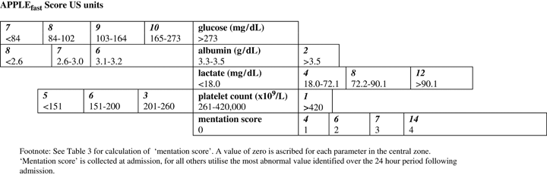
- 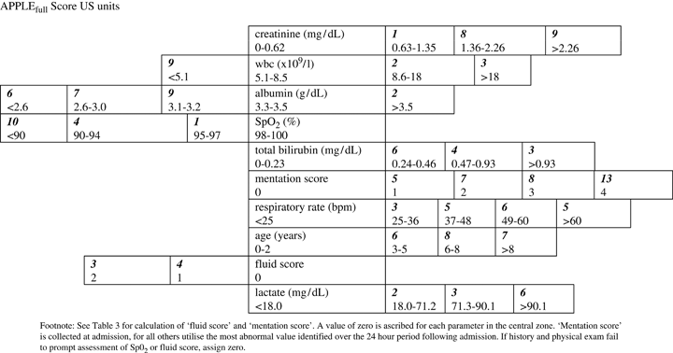

Luschini JVECC 2010: Incidence of ionized hypocalcemia in septic dogs and its association with morbidity and mortality: 58 cases (2006–2007).
- 58 cases with ≥ 2 SIRS Criteria + infection (cytology, culture or pneumonia)
- Both mean and lowest iCa were associated with survival

Hamacher 2015: Serum Cardiac Troponin I Concentrations in Dogs with Systemic Inflammatory Response Syndrome
- 60 dogs with ≥ 2 SIRS criteria
- Checked troponin days 1-5
- Higher troponin on intake and highest troponin were associated with non-survival
- Not useful to monitor throughout hospitalization

Hauptman 1997: Evaluation of the Sensitivity and Specificity of Diagnostic Criteria for Sepsis in Dogs

30 septic patents, 320 non/septic

SIRS criteria, platelets, BG

Temp, HR, WBC, % bands higher, platelets lower

RR/BG not different

≥2 SIRS criteria had 97% sensitivity but very poor specificity

Okano 2002: Usefulness of systemic inflammatory response syndrome criteria as an index for prognosis judgement

Relationship between number of abnormal SIRS criteria and mortality

First study to increase RR cut off to 40

5% mortality in dogs not fulfilling SIRS criteria, 18% in dogs that did

Brady 2000 JAVMA: Severe sepsis in cats: 29 cases (1986–1998)
- 29 cats with severe sepsis and necropsy results
- Used to establish first SIRS criteria in cats

Conti-Patara JVECC 2012: Changes in tissue perfusion parameters in dogs with severe sepsis/septic shock in response to goal-directed hemodynamic optimization at admission to ICU and the relation to outcome
AIM:
- Evaluate the changes in ScvO2, lactate, BD in dogs with severe sepsis/septic shock in response to goal-directed therapy
- Correlate values with mortality

METHODS
- Bitches with severe sepsis/septic shock with pyometra treated surgically
  - ≥ 2 SIRS criteria
  - Organ dysfunction (Doppler <90, PaO2/FiO2 <300, acute oliguria (<2mL/kg/h), increased serum creatinine (>1.8), thrombocytopenia (<200), Bili >0.25, lactate >2.5
  - Septic shock = organ dysfunction not reversed by fluid resuscitation
- Maintain BP >90, CVP 8-11, UOP >2ml/kg/hr, ScvO2 >70, Hemoglobin > 7
- HES then dopamine if not improved
RESULTS
- 30 dogs; 17 severe sepsis, 13 septic shock
- 36% mortality, 12/13 septic shock died
- Nonsurvivors had greater need for vasoactive drugs and greater crystalloid needs in first 5x90mins
- Nonsurvivors had lower ScvO2 and higher base deficits/lactate
- No significant effect of change in parameters on mortality
- No control arm

DeLaforcade 2003: Hemostatic Changes in Dogs with Naturally Occurring Sepsis
- Dogs with sepsis have lower antithrombin and protein C
- Higher D dimers, FDPs, PT and PTT
- Platelet counts no difference
- These factors not correlated with survival

Bentley 2013: Alterations in the hemostatic profiles of dogs with naturally occurring septic peritonitis
- 27 cases of septic peritonitis, 59% survival
- Preoperative PC > 60% predicted survival (sensitivity of 93%, specificity of 82%)
- Preoperative AT > 41.5% predicted survival (sensitivity of 100%, specificity of 82%)
- TEG more hypercoagulable in survivors

