Rose Chapter 8 – Regulation of Effective Circulating Volume

Effective circulating volume

- The part of the extracellular fluid that is in the arterial system, effectively perfusing the tissues
- Physiologic definition = pressure perfusing the arterial baroreceptors and glomerular afferent arterioles (change in pressure rather than a change in volume that is sensed)
- Effective circulating volume depletion is usually evidenced by a urine Na+ below 15-20 mEq/L
- Varies directly with ECF volume (in healthy patients)
- Both ECF and ECV are proportional to total body Na+; i.e. Na+ loading will tend to produce volume expansion whereas Na+ loss will lead to volume depletion

How does CHF affect (a) Effective circulating volume, (b) Extracellular fluid, (c) Cardiac output?

  - CHF results in decrease of ECV but increase in ECF
    - primary decrease in cardiac output lower presser at the baroreceptors compensatory fluid retention by the kidneys expansion of the ECF

How does peripheral vasodilation (eg. Advanced hepatic cirrhosis with ascites, arteriovenous fistula) affect (a) Effective circulating volume, (b) Extracellular fluid, (c) Cardiac output?

  - Peripheral vasodilation (eg. Advanced hepatic cirrhosis with ascites, arteriovenous fistula) results in a decrease in ECV and increase in ECF
    - Reduction in SVR reduction in blood pressure very low rate of Na+ excretion progressive increase in hormones that are typically released in response to hypovolemia (renin, norepi, ADH)
Changes in Na+ Excretion

Small alterations in Na+ intake result in parallel changes in Na+ excretion.

If dietary intake of Na+ is abruptly increased
- ~1/2 of excess intake will be excreted on the first day and the remainder is retained, increasing total body Na+ stores
- Elevation in plasma osmolality stimulates thirst and ADH secretion water retention inc ECV and inc body weight return of plasma osmolality to normal
- Over the subsequent days, there a progressively greater fraction of the excess intake is excreted until ~day 3-4, where new steady state is achieved and Na+ excretion matches intake

Diuretics -> initial loss of Na+ activates Na+ retaining mechanisms (eg. RAAS), which limit further loss. Counter regulatory forces are so efficient that if the diuretic dose is constant, all fluid and electrolyte losses will occur in the first 7-14 days of therapy with maximum response being induced by the first dose

Regulation of Effective Circulating Volume

Where are the primary receptors that sense changes in ECV?

- Primary receptors
  - (1) cardiopulmonary system (carotid sinus and aortic arch)
  - (2) juxtaglomerular apparatus of the afferent glomerular arterioles in the kidney (lesser degree macula densa cells in the early distal tubule)
- Sensing changes in pressure (or stretch)

Effectors --- RAAS and SNS

Sympathetic nervous system
- Volume depletion: Inc neural tone and inc secretion of catecholamines from the adrenal medulla
- Decrease pressure at baroreceptors results in inc in baroreceptor afferent discharge to vasomotor centres in the brainstem inc in peripheral sympathetic tone
  - Venous constriction
  - Inc myocardial contractility and HR
  - Direct arteriolar constriction
  - Renin -> AngII -> systemic vasoconstriction
  - Renal tubular Na+ reabsorption is enhanced from direct adrenergic effect and inc in angiotensin II and aldosterone secretion

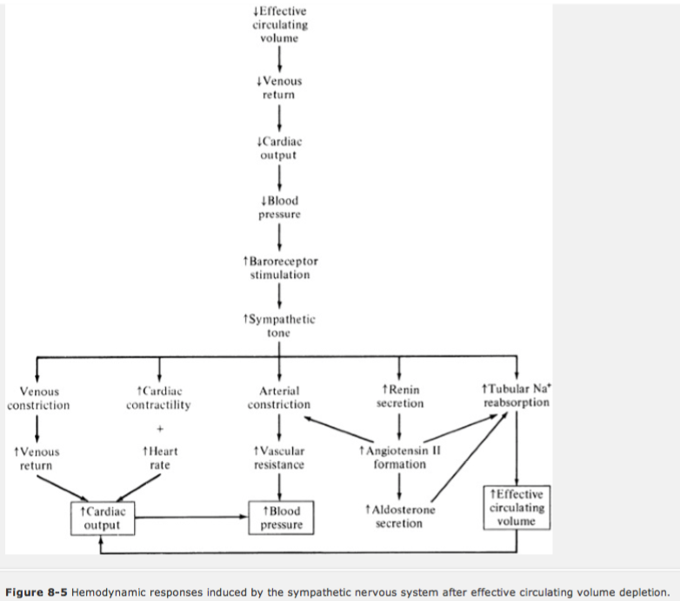

Regulation of renal Na+ excretion

When volume is expanded, urine Na+ concentration can exceed 100 mEq/L, or in contrast can be as low as 1mEq/L in the presence of volume depletion and normal renal function

These changes result from changes in: (1) GFR; (2) Tubular reabsorption

An increase in GFR will result in and ____ in Na+ excretion. A decrease in GFR will result in an ____ increase in Na+ excretion.

- Increased Na+ excretion with volume expansion and falls with volume depletion
- Changes in GFR are not required for maintenance of Na+ balance
- Even with substantial reduction in GFR due to renal dx, Na+ excretion can usually be adjusted by reduction in the rate of tubular reabsorption
- Also, glomerulotubular balance – primary alteration in GFR leads to parallel change in tubular reabsorption

Tubular reabsorption
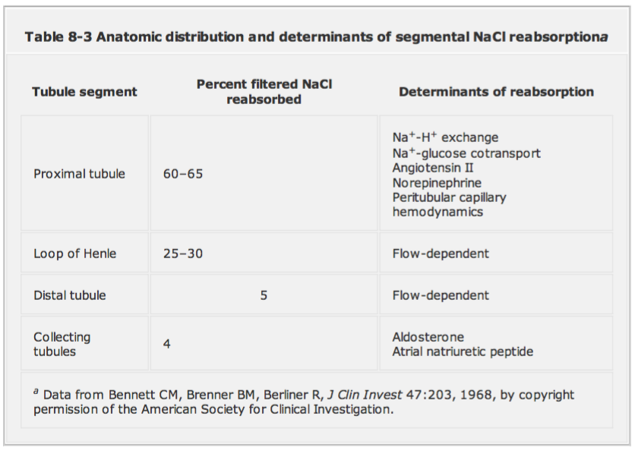
Percent filtered NaCl reabsorbed:
- 5%
- 5%
- 30%
- 60%

Determinants of reabsorption:
- Aldosterone
- Na+/H+ exchange
- Na+/glucose cotransport
- AngII
- ANP
- Norepi
- Peritubular capillary hemodynamics
- Flow-dependent

- Tubular reabsorption is the main adaptive response to fluctuations in ECV
- LOH and distal tubule make important contribution to Na+ handling, but transport in these segments primarily varies with amount of Na+ delivered (flow-dependent)
- Neurohumoral regulation of Na+ reabsorption occurs primarily in the proximal tubules and collecting tubules
  - Proximal tubules: inc activity of Na+/H+ exchanger that is responsible for both NaHCO3 and NaCl reabsorption; increased secretion on AngII and norepi
  - Collecting tubules: inc tubular reabsorption primarily via aldosterone

Pressure Natriuresis
- A small elevation in blood pressure results in a relatively large increase in urinary excretion of Na+ and H20. This phenomenon does not require neurally or humoral mediated sensor mechanisms
- Any rise in BP is eventually limited by fluid loss by pressure natriuresis
- Pressure natriuresis is likely only relevant when there is impairment of neurohumoral mediators of volume regulations
- Thought to occur via rise in interstitial pressure in the medullary interstitium
  - Diminish movement of reabsorbed solutes and water from the interstitium into the capillary
  - Tend to push fluid into the water-permeable descending limb of the LOH counteracting the osmotic movement of water out of this segment, which reduced the rises in tubular Na+ concentration reaching the thin ascending limb

Cardiorenal reflex - Volume receptors in the left side of the heart cause a reduction in renal sympathetic tone.

- Induction of hypotensive hemorrhage (lowers left-sided pressures) can result in a decrease renal blood flow as much as 90% and cessation in urine output. This is due to hypotension-induced inc sympathetic activity and marked renal vasoconstriction.
- Alternatively, an acute myocardial infarction (rise in left-sided pressures), is associated with only a ~25% fall in renal blood flow and persistent urine output. Volume receptors in the left side of the heart cause a reduction in renal sympathetic tone.
- Explains why we see acute tubular necrosis following hypotensive events, but rarely with renal hypoperfusion secondary to heart failure.

Plasma sodium concentrations

- Plasma sodium concentration does not play an important role in daily regulation of Na+ excretion
- Plasma Na+ conc is maintained by ADH and thirst
- ECV is the more important determinant of Na+ excretion
- Examples:
  - Syndrome of inappropriate ADH secretion is characterized by water retention, hyponatremia and volume expansion, which will lead to enhance Na+ excretion.
  - Conversely, volume-depleted patients who are hypernatremic will reduce urinary Na+ excretion

Volume regulation vs Osmoregulation

Plasma osmolality is determined by ratio of solutes to H20, whereas extracellular fluid is determined by absolute amounts of Na+ and H20.

- Osmoregulation is achieved alterations in water balance; Na+ is not directly affected
- Volume regulation attempts to maintain tissue perfusion
- Major overlap is the release of ADH, which occurs in both scenarios

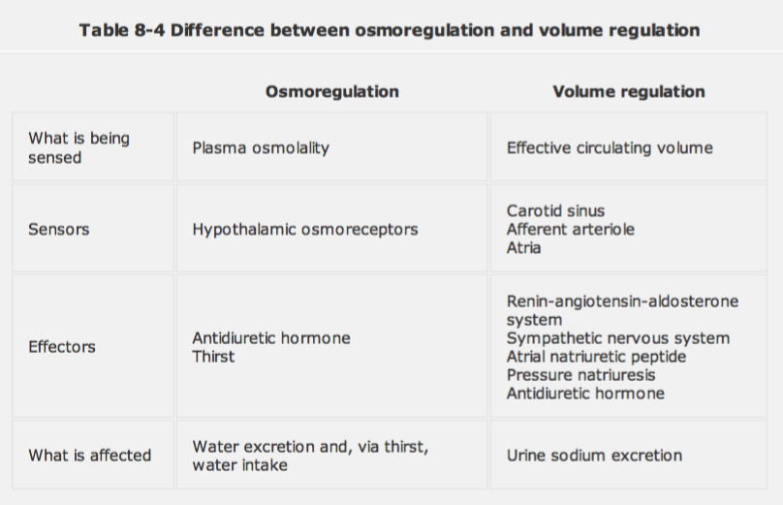

In the following situations
- does (A) plasma osmolality, and (B) extracellular fluid, increase/decrease/stay the same
- What is the response of the body?

Exercise on a hot day

Loss of dilute fluid will cause rise in plasma osmolality + decrease in extracellular fluid
ADH release and thirst + activation of RAAS highly concentrated urine with relatively little sodium

Administration of isotonic saline

no change in plasma osmolality + increase in extracellular fluid
diminished release of aldosterone and inc release of ANP excretion of excess Na+ and water in relatively isosmotic urine

Administration of ½ isotonic saline

reduction in plasma osmolality + increase in extracellular fluid
diminished ADH release, diminished Renin release excess NaCl excreted in dilute urine

