CHAPTER ONE – INTRODUCTION TO RENAL FUNCTION

Renal Morphology
- Basic unit of the kidney = nephron
- Nephron = glomerulus (tuft of capillaries between the afferent and efferent arterioles) + series of tubules lined with continuous epithelial cells
  - Glomeruli are located within the cortex
  - Tubules are located in the cortex and medulla

Fluid filters across the glomerulus Bowman’s space proximal tubule (initial convoluted segment then pars recta) loop of Henle (thin descending limb + think ascending limb + thick ascending limb/ macula densa) distal convoluted tubule connecting segment collecting tubule calyces renal pelvis ureters bladder
- Loop of Henle lengths are not uniform and are dependent on the where in the cortex the glomerulus is located
- Near the afferent glomerular arteriole, the thick ascending limb of the LOH contains an area of specialized tubular cells called the macula densa
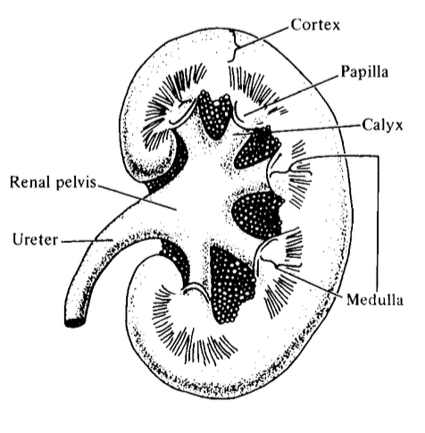
  - Juxtaglomerular cells of the afferent arteriole + macula densa = juxtaglomerular apparatus (important for renin secretion)

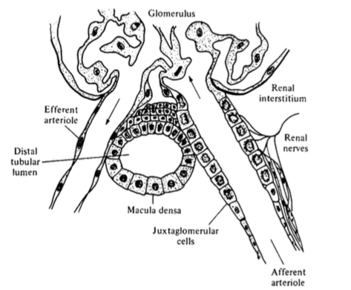
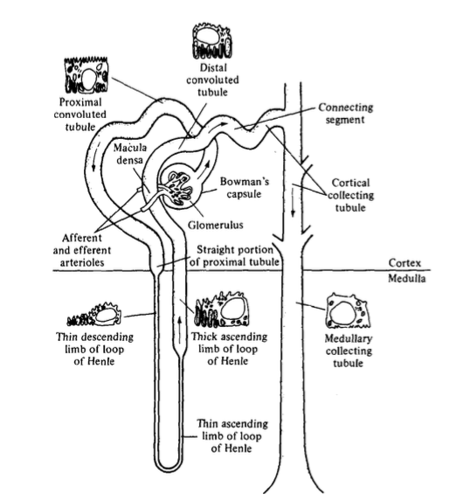
Functions of the kidney
- Excretion of waste products
- Secretion of hormones – renin, angiotensin II, prostaglandins, nitric oxide, endothelin, bradykinin, erythropoietin, calcitriol
- Catabolism of peptide hormones, gluconeogenesis, etc

Where in the nephron is the bulk of filtered solutes and H20 reabsorbed?

Excretory function:
- Formation of the an ultrafiltrate of plasma across the glomerulus
- Tubules modify this fluid through (a) reabsorption & (b) secretion
  - Proximal tubule and LOH reabsorb the bulk of filtered solutes and water, collecting tubules make final small changes
  - Tubular reabsorption includes both:
    - transcellular (facilitated by protein carriers or ion-specific channels – to overcome lipid bilayer of cell)
    - paracellular
  - Healthy individual reabsorbs 98-99% of all filtered Na+, Cl-, H20 and HCO3-
    - H+ is secreted
    - K+ and uric acid are reabsorbed and secreted
    - Creatinine is excreted unchanged
  - Spatial orientation of cells is important because luminal and basolateral membranes have different characteristics
    - eg. N+/K+/ATPase pump on basolateral membrane keeps low [Na+] within the cell, allowing for Na+ reabsorption throughout the nephron
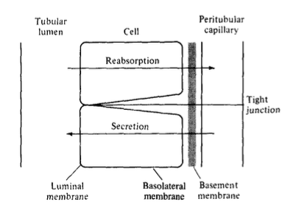
What are the 2 primary roles of tight junctions between tubular epithelial cells?
Where in the nephron are tight junctions most and least “leaky”?

Tight junctions
Composed of zona occludens (strand-like structure on luminal membrane that brings adjacent cells into apposition at their luminal surface). 2 important functions:
- Paracellular gate - barrier from the passive diffusion of solutes and water between cells
  - Leakiness of gate varies with nephron segment – eg. Proximal tubule is ‘leaky’ and 1/3 of proximal Na+ reabsorption occurs via paracellular route, whereas collecting tubule is “tight” allowing this area to sustain very large transepithelial concentration gradients
- Fence for polarity - boundry between the luminal/ apical and basolateral membranes preventing lateral movement of transporters or channels from one membrane to another
  - Eg. Na+ is enters cell across luminal membrane via specific transporters or channels, then is returned to systemic circulation with Na+/K+/ATPase pump on basolateral membrane. If tight junctions open, as in ischemia, then Na+ reabsorption is impaired partly because Na+/K+/ATPase pumps can translocate to the luminal membrane
  - Abberant localization of membrane proteins may contribute the development of multiple disorders.

Membrane recycling
Membrane components may be newly synthesized or recycled. eg. ADH combines with its receptor on the basolateral membrane of collecting tubular cells, initiating a sequence of events in which aquaporin-2 channels are inserted into the luminal membrane. The hormone-receptor complex is then internalized by endocytosis and enters acidic endosomes, where the hormone and receptor are split. The hormone is metabolized by the cell, and receptor returns to the basolateral membrane

Composition of Urine
- Quantity of solutes and water in the urine is dependent on the intake to maintain a relatively constant extracellular fluid, thus there are no absolute “normal” values for urine solute or water
- Urine has high concentrations of uncharged molecules, eg. urea, unlike ECF where most solutes are ions

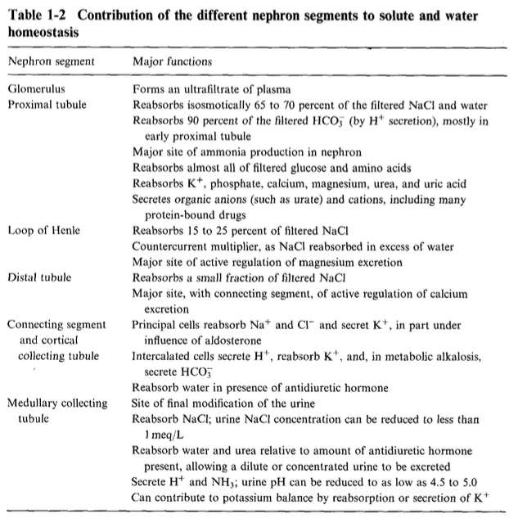

Units of Measurement

Moles
1 mole of a substance is defined as the molecular/ atomic weight of that substance in grams, or 1 mmol is one-thousandth of the molecular/ atomic weight of a substance in milligrams

eg. 1 mmol Na+ = 23 mg
1 mmol Cl- = 35.5 mg
1 mmol NaCl = 58.5 mg

1 mole of any nondissociable substance contains the same number of particles (Avogadro’s law 6.02 x 10^23)

Uncharged molecules, eg. glucose and urea, can also be measured in mmol/L but are often measured in mg/dL

mmol/L = (mg/dL x 10) / mol weight

Electrochemical equivalence
One equivalent is defined as the weight in grams of an element that combines with or replaces 1 gram of H+ . Ions combine milliequivalent for milliequvalent to maintain electroneutrality.

1 g H+ = 1 mol H+ = 6.02x10^23 particles
1 mol of any univalent anion will combine with H+ and equal on equivalent

eg.
1 mol H+ + 1 mol Cl- = 1 mol HCl
1 mol Ca2+ + 2 mol Cl- = 1 mol CaCl2

Thus,

mEq/L = mmol/L x valence

What is osmotic pressure and what is the difference between total and effective osmolality?

Osmotic pressure and Osmolality
Osmotic pressure generated by a solution is proportional to the number of particles per unit volume of solvent (rather than the type, valence or weight of the particles)

One osmole is defined as 1 gram molecular weight (1 mol) of any nondissociable substance and contains 6.02x10^23 particles

mosmol/kg = n x mmol/L
where n = number of dissociable particles per molecule

1 mmol/L of a molecule will generate a potential osmotic pressure of 1 mosmol/kg
If an object dissociates into 2 or more particles, then 1 mmol/L will generate and osmotic pressure greater than 1 mosmol/L
Eg. for each 1 mmol/L NaCl (only 75% dissociated) there will be 0.75 mmol/L of each Na+ and Cl- and 0.25 mmol/L of NaCl = 1.75 mosmol/kg

Total vs Effective Osmolality:
Only solutes that cannot cross the membrane separating 2 compartments generate an effective osmotic pressure. Eg. urea (lipid-soluble) does not contribute to osmotic pressure but will be measured in ‘plasma osmolality’ measured by freezing point or vapour pressure depression

CHAPTER 2 – RENAL CIRCULATOIN AND GLOMERULAR FILTRATION RATE

Blood flow to the kidneys is ~20% of cardiac output

Passage of blood flow: renal arteries interlobar, arcuate and interlobular branches afferent arterioles glomerular capillaries efferent arterioles postglomerular/ peri-tubular capillaries
- Branches of the efferent arterioles of the juxtamedullary glomeruli enter the medulla and form the vasa recta capillaries

Renal circulation affects urine formation through:
- Rate of GFR
- Modulation of the degree of proximal tubular reabsorption and secretion via peri-tubular capillaries
- Countercurrent mechanism via the vasa recta

Glomerular anatomy and function

Glomerulus is a tuft of capillaries interposed between the afferent and efferent arterioles. Each glomerulus is enclosed within an epithelial cell capsule, i.e. Bowman’s capsule, which is continuous with the epithelial cells that surround the glomerular capillaries and the cells of the proximal convoluted tubule.

What are the 3 layers of the capillary wall through which the filtrate must pass?

- Fenestrated endothelial cells
- Glomerular basement membrane
  - Type IV collagen forms cords to make basic structure
  - Other substances fill the spaces between the cords: laminin, nidogen, heparin sulfate proteoglycans
- Epithelial cells
  - Attached to GBM by discrete foot processes/ podocytes
  - Pores between foot processes (called slit pores) are closed by a thin membrane called the slit diaphragm, which functions as a modified adherent junction

Glomerular basement membrane surround the capillary loops, but most of the mesangium is separated from the capillary lumen by only the relatively permeable fenestrated endothelium.
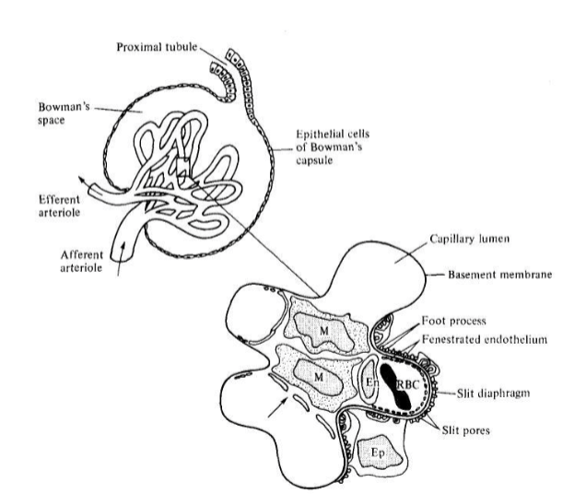

Glomerular cells also have synthetic, phagocytic and endocrine functions
- Epithelial cells synthesize the GBM and remove macromolecules that pass through the GBM and enter the subepithelial space
- Endothelial cells regulate vasomotor tone via the release of prostacyclin, endothelin and nitric oxide. Also, in inflammatory disorders they express adhesion molecules that promote accumulation of inflammatory cells

Mesangium is composed of 2 cell types:
- Mesangial cells: Microfilaments similar to smooth muscle cell
  - can respond to angiotensin II (which is produced by endothelial cells in the afferent arteriole) and can synthesize prostaglandins and release cytokines
- Circulating macrophages & monocytes
  - primarily remove macromolecules that enter the capillary wall and cannot cross the basement membrane via phagocytosis

Filtration Barrier and Protein Excretion

What 2 characteristics determine if a molecule is able to be filtered?

- Size selectivity
- allows filtration of small particles and water, while restricting passage of large molecules
  - Solutes up to the size of inulin (mol wt 5200) are freely filtered
  - Albumin (mol wt 69,000) is filtered to only a minor degree
- Both GBM, slit diaphragms and cellular components of the glomerular capillary wall contribute to size selectivity
- Endothelial cells do not contribute to size selectivity as the fenestrae are relatively wide open

- Charge selectivity
- 2nd major determinant in filtration across the glomerulus
- Cations and neutral molecules are filtered to a greater degree than negative molecules, partly due to electrostatic repulsion by anionic sites in the endothelial fenestrae and in the GBM (mostly from heparin sulfate proteoglycans).

Cation, Anion or neutral?
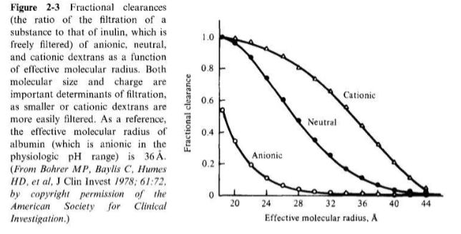
albumin

Renin-Angiotensin System

What cells synthesize renin?

- Juxtaglomerular cells (specialized cells of the glomerular afferent arterioles) synthesize prorenin, which is cleaved into the active renin

Name the 2 primary triggers for renin release

- Renin release is stimulated by renal hypoperfusion (hypotension or volume depletion) and increased sympathetic tone
  - Renin release is highest in outer cortical glomeruli, lesser in mid-cortex glomeruli, and very little in juxtamedullary glomeruli

Explain the RAAS pathway

- Renin initiates cleavage of angiotensinogen (produced by the liver) to angiotensin I, which is then converted by ACE to angiotensin II
  - ACE is in the highest concentrations in the lung, but is also found in luminal membrane of vascular endothelial cells, the glomerulus, adrenal gland, brain, etc
    - Local angiotensin II production is important for regulation of local processes, eg. proximal tubule contains and ACE and angiotensin II receptors that stimulate Na+ reabsorption
    - Intrarenal renin-angiotensin system may play an important role in certain disease states – eg. patients with hypertension or congestive heart failure retain Na+ through intra-renal RAS despite serum renin and angiotensin II levels being comparable to healthy patients

What are the actions of angiotensin II?

- Angiotensin II actions (mediated by AT1 and AT2 receptors)
  - (1) Systemic vasoconstriction to increase blood pressure
    - Direct action on vascular smooth muscle, mediated by protein kinase C & enhanced sensitivity and facilitated release of norepinephrine
  - (2) Water and NaCl retention to increase plasma volume
    - Increased secretion of aldosterone from the adrenal cortex Na+ transport in the collecting tubule
    - Direct stimulation of Na+ reabsorption in the early proximal tubule
      - Stimulation of an inhibitory G protein that decreases cAMP generation decreased suppression of the Na+/H+ antiporter in the luminal membrane
  - (3) Regulation of GFR
    - Constriction of the efferent and afferent glomerular arterioles and the interlobular artery mediated in part by thromboxane A2
    - Stimulates release of vasodilator prostaglandins from the glomeruli, preventing excessive renal vasoconstriction
    - At high concentrations, constricts glomerular mesangium, lowering the surface area for filtration
    - Tubuloglomerular feedback

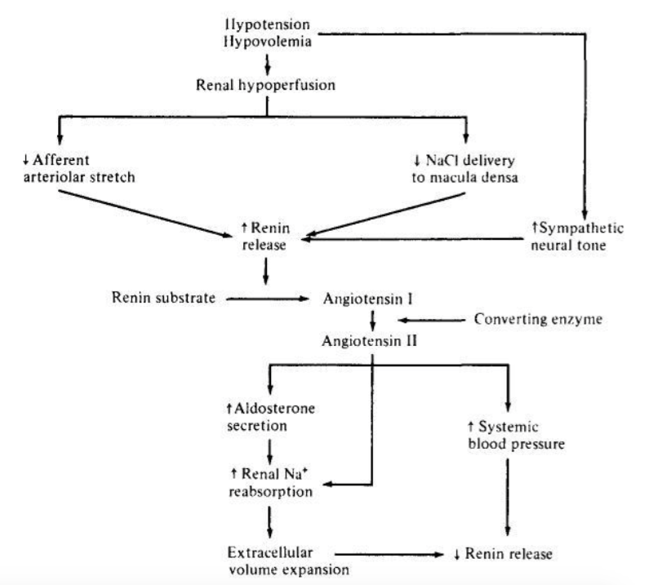

Control of renin secretion

Name 3 mechanisms by which changes in volume are sensed and lead to increased renin secretion

- Major determinant is N+ intake (more Na+ intake results in less renin secretion and vice versa)
- Acute increases in renin are accomplished by release of preformed renin from secretory granules, whereas more chronic states require synthesis of new prorenin
- Changes in volumes are sensed at 3 sites:
  - (1) Baroreceptors in the wall of afferent arterioles
    - Respond to changes in stretch
    - When perfusion pressure increases: enhanced calcium entry into the cell
    - When perfusion pressure decreases: local release of prostacyclin
  - (2) Cardiac and arterial baroreceptors
    - Regulate sympathetic neural activity and level of circulating catecholamines
  - (2) Cells of the macula densa in the early distal tubule
    - Stimulated by a reduction in Cl- concentration
    - Na+/K+/2Cl- cotransporter in the luminal membrane of the thick ascending limb and macula densa is stimulated by low concentrations of Cl-, Na+ and K+
      - Eg. With volume expansion, there is a decreased in proximal NaCl reabsorption, which will increase Cl- concentration at the macula densa, thereby reducing renin secretion
      - Mechanism by which the macula densa affects renin secretion is mediated by adenosine (suppresses renin release) and PGE2 (enhances renin release)

Determinants of GFR

What 2 components are the primary determinants of GFR?

Changes in GFR are produced by:
  - alterations in Starling’s forces
  - rate of renal plasma flow

Write out Starling’s equation in reference to GFR

GFR = LpS (P_{gc} – P_{bs} – π_{p})

Lp = permeability of the capillary wall
S = surface area available for filtration
P_{gc} = hydraulic pressure in the glomerular capillary
P_{bs} = hydraulic pressure in Bowman’s space
π_{p} = oncotic pressure in the plasma
*Oncotic pressure in Bowman’s space is 0

Filtration equilibrium: Capillary oncotic pressure progressively rises due to filtration of protein-free fluid. Gradient favouring filtration falls from afferent arteriole to efferent arteriole as the plasma oncotic pressure rises

The GFR can be rapidly regulated through changes in glomerular capillary hydrostatic pressure through changes in (1) aortic pressure, (2) resistance at the afferent arteriole, (3) resistance at the efferent arteriole

Arteriolar tone will also affect renal plasma flow, as the renal vascular resistance is primarily provided by the arterioles (small contribution from the peritubular capillaries and renal veins). Increase in arteriolar tone at either end of the glomerulus will elevate total renal resistance and reduce renal plasma flow.

What change would be expected to the glomerular capillary hydrostatic pressure, GFR and renal plasma flow under the following circumstances?

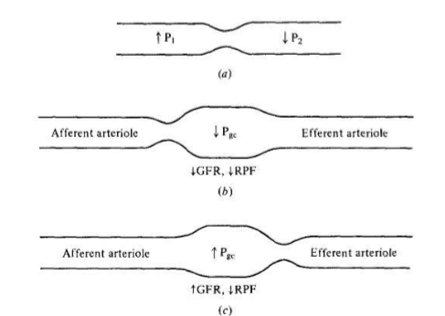

Autoregulation

What is meant by the term “autoregulation”?

Normal GFR is maintained within relatively narrow limits over a range of arterial pressures to prevent excessive solute and water loss = autoregulation

As systemic pressure rises, the vascular tone in the afferent arteriole increases and prevents this pressure from being transmitted to the glomerulus, allowing glomerular hydrostatic pressure and GFR to remain unchanged

As blood pressure decreases, afferent arteriolar dilation with initially protect both GFR and RPF, but ability to maintain this will become impaired at pressures below 70 mmHg and GFR will cease with systemic pressures reach 40-50 mmHg. The ability of autoregulation to protect the GFR is impaired if the perfusion pressure is markedly reduced

Autoregulation is mediated by
- (1) stretch receptors in the afferent arteriole,
- (2) angiotensin II,
- (3) tubuloglomerular feedback

What is the myogenic mechanism?

- Myogenic stretch receptors in the wall of the afferent arteriole sense increased pressure and promote constriction, and vice versa. Efferent arterioles do not respond to changes in stretch and do not contribute directly to the myogenic response

- Angiotensin II
  - Administration of an angiotensin II antagonist result in dissociation of the autoregulation of RPF and GFR
  - Autoregulation in reverse – when renal perfusion pressure is elevated angiotensin II levels may fall to maintain GFR, but this is limited as basal levels of angiotensin II are already low

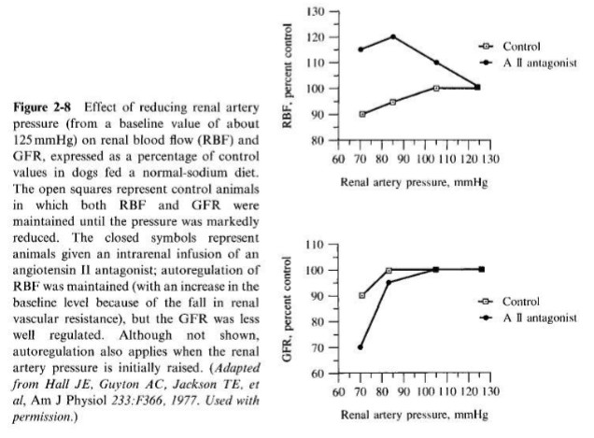

Explain tubuloglomerular feedback

- Tubuloglomerular feedback: ability of macula densa to decrease the GFR when distal delivery is enhanced, which would otherwise lead to life threatening loss of Na and water
  - Refers to alterations in GFR that can be induced by changes in tubular flow rate
    - Mediated by specialized cells in the macula densa segment at the end of the thick ascending limb of the LOH
    - These cells sense changes in the delivery of Cl-
    - Increase in Cl- delivery will cause afferent arteriole vasoconstriction, decreasing GFR
  - Loop diuretics (inhibition of Na+/K+/2Cl- cotransporter) impair autoregulation
  - Mediators of TGF
    - Adenosine: induces constriction of the afferent arteriole. Increased NaCl delivery results in blockade of adenosine receptors or inhibition of adenosine formation
    - Thromboxane: Vasoconstrictor - thromboxane production is increased when tubuloglomerlar feedback is activated
    - Nitric oxide: vasodilatory – blunts the tubuloglomerular feedback response

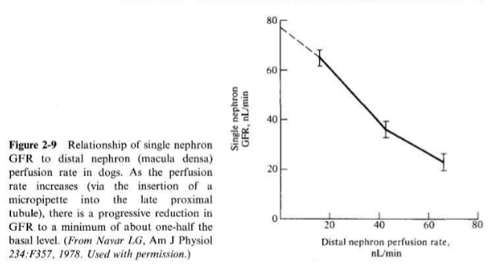

Volume expansion – associated with increased renal perfusion and a mild increase in GFR, reduced secretion of angiotensin II and norepinephrine, and enhanced release of dopamine and atrial natriuretic peptide
- Dopamine dilates both the afferent and efferent arterioles, increasing renal perfusion with no change in GFR
- ANP produces afferent dilation and efferent constriction increased GFR

Endothelin
- released locally from endothelial cells
- Not an important regulator in normal subjects, but plays a role in the reduction of GFR seen with post-ischemic acute renal failure
- Potent vasoconstrictor affecting both afferent and efferent glomerular arterioles reduced GFR
- Degree of ischemia is minimized by endothelin-induced release of prostacyclin and tonically released nitric oxide

NSAIDS
- Inhibit prostaglandin synthesis. Little effect on renal function in normovolemic subjects where level of renal prostaglandin production is low
- In patients with high angiotensin II and norepinephrine levels (i.e. in conditions with decreased effective circulating volume), prostaglandin synthesis is enhanced, allowing NSAID administration to lead to unopposed vasoconstriction reduced GFR ARF

Intraglomerular hypertension
- partially responsible for the progression to end-stage renal failure
- Loss of nephrons leads to a compensatory rise in filtration in the remaining nephrons
- Driven by a rise in afferent arteriolar dilatation, which leads to a rise in both P_{gc} and plasma flow
- Elevation in intraglomerular pressure is maladaptive as it leads to progressive glomerular damage
- Medical treatment: dietary protein restriction, antihypertensive therapy (ACE inhibition)
  - ACE inhibition will reverse angiotensin II-induced constriction of the efferent arteriole

Measurement of GFR

What is the most accurate way to measure GFR?

Total GFR is an index of functioning renal mass. A fall in GFR may be the earliest and only sign of renal disease due to compensatory hyperfiltration in the remaining functioning nephrons

Inulin can achieve a stable plasma concentration, is freely filtered, and is not reabsorbed/ secreted/ synthesized/ metabolized by the kidney.
Filtered inulin = excreted inulin
C = UV/P
Clearance = (Urine inulin concentration x urine volume) / plasma inulin concentration

How is GFR more commonly measured in a clinical setting? What are the limitations of this method?

Creatinine clearance is more commonly used than inulin. Plasma creatinine concentrations are very stable and it is freely filtered and not absorbed. A small amount is secreted, making creatinine clearance tend to exceed inulin clearance by 10-20%. This is usually mitigated by error obtains when measuring plasma creatinine by coloimetric reaction.

Limitations of creatinine clearance
- incomplete urine collection
- increased tubular secretion of creatinine as renal function declines

Generally, creatinine clearance is a representation of an upper limit of the true GFR

Changes in the GFR can be estimated from plasma creatinine
The plasma creatinine varies inversely with the GFR
GFR x plasma creatinine = constant

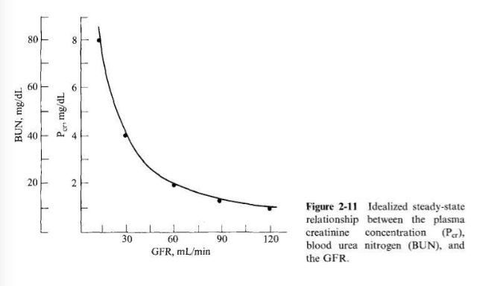

*only valid with plasma creatinine is stable
*initial elevation in the plasma creatinine represents a major loss of GFR
*dependent on rate of creatinine production, which varies based on muscle mass and meat/ protein intake

Why is BUN clearance not an accurate measure of GFR?

BUN – not an accurate measure GFR. Affected by changes in urea production (conversion of ammonia into urea in the liver) and tubular urea reabsorption (typically ~40-50% is reabsorbed).

Sometimes it is suggested to combine creatinine clearance (Overestimates GFR) and BUN clearance (underestimated GFR)

Other potential means of measuring GFR: radiolabeled compounds such as iothalamate or DTPA, measuring creatinine with administration of cimetidine to block creatinine secretion, cystatin C (protein produced by all nucleated cells that is unaltered by inflammation or changes in diet),

Measurements of Renal Plasma Flow

- Not generally a clinically useful measurement
- Paraaminohippurate (PAH) is almost completely removed from the plasma in a single pass through the kidney. Thus,
  - Clearance PAH = Urine PAH concentration x Volume/ Plasma PAH concentration
  - Renal blood flow = (Clearance PAH) / 1- Hct

