Respiratory Literature Review 2018

Seminal Articles

Foronda F, Troster EJ, Farias JA, Barbas CS, et al. Impact of daily evaluation and spontaneous breathing test on the duration of pediatric mechanical ventilation: a randomized controlled trial. Critical Care. 2011 Jun 22;15(2):P45. (ABSTRACT only)
- Objective
  - 1ary outcome: assess whether the combination of a daily evaluation and application of a spontaneous breathing test (SBT) could shorten the duration of MV, compared with weaning based on standard of care
  - 2ary outcome: extubation failure rate and need for non-invasive ventilation
- Methods
  - Prospective randomized controlled trial in 2 pediatric ICU in Brazil (294 children)
  - Children between 28 d - 15 yrs on MV for at least 24 hrs
  - Randomly assigned to one of two weaning protocols
    - Test group, daily evaluation to check readiness for weaning and a SBT with PS of 10 cmH2O and PEEP of 5 cmH2O for 2 hours, with the SBT repeated on the next day in children failing it (155 kids)
    - Control group, weaning was performed according to the services routine (139 kids)
- Results
  - Time to extubation was shorter in the test group, median duration of MV was 3.5 (95% CI = 3.0 to 4.0) days, in comparison with 4.7 (95% CI = 4.1 to 5.3) days in the control group (P = 0.0127)
  - SBT was not associated with increased rates of extubation failure or NIV, 30% reduction in the risk of remaining under MV
- Conclusion
  - In children ventilated >24 hrs, a daily SBT to check readiness for weaning reduced the duration of MV, without increasing the extubation failure rate or the need for NIV

Pang D, Hethey J, Caulkett NA, et al. Partial pressure of end‐tidal CO2 sampled via an intranasal catheter as a substitute for partial pressure of arterial CO2 in dogs. Journal of Veterinary Emergency and Critical Care. 2007 Jun 1;17(2):143-8.
- Objective
  - Demonstrate correlation and clinical usefulness of ETCO₂ measurement by nasal catheter placement in sedated dogs with and without concurrent nasal oxygen administration as a substitute for PaCO₂
  - Previous study had shown that panting decreased accuracy of nasal cannula ETCO2 measurements
- Methods
  - Prospective, cross-over trial, Saskatchewan veterinary research laboratory
  - Six cross-breed healthy dogs 28-30kg
  - All dogs were sedated with 5 μg/kg medetomidine IV, arterial cath for gas analysis
  - Nasal catheter was placed connected to a capnometer for ETCO₂
  - Dogs receiving supplemental nasal O2 had a 2nd nasal catheter placed in contralateral naris (150 ml/kg/min)
  - ABG taken before instrumentation, at full sedation, ½ sedation and full recovery (1/2 and full dose atipamezole)
- Results
  - Group w/o nasal O2, ETCO₂ underestimated the PaCO₂ by −2.20 mmHg
  - Group w nasal O2, ETCO₂ underestimated the PaCO₂ by −2.46 mmHg
- Conclusions
  - ETCO₂ monitoring via a nasal catheter provides a clinically acceptable substitute to arterial blood gas analysis as a means of monitoring ventilation in healthy, sedated dogs, with and without concurrent insufflation of oxygen.

Papazian L, Forel JM, Gacouin A, et al. Neuromuscular blockers in early acute respiratory distress syndrome. N Engl J Med. 2010 Sep 16;363(12):1107-16.
- Objective
    - Identify if 48 hr therapy with cisatracurium early in ARDS reduces adjusted 90-day in-hospital mortality rate
  - Design
    - Multicenter, double blind, randomized clinical trial, 20 ICUs in France
    - 340 patients with ARDS within the past 48 hrs
    - Randomized to receive either cisatracurium or placebo, sedation w/ sulfentanil and midazolam prior to intervention
  - Results
    - 90-day mortality was 31.6% in the cisatracurium group and 40.7% in the placebo group
    - 28-day mortality was 23.7% with cisatracurium and 33.3% with placebo
    - ICU-acquired paresis did not diﬀer between the two groups
  - Conclusions
    - In patients with severe ARDS, early administration of a neuromuscular blocking agent improved the adjusted 90-day survival and increased the time oﬀ the ventilator without increasing muscle weakness.

Swinbourne F, Baines EA, Baines SJ, et al. Computed tomographic findings in canine pyothorax and correlation with findings at exploratory thoracotomy. Journal of Small Animal Practice. 2011 Apr 1;52(4):203-8.
- Objectives
  - Describe CT findings in canine spontaneous pyothorax and compare them to sx findings
  - Assess the utility of CT in guiding case management
- Methods
  - 2003 – 2010, dogs with spontaneous pyothorax, which had undergone CT (12 dogs)
  - Cases were managed medically or surgically
  - CT images and surgery reports were reviewed and compared for surgical cases
- Results
  - 8 surgically managed, 3 medically managed, one died before management
  - 100% pleural fluid on CT, 8/12 detected at surgery
  - Pleural gas identified in five dogs on CT
  - Pleural thickening detected in 8 dogs on CT, 8 dogs at surgery, 6 identified on CT
  - Abnormal pulmonary parenchyma detected in 10 dogs on CT and 5 dogs at surgery, all identified on CT
  - Mediastinal involvement detected in 10 dogs on CT, 6 dogs at surgery, 5 identified on CT
- Conclusions
  - CT and surgical findings are similar in most cases of canine spontaneous pyothorax
  - CT is a useful diagnostic tool for guiding case management

Villar J, Blanco J, Añón JM, et al. The ALIEN study: incidence and outcome of acute respiratory distress syndrome in the era of lung protective ventilation. Intensive care medicine. 2011 Dec 1;37(12):1932-41.
- Objective
  - To examine ARDS incidence and outcome under current lung protective ventilatory strategies before and after diagnosis of ARDS
- Methods
  - 1-year prospective, multicenter, observational study in Spain, between 2008-2009
  - 225 ARDS patients
  - Data on ventilatory management, gas exchange, hemodynamics, and organ dysfunction were collected
- Results
  - Incidence of 0.007% a year
  - Pneumonia and sepsis were the most common causes of ARDS
  - ICU mortality was 42.7% and hospital mortality was 47.8%
- Conclusions
  - Despite use of lung protective ventilation, overall ICU and hospital mortality of ARDS patients is still higher than 40%

Journal of Veterinary Internal Medicine

Lappin MR, Blondeau J, Boothe D, Breitschwerdt EB, Guardabassi L, Lloyd DH, Papich MG, Rankin SC, Sykes JE, Turnidge J, Weese JS. Antimicrobial use guidelines for treatment of respiratory tract disease in dogs and cats: antimicrobial guidelines working group of the International Society for Companion Animal Infectious Diseases. Journal of Veterinary Internal Medicine. 2017 Mar 1;31(2):279-94.
- Feline Upper Respiratory Tract Disease
  - Majority of cats with URTD have herpesvirus 1 or calicivirus associated URI
  - Normal nasal cat flora: Staphylococcus spp, Streptococcus spp, Pasteurella multocida, E. coli and anaerobes
  - 2ary bacterial infections: Chlamydia felis, Bordetella bronchiseptica, Streptococcus canis, Streptococcus equi subspp. Zooepidemicus and Mycoplasma spp
  - If nasal discharge are serous, antibiotics are NOT recommended
  - If nasal discharge is mucopurulent, in the absence of evidence of URTD from physical or history, observation period without antibiotics is recommended (up to 10 days)
  - Nasal cultures are NOT recommended
  - If fever, lethargy and anorexia are present with mucopurulent discharge
    - Doxycycline 7-10 days
    - Amoxicillin 7-10 days ( when C felis and Mycoplasma are not suspected)
  - If > 10 days of clinical signs, diagnostic workup involving advanced imaging, rhinoscopy, cytology +/- cultures
    - Antibiotics chosen based on cultures, for 7 days and if improvement is seen continued as long as there continues to be improvement and for at least 1 week past clinical resolution or plateau in response
    - If there is recurrence after 3 months, try same antibiotic empirically for 7-10 days
    - If recurrence within 3 months, change antibiotic

- Canine Infectious Respiratory Disease Complex
  - Associated with acute onset of cough with or without sneezing, +/- nasal and ocular discharge, fever is uncommon
  - Viruses: canine adenovirus 2, canine distemper virus, canine respiratory coronavirus, canine influenza viruses, canine herpesvirus, canine pneumovirus, and canine parainfluenza virus
  - Bacteria: B. bronchiseptica, S. equi subspecies zooepidemicus, and Mycoplasma spp
  - Usually self-limiting virus, observation period without antibiotics is recommended (up to 10 days)
  - If nasal discharge, fever, lethargy or inappetance (no pneumonia)
    - Doxycycline 7-10 days
    - Amoxicillin 7-10 dyas (if bacterial contamination is suspected)
    - Do NOT use Clavamox since mycoplasma and some Bordetella is resistant

- Bacterial Bronchitis in Dogs and Cats
  - Associated with inhaled irritants, infections, Dirofilaria immitis, resp parasites (Toxocara canis), pharyngeal or esophageal dysfunction and allergies
  - 2ary bronchitis: laryngeal paralysis, collapsing trachea
  - Cough w/wo signs of resp distress
  - Most accurate diagnosis: BAL neutrophilic inflammation, intracell bacteria + positive bacterial culture + radiographic characteristics make
  - If signs are not severe, do NOT start antibiotics
  - If clinical disease is severe
    - Doxycycline 7-10 days, till culture results are back
    - Continue till 1 week pasta clinical resolution
    - Fluoroquinolones or Azithromycin can be considered

- Pneumonia in Dogs and Cats
  - 1ary pneumonia: B. bronchiseptica, Mycoplasma spp., S. equi zooepidemicus, S. canis, and Yersinia pestis
  - 2ary are most common: E. coli, Pasteurella spp., Streptococcus spp, B. bronchiseptica, Enterococcus spp., Mycoplasma spp., S. pseudintermedius and other coagulase-positive Staphylococcus spp., and Pseudomonas spp
  - Associated with fever, lethargy, inappetence, or tachypnea
  - Thoracic radiographs (alveolar lung disease), CBC, BAL, TTW, culture and susceptibility should be performed
  - Antibiotics should be started ASAP
  - Endoscopy contamination: Serratia or Stenotrophomonas
  - Parenteral treatment is recommended while hospitalized, regardless of severity
    - Doxycycline if B. bronchiseptica or Mycoplasma spp is suspected and no other systemic signs are present
    - Beta-lactam or 1st generation cephalosporin, if no systemic sepsis
    - Enrofloxacin + Gram-positive and anaerobic spectrum drug if septic
      - If bacteroides suspected add metronidazole
    - Treatment for 10-14 days, decisions to extend treatment should be based on clinical, hematological, and radiographic findings

- Pyothorax in Dogs and Cats
  - Most common isolates: Fusobacterium, Prevotella, Porphyromonas, Bacteroides, Peptostreptococcus, Clostridium, Actinomyces, Filifactor villosus, Pasteurella spp, Streptococcus spp., and Mycoplasma spp.
  - Cats most commonly from bite wounds and URI
  - Dogs most commonly from migrating plant FB, trauma and bite wounds
  - Radiographs after thoracocentesis to evaluate lung consolidation
  - Actinomyces and Nocardia require specialized growth conditions and prolonged incubation, alert lab
  - Chest tubes, with or without lavage, surgical debridement may be needed
  - Parenteral treatment is recommended while hospitalized
    - Enrofloxacin + a Penicillin or Clindamycin
    - Pradofloxacin may be administered as a single drug
    - Change depending on culture results
    - 10-14 days then decisions to extend treatment should be based on clinical, hematological, and radiographic findings

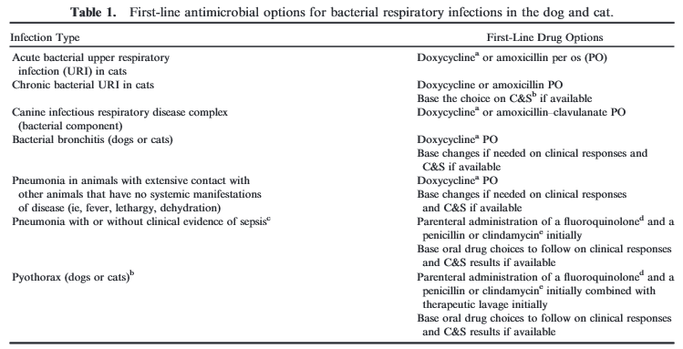

Boedec K, Heng HG, Snyder PW, Pressler BM. Pulmonary abnormalities in dogs with renal azotemia. Journal of veterinary internal medicine. 2012 Sep 1;26(5):1099-106.
- Retrospective cohort study, 167 pet dogs (54 AKI, 50 CKD, 63 non-azotemic control dogs diagnosed with intracranial disease)
- 30% dogs had respiratory signs
- Prevalence of an alveolar lung pattern > in AKI and CKD dogs
- Alveolar mineralization was the most common pulmonary histologic lesion in AKI dogs (6/8)
- Abnormalities indicative of pulmonary disease are more common in azotemic dogs than in control dogs
- Prognosis is not associated with presence of clinical or radiographic pulmonary dysfunction

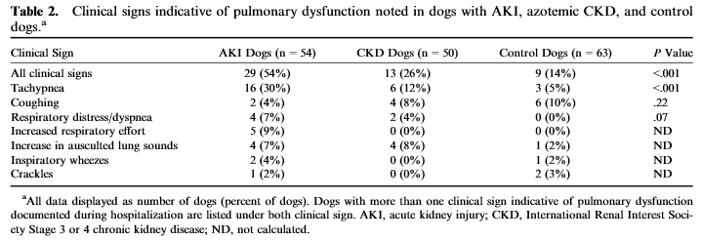

Kohn B, Steinicke K, Arndt G, Gruber AD, Guerra B, Jansen A, Kaser‐Hotz B, Klopfleisch R, Lotz F, Luge E, Nöckler K. Pulmonary abnormalities in dogs with leptospirosis. Journal of veterinary internal medicine. 2010 Nov 1;24(6):1277-82.
- Retrospective, 2006-2009, University of Berlin, 31 lepto + dogs with at least 1 thoracic radiograph on admission and at least 2 if they developed resp distress
- 70% dogs with leptospirosis had pulmonary changes ranging from dyspnea to abnormal radiological lung patterns
- 38% presented dyspneic on admission
- Dogs with pulmonary changes have higher mortality rates
- Necropsy of euthanized dogs showed severe, diffuse, acute, pulmonary alveolar, and subpleural hemorrhage with multifocal to coalescing coagulative necrosis of alveolar walls, partly with hyaline membranes

Journal of Veterinary Emergency and Critical Care

Walton RA, Wey A, Hall KE. A retrospective study of anti‐inflammatory use in dogs with pulmonary blastomycosis: 139 cases (2002–2012). Journal of Veterinary Emergency and Critical Care. 2017 May 31.
- Blastomyces dermatidis is inhaled and causes infection, prognosis is good, remission rates 68-75%, except those with severe pulmonary involvement
- Anti-inflammatories are used in human medicine
- Use of NSAIDs or steroids did not impact 30-day survival in dogs with blasto
- Need for O2 supplementation was associated with mortality

Liu DT, Silverstein DC. Feline secondary spontaneous pneumothorax: A retrospective study of 16 cases (2000–2012). Journal of veterinary emergency and critical care. 2014 May 1;24(3):316-25.
- 2ary spontaneous pneumothorax 54% survival rate
- Natural causes: asthma (1.2% incidence), HW infection, neoplasia, PTE, pulmonary abscess, pneumonia 2ary to Aelurostrongylus abstrusus, Salmonellosis, ruptured bullae 2ary to bronchopulmonary dysplasia
- Associated w/extensive pulmonary pathology
- Supportive medical management, except in rare focal congenital abnormalities where sx can be performed
- 83% survived to discharge, 25% were due to asthma (all survived to discharge)
- AST was elevated in 90% of cats (presumed muscle hypoxia and associated peripheral vasoconstriction)

Veterinary Radiology and Ultrasound

Secrest SA, Sharma A. Thoracic radiographic characteristics of canine influenza virus in six dogs. Veterinary Radiology & Ultrasound. 2016 Sep 1;57(5):462-6.
- Canine inﬂuenza virus should be considered as a differential diagnosis for canine patients with respiratory signs and a cranioventral unstructured interstitial to alveolar pulmonary pattern

Journal of Feline Medicine and Surgery

Crisi PE, Aste G, Traversa D, Di Cesare A, Febo E, Vignoli M, Santori D, Luciani A, Boari A. Single and mixed feline lungworm infections: clinical, radiographic and therapeutic features of 26 cases (2013–2015). Journal of feline medicine and surgery. 2017 Oct;19(10):1017-29.
- Aelurostrongylus abstrusus (intermediate hosts: snails and slugs, paratenic hosts: birds, frogs, lizards, snakes, rodents), Troglostrongylus brevior (molluscs) and Capillaria aerophila (trachea, bronchi and bronchioles of wildlife and domestic carnivores) are the most common lung worms in domestic cats
- Outdoor cats, commonly presenting with cough, resp effort, sneezing, ocular/nasal discharge
- Most commonly normocytic, normochromic anemia is seen, occasionally neutrophilia and eosinophilia, elevated AST, ALT can be seen
- Interstitial and bronchial patterns are common on CXR
- Dx: fecal, Rx: Fenbendazole

Pennisi MG, Hartmann K, Addie DD, Boucraut-Baralon C, Egberink H, Frymus T, Gruffydd-Jones T, Horzinek MC, Hosie MJ, Lloret A, Lutz H. Lungworm disease in cats: ABCD guidelines on prevention and management. Journal of feline medicine and surgery. 2015 Jul;17(7):626-36.

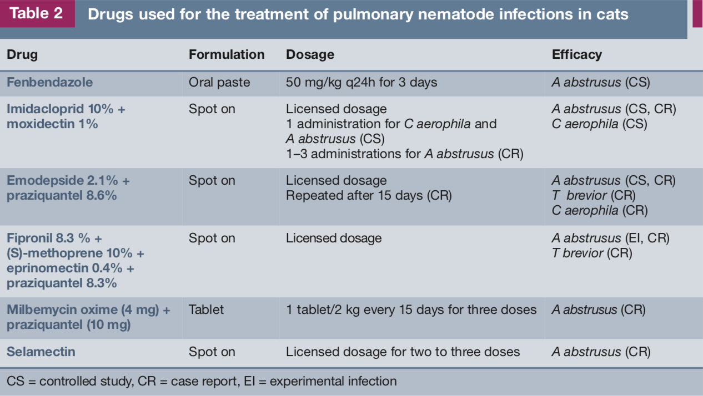

Parasites and Vectors

Dillon AR, Blagburn BL, Tillson M, Brawner W, Welles B, Johnson C, Cattley R, Rynders P, Barney S. Heartworm-associated respiratory disease (HARD) induced by immature adult Dirofilaria immitis in cats. Parasites & vectors. 2017 Nov;10(2):514.

- 3 groups of cats infected with L3 larvae
  - Group A treated with selamectin (Revolution) at 28-day post infection and once monthly x 8 months
  - Group B treated with ivermectin 150 ug/kg at day 70 post infection, then q2 weeks x 5 months
  - Group C was untreated
  - Day 0, 70, 110, 168, 240, blood, serum, BAL and CXR were performed
  - Day 245 euthanasia and necropsy
- Group A did not develop CXR changes and no worms were found on necropsy
- Group B had an abbreviated HW life cycle, with no worms were found on necropsy, but severe pulmonary airway, interstitial and arterial lung lesions were noted
- Cats in Groups B and C could not be differentiated based on radiographic changes, serologic antibody titers, CBC, or BAL cytology at any time point throughout the study
- 80% cats in Group A and 100% of Group B and C became HW antibody + at some time post infection
- All cats in Group C had peripheral eosinophilia
- Cats that become infected w/ HW and are transiently + may not develop adult HWs, but do develop HARD (HW associated respiratory disease)

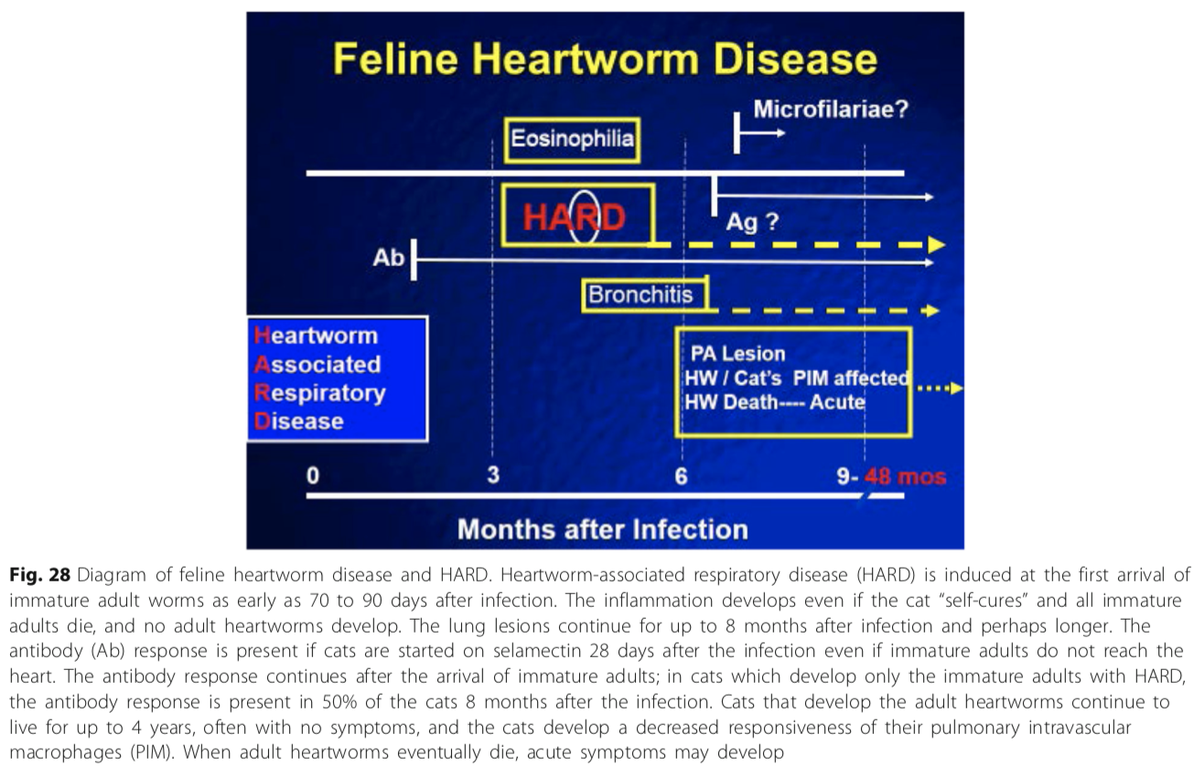

Winter RL, Dillon AR, Cattley RC, Blagburn BL, Tillson DM, Johnson CM, Brawner WR, Welles EG, Barney S. Effect of heartworm disease and heartworm-associated respiratory disease (HARD) on the right ventricle of cats. Parasites & vectors. 2017 Nov;10(2):492.

- Cats infected with immature stages of D. immitis and mature adult D. immitis develop a loss of RV myocardial collagen content but no change in RV mass at 8 and 18 months after infection
- This loss of RV myocardial collagen is correlated with the severity of pulmonary parenchymal and arterial pathology and persists even many months after resolution of an immature D. immitis infection

Dillon AR, Blagburn BL, Tillson M, Brawner W, Welles B, Johnson C, Cattley R, Rynders P, Barney S. The progression of heartworm associated respiratory disease (HARD) in SPF cats 18 months after Dirofilaria immitis infection. Parasites & vectors. 2017 Nov;10(2):533.

- Heartworm-associated respiratory disease (HARD) in cats is induced by the arrival and death of immature adult Dirofilaria immitis in the pulmonary system and is indistinguishable from mature adult heartworm infection
- 3 groups of cats infected with L3 larvae, 18 month study
  - Group A treated with selamectin (Revolution) at 28-day post infection and once monthly x 8 months
  - Group B treated with ivermectin 150 ug/kg at day 70 post infection, then q2 weeks x 5 months
  - Group C was untreated
  - Day 0, 70, 110, 168, 240, 309, 380 and 505, blood, serum, BAL and CXR were performed
- All cats became HW antibody + at some time during the study, except 1 cat from group A
- Only cats in Group C were HW antigen +
- Eosinophilic BAL and peripheral eosinophilia were most pronounced at day 110 in all cats
- Randomly distributed myofibrocytes in the lungs of some Group A cats suggest that precardiac larval stages were affecting the lungs
- Radiographs in Group B cats demonstrated partial resolution of the initial HARD reaction but chronic myofibrocyte proliferation was histologically evident 18 months after infection (restrictive lung disease)
- Abnormal radiographic lung patterns continued in a subset of Group B cats for months after heartworm antibody serology and BAL cytology returned to normal

