Pathophysiology of Sepsis

Key Points
- Sepsis is a life-threatening organ dysfunction caused by a dysregulated host response to infection

- Alterations in the regulation of vasomotor tone, increased vascular permeability, dysfunctional microcirculation, and coagulation abnormalities are hallmarks of sepsis

- Microcirculatory abnormalities are often present in the face of normal macrohemodynamics

- Septic shock is a subset of sepsis in which underlying circulatory and cellular/metabolic abnormalities are profound enough to substantially increase mortality

- Patients with septic shock can be identified by persisting hypotension requiring vasopressors to maintain MAP ≥65 mm Hg and having a serum lactate level >2 mmol/L despite adequate volume resuscitation

Defining Sepsis in Veterinary Medicine
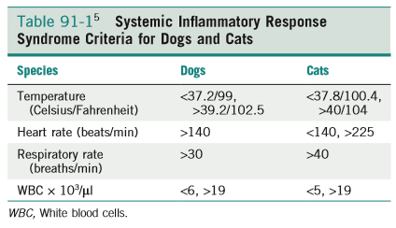
+ Infection
Dogs 2/4 SIRS criteria
Cats 3/4? SIRS criteria

PIRO | Staging System
Predisposition | Genetics, gender, age, nutritional status, breed (ie: Doberman, Rottweilers / Parvo)
Infection | Type and location of infection
Recognize | SIRS criteria, biomarkers,
Organ Failure | ARDS< AKI

Cats:
- common clinical abnormalities include lethargy, signs of diffuse abdominal pain, tachypnea, bradycardia, weak pulses, anemia, hypoalbuminemia, hypothermia, and icterus and 3/4 SIRS criteria should be used (Brady et al, 2000)
  - may not develop tachycardia in response to hypotension because of simultaneous baroreceptor stimulation of vagal and sympathetic fibers
  - Cats with induced endotoxemia ->↓ L ventricular contractility and ↑ L ventricular end-diastolic pressure, ↑ ventricular end-diastolic volume, results in stretch of L ventricular receptors -> reflex bradycardia through vagal stimulation
- > likely to have band neutrophilia and hypoalbuminemia, hypochloremia is a negative prognostic indicator (Declue et al, 2011)

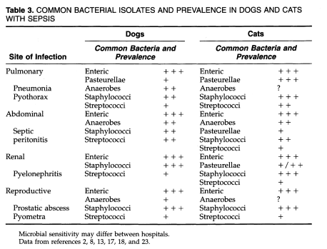

Microbial Factors in Sepsis
- Gram (+) activate inflammation cascade in response to cell wall components (lipoteichoic acid, peptidoglycan, peptidoglycan stem peptides), bacterial DNA or exotoxins and then induce widespread activation of T-cells leading to uncontrolled release of cytokines (TNF-α, IL-1, IL-6, IL-8 and interferon-γ)

- Gram (–) activate inflammation cascade in response to cell wall component lipopolysaccharide (LPS), this binds to LBP (LPS binding protein) and then bind to CD14 on macrophages -> initiates TLR to initiate production of cytokines (TNF-α, IL-1, IL-6, IL-8 and interferon-γ)
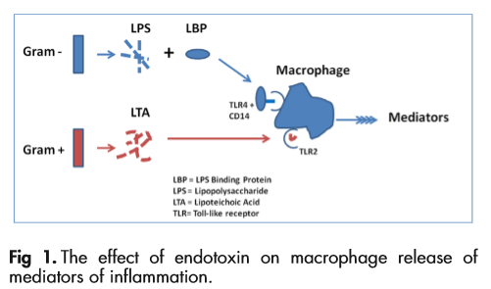
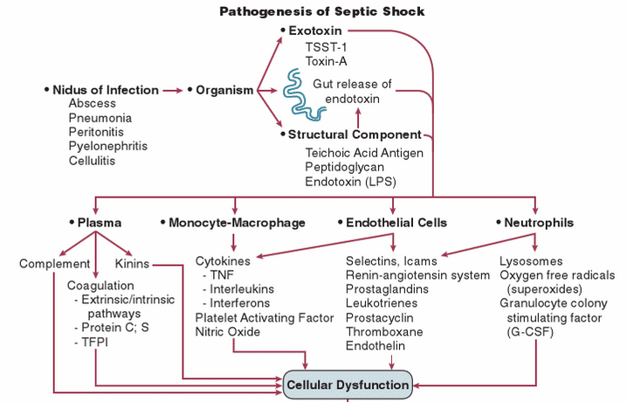
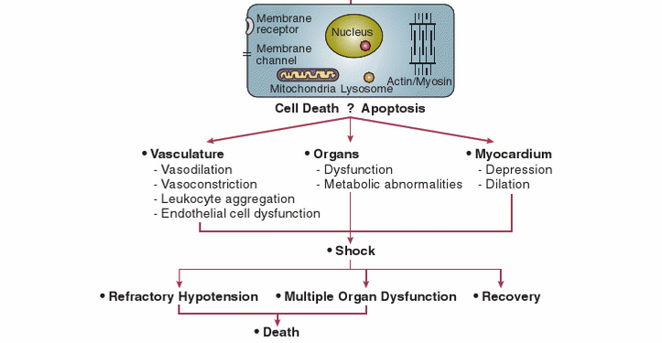

Loss of Homeostatic Mechanisms in Sepsis
- Loss of vasomotor tone
  - Overproduction of nitric oxide (NO), NO is a powerful vascular smooth muscle relaxant that leads to vasodilation in septic shock
  - NO is induced by endotoxins, TNF-α, IL-1 or platelet activating factor (PAF)
  - Osterbur et al, prospective, observational study in dogs, NO breakdown products (nitrite/nitrite) were significantly greater in septic/SIRS dogs compared to healthy controls

- Dysregulation of inflammation and coagulation
  - Bacterial infection and host inflammatory cytokines upregulate tissue factor (TF)
  - TF + VIIa -> initiate coagulation cascade -> activate platelets
  - Natural anticoagulant and fibrinolytic processes are inhibited in sepsis due to downregulation of antithrombin, TF pathway inhibitor, TPA and increased plasminogen activator inhibitor (PAI-1)
  - Protein C pathway is also inhibited -> reduction of protein C anticoagulant and anti-inflammatory effects
  - In sepsis, patients are procoagulant and antifibrinolytic initially then hypocoagulable due to decreased host synthesis, effectiveness of natural coagulation inhibitors

- Endothelial, microcirculatory and mitochondrial abnormalities
  - Alteration in endothelium, increased vascular permeability and microvascular derangements occur due to:
    - Endothelial dysfunction
    - Alterations and damage to glycocalyx
    - Rheologic changes to rbc
    - Leukocyte activation
    - Microthrombosis
    - Loss of vascular smooth muscle autoregulation
  - Alterations in tissue extraction and tissue hypoxia occur due to:
    - Decreased functional capillary density
    - Increased diffusional distance for O2
    - Microvascular thrombosis
    - Cytopathic hypoxia from mitochondrial dysfunction

Mechanisms of Immune Suppression in Sepsis
- Shift to anti-inflammatory cytokines
  - Activated CD4 T cells secrete cytokines
    - Inflammatory: Type 1 helper T cell properties (ie: TNFα, interferon-γ, IL-2)
    - Anti-inflammatory: Type 2 helper T cell properties (ie: IL-4, IL-10)
  - Unknown what causes CD4 T cells to have Th1 or Th2, may be influenced by type of pathogen, amount of pathogen and site of infection

- Anergy
  - State of unresponsiveness to antigen, T cells fail to proliferate r secrete cytokines in response to antigens-> correlated with mortality
- Death of immune cells
  - Apoptosis induced loss of CD4 T cells (macrophage activation), B cells (decreased antibody production), and dendritic cells (antigen presentation)

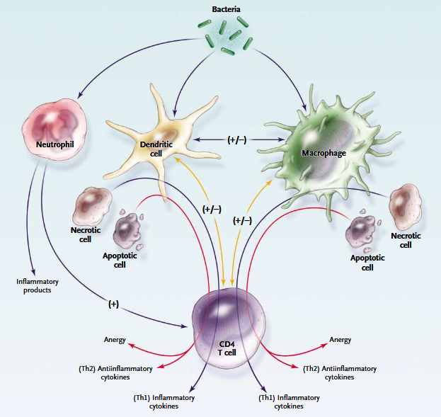
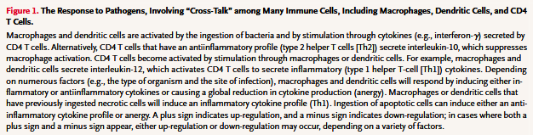

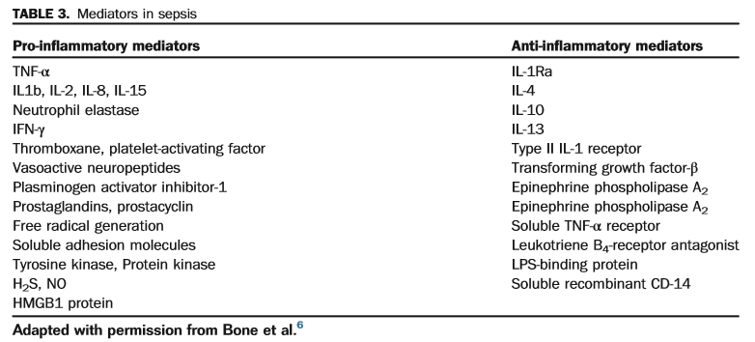

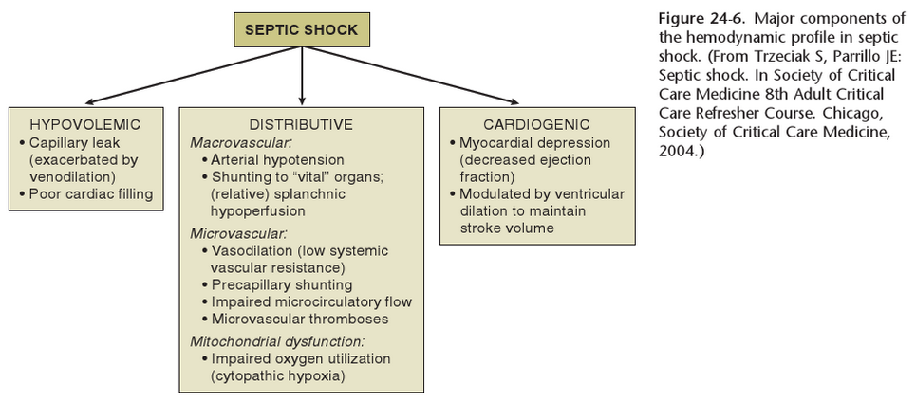

Bibliography:
Parrillo, Joseph E., and R. Phillip Dellinger. Critical Care Medicine E-Book: Principles of Diagnosis and Management in the Adult. Elsevier Health Sciences, 2013.
Silverstein, Deborah, and Kate Hopper. Small Animal Critical Care Medicine-E-Book. Elsevier Health Sciences, 2014.
Hotchkiss, Richard S., and Irene E. Karl. "The pathophysiology and treatment of sepsis." New England Journal of Medicine 348.2 (2003): 138-150
Sagy, Mayer, Yasir Al-Qaqaa, and Paul Kim. "Definitions and pathophysiology of sepsis." Current problems in pediatric and adolescent health care 43.10 (2013): 260-263.
Singer, Mervyn, et al. "The third international consensus definitions for sepsis and septic shock (sepsis-3)." Jama 315.8 (2016): 801-810.
DeClue, Amy E., et al. "Clinical and immunologic assessment of sepsis and the systemic inflammatory response syndrome in cats." Journal of the American Veterinary Medical Association 238.7 (2011): 890-897.
Brady, Colleen A., et al. "Severe sepsis in cats: 29 cases (1986–1998)." Journal of the American Veterinary Medical Association 217.4 (2000): 531-535.
Brady, Colleen A., and Cynthia M. Otto. "Systemic inflammatory response syndrome, sepsis, and multiple organ dysfunction." Veterinary clinics of north america: Small animal practice 31.6 (2001): 1147-1162.

