Canine Parvovirus (CPV) and Feline Panleukopenia Virus

Canine Parvovirus

- Variants
  - CPV-2, CPV-2a, CPV-2b, CPV-2c
    - CPV-2a: developed ability to replicate in feline cells
- Virus
  - Small, non enveloped single strand DNA virus
  - Can survive for over 1 year in environment
  - Spread fecal-oral
    - Vomit, diarrhea, fomites
  - Needs mitotically active cells to replicate
    - Replicates in nucleus of dividing cells in late S phase or early G2 phase of the cell cycle
  - Dogs 6 weeks to 6 months more likely to become ill
  - High particle to infection rate for most parvoviruses (most particles that enter the cell do not replicate)
- At the cellular level (proposed mechanism):
  - Uses transferrin receptor to enter host cells
  - Rapidly transported by clathrin mediated endocytosis into an early sorting endosome
  - Virus is separated from fluid phase ligands and within 10 minutes transported to perinuclear recycling vesicles
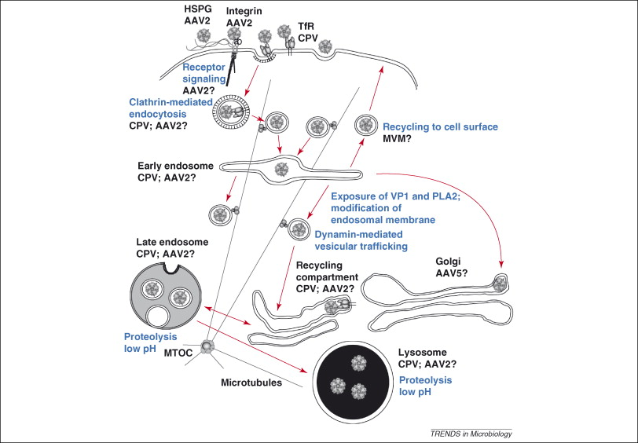
  - Virus penetrates to cytoplasm and delivers DNA to nucleus (unclear how but involves a nuclear localization signal) [Parker and Parrish. Cellular Uptake and Infection by Canine Parvovirus Involves Rapid Dynamin-Regulated Clathrin-Mediated Endocytosis, Followed by Slower Intracellular Trafficking. J. Virol. 2000.] [Liu et al. Virology Journal. The role of nuclear localization signal in parvovirus life cycle. 2017. ]
  - Diagrams from Harbison, Chiorini and Parrish. The Parvovirus capsid odyssey: from the cell surface to the nucleus. Trends in Microbiology. 2008.

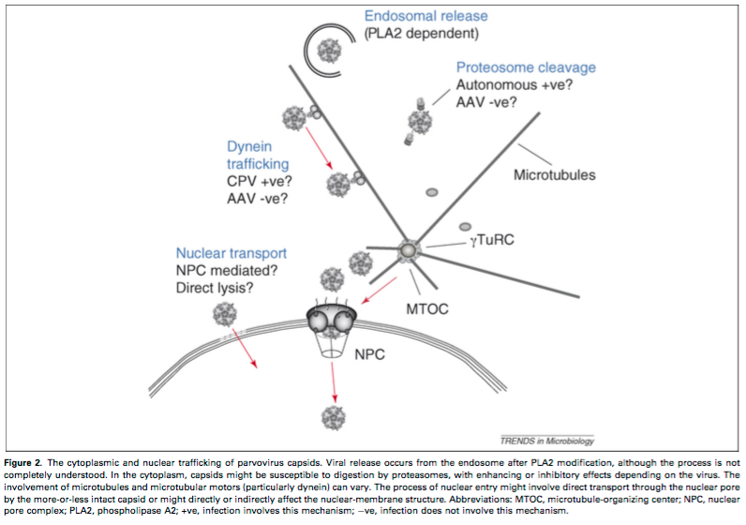

- Shedding
  - Shed a few days before presence of clinical signs
  - Decreases after 7 days
  - Incubation is 7-14 days, although even 4 days have been seen in experimental infections
  - Replicates in oropharyngeal tissues and then viremia occurs
  - GI tract, thymus, LN, bone marrow
    - Tongue, oral cavity, esophagus, intestinal tract and intestinal crypt germinal epithelial cells > Malabsorption and increased intestinal permeability
    - Secondary bacterial infections > bacterial translocation > bacteremia > endotoxemia > can lead to MODS and death
- PE
  - Fever up to 105 (rarely hypothermia)
  - Lethargy/Weakness/Dehydration
  - Abdominal tenderness/Fluid filled intestinal tract on palpation
  - Vomiting
    - Scoring system De La Puente-Redondo 2007
      - Mild: non productive retching
      - Moderate: vomiting without bile
      - Severe: vomit containing bile
  - Diarrhea, fecal staining (diarrhea or frank blood)
  - Occasionally tubular mass (intussusception)
  - Ulcerative glossitis
  - Mucosal pallor
  - Prolonged CRT
  - Neurologic signs (tremors/seizures)
    - Hypoxia secondary to myocarditis, hypoglycemia, intracranial thrombosis or hemorrhage
    - Co-infection with CDV
  - Tachypnea/CHF in puppies with myocarditis
    - Puppies infected in utero or up to 2 weeks
  - Erythema multiforme > generalzed cutaneous and mucosal ulceration > swelling of the pinnae and paws
  - Infertility, resorption, abortion in pregnant dam
- Kocaturk/Panda (PVE) /Walker (Calves with diarrhea) severity score
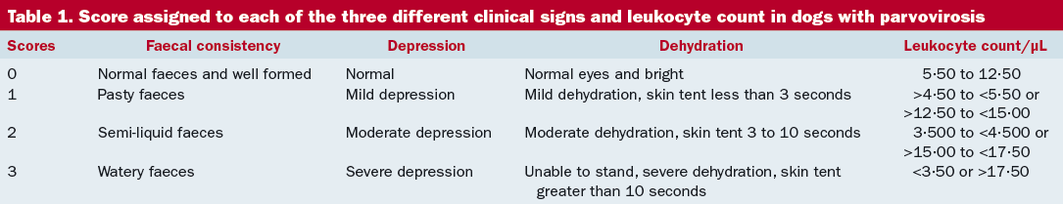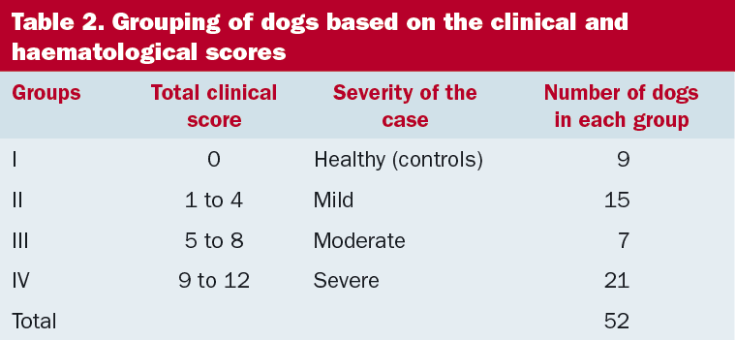
- Clinical pathology
  - CBC: leukopenia, neutropenia, lymphopenia, toxic neutrophils, monocytopenia, anemia from GI blood loss, thrombocytosis/thrombocytopenia
    - Infection of bone marrow, Sequestration in GI
  - CHEM: hypoproteinemia, hypoalbuminemia, hypoglycemia, prerenal azotemia from severe dehydration
  - Electrolytes: decreased Na, Cl, K
    - Cl was determined to be the most important contributor to acid base changes (SIM). Severely affected animals tended to have hypochloremic alkalosis whereas mildly affected patients had hyperchloremic acidosis. Chloride (not corrected) was significantly lower in CPV affected patients. [Burchell et al. The central role of chloride in the metabolic acid-base changes in canine parvoviral enteritis. The Veterinary Journal. 2014.]
- Fecal tests for co-infections
  - In a study of 113 puppies from the Netherlands < 12 months of age with acute diarrhea, significant positive association was found between CPV and Canine coronavirus, and CPV and Cytoisospora spp. [Duijvestijn et al. Enteropathogen infections in canine puppies: (Co-) occurrence, clinical relevance and risk factors. Veterinary Microbiology 2016]
- Microbiological Tests
  - Fecal Parvo Antigen ELISA
    - Rectal swab
    - Sensitivity: shedding transient, antibody (such as maternal) can bind antigen such that it is unavailable for assay
    - Sensitivities between 40 and 60% when compares to immunoelectron microscopy between 16-26% when compared to fecal PCR assay and in another paper between 77 and 80% when samples with high antigen loads were compared to rtPCR
    - Specificities were between 92 and 98% (false positives uncommon)
      - False positive antigen tests can occur 4-8 days after vaccination with attenuated live CPV-2 vaccines
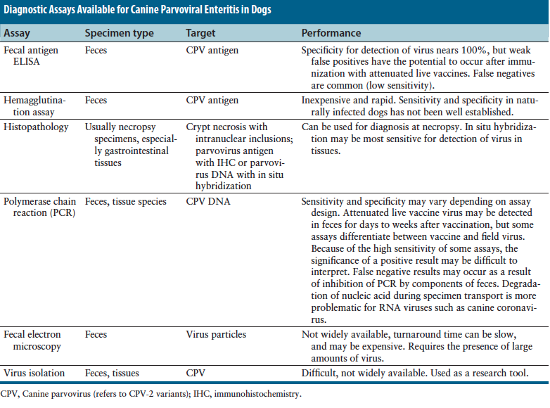
    - In a recent study (Mexico) only 30/45 patients who tested positive for CPV-2 via nPCR were positive via immunochromatography test. 5 negatives correctly diagnosed. (sensitivity 66.6% and specificity 100%). Using PCR 36/45 tested positive, and 5 negative tested negative. (sensitivity 80% specificity 100%). [Faz et al. Reliability of clinical diagnosis and laboratory testing techniques currently used for identification of canine parvovirus enteritis in clinical settings. The Journal of Veterinary Medical Science. 2017.)

- Biomarkers
  - Dogs with parvoviral enteritis had significant increase in C-reactive protein compared with healthy dogs and a higher magnitude of increase in animals with more severe clinical signs. Possibly related to magnitude of secondary bacterial infection as bacterial infection is a cause for increase in CRP while viral infection generally is not (or not to same extent).
  - Haptoglobin (Hp) increase in dogs with parvo but not related to severity. Possible that GI hemorrhage in severe cases is related to this as hemorrhage and hemolysis lower Hp concentrations. So, a high CRP that is not accompanied by high Hp could raise index of suspicion for hemorrhage or hemolysis in these cases. [Kocaturk et al. Inflammatory and oxidative biomarkers of disease severity in dogs with parvoviral enteritis. Journal of Small Animal Practice. 2017.]
- Treatment
  - Supportive care
    - Monitor BG, K
    - Antiemetics
      - Metoclopramide (0.5 mg/lg IV q8hrs), Ondansetron (0.5 mg/kg IV q8hrs) and Maropitant (1 mg/kg SQ q24hrs) equally effective in reducing parvovirus enteritis emesis in dogs. [Yalcin E, Kesser GO. Comparative efficacy of metoclopramide, ondansetron and maropitant in preventing parvoviral enteritis-induced emesis in dogs. J vet Parmacol Therap. 2017;00:1-5. doi:10.1111/jvp.12396.]
    - H2 blockers /GI protectants
    - Whole blood/pRBCs if anemic
    - Plasma or Colloids (Hetastarch) for puppies with low oncotic pressure
      - Plasma may contain antibodies from immune dogs, but titers may not be beneficial
      - Hetastarch anticoagulant properties…AKI in people
    - Early enteral nutrition
    - NAC?
      - NAC treatment progressively improved leukocyte, neutrophil, monocyte and eosinophil counts over time in parvovirus infected dogs compared to dogs that received only supportive treatment. [Gaykwad et al Amelioration of oxidative stress using N-acetylcysteine in canine parvoviral enteritis. J. Vet. Pharmacol. Therap. 2017.]
      - A recent paper found that canine parvovirus NS1 induced apoptosis through opening of mitochondrial permeability transition pores (intrinsic pathway). Expression of NS1 causes accumulation of ROS and addition of an antioxidant to medium reduced extent of apoptosis. [Gupta et al. Canine parvovirus NS1 induced apoptosis involves mitochondria, accumulation of reactive oxygen species and activation of caspases. Virus Research. 2016.]
    - Others
      - Recombinant bactericidal permeability increasing (BPI) protein, recombinant feline interferon omega (rfIFN-omega), recombinant G-CSF not helpful
      - Recombinant feline interferon omega associated with reduced disease severity and reduced mortality in dogs
      - Oseltamivir: secondary infections? May prevent drop in leukocyte count, concern over development of resistant influenza viruses
      - CPV infected dogs undergoing treatment and supplemented with a single 5 mg Transfer Factor (caprine) dose had a reduction in group mortality (68% of TF treated group versus 32% of placebo), coinciding with an increase in IFN gamma. [Willeford et al. Serum derived transfer factor stimulates the innate immune system to improve survival traits in high risk pathogen scenarios. Drug Development Research. 2017.]
  - Outpatient
    - Covered recently in Journal Club. Stabilization followed by maropitant, cefovecin, SQ fluids. 90% success for inpatient versus 80% for outpatient. No different in duration of hospitalization (all IP and OP hospitalized for study). Metabolic disturbances frequent for OP and supplementation with dextrose and potassium indicated. [Venn et al. Evaluation of an outpatient protocol in the treatment of canine parvoviral enteritis. JVECC 2017.]
  - Prognostic indicators
    - Related to mortality: initial leukopenia, lymphopenia , monocytopenia, neutropenia, SIRS , Rotties, young puppies less than 7-12 weeks of age
    - Prolonged hospitalization: vomiting and lethargy at admission, lymphopenia, hypoalbuminemia (+ 2 days)
    - Survival: positive changes in leukocyte counts as early as 24 hours after admission
  - Complications
    - Bacteremia, septic shock, intestinal intussusception, aspiration pneumonia, esophageal stricture

Feline Parvovirus

- Pathogenesis
  - Incubation 2-10 days
  - Co-infections with feline enteric coronavirus, Clostridium piliforme, Salmonella , FeLV, astroviruses
  - Peracute: death without premonitory signs
  - Clinical signs similar to parvo, vocalizing, some may only have lethargy and anorexia
  - Infection in late pregnancy or up to 1 week of age > destruction of Purkinje cells and precursor cells in the cerebellar external granular layer leading to cerebellar hypoplasia.
    - Severity can vary between kittens in a litter
    - Cerebellar ataxia non-progressive, most apparent at 2-3 weeks of age when learning to walk
    - Other areas of brain can be affected
    - Ocular lesions (retinal folding, dysplasia and degenerations, optic nerve hypoplasia)
    - FPV DNA in myocardium of cats with hypertrophic dilated and restrictive cardiomyopathy
    - Fecal shedding up to 6 weeks
  - PE
    - Similar to dogs with parvo
    - Weakness, lethargy, dehydration
    - Fever 103-107
    - Kitten with cerebellar hypoplasia: intention tremors, incoordination, ataxia, hypermetria, broad based stance, decreased postural reactions, truncal sway, absence of menace
  - CBC
    - Leukopenia (neutropenia and lymphopenia)
    - Thrombocytopenia (marrow damage and/or DIC)
    - Mild anemia
  - MRI
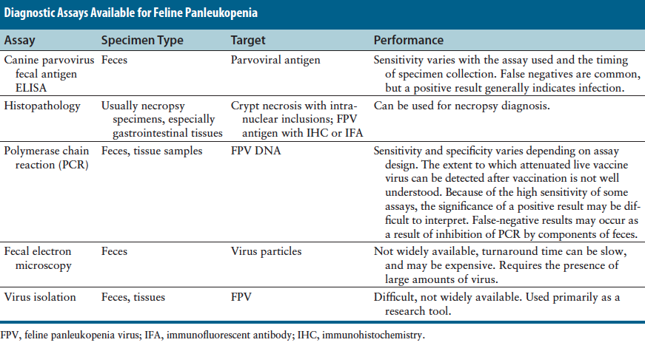
    - Evidence of cerebellar agenesis or hypoplasia
- Treatment
  - Withhold food and water until vomiting stopped (early enteral nutrition not reported in cats)
  - Treatment with recombinant feline interferon omega not beneficial for cats
- Prognosis
  - Recovery more prolonged than in dogs with PVE
  - If survive first 5 days then generally recover
  - Recovery from one study 51%
  - Non-survivors lower leukocyte and platelet counts
    - WBC < 1000/uL twice as likely to die than WBC > 2500/uL
  - Total leukopenia but not lymphopenia was correlated with mortality
  - Hypoalbuminemia and hypokalemia increased risk of mortality

