Neurolocalization

Neuroanatomic diagnosis

- Brain
- Rostrotentorial
  - Cerebrum and diencephalon (thalamus, hypothalamus, etc.)
- Caudotentorial
  - Brainstem and cerebellum

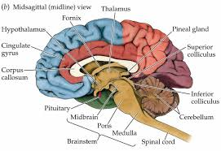

- Spinal cord
- C1-C5
- C6-T2
- T3-L3
- L4-S1(3)

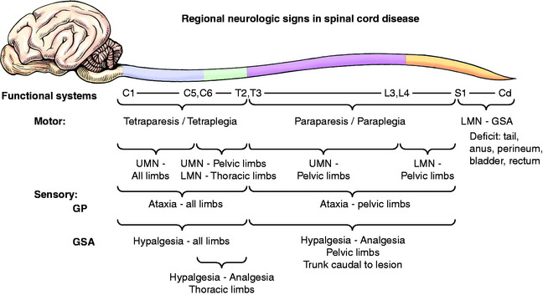
- Neuromuscular
- Neuropathy
- Junctionopathy
- Myopathy
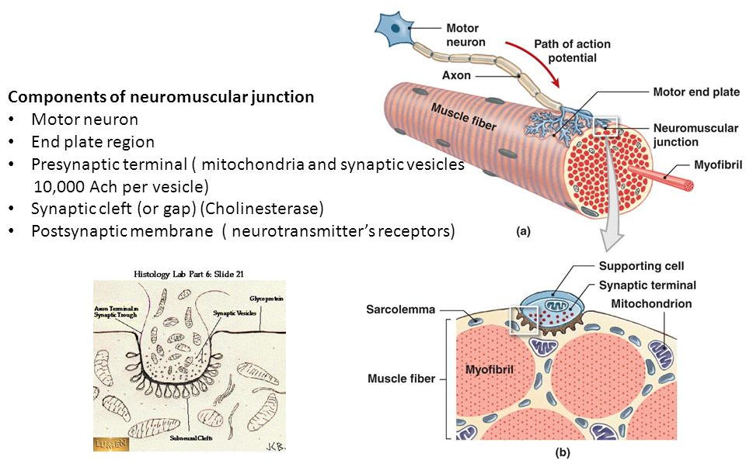

Neurologic syndromes
The nervous system can be divided into several functional regions where disease leads to a “typical” group of clinical signs referred to as neurologic syndromes.

- Forebrain (cerebrum, thalamus)
Intracranial
- Brainstem
- Cerebellum
- Vestibular – peripheral or central
- C1-C5 spinal cord
- C6-T2 spinal cord
- T3-L3 spinal cord
- L4-S3 spinal cord
- Neuromuscular

Forebrain (Prosencephalon)
- Includes all structures rostral to the midbrain
  - Cerebral hemispheres, thalamus, hypothalmus, epithalamus, and subthalamus

Common clinical signs of forebrain dysfunction
- Seizures
- Behavior change and/or loss of trained habits (e.g., urinating/defecating in house)
- Circling and head turn toward side of lesion
- Contralateral postural reaction deficits and vision deficits
- Compulsive pacing or wandering aimlessly
- Head pressing, staring off into space, or getting stuck behind furniture or in tight spaces
- Mental status changes (dull, stupor, coma) – most often with diffuse forebrain disease due to limbic system dysfunction
- Endocrine signs are possible if hypothalmus or pituitary gland dysfunction

Brainstem
- Consists of the midbrain, pons, and medulla oblongata
- Important structures in the brainstem include the nuclei giving rise to:
  - Most of the cranial nerves (III-XII)
  - Ascending Reticular Activating System (ARAS) controlling level of consciousness
  - Chemoreceptor trigger zone
  - Heart rate and respiratory centers
  - 1ary gait generators for dogs and cats (likely midbrain), involving the extrapyramidal tracts
- Lesions cranial to midbrain - contralateral postural reaction deficits and/or weakness
- Lesions caudal to midbrain (pons, medulla, cerebellum, spinal cord) - ipsilateral deficits
  - proprioceptive and corticospinal motor tracts cross in the midbrain

Common clinical signs of brainstem disease
- Altered mental status (dull, stupor, coma, disoriented)
- Weakness and ataxia (tetraparesis, ipsilateral hemiparesis)
- Cranial nerve deficits (III-XII possible)
- Postural reaction deficits (ipsilateral unless lesion is cranial midbrain - contralateral)
- Central vestibular dysfunction
- Irregular respiration

Case: 5yo NM DSH, weird behavior at home, will react sometimes when owner pets him

http://www.neurovideos.vet.cornell.edu/Video.aspx?vid=18-13#

6mo SF Miniature Schnauzer

http://www.neurovideos.vet.cornell.edu/Video.aspx?vid=13-02#

Cranial Nerves:

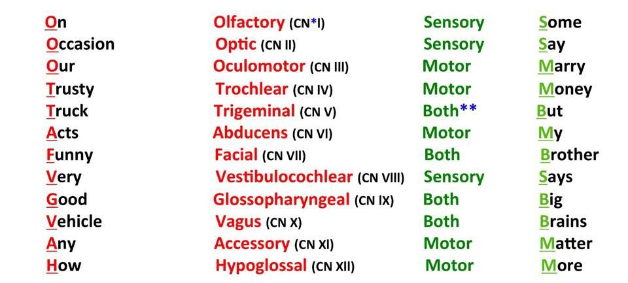
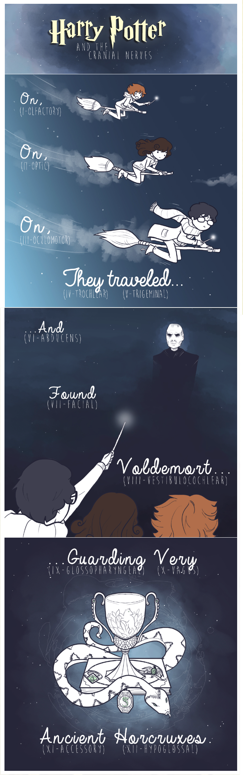
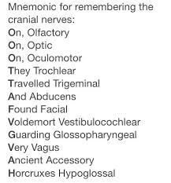

Cranial Nerve Evaluation
I | Smell
II | Menace
III | Pupillary size  PLR direct and consensual
III, IV, VI | Strabismus  Physiological nystagmus  Corneal reflex  Pupil size
V | Palpebral reflex  Corneal reflex  Jaw tone  Lip pinch  Masticatory muscle atrophy
VI | Strabismus  Physiological nystagmus  Corneal reflex
VII | Facial symmetry  Palpebral reflex
VIII | Auditory  Head tilt  Nystagmus
IX, X, XII | Tongue movement  Tongue atrophy
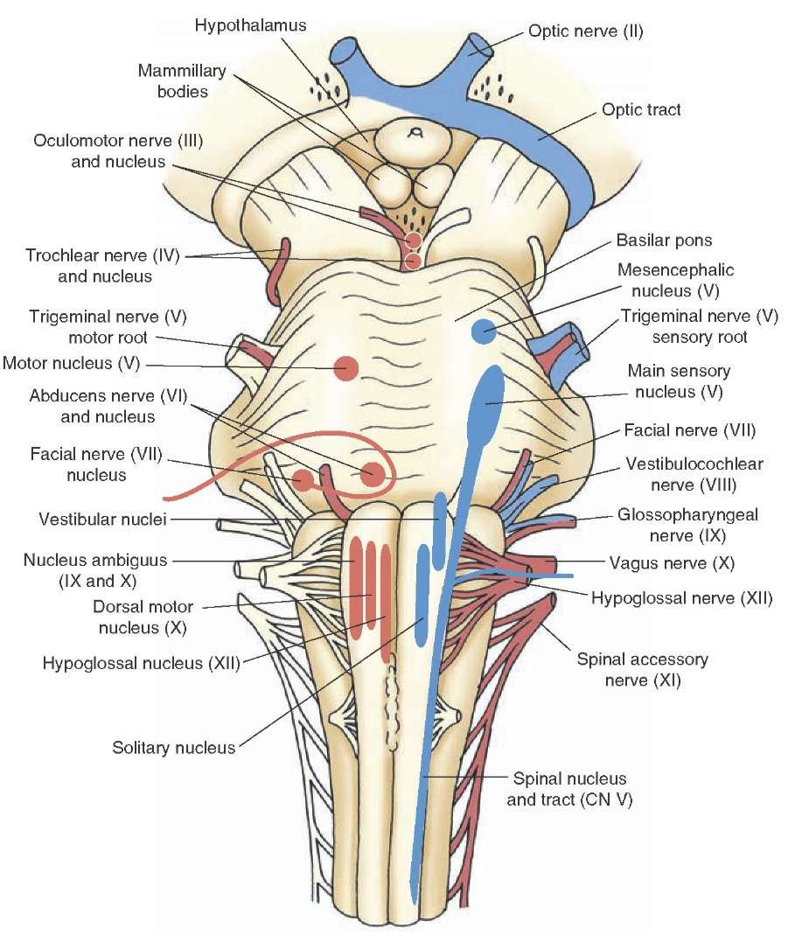

Menace Response:
- visual stimulus – CN II (optic) – contralateral thalamus – contralateral visual cortex of occipital lobe – contralateral motor cortex – contralateral pontine nucleus – ipsilateral cerebellum – facial nucleus – CN VIII (facial) – Blink

http://vmerc.uga.edu/CranialNerves/mrp.html

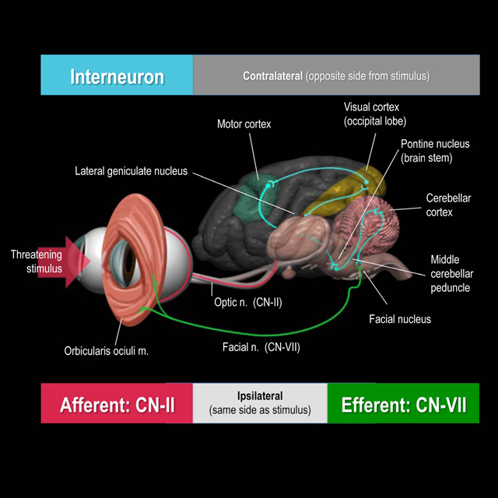

Pupillary Light Reflex:
- Direct: visual stimulus – CN II – contralateral optic tract – contralateral pretectal region – ipsilateral accessory oculomotor nucleus – ipsilateral CN III (oculomotor) – direct miosis
- Consensual: visual stimulus – CN II – ipsilateral optic tract – contralateral accessory oculomotor nucleus – contralateral CN III - consensual miosis
- Pupillary constriction is 50% less than stimulated eye

http://vmerc.uga.edu/CranialNerves/plrp.html

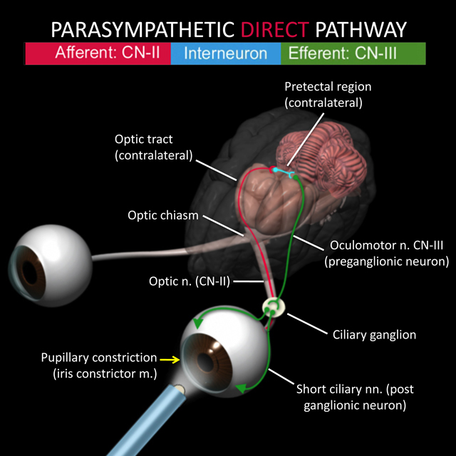

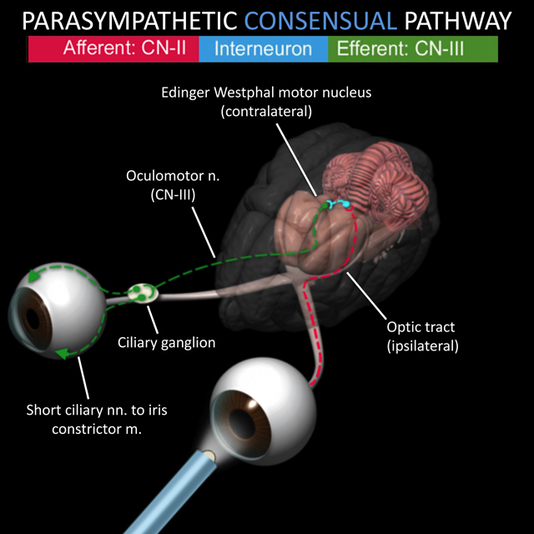

Visual Pathway Lesions:

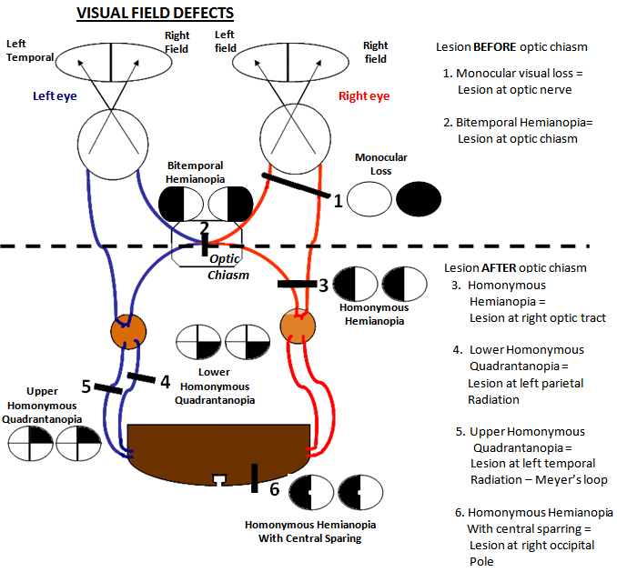
Horner’s syndrome:
- Sympathetic denervation to the eye, any lesion of sympathetic pathway can lead to ipsilateral horner’s
- Upper motor neuron: hypothalamus – brainstem – cervical spinal cord to T1-T3
- Preganglionic or Second order neuron: T1-T3 – ventral roots through cranial thorax (part of vagosympathetic trunk) - cranial cervical ganglion (ventromedial to tympanic bulla)
- Postganglionic or Third order neuron: Cranial cervical ganglion – near (dogs) or through (cats) tympanic bulla – into calvaria – eye

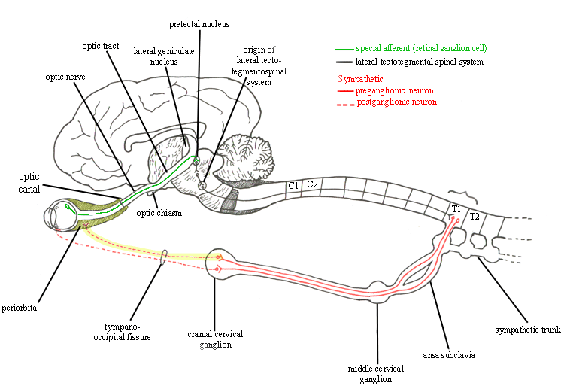
central vestibular

Vestibular
- Responsible for maintaining normal body position and coordination
- Divided into two portions
  - Peripheral vestibular system (inner ears, vestibulocochlear nerve)
  - Central vestibular system (brainstem)
  - Vestibular structures in the cerebellum (fastigial nucleus, flocculus, nodulus) and caudal cerebellar peduncle - causes paradoxical central vestibular signs
- Head tilt, cricling, falling, rolling toward lesion
- Nystagmus fast phase away from the lesion
- May have horner’s syndrome with middle and inner ear lesions

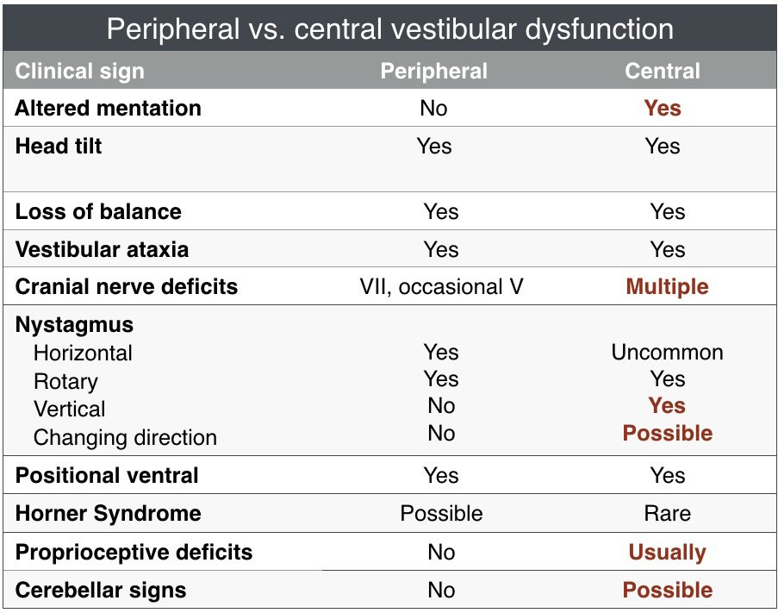

Paradoxical central vestibular dysfunction
- Cerebellum or caudal cerebellar peduncle lesion
- Head signs suggest lesion on one side of the body while the postural reaction deficits indicate the other side
  - Always trust postural reaction deficits, they are always ipsilateral to the lesion in patients with vestibular dysfunction

Bilateral peripheral vestibular dysfunction
- Otitis interna is the most common cause, also hypothyroidism
- Vestibular ataxia (often to both directions) and horizontal or rotary nystagmus
- No head tilt, or they have a head tilt that intermittently changes sides
- Walk low to the ground or crouched and will have wide side-to-side lateral head excursions

Vestibular dysfunction due to thalamic disease
- Central vestibular signs can occur 2ary to a thalamic lesion
- Not very common

Case:

A 10-year-old MC Greyhound is presented to you with an acute onset of non-progressive clinical signs of right head tilt, vestibular ataxia, resting & positional left rotary nystagmus, and left-sided postural reaction deficits.

In this patient, the head tilt and nystagmus suggest a right-sided lesion while the postural reaction deficits suggest a left-sided lesion. The neuroanatomic diagnosis for this patient would be:left paradoxical

Cerebellum
- Responsible for rate and range of motion, fine motor control, and equilibrium

Common clinical signs of cerebellar dysfunction
- Dysmetria – most often hypermetria (“goose stepping”)
- Truncal ataxia
- Intention tremors
- Vestibular signs
- Ipsilateral postural reaction deficits
- Occasional ipsilateral absent menace response (with normal vision, palpebral and no forebrain signs)
- +/- Anisocoria (pupil dilated contralateral to lesion)
- +/- Opisthotonus

Case: 3 yo SF GSD, developed an abnormal gait over the past few days, after a bout of diarrhea treated with unknown medications. This is the dog’s gait

http://www.neurovideos.vet.cornell.edu/Video99.aspx?vid=99-02

C1-C5 spinal cord
- Causes signs of UMN dysfunction in all 4 limbs

Common clinical signs of C1-5 myelopathy
- Weakness, paralysis and/or ataxia in all 4 limbs, ipsilateral limbs or only one thoracic limb
- UMN signs in all 4 limbs
- Normal to exaggerated spinal nerve reflexes
- Normal withdrawal reflex all 4 limbs
- Normal to increased muscle tone in affected limbs
- Late disuse muscle atrophy
- Cervical vertebral discomfort, muscles spasms, rigidity
- +/- UMN bladder
- +/- Respiratory difficulty (UMN dysfunction to phrenic and intercostal nerves)
- +/- Horner Syndrome (1st order sympathetic neurons)

Case: 3yo NM Great Dane, acutely down on all 4
http://www.neurovideos.vet.cornell.edu/Video.aspx?vid=10-30#

C6-T2 spinal cord
- Causes signs of LMN dysfunction in the thoracic limbs and UMN in the pelvic limbs
- May have normal thoracic limbs and abnormal pelvic limbs, especially with compressive spinal cord lesions
  - Pelvic limb spinal tracts are more peripheral than the centrally located LMN cell bodies in the ventral horn of the grey matter
  - Mild to moderate external compression of the spinal cord will compress the pelvic limb tracts first causing UMN signs to the pelvic limbs, while still having normal thoracic limbs
  - As compression worsens, the thoracic limb LMNs are affected leading to LMN signs in the thoracic limbs as well.
  - Cervical discomfort/rigidity can help distinguish C6-T2 signs from a T3-L3 lesion

Common clinical signs of C6-T2 myelopathy
- Weakness, paralysis or ataxia in all 4 limbs ipsilateral limbs or only one thoracic limb
- Decreased withdrawal reflexes in thoracic limbs
- Normal to exaggerated withdrawal reflexes in pelvic limbs
- Postural reaction deficits in thoracic and pelvic limbs
- Early denervation atrophy of thoracic limb(s), late onset disuse muscle atrophy in pelvic limbs
- +/- Cervical pain, muscle spasms, rigidity
- +/- Root signature
- +/- Decreased or absent cutaneous trunci
- +/- UMN bladder
- +/- Respiratory difficulty (LMN dysfunction to phrenic and UMN to intercostal nerves)
- +/- Horner Syndrome (1st order sympathetic neurons)

T3-L3 spinal cord
- Causes signs of UMN dysfunction in the pelvic limbs and normal thoracic limbs

Common clinical signs of T3-L3 myelopathy
- Spastic weakness, paralysis and ataxia in pelvic limbs
- Normal to exaggerated spinal nerve reflexes in pelvic limbs
- Normal withdrawal reflexes in the pelvic limbs
- Postural reaction deficits in pelvic limbs
- Late onset disuse muscle atrophy
- +/- Decreased or absent cutaneous trunci reflex (usually 1-2 vertebrae cranial to cutoff)
- +/- Paravertebral pain at site of lesion
- +/- UMN bladder
- +/- Schiff-Sherrington posture
  - Will have normal postural reactions in the thoracic limbs, while a patient with a C1-C5 lesion will have delayed or absent postural reactions

L4-S3 spinal cord
- Causes signs of LMN dysfunction in the pelvic limbs and normal thoracic limbs.

Common clinical signs of a L4-S3 myelopathy
- Flaccid weakness/paralysis and ataxia in pelvic limbs
- Decreased to absent spinal nerve & withdrawal reflexes in pelvic limbs
- Postural reaction deficits in pelvic limbs
- Decreased to absent muscle tone in affected limb(s) or tail
- Early denervation muscle atrophy
- +/- Decreased or absent cutaneous trunci reflex
- +/- Paravertebral pain at site of lesion
- +/- Root signature
- +/- LMN bladder
- +/- Decreased/absent anal tone or dilated anus
- +/- Urinary or fecal incontinence

Case: 8yo NM Labrador Retriever, presenting for exercise intolerance
http://www.neurovideos.vet.cornell.edu/Video99_3.aspx?vid=99-03#

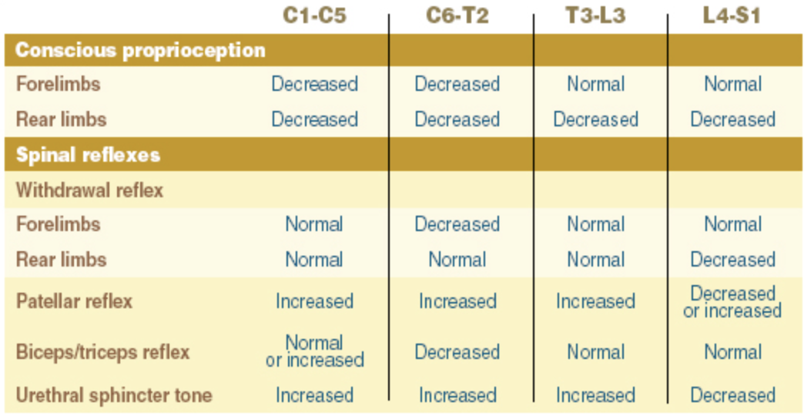

Neuromuscular
- Consists of the peripheral nerves, neuromuscular junction, and muscles

Common clinical signs of neuromuscular dysfunction

Motor neuropathy
- Flaccid paresis / paralysis
- Reduced/absent spinal nerve reflexes
- Postural reaction deficits
- Decreased muscle tone
- Denervation muscle atrophy

Sensory neuropathy
- Decreased/absent spinal nerve & withdrawal reflexes, usually without muscle atrophy
- Postural reaction deficits
- Decreased pain response
- Self-mutilation
- Abnormal sensation/sensitivity (paraesthesia) of face, trunk or limbs
- Autonomic neuropathy (alone or in combo with above)
- Anisocoria or dilated pupils
- Decreased tear production
- Decreased salivation
- Bradycardia

Myopathy
- Generalized weakness
- Exercise intolerance
- Stiff, stilted gait
- Localized or generalized muscle atrophy
- Generalized muscle hypertrophy
- Dimple contracture
- Painful response to muscle palpation

Case: 3yo IM Coonhound, acutely down
http://www.neurovideos.vet.cornell.edu/Video.aspx?vid=05-01#

Case: 4mo F English Springer Spaniel
http://www.neurovideos.vet.cornell.edu/Video.aspx?vid=05-06#

Case: 8yo NM Abyssinian
http://www.neurovideos.vet.cornell.edu/Video.aspx?vid=05-05#

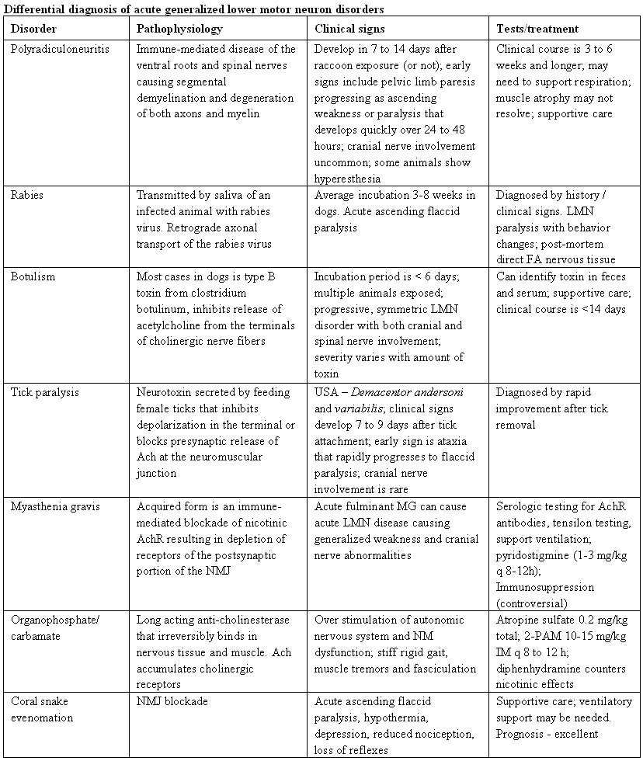

Resources:
http://vmerc.uga.edu/CranialNerves/index.html

