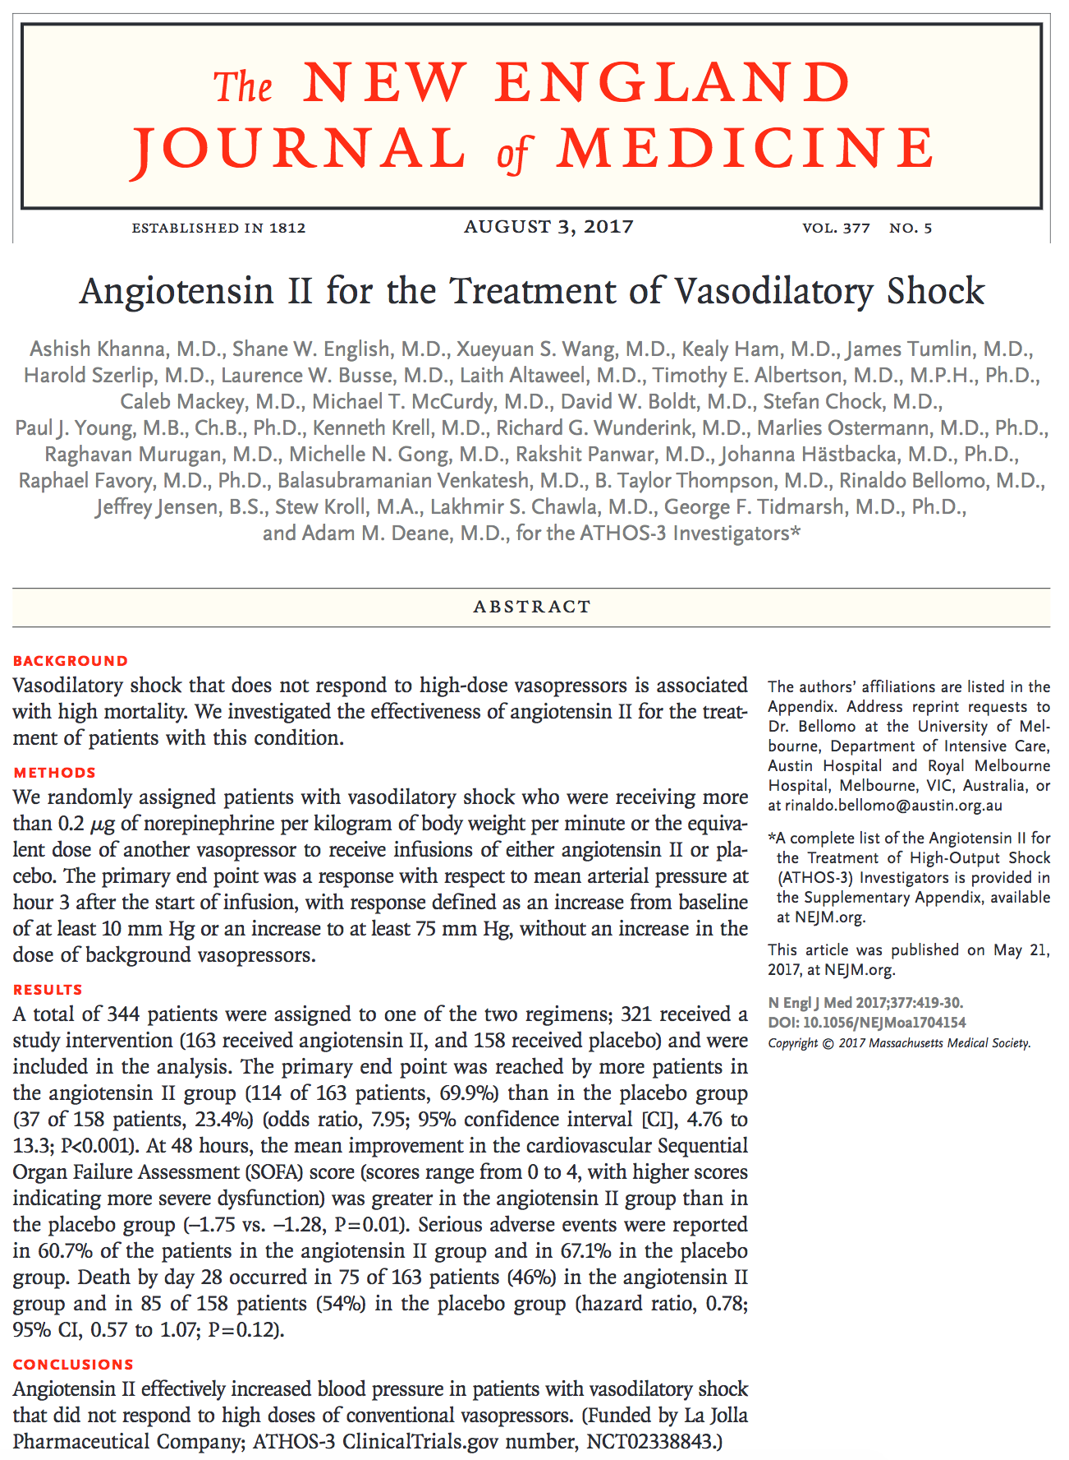
ATHOS-3 (Angiotensin II for the Treatment of High-Output Shock) Trial

- Patients with severe vasodilation, with hypotension despite the use of high doses of vasopressors have a poor prognosis, with a 30-day all-cause mortality exceeding 50%

- Randomized, double-blinded, placebo-controlled trial

- Eligible patients: 321 patients
  - >18yo
  - Vasodilatory shock despite IV resuscitation of at least 25 ml/kg over 24hours, and the administration of high dose vasopressors (norepi > 0.2 ug/kg/min)
  - Indwelling u-cath and art line

- Exclusion criteria:
  - > 20% burns, Acute coronary syndrome, Bronchospasm, Liver failure, Mesenteric ischemia, Active bleeding, Abdominal aortic aneurysm, Neutrophil count < 1000, ECMO, High dose glucocorticoids

- Patients randomized to receive Ang II or saline as placebo
  - Baseline arterial pressure (mean of 3 measurements) 30, 15 and 0 min before tx
  - Ang II 20 ng/lg/min, adjusted during 1st 3 hours to increase MAP to at least 75 mmHg, (max 200 ng/kg/min)
  - Norepi not adjusted during this time, if needed to be adjusted patient was designated as not responsive to tx
  - After 3 hours, Ang II, placebo or norepi were adjusted to maintain MAP between 65-75 mmHg
  - At 48 hours Ang II or placebo was weaned off, if patient became hypotensive and norepi was increased > 0.1 ug/kg/min or if the patient became unstable, study drug could be resumed for up to 7 days (however if it had been discontinued for > 3 hours it could not be restarted)

- Primary end point: MAP response at hour 3, mening MAP of 75 mmHg or higher or increase of MAP of at least 10 mmHg, without increase of norepi
  - Ang II 70% responded, odds ratio 7.95
  - Ang II increased mean 12.5 mmHg
  - MAP increased quickly, allowed Ang II to be decreased in 67% of patients within 30 min and allowing decrease of othe vasopressors
  - During 1st 48 hrs other vasopressors were less in Ang II group than placebo, HR were higher in Ang II group and cardio sofa scores were greater in Ang II group
  - Ang II discontinued due to adverse events in 14.1% (septic shock, MODS, cariogenic shock, CPA), severe adverse events 60.7% ANG II and 67.1% placebo (tachyarrythmias, distal ischemia, v-tach, afib)

- In conclusion, Ang II administered IV increased MAP blood and allowed catecholamine dose reductions in patients with vasodilatory shock who were receiving high-dose vasopressors

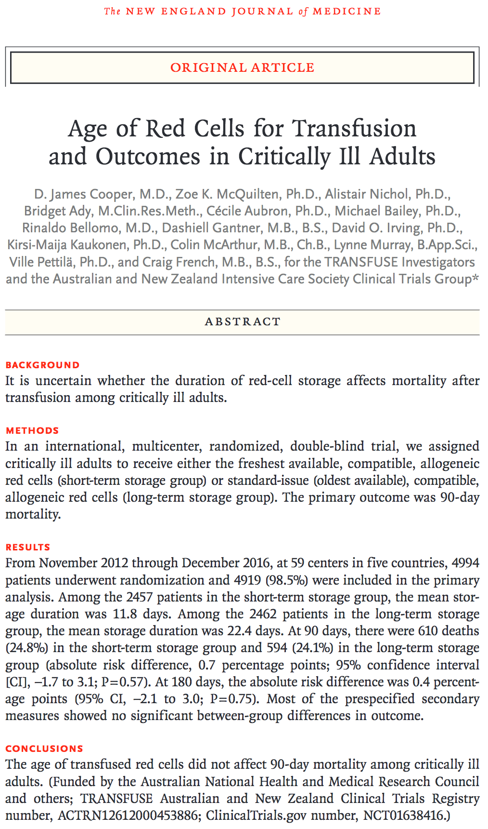
TRANSFUSE (TRANSfusion vs Fresher red cell USE in intensive care) Trial

- Rbc can be stored up to 42 days depending on additives and regulations, as they age they are subject to storage lesions
- Transfusion of older cells has been associated with increased morbidity and mortality in critically ill, surgical and trauma patients
- ABLE trial studied 2340 critically ill adults and INFORM trial studied 10,578 patients in the ICU
  - Both showed no significant difference in outcomes between fresher cells vs older red cell transfusions
  - ABLE had a 10hr lapse between randomization and 1st transfusion
  - INFORM had low severity scores

- Multi-center, randomized, double-blind, parallel-group trial

- Eligible patients: 4994 patients
  - 18 y or older, at least 24hr in ICU, requiring 1 or more rbc transfusion

- Exclusion criteria:
  - Previous rbc transfusions
  - Cardiac surgery, hematologic cancer, organ transplant, pregnancy, expected death in 24 hr, objection to administration of human blood, participation in other study or clinician decline

- Randomized to receive either the freshest rbc or oldest rbc unit, after leaving ICU patients continued to receive blood from their randomized rbc age throughout their hospitalization

- All leukoreduced blood before storage, resuspended in saline-adenine-glucose-mannitol solution for 42 days or 35 days (according to policies in different countries)

- Primary outcomes: 90-day all-cause mortality
- Secondary outcomes:
  - 28-day mortality
  - persistent organ dysfunction or death at 28 days
  - Days alive and free of mechanical ventilation at day 28
  - Days alive and free of renal replacement therapy at day 28
  - New bloodstream infection in the ICU
  - Febrile nonhemolytic transfusion reaction
  - Length of stay in hospital and ICU

- Patients received mean 4.1 +/- 6 rbc unuts in the fresh rbc group and 4.0 +/-6.2 in the old rbc group
- Mean storage or fresh rbc was 11.8 +/-5.3 days and 22.4 +/- in the old rbc group
- Median time from randomization to administration of transfusion was 1.6 hr

- In conclusion, there is No significant difference between fresh or old rbc on mortality or secondary outcomes

