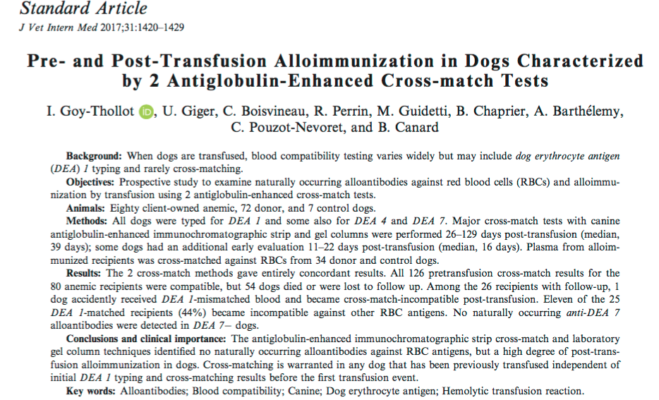

- Objective: to identify alloantibodies against RBCs pre-transfusion and alloimmunization by transfusion using 2 different cross match tests (canine anti-globulin enhanced immunochromatographic strip and gel column)
- Study set up:
  - 80 client owned dogs, 72 donor and 7 control dogs
    - anemic dogs in the intensive care unit receiving fresh or stored whole blood or pRBCs (excluded based on weight < 3or equal to 3 kg, previously transfused or dialysis, incomplete med records)
    - plasma used for major cross match with donor RBCs before transfusion, stored for later testing against panel RBCs
      - DEA 1
        - Immunochromatographic strip kit: Canine LabTest DEA 1 Blood Typing Alvedia
          - DEA 1 negative or weak, moderate, strong positive
        - Flow cytometric DEA 1 typing (same grading as above, same murine anti DEA 1 – antibody)
      - DEA 4 (card, visual examination for agglutination)
      - DEA 7 (gel column)
      - DAT (Coombs) immunochromatographic strip test (Alvedia canine lab test DAT)
      - Major Crossmatch
        - Novel immunochromatographic strip kit (Alvedia LabTest Crossmatch)
          - Also used for DEA 7- dogs against DEA 7+ control
          - Buffer + donor RBCs + plasma from recipient > incubate, wash, centrifuge > add migration buffer > tip of strip placed into suspension for 4 mins > read banding pattern
          - Strip impregnated with control anti-glycophorin antibody that binds all canine RBCS and anti-canine antiglobulin binding only RBCs coated with IgG, IgM or complement C3 or a combo of these.
        - Lab gel column cross match
      - Panel RBCs
        - Alloimmunized recipient plasma was tested in a major cross match against a panel of RBCs from donor and control dogs (different DEA 1 and DEA 7 types)
  - 26-129 days post transfusion
    - cross match and panel RBC testing for alloantibodies
  - some also 11-22 days post transfusion
  - donor and control dogs
    - blood drawn for typing, cross matching, and panel RBC alloantibody testing
    - DEA 7 – dogs sampled and later tested for anti-DEA 7 alloantibodies against DEA 7+ RBCs from 1 control dog
- Results:
  - 80 client owned dogs/126 transfusions/ 72 donors
    - 21.3% of recipients and 43% of donor + control dogs were DEA –
    - 54 died or were lost to follow up
  - No categorical discrepancies obtained between flow cytometry and immunochromatographic strip typing technique
  - All 126 pre transfusion cross match results were compatible (no natural anti-RBC antibodies)
  - All dogs DEA 4 + with moderate reactions
  - No naturally occurring DEA 7 alloantibodies.
  - 56 healthy dogs and 15 recipients were typed for DEA 7 and 41.1% and 40.0% were DEA 7+ with moderate to strong agglutination by gel column technique
  - All healthy dogs DAT -, 8/80 recipients were DAT + (IMHA)
  - 26 recipients could be followed up on and of these 12/26 (46%) became alloimmunized (strip kit and gel agreed)
  - RBC panels: all 7 screened recipients that were incompatible with their donors were incompatible with another 1-33 dogs. Sensitization not affected by receiving 1 or 2 units not from DEA 7 compatibility.
- Notes:
  - One DEA – dog received DEA + blood and developed anti DEA 1 alloantibodies. A weak band at the DEA 1 position of the strip should be considered DEA + when referring to the donor to avoid sensitization. A weakly DEA 1+ patient should preferably receive DEA 1- blood.
  - A positive DAT did not lead to a positive cross match result > dogs with IMHA can be cross matched
  - 2 dogs receiving immunosuppressive doses of steroids still became sensitized – cross match even when on steroids

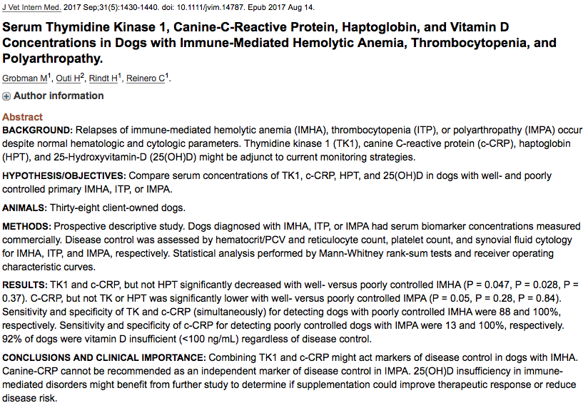

      - Purpose: Compare serum concentrations of TK1, c-CRP, HPT and 25 (OH)D in dogs with well and poorly controlled primary IMHA, ITP or IMP.
      - Background:
  - Thymidine kinase is a cell cycle dependent enzyme used as a biomarker for cell proliferations. Concentrations are low to absent in non-proliferating cells but increase by 10-20 times by the mitotic phase. Associations with neoplastic diseases, hemolysis and erythro-megakaryocytopoiesis. TK1 is needed for cell division and is released from dead cells.
  - CRP released from the liver in response to IL-6 from macrophages and T cells > binds lysophosphatidylcholine on dead and dying cells (also binds some bacteria) > activated complement
  - Haptoglobin binds hemoglobin released from erythrocytes with high affinity > inhibits oxidative ability > HPT-HGB complex removed by reticuloendothelial system.
  - Vitamin D promotes a shift from CD4 Th1 to Th2 polarity in autoimmune conditions promoting a state of immune tolerance. In humans vitamin D supplementation improves treatment response in refractory ITP and reduced CRP concentrations in hemolytic anemia.
- Study Pop: 38 client owned dogs
  - controlled IMHA = no evidence of anemia, no clinical signs of disease, normal slide differentials on CBC when performed, reticulocytes < 1% (poorly controlled = anemia, persistent spherocytosis, agglutination, evidence of regeneration)
  - controlled ITP = platelet count > 200,000/uL with no evidence of clinical disease (petechiations, ecchymoses)
  - controlled IMPA: unremarkable joint fluid cytology on multiple distal joints (poorly controlled when joint fluid cytology contained > 10 % nondegenerate neutrophils)
  - glucocorticoids (alone and in combination) were the most common immunosuppressant used in dogs already undergoing treatment (cyclosporine, mycophenolate mofetil, leflunomide, azathioprine)

- Results:
  - Tk1 significantly increased in dogs with IMHA compared to IMPA.
  - There were no significant differences between IMHA, ITP or IMP for c-CRP, HPT, or 25(OH)D
  - serum 25(OH)D concentrations were insufficient in 92% of dogs
  - No difference in TK1 activity or c-CRP based on glucocorticoid treatment
  - serum HPT significantly higher in dogs treated with steroids
  - could not compare between well and poorly controlled ITP due to low numbers
  - well controlled IMHA had significantly lower c-CRP and TK1 activity compared to poorly controlled IMHA and using both of these markers TKI plus c-CRP had a sensitivity and specificity for detecting a poorly regulated dog with IMHA of 0.88 and 1.00 respectively
  - in dogs with IMHA significant strong positive correlations between TK1 And reticulocyte count and WBC count and significant negative correlation between c-CRP and HCT
  - Dogs with well controlled IMPA had significantly lower c-CRP with a sensitivity and specificity of 0.13 and 1.00. c-CRP is potentially useful as a marker of remission however it was only modestly elevated in most dogs with poorly controlled IMPA and though highly specific lacked sensitivity for detecting patients with poorly controlled disease.
  - no significant differences between IMHA, ITP and IMPA with c-CRP and HPT (these APP cannot distinguish type of immune mediated disease)

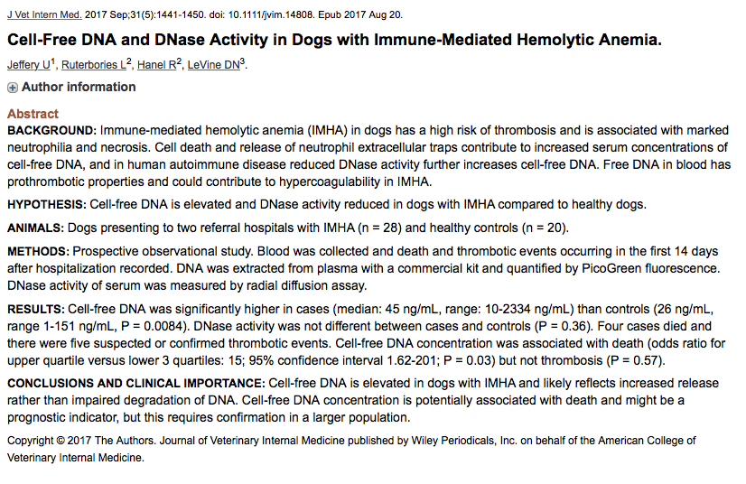

- Hypothesis: cfDNA is elevated and DNase activity is reduced in dogs with IMHA compared to healthy dogs.
- Purpose: test above hypothesis, determine if DNase activity is negatively correlated to cfDNA, to determine if cfDNA was positively correlated to D dimers and provide analysis of association between cfDNA and survival or suspected/confirmed thrombosis in the first 14 days after admission.
- Background
  - cfDNA is released from necrotic cells and activated neutrophils
  - endogenous DNase 1 normally breaks down cfDNA but its activity is reused in human autoimmune disease leading to further elevation
  - cfDNA is prothrombotic: activation of contact pathway (negative charge provides a surface) of coagulation and inhibition of fibrinolysis (forms inhibitory complexes with fibrin and plasmin)
  - concentrations of cfDNA are correlated with disease severity in dogs.
- Study populations 28 dogs with IMHA and 20 controls
- Results
  - Median cell free DNA was significantly higher in dogs with IMHA than healthy controls
  - DNase activity as assessed by area of lysis of ethidium bromide containing DNA gel was not significantly difference between cases and controls
    - This suggests that increased cfDNA is due to increased production not impaired degradation
  - D- dimers could be analyzed in 22 dogs and median D- dimer concentration was 760 ng/mL. D dimers were not significantly correlated to cf-DNA
  - The odds ratio for death or euthanasia in dogs in the highest quartile for cell free DNA was 15 (the area under the ROC curve sig diff from 0.5) ,the odds ratio for suspected or confirmed thrombosis was 2.4 (area under the ROC curve not sig diff from 0.5.)
    - Could have significance as a prognostic indicator for dogs with IMHA

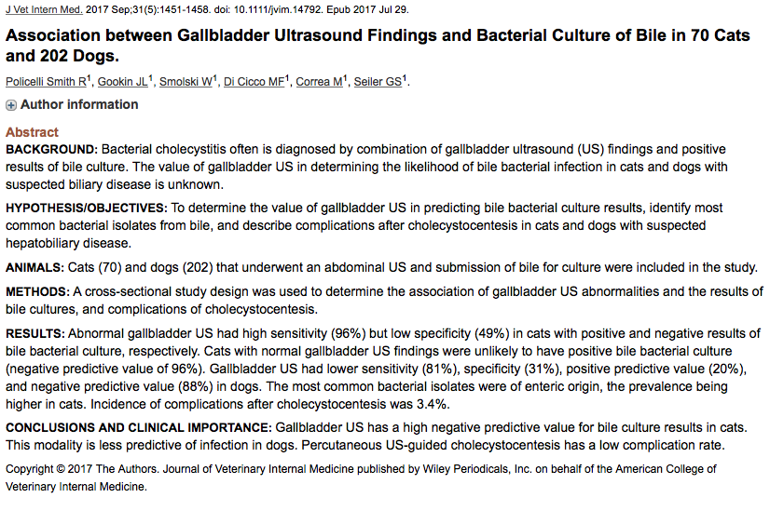

- Purpose: determine sensitivity, specificity and positive and negative predictive value of gallbladder ultrasound in cats and dogs with suspected hepatobiliary disease that also had bile sampled for culture, describe most common bacterial species isolated from bile samples, describe incidence of complication associated with percutaneous US guide cholecystocentesis (PUC)
- Retrospective study: study pop 70 cats and 202 dogs
- Gallbladder abnormality on ultrasound = thickened gallbladder wall, gallbladder wall edema, mucosal hyperplasia, hyperechoic biliary gallbladder contents, choleliths, or a mucocele
- Cholecystocentesis via US guided (7/72 cats and 45/208 dogs), or at time of surgery or laparoscopy
- 233/280 bile samples cultured under aerobic and anaerobic conditions, 47/280 aerobic conditions only
- 35% of cultures from 33% of cats were positive. Growth of bacteria from sampled bile was significantly more common in cats than dogs.
- 19% of cultures from 18% of dogs were positive
- In both cats and dogs a single isolate was isolated 75% of the time and E. coli and Enterococcus were the most common species. ~ ½ of mixed bacterial cultures were a co-infection of these two organisms. For pets with more than one culture, a change in identity of bacteria was seen over time.
- 66% of US examinations of cats and 71% of US exams on dogs found an abnormality. In cats us gallbladder wall thickening and in dogs sludge. Dogs has more choleliths than cats.
- Cats: sensitivity 96% specificity 49% PPV 48% NPV96% (prevalence 33%)
- Dogs: sensitivity 81% specificity 31% PPV 20% NPV 88%
- Complications, peritoneal hemorrhage, gallbladder wall edema, gallbladder collapse with needle pressure, intraluminal GB hemorrhage. )

