July/August 2017
The effect of prazosin on outcome in feline urethral obstruction
Prospective randomized
Background: 22-57% recurrence rates of UO reported with medial recurrence of 17 days and 80% incidence of FLUTD signs after UO.
Prazosin is alpha-1 adrenergic antagonist
Retrospective study supporting prazosin reducing recurrence of UO. Another prospective non-randomized failed to show benefit.
27 cats got 0.25mg PO BID of prazosin after UO, 20 cats got placebo
All inpatient cases.
Prazosin group and placebo were similar except that prazosin group was more likely to have had previous FLUTD.
7/45 (15%) cats that had urine culture had positive culture
Shorter hospitalization for prazosin group.
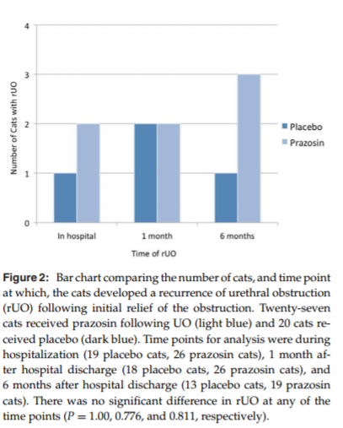
Study was underpowered: “In order to detect a difference in rUO given the findings in this study with a power of 0.8 and an alpha of 0.05, we would have needed 1149 cats in the prazosin-treated group and 766 cats in the placebo treated group”.

Prevalence of and risk factors for intraoperative gastroesophageal reflux and postanesthetic vomiting and diarrhea in dogs undergoing general anesthesia
Results:
Increased GER: Intraabdominal surgery, longer anesthesia.
Increased post-op vomiting: Changes in ventilation mode during anesthesia, length of anesthesia, and use of colloids for hypotension
Reduced vomiting: Use of acepromazine as premedication
Increased diarrhea: length of anesthesia, changes in body position, change in vent mode, intraop hypoxemia

Comparison of two species-speciﬁc
oscillometric blood pressure monitors with
direct blood pressure measurement in
anesthetized cats
Comparison of two species-speciﬁc
oscillometric blood pressure monitors with
direct blood pressure measurement in
anesthetized cats
Comparison of two species-speciﬁc
oscillometric blood pressure monitors with
direct blood pressure measurement in
anesthetized cats
Comparison of two species-speciﬁc
oscillometric blood pressure monitors with
direct blood pressure measurement in
anesthetized cats
Comparison of two species-specific oscillometric blood pressure monitors with direct blood pressure measurement in anesthetized cats

Comparison of two species-speciﬁc
oscillometric blood pressure monitors with
direct blood pressure measurement in
anesthetized cats

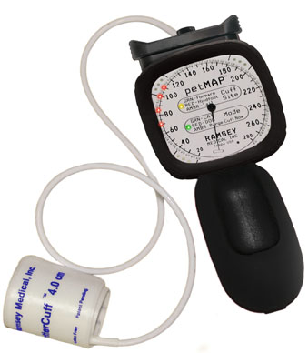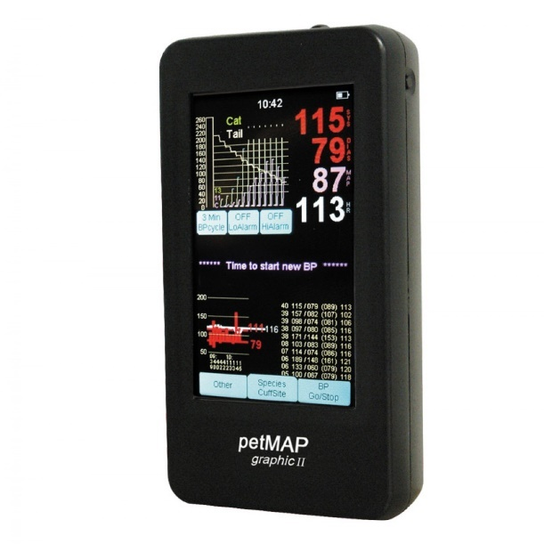

Results: Both were useful for estimating MAP (but NOT systolic pressure) in anesthetized cats with both normotension and hypotension.

Retrospective evaluation of the impact of early enteral nutrition on clinical outcomes in dogs with pancreatitis: 34 cases (2010–2013)

Early nutrition group (<48 hours to intake) had fewer signs of gastrointestinal intolerance and was eating full RER on own more quickly

Escalator-related injuries in 30 dogs (2007–2014)
Small dogs got injured more than large dogs
Back paws more than front paws
“Prevention of these injuries can be achieved through client education. In particular, it should be impressed upon owners of small dogs that they should carry their dogs while riding escalators, in order to prevent injury altogether”

A retrospective study of anti-inflammatory use in dogs with pulmonary blastomycosis: 139 cases (2002–2012)
Background: Blastomycosis is systemic fundal disease. Endemic to central and SE USA.
Infectious via inhalation.
Prognosis is good with 58-75% remission.
Worse prognosis with pulmonary involvement.
Human use of methylpred has been described to help with pulmonary effects (such as ARDS)
Results: Overall survival was 61% for dogs with pulmonary involvement
No association with use of NSAIDS or corticosteroids with increased survival
Treatment of meloxicam overdose in a dog via
therapeutic plasma exchange

Treatment of meloxicam overdose in a dog via therapeutic plasma exchange
TPE seems to be effective in meloxicam overdose at reducing plasma concentration due to meloxicam’s high protein binding

Treatment of ibuprofen intoxication in a dog via therapeutic plasma exchange
TPE appeared to hasten the resolution of disease in a 200mg/kg ibuprofen ingestion that had GI and renal effets

The use of therapeutic plasma exchange to reduce serum bilirubin in a dog with kernicterus
5 year old Lhasa Apso with IMHA and kernicterus
Aggressive plasma exchange reduced Bili by amount 26% each time
Dog was still euthanized due to neurologic changes and postmortem confirmed kernicterus

Use of a vascular closure device during percutaneous arterial access in a dog with impaired hemostasis
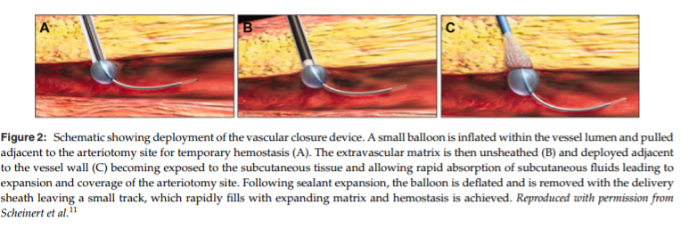

Acute respiratory distress syndrome and septic shock in a cat with disseminated toxoplasmosis
Cat developed ARDS after immune suppression for eosinophilic dermatitis.
Developed pulmonary toxoplasmosis, ARDS and died
Consider testing for toxo prior to immunosuppressing a cat

