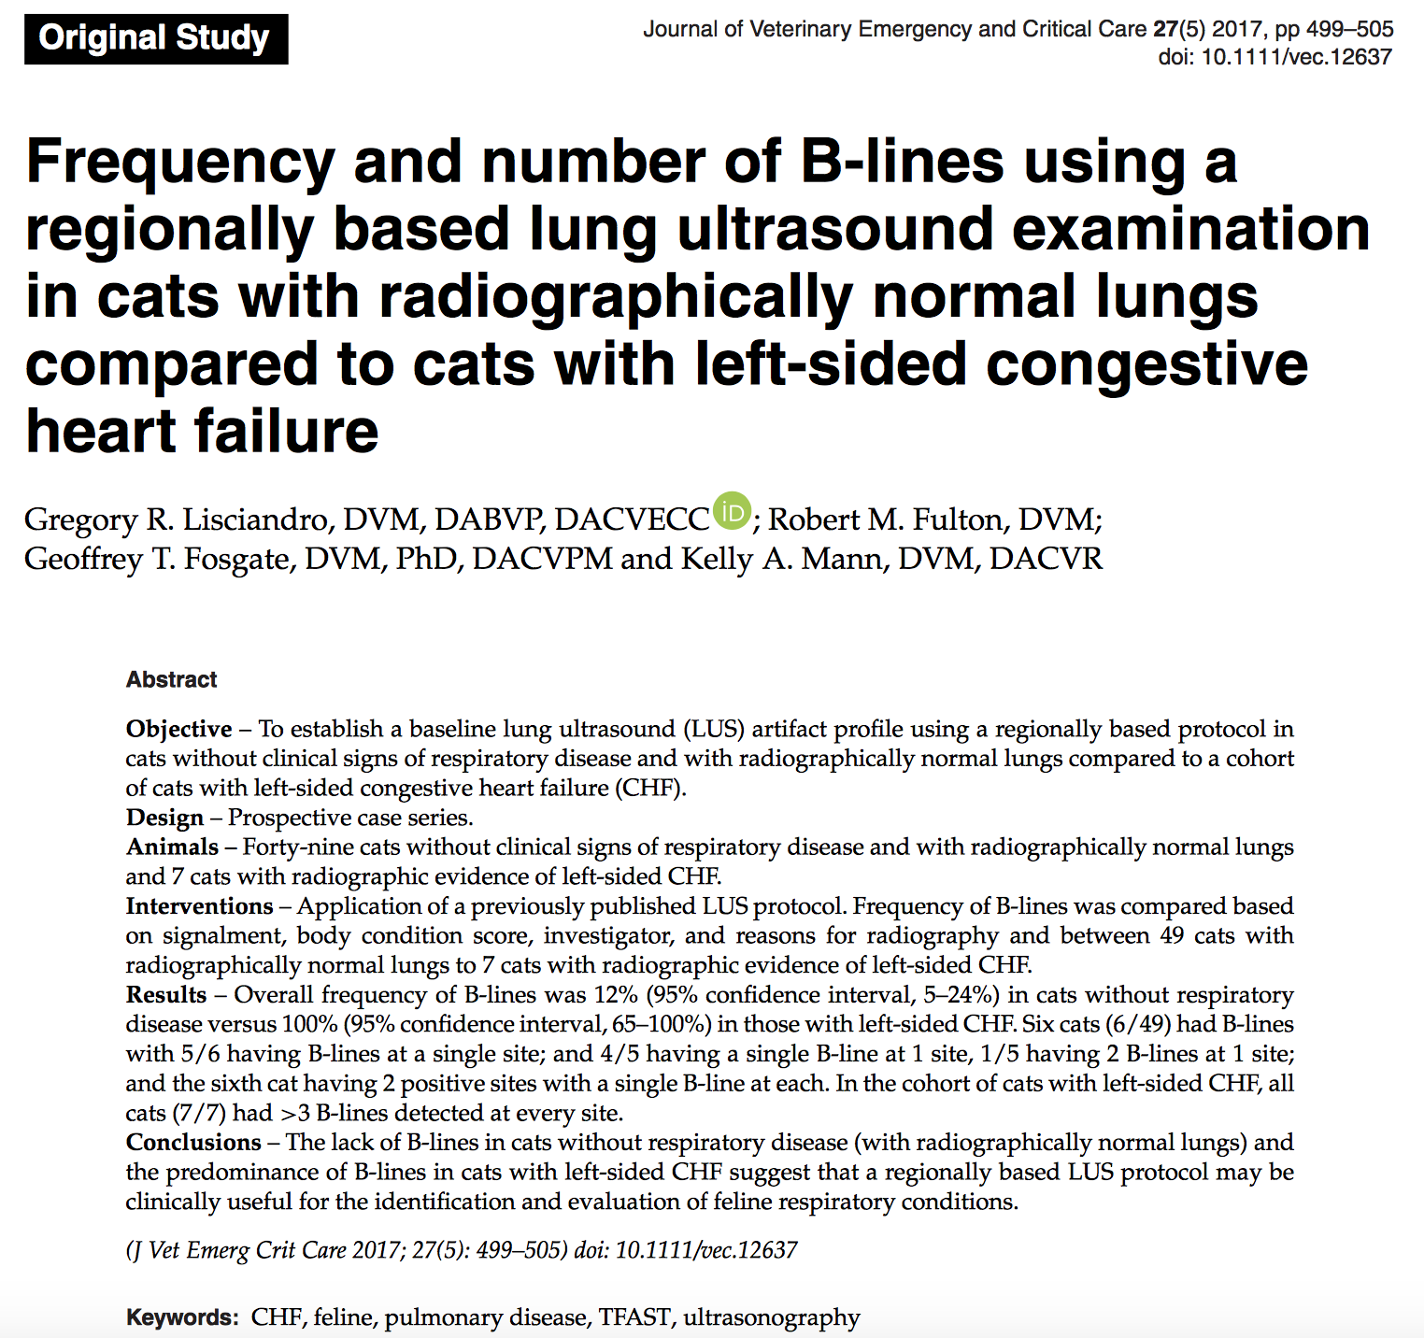

- Healthy cats may have an incidental b-line, cats with CHF tend to have a predominance of b-lines

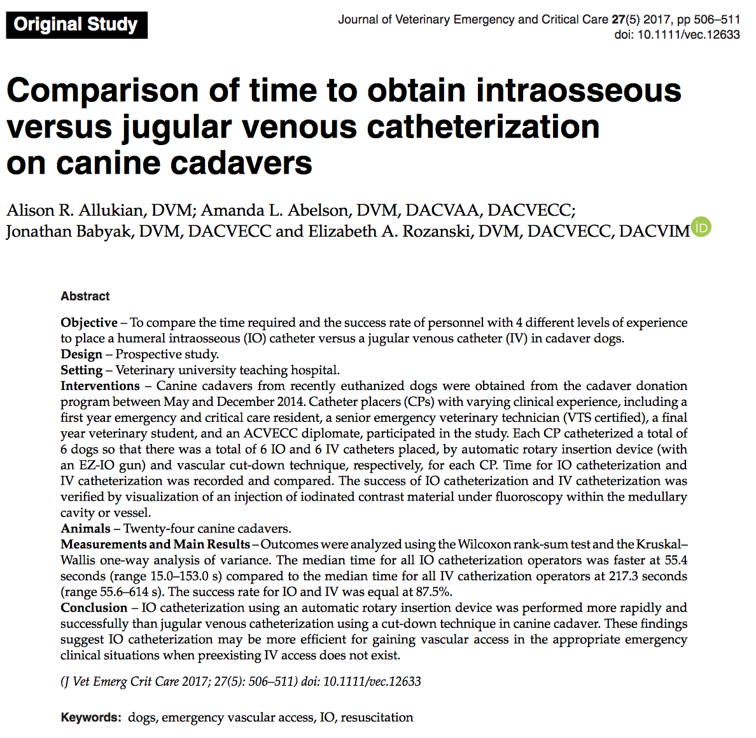

- Despite varied clinical experience, with minimal verbal instruction, IO catheter using an EZ-IO is faster and more successfully placed than jugular cut-downs in cadavers

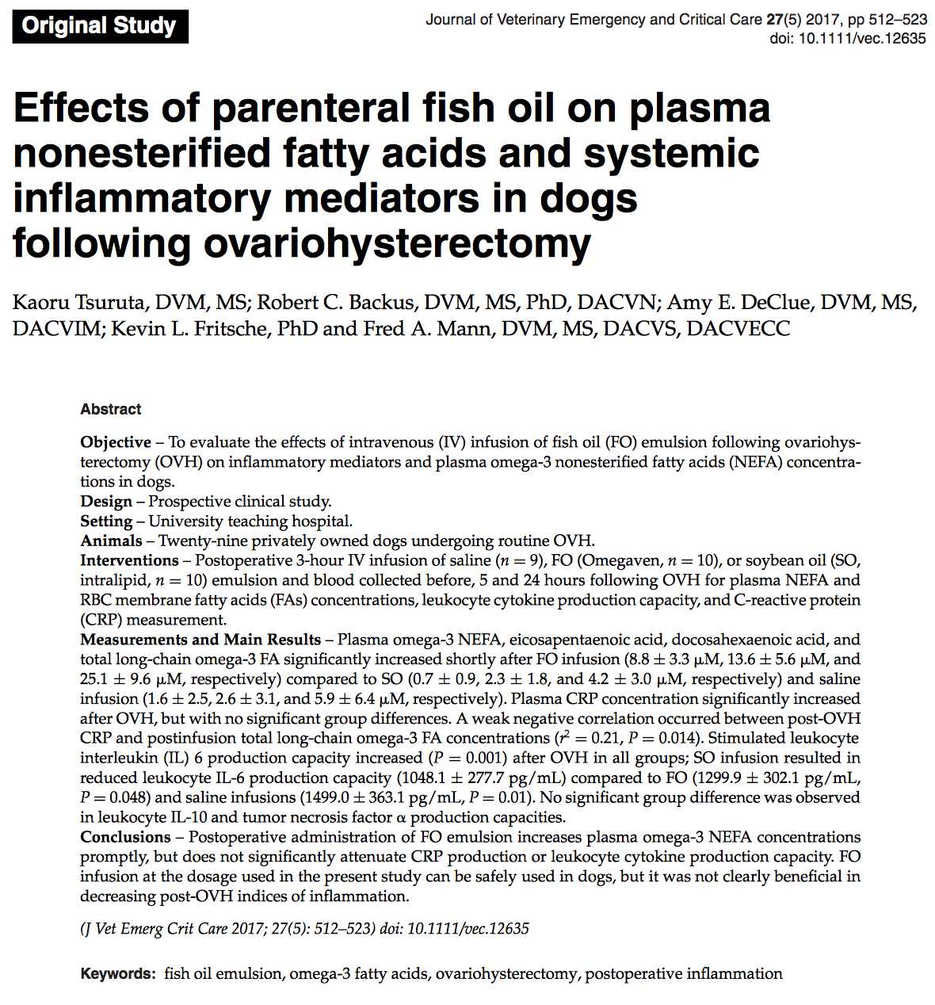
- Fish oil IV is safe but no clear benefit as an anti-inflammatory was found at these doses

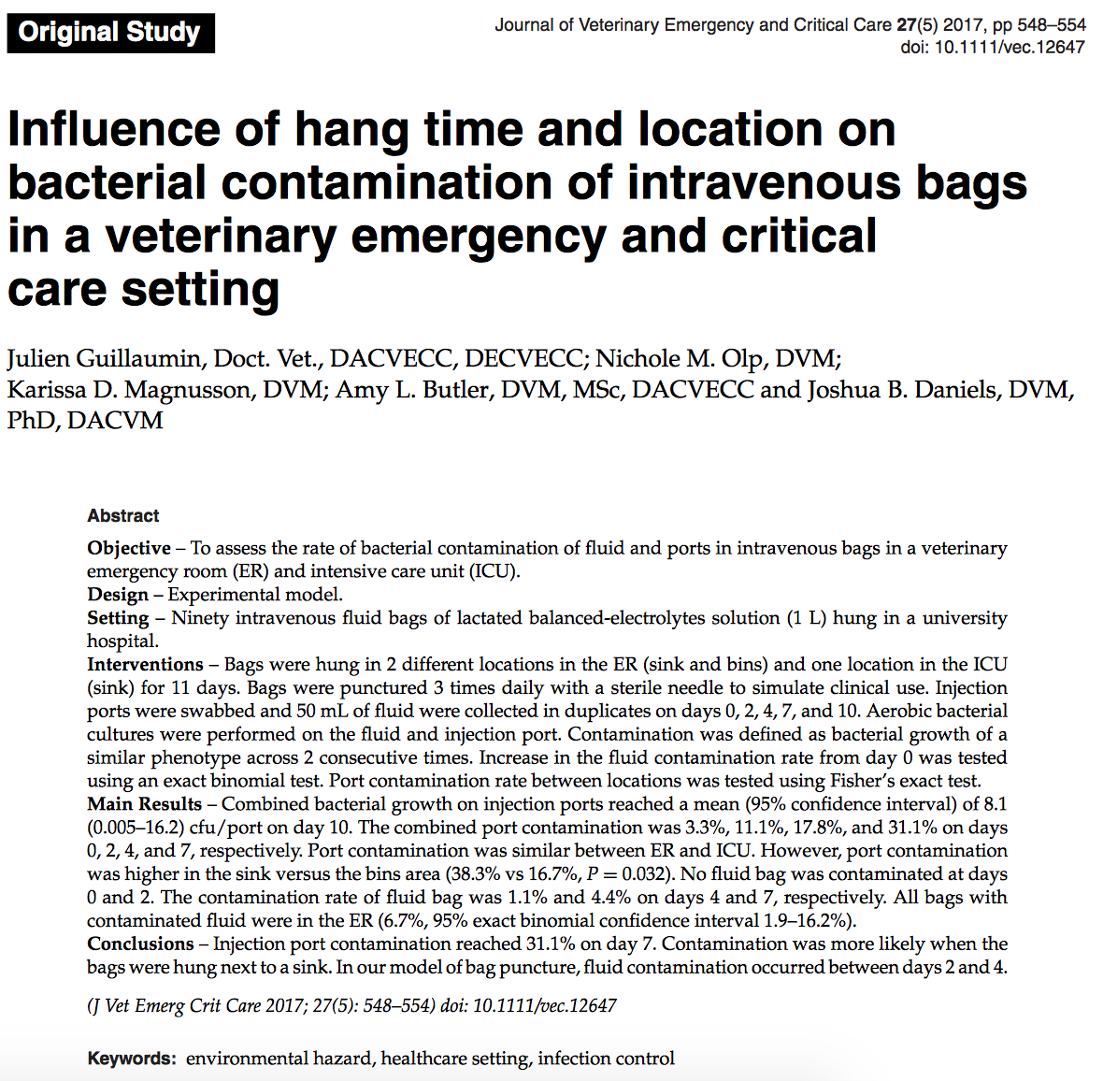

- 31% Injection ports were contaminated on the 7th day
- More contamination near the sink
- No contamination day 0-2

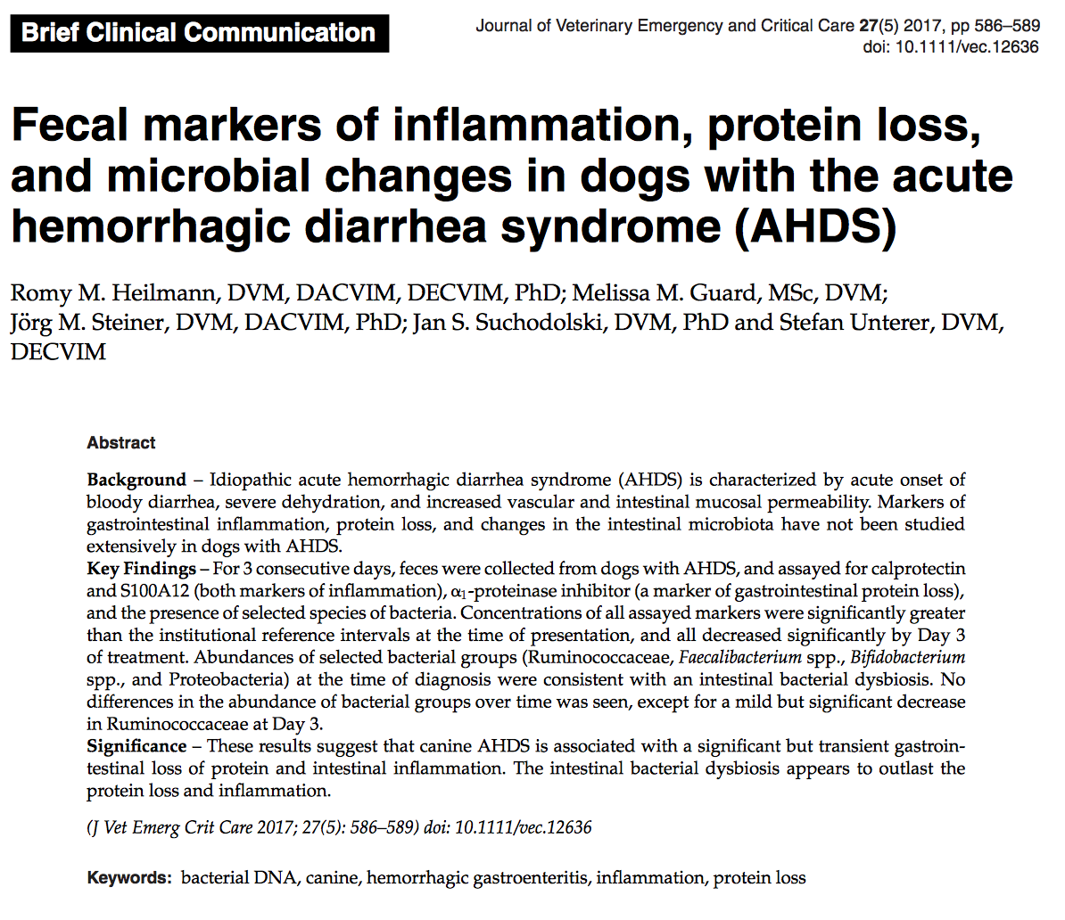
- Transient, severe PLE and intestinal inflammation

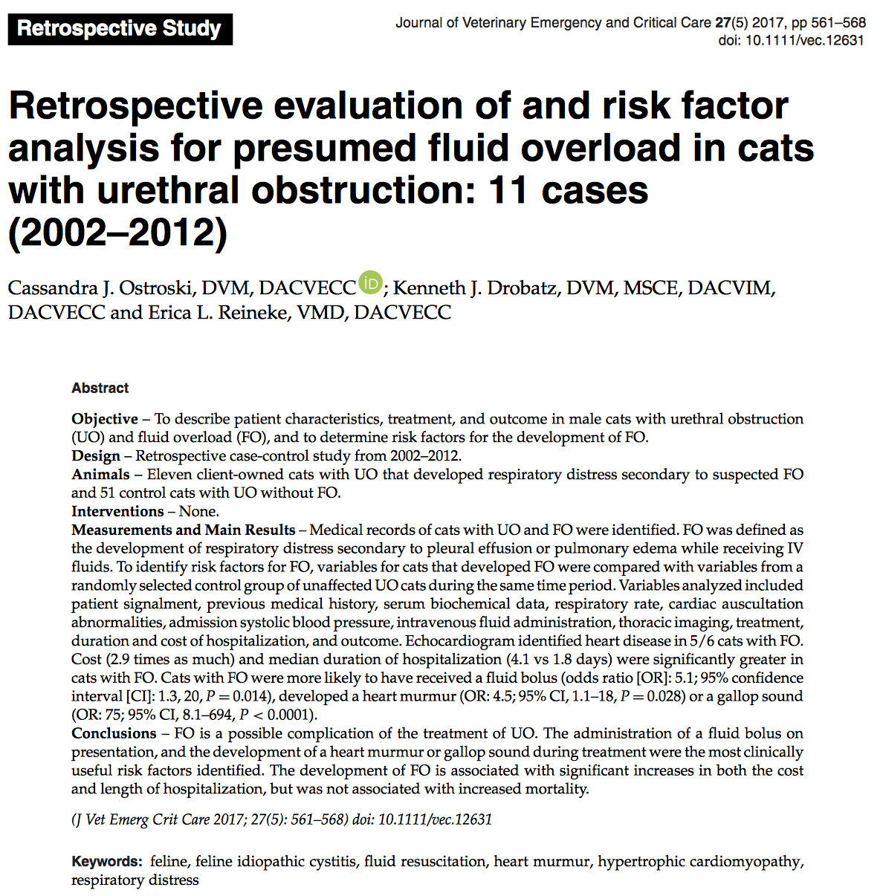

- Fluid bolus on presentation and gallop/heart murmur development are clinically useful risk factors for fluid overload in UO cats

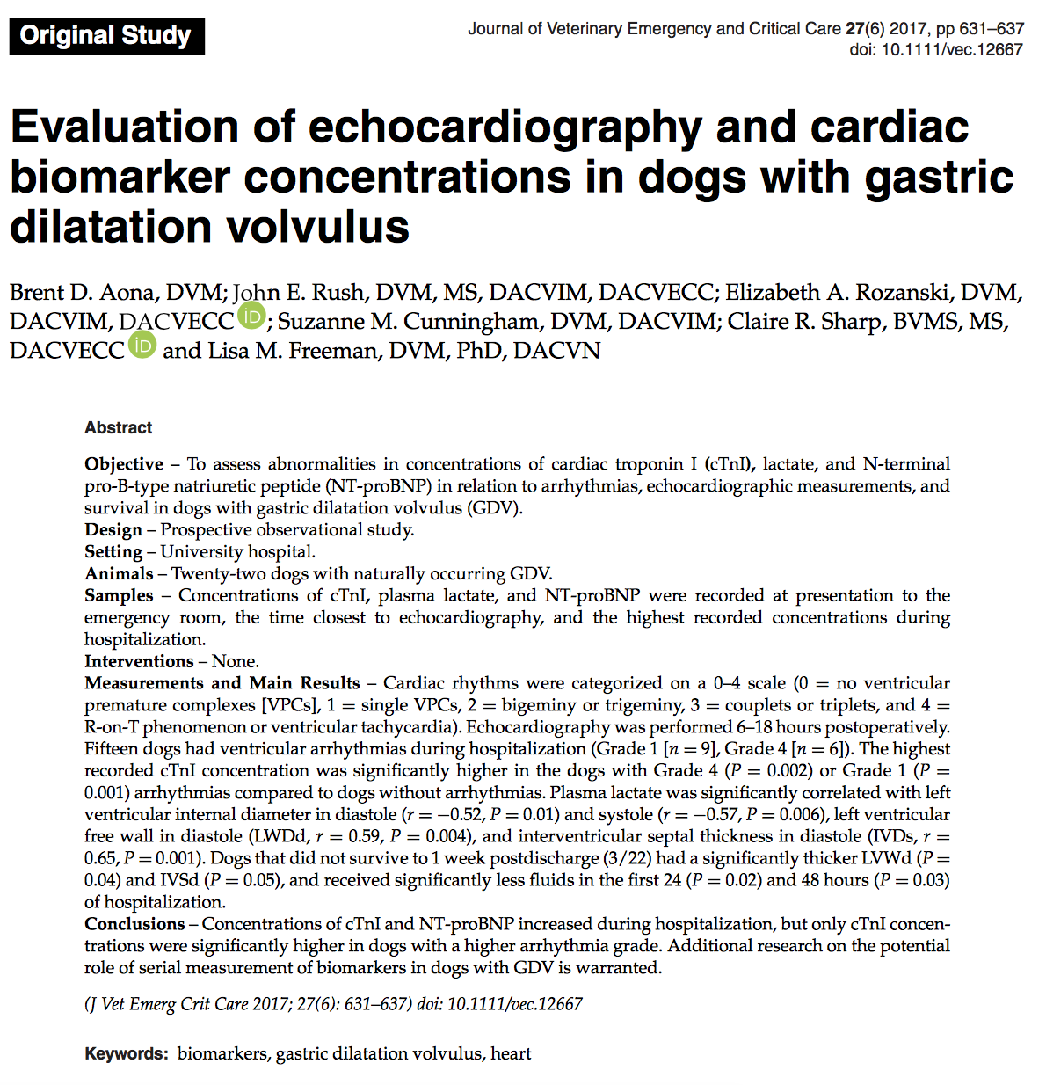

- 22-77% dogs with GDV develop arrhythmias, in this study 68% had arrhythmias
- Lactate was associated with gastric necrosis
- Non-survival was associated with thicker heart walls, and small fluid volumes in the 1st 24hr
- Troponin was higher in in dogs with higher ventricular arrhythmia grade

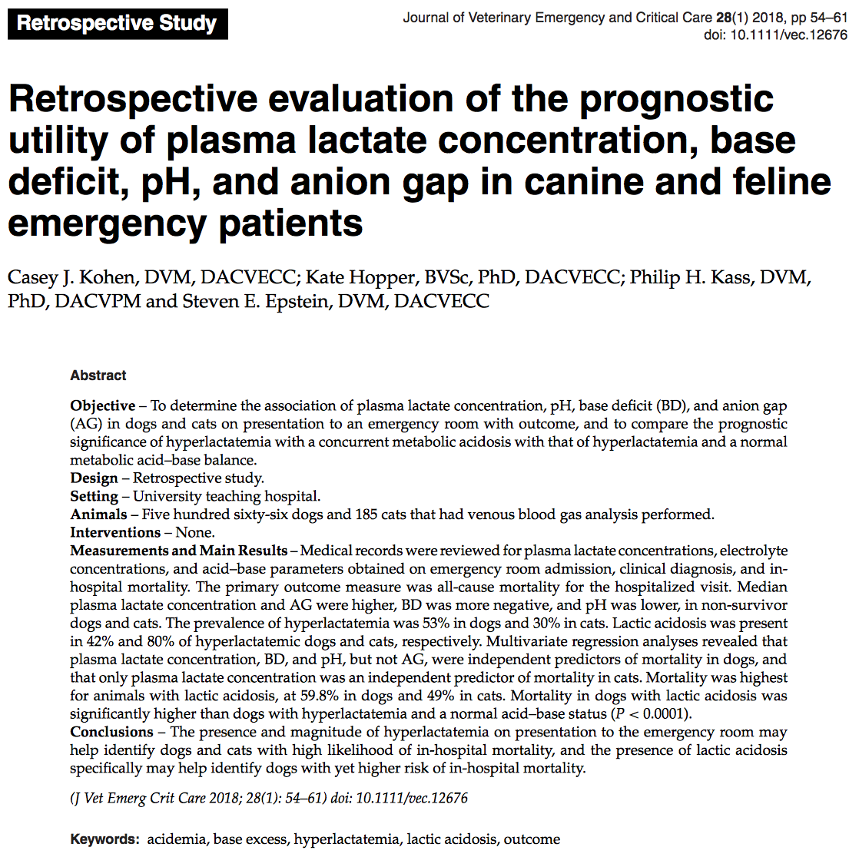

- Presence and magnitude of hyperlactatemia may help identify high risk of mortality in dogs and cats
- Lactate + acid base analysis has more value than lactate alone

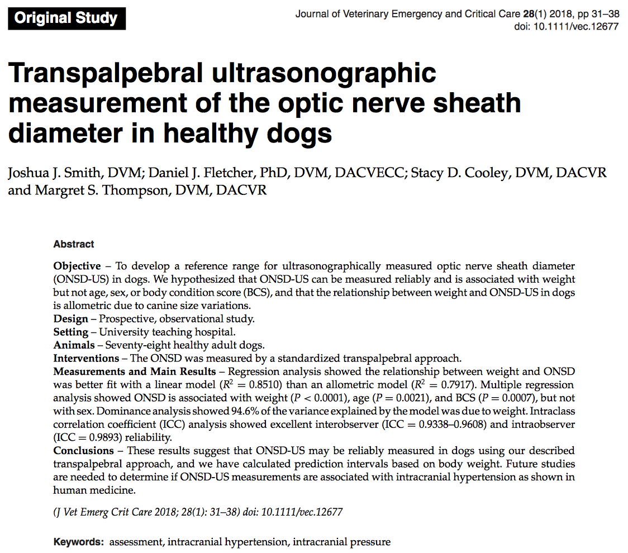
- Transducer was placed on the upper eyelid in a slightly temporal position along a transverse plane with the transducer indicator pointing toward midline to standardize the image plane
- The transducer is fanned dorsally and ventrally until the optic nerve was visualized and optimized in position.
- Visualization of the hyperechoic posterior lens capsule was used as a landmark, as the optic nerve was identiﬁed caudal to the lens approaching the optic disc on the retina. Depth was adjusted so that the image of the eye ﬁlled the screen, typically at 3–5 cm

