Intervertebral Disc Disease

Pathophysiology
- Normal intervertebral disc: incompressible nucleus pulposus (derived from embryonic notochord), encompassing annulus fibrosis, cartilaginous endplates against the vertebrae
  - Acts to form joint between vertebrae and resist compressive forces along the spine

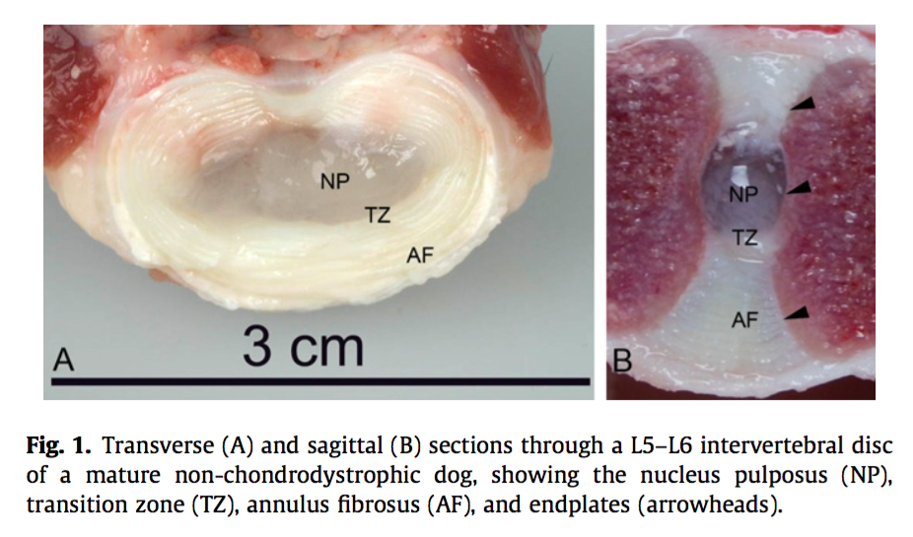
- Loss of capacity for vertebral endplate vessels to supply nutrition to the nucleus pulposus decreased production of the ECM (hydrophilic proteoglycans) changes mechanical properties of the nucleus degenerative change in annulus fibrosis

In chrondrodystrophic dogs, notochordal cells are prematurely replaced with what type of cell?

- Predisposition is dogs is likely due to genetic factors resulting in vasculopathy, and in chrondrodystrophic dogs, premature senescence of notochordal cells and replacement with chondrocyte cells

Match the following characteristics with Hansen Type 1 vs Hansen Type 2 discs:
- Chrondroid degeneration vs Fibroid degeneration
- Nuclear extrusion versus annular protrusion
- Chrondrodystrophic vs non-chrondrodystrophic
- Chronic versus acute (typically)

- Hansen types
  - Hansen type 1
    - Chrondroid degeneration, occurs in chrondrodystrophic dogs
    - Nucleus pulposus dehydrated and becomes calcified
    - Causes foci of pressure on annulus fibrosis, ultimately resulting in mechanical failure and release of the degenerate nucleus
    - Frequently dorsally directed extrusion because of nucleus’ eccentric position within the annulus
    - Nuclear extrusion – mixed compressive and contusive lesion, variable depending on volume and rate of extrusion
  - Hansen type 2
    - Fibroid degeneration
    - Predominantly in non-chrondrodystrophic dogs
    - Annulus degenerates – fibers split and allow accumulation of tissue fluid and plasma between the layers
    - Annulus thickens, particularly dorsally, and protrudes into vertebral canal where it compresses cords or roots
    - Annular protrusion – typically occurs over months to years causing progressive compression. Sometimes may have dynamic compression as well, depending on body position
  - Less difference in the degenerative process between chrondrodystrophic and non-chrondrodystrophic dogs than once thought. In advanced annulus fibrosis degeneration, notochord-like cells will also be replaced with chrondrocyte-like cells
  - Type 3, high-velocity low volume
    - Peracute extrusion of healthy nucleus presumed to be due to supraphysiology mechanical stress during athletic activity

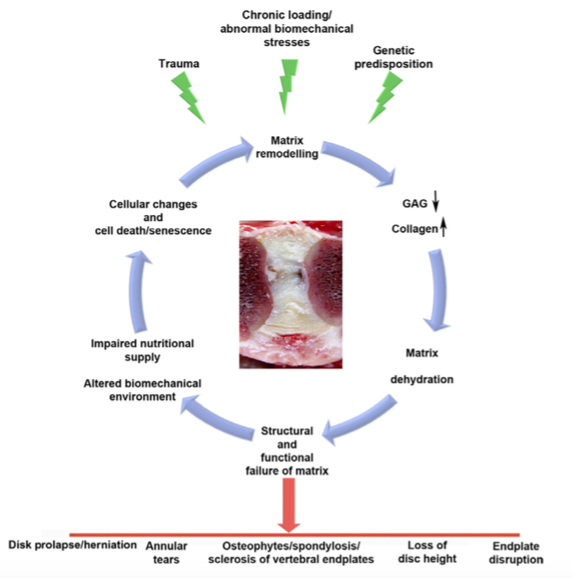

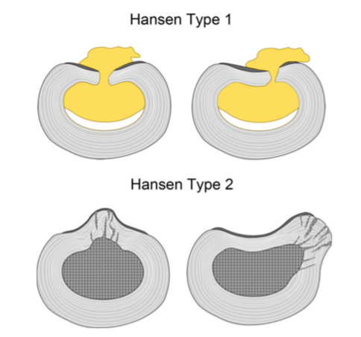

What are the two types of injury that can occur to the spinal cord?
Describe the difference between them.
How do clinical signs differ between the two?
Which occurs with Type 1 vs Type 2 discs?

- Types of injury
  - Contusion
    - Primary injury
      - Vascular injury, damage to blood/ spinal cord barrier
      - Little structural disruption
    - Secondary injury
      - occurs over the next 7 days – vasoconstriction, extravasation of cells and plasma, cellular response causes tissue damage and replacement with tissue fluid and reactive astrocytes
        - Calcium entry into neuronal cells following contusive injury is important – activation of enzymes (calpains, caspases) that cause apoptosis and necrosis
      - Free radical release, activation of neuronal nitric oxide synthase
      - Cytokines – IL1, TNFa, nitric oxide
    - Occurs with Hansen Type 1
    - Rapid loss of neurologic function
  - Compression
    - Chronic compression leads to axonal loss and Wallerian degeneration in the segments distal to the lesion
    - Assumed secondary to decreased blood flow from increased pressure
    - Occurs with Hansen Type 1 and Hansen Type 2
    - Loss of function occurring over weeks to months, often occurring in a step-like fashion
- Nerve compression
  - Can occur at the vertebral canal in LS region, and the foramina at any IVD space (lateral herniation), which can cause limb pain or lameness
  - Compression of cauda equina

Clinical signs

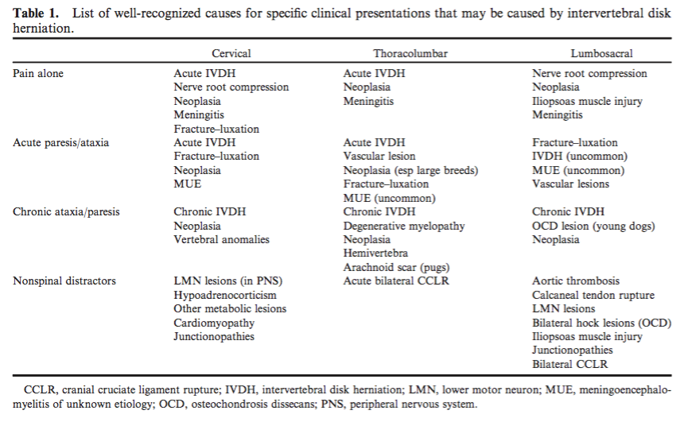

- Spinal shock
  - spinal reflexes caudal to severe acute lesion may be depressed transiently (potentially for several days)
- Myelomalacia
  - may spread caudally or cranially
  - Common after severe acute TL extrusion
  - Consequence of ischemia; cause is not clear

What is the most common region for acute IVDH?
Why is disc herniation from T1-T9 rare?

Location
- Acute IVDH occurs most commonly between T11-L1 or C2-C4
- Chronic IVDH occurs most commonly in caudal cervical region, TL junction and L7/S1
- T1-T9 is rarely seen
  - Presence of intercapital ligament, sternum and rib cage providing extra stability
  - Hearon K, Berg JM, Bonczynski J et al. Upper Thoracic Disc Disease (T1–T9) in Large-Breed Dogs. JAAHA 2014; 50: 105-111
    - 723 cases, 73% small breed dogs
    - 10% large breed dogs with T1-T9 lesion and more likely to have multiple lesions
    - GSD most commonly affected
- Cervical IVDD
  - 16-25% of all disc extrusions
  - Potentially more difficult to manage medically than TL IVDD – difficult to immobilize neck? Larger volumes of herniated disc material?
  - Levine JM, Levine GJ, Johnson SI et al. Evaluation of the Success of Medical Management for Presumptive Cervical Intervertebral Disk Herniation in Dogs. Veterinary Surgery 36:492–499, 2007
    - 88 dogs with presumptive cervical IVDD
    - 49% dogs responded to medical management, 33% had recurrence of signs and 18% failed
    - Associations with success: NSAID administration, lower neurologic score
    - No associated: glucocorticoids, duration of cage rest

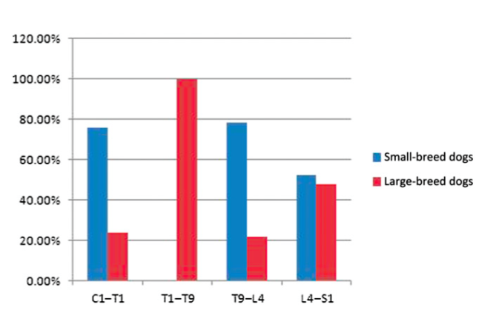

Diagnosis
- Spinal radiographs – useful in diagnosis of neoplasia, discospondylitis
  - Indications of IVDD – decreased distance between vertebral end plates, disk space wedging, reduction in space between articular processes
- Myelography – useful identifying swollen regions of spinal cord (that occurs with contusion) and regions of deviation in the subarachnoid space
- CT
  - Useful if extruded material is calcified
  - Decreased sensitivity compared to MRI
- MRI
  - Hyperintensity (T2W) indicated region of compromised blood-spinal cord barriers, indicating edema, necrosis or hemorrhage
  - Extent of hyperintensity can have prognostic value
  - Can distinguish buldging, protrusion and extrusion

Treatment
- Contusion – no specific medical or surgical intervention beyond ensuring normal blood pressure
  - No evidence that corticosteroids are helpful
  - Treatment is supportive care – bladder management, rehab
- Compression – medical or surgical
  - Spinal cord is still able to function with compression to some degree
  - Type I
    - Combination of contusion and compression
    - Degree of compression does not clearly correlate with clinical signs
    - Difficult to interpret what signs are coming from contusion and which from compression
  - Type II
    - slow and progressive so little chance of spontaneous improvement
    - Medical – anti-inflammatory to decrease accumulation of fluid
    - Not clear when to intervene surgically
  - Medical
    - Cage rest, physical rehabilitation, pain medication, anti-inflammatories
    - Allow for ligamentous healing and prevent further disc herniation
  - Hemilaminectomy
    - Ingram EA, Kale DC, Balfour RJ. Hemilaminectomy for Thoracolumbar Hansen Type I Intervertebral Disk Disease in Ambulatory Dogs With or Without Neurologic Deficits: 39 cases (2008–2010). Vet Surg 42 (2013): 924-931
      - Longer duration of signs pre-operatively correlates with length of time to recovery post-operatively
  - Fenestration
    - Removes disc from normal anatomical position to reduce risk of herniation recurrence – risk decreased from 17% to 7%
    - For type 1 (in type 2 annulus can continue to buldge)
    - Potential for increased risk of neural or vascular injury, increased surgical time and infection
  - New treatment approaches
    - High-dose glucocorticoids – neuroprotective effect? Conflicting reports
    - Polyethylene glycol (PEG) – one study showing enhanced motor and sensory recovery, but inadequate control group
    - NAC – reduce oxidative stress? No improvement in motor recovery but small study
    - Matrix metalloproteinase block – MMP-9 expression potentiates lesion progression?

Prognosis
- Medical - 55-100% depending on article
- Surgical - 90-100% success rate if intact deep pain
  - Loss of deep pain – 50% recovery with surgery
- Biomarkers
  - MMP-9: high concentrations in CSF associated with poor outcome
  - Tau protein: increased concentration in CSF is associated with degree of spinal cord damage
    - Roerig A, Carlson R,Tipold A, et al. Cerebrospinal fluid tau protein as a biomarker for severity of spinal cord injury in dogs with intervertebral disc herniation. Vet J 2013;197:253–258.

Recurrence
- Most animals with IVDD are at risk of future episodes due to the degenerative process

Jeffery ND, Barker AK, Hu H et al. Factors associated with recovery from paraplegia in dogs with loss of pain perception in the pelvic limbs following intervertebral disk herniation. J Am Vet Med Assoc 2016; 248:386–394

- Study design
  - Prospect cohort study (Iowa State, Texas A&M, University of Bristol) from 2011-2014
  - 78 dogs undergoing spinal decompression
  - Inclusion: paraplegia, absence of deep pain bilaterally
  - Exclusion: paraplegia secondary to something other than IVDD between T10-L3, concurrent neurologic disease
  - Primary outcome: ability of dog to walk independently within 3 months of surgery
  - Prognostic factors evaluated: (1) interval from when clinical signs were noted to the point when dog was unable to walk; (2) interval from when dog was unable to walk to when the dog was evaluated; (3) severity of spinal cord compression; (4) corticosteroid administration (yes or no); (5) patient age
  - MRI or CT evaluated by independent observers
    - ratio of compressed to uncompressed cord area measured
- Results
  - 78 dogs
    - 44 Dachshunds, 34 small to medium mixed breed dogs
  - 58% of dogs recovered ability to ambulate within 3 months post-op
    - Of these dogs, median time to recovery was 27 days
  - 10% of dogs has ascending myelomalacia – too few dogs to assess for prognostic associations
  - None of the factors evaluated were prognostic for return to ambulation in neither univariate or multivariate analysis
    - greater delay between onset of paraplegia and referral evaluation was not associated with a poorer prognosis

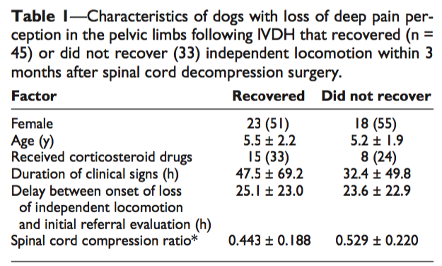
- Conclusions
  - Prognosis in dogs with loss of deep pain may not be time-dependent, as traditionally thought
  - Perhaps prognosis is dependent on primary mechanical injury that occurs in the initial event
  - Limitations
    - Inadequate power to detect true difference?
    - Owner-reported timing of events

Aikawa T, Fujita H, Kanazono S et al. Long-term neurologic outcome of hemilaminectomy and disk fenestration for treatment of dogs with thoracolumbar intervertebral disk herniation: 831 cases (2000–2007). J Am Vet Med Assoc 2012;241:1617–1626
- Study design
  - Retrospective case series; Aikawa Veterinary Medical Center; 2000-2007
  - 831 dogs with TL IVDH treated by hemilaminectomy and disk fenestration
- Results
  - 95.4% of dogs were chrondrodystrophic, 4.6% other (mostly small breeds)
  - 5 dogs (0.6%) had grade 1, 274 (33.0%) had grade 2, 180 (21.7%) had grade 3, 84 (10.1%) had grade 4a, 77 (9.3%) had grade 4b, and 211 (25.4%) had grade 5 neurologic function
  - 14.7% (122) dogs had unsuccessful outcomes
  - 85.3% (709) had successful outcomes
    - 13% had urinary incontinence and 6.8% fecal incontinence; rate significantly lower in low-grade dogs compared to grade 4a or higher
  - Deep pain intact (620 dogs) – 97.7% ambulatory post-op, 7 of these dogs were consider to have an unsuccessful outcome has the severity of their ataxia did not improve
    - No difference between grade 1 through grade 4b dogs, except for earlier recovery in grade 1 and 2 dogs
  - Loss of deep pain (211) – 52.1% ambulatory post-op
    - 75 dogs had persistent loss of deep pain post-op; 20 of which became ambulatory (6 able to walk coordinated; 14 developed spinal walking and required assistance to urinate)
  - Dogs with paraplegia pre-op had a higher frequency of incontinence compared with ambulatory dogs
- Conclusions
  - Dogs with TL IVDH that retain deep pain in at least one pelvic limb or tail pre-op have an excellent prognosis
  - Dog that lack deep pain have a worse prognosis, and are more likely to have delayed time to ambulation and higher risk of incontinence

