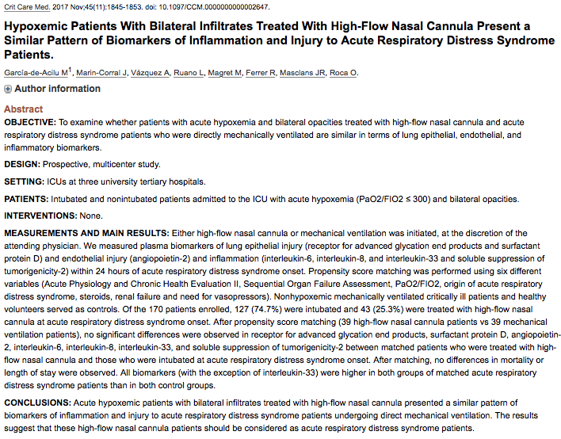
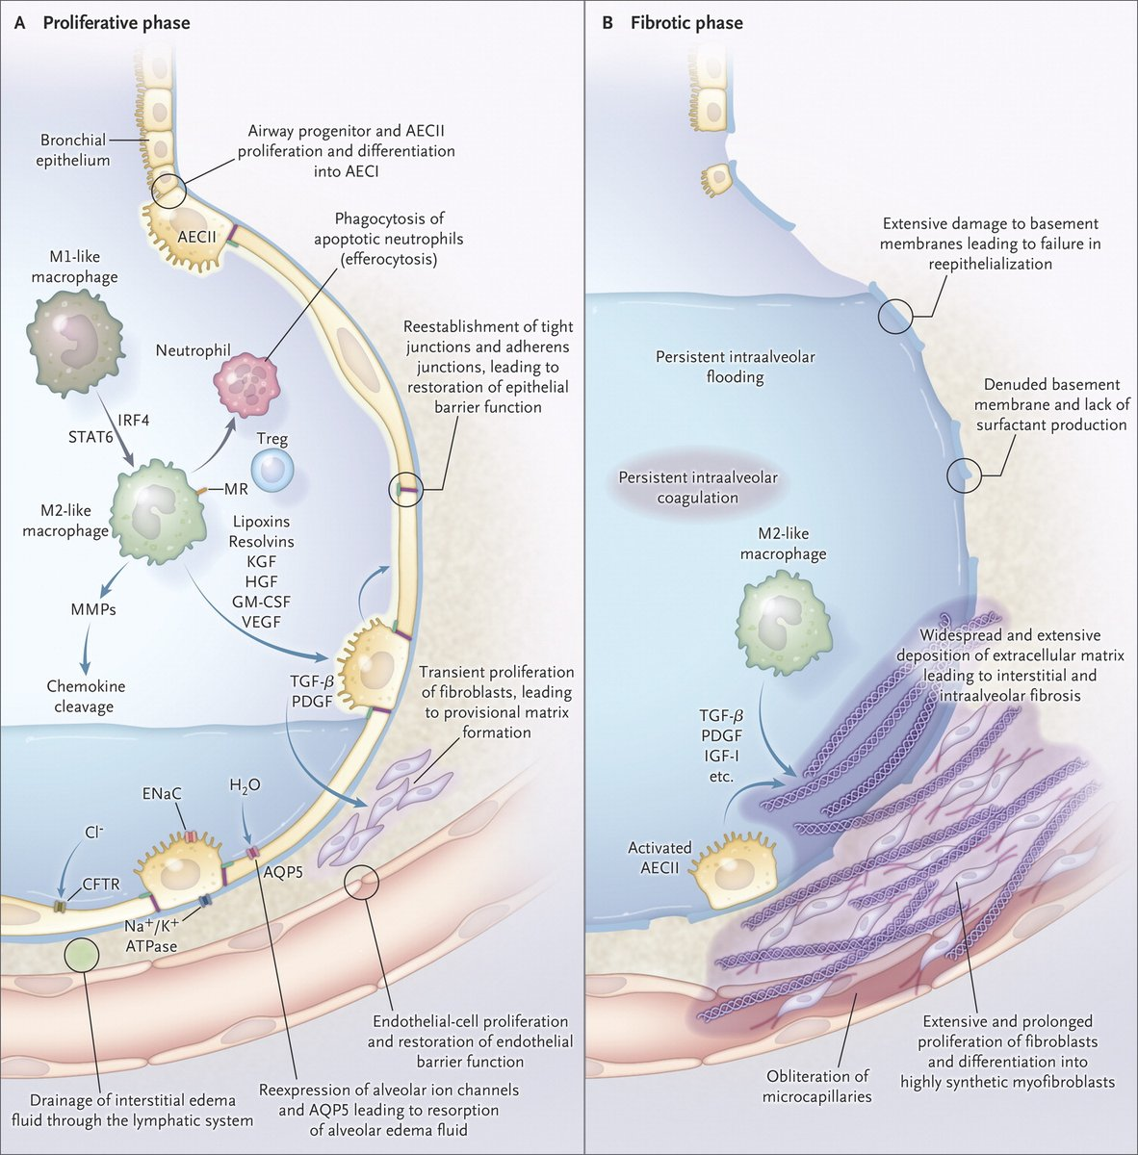
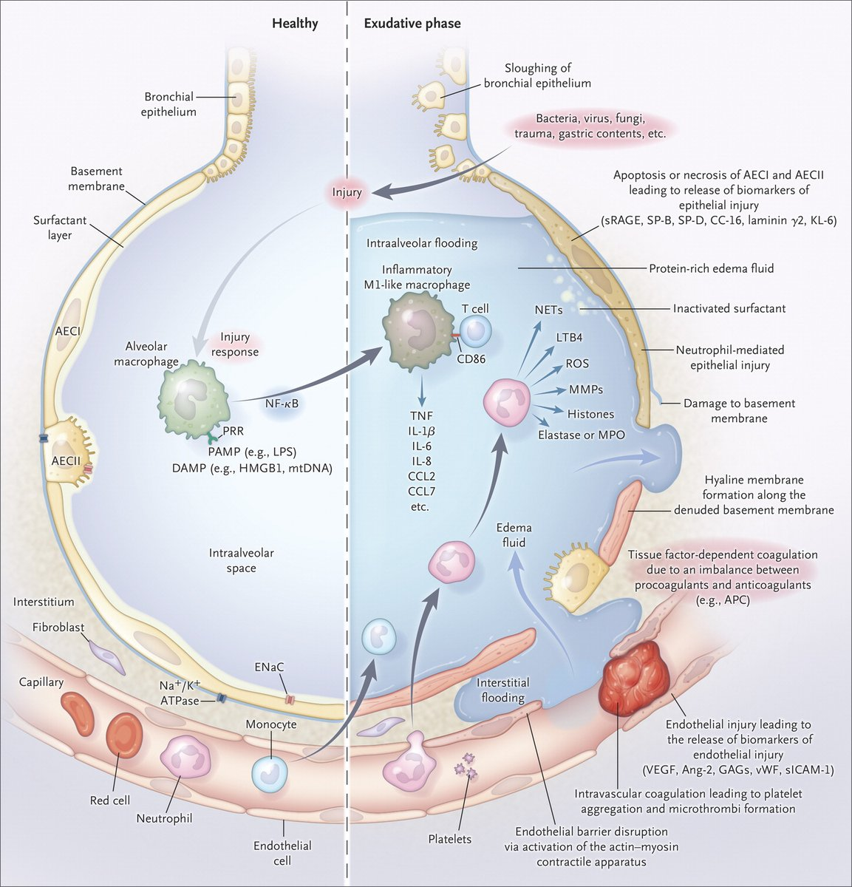
ARDS Pathophysiology
Objectives:
- Do patients with acute hypoxemia + bilateral opacities on radiographs treated with high flow nasal cannula (HFNC) have lung epithelial, endothelial and inflammatory biomarkers similar to patients with acute respiratory distress who are mechanically ventilated (MV).
- Prospective multicenter study at 3 university ICUs over 3 years (2014-2016)
- Intubated and non-intubated patients with acute hypoxemia (PaO2/FiO2 ≤ 300, SpO2/FiO2 < 315) and bilateral opacities
  - 170 total patients
    - 127 (74.7%) intubated
    - 43 (25.3%) HFNC
- HFNC or MV initiated at discretion of attending clinician
- Plasma biomarkers within 24 hours of ARDS onset
  - Lung epithelial injury: receptor for advanced glycation end products (RAGE), surfactant protein D
    - RAGE: PRR, member of Ig superfamily
      - Membrane bound (mRAGE) and soluble (sRAGE) forms
        - sRAGE is a decoy receptor that competitively inhibits RAGE activation
      - Signaling cascade > NF-kB & MAPK pathway > pro-inflammatory cytokines
      - RAGE is expressed constitutively in the lung under basal conditions and is enhanced during inflammatory states (ALI/ARDS)
        - Primarily located on the basal membrane of alveolar type I epithelial cells
      - RAGE interacts with non-glycated endogenous peptide ligands too such as HMGB-1, S100/calgranulin family, amyloid fibrils, LPS and phosphatidylserine
      - RAGE enhances the adherence of epithelial cells to collagen-coated surfaces and induces cell spreading > may assist AT I cells to spread and ensure effective gas exchange and alveolar stability
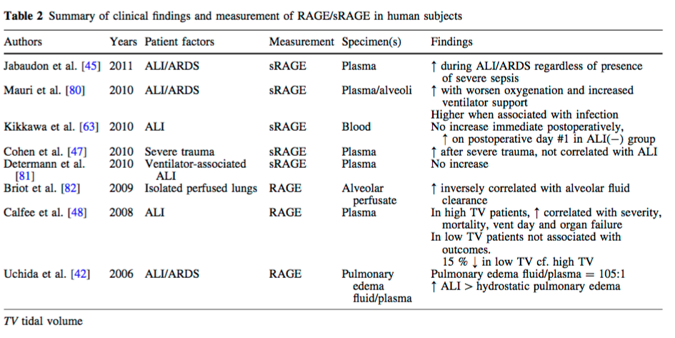
      - ref: Guo, W.A., et al. The receptor for advanced glycation end products and acute lung injury/acute respiratory distress syndrome. Intensive Care Medicine (2012) 38:1588-1598.
    - Surfactant protein D
      - Surfactant is composed of a lipid component (90%, mainly saturated phospholipid) and a protein component (10%, mainly surfactant specific apoprotein = surfactant proteins-A,-B,-C and –D.)
      - SP-B and SP-C are hydrophobic and lower the alveolar surface tension
      - SP-A and SP-D are hydrophilic and mediate host defense function
      - SP-A and SP-D are collectins (collagen-lectins) which have a C-terminal carbohydrate recognition domain (CRD) which mediates interaction with pathogens > cellular phagocytosis
      - Collectins bind to cell surface receptors on alveolar macrophages and type II cells and also form multimers to increase their affinity to immune cells and pathogens
      - Primarily expressed and secreted by type II alveolar cells, also by Clara cells, and in tracheal and bronchial glands of lower airways
      - Can interact with T lymphocytes and result in inhibition of T cells proliferation
      - Binds with high affinity to alveolar macrophages and improves phagocytosis by increasing activity of recognition receptors on alveolar macrophages. Alveolar macrophages also are involved in SP-D turnover via internalization and degradation.
      - Modulates migration of monocytes and neutrophils, recognizes DNA and RNA of apoptotic cells and facilitates clearance.
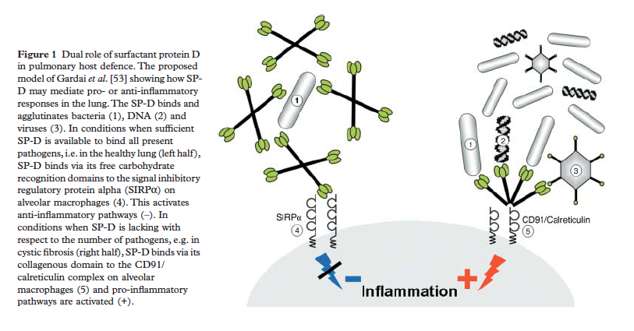
      - Ref: Hartl, D and Griese, M. Surfactant protein D in human lung disease. European Journal of Clinical Investigation (2006) 36, 423-435.

  - Endothelial injury: angiopoietin-2
    - Angiopoietin 1 interacts with Tie2 (tyrosine kinase with immunoglobulin like and EGF like domains 2). Angiopoietin 1 (Ang-1) protects against inflammation and vascular leakage induced by hemorrhagic shock where as angiopoietin-2 (Ang-2) promotes inflammation and vascular leakage in the lung and other organs and enhances effects of hyperoxia-induced lung injury.
    - Ang-1 expressed in different cell types including pericytes, vascular smooth muscle cells, fibroblasts and megakaryocytes
    - Ang-2 present in endothelial cells in storage granules (Weibel-Palade bodies) and can be rapidly released upon activation of the endothelium, becoming involved in vascular reactions such as inflammation. It modulates the response to stimuli like thrombin, VEGF and TNF-alpha
    - Ang-2 prevents Ang-1 from binding to its receptor (Tie2)
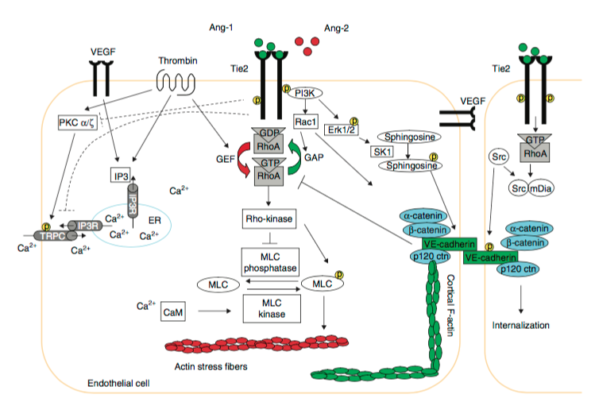
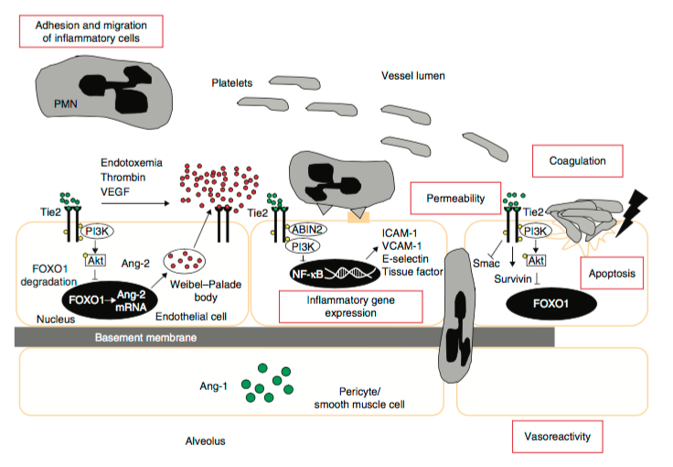
- ref: van der Heijden. 2009. The angiopoietin-Tie2 system as a therapeutic target in sepsis and acute lung injury. Expert Opinion on Therapeutic Targets 13:1, 39-53.
  - Inflammation: IL-6, IL-8, IL-33, soluble suppression of tumorigenicity-2
- Propensity score matching: 39 HFNC and 39 MV patients. Done to reduce selection bias and confounding due to differences between HFNC group and MV group. Nearest neighbor one to one matching. Balanced in terms of baseline characteristics and severity.
  - Used variables with p < 0.1 in univariate analysis OR variables previously used to describe ARDS severity
  - Acute Physiology and Chronic Health Evaluation II
  - Sequential Organ Failure Assessment
  - PaO2/FiO2
  - Origin of ARDS
  - Steroids
  - Renal Failure
  - Need for Vasopressors
- Controls: Non hypoxemic MV critically ill patients and healthy volunteers
- After propensity score matching, no significant differences in any of the biomarkers studied, mortality or length of stay.
- All biomarkers EXCEPT IL-33 were higher in ARDS patients than controls.
- Conclusions: HFNC patients should be considered ARDS patients.
- 8 mLs blood collected in EDTA tubes within 24 hours of ARDS onset (MV) or hypoxemia + bilateral infiltrates (HFNC)
- Plasma biomarkers were measured via commercial ELISA kits
- HFNC: Optiflow or Airvo 2: deliver up to 60 L/min of totally conditioned (37C 100% relative humidity) gas admixture. Used for patients with SpO2 < 92% or RR > 30 rpm with conventional O2 > 9 LPM. FIO2 > 0.5 and flow rate ≥ 40 LPM at onset. Flow adjusted to target SpO2 > 92% and flow adjusted per patient tolerance.
  - Failure of HFNC defined as subsequent need for MV based on decreased LOC (GCS < 12), cardiac arrest/arrhythmias/severe hemodynamic instability (norepi > 0.1 ug/kg/min) or persisting/worsening respiratory condition with at least two of the following:
    - Failure to achieve correct oxygenation (PaO2 < 60 mmHg on HFNC flow ≥ 30 LPM and FIO2 of 1)
    - Respiratory acidosis (PaCO2 > 50 mmHg with pH < 7.25)
    - RR > 30 rpm
    - Inability to clear secretions
- Results
  - Baseline characteristics
    - 21 (48.8%) of HFNC patients needed to be intubated. Afterwards duration of ventilation was similar to those directly intubated undergoing MV.
    - ICU and hospital mortality was lower in HFNC group
    - HFNC survivors had shorter ICU length of stay than MV survivors.
  - Propensity Score Biomarkers
    - No difference in mortality
    - No difference in lung epithelial (RAGE, SP-D) or endothelial (angiopoietin-2) injury biomarker levels between HFNC and MV
    - No differences in plasma IL-6, IL-8, IL-33 and ST2
    - Compared with control groups, all markers were higher in ARDS patients EXCEPT 1) IL-33 (only significantly different between MV and healthy controls) and 2) only a trend to higher angiopoietin-2 in HFNC patients compared to MV patients without lung injury.
  - HFNC failure
    - 19 patients (48.7%) in the matched population and 21 patients (48.8%) in the overall cohort failed HFNC and were then intubated
      - Mean PaO2/FIO2 of HFNC failures 24 hours post MV onset was 113 (93-204)
    - Higher ICU mortality and LOS than HFNC survivors
    - HFNC failures had higher concentrations of IL-8within 24 hours of ARDS onset than HFNC survivors
      - Levels of IL-8 ≥67.16 pg/mL independently predicted the need for MV in patients treated with HFNC even after adjusting for severity.
- Discussion
  - Lots of biomarker studies
    - ARDS vs MV controls vs heart failure
    - Direct (higher epithelial biomarkers like RAGE and SP-D) versus indirect ARDS (higher endothelial injury biomarkers like angiopoietin-2)
    - Inflamed (higher inflammatory biomarker levels, higher prevalence of sepsis/shock/metabolic acidosis and worse outcomes, benefit to higher PEEP) versus noninflammed endotype
  - HFNC group met all Berline criteria other than PEEP and express same biomarkers of lung injury, therefore should be considered ARDS
    - Study shows ARDS is prevalent in nonintubated patients
    - Reports of noninvasive management of ARDS with HFNC or noninvasive ventilation
  - Late intubation can worsen prognosis – potential utility for biomarkers to determine which patients may require MV
  - Things that make patients less likely to respond to HFNC
    - Shock, need for vasopressors
    - Other organ failure
  - Things that may indicate need to move from HFNC to MV
    - No significant decrease in RR
    - Thoracoabdominal asynchrony
    - Additional organ failure
    - Respiratory rate – oxygen index (SpO2/FIO2:RR) ≤ 4.88
