Board Review 8/17/17
HAI/MDR/MRSA

Ogeer-Gyles JS, Mathews KA, Boerlin P. Nosocomial infections and antimicrobial resistance in critical care medicine. Journal of Veterinary Emergency and Critical Care 16(1) 2006.
- Bacteria in a hospital environment are more resistant than those in the community given their exposure to antimicrobial drugs
- Rates of MDR organisms are increasing as antimicrobial use increases
  - Critically ill patients on antimicrobial drug therapy are at greatest risk for infection with MDR bacteria
  - Septic hospitalized humans who initially receive incorrect antimicrobials have increased morbidity and mortality
  - Eg. Dogs treated with enrofloxacin for 21 days shed large numbers of MDR E. Coli in their feces; providing a source for MDR infections in other patients
- Human hospitals in USA surveillance via National Nosocomial Infections Surveillance (NNIS)
- Concerning MDR bacteria in human medicine:
  - Methicillin-resistant Stapylococcus aureus (MRSA)
  - Vancomycin-resistant Enterococcus (VRE)
  - Extended-spectrum B-lactamase producing Gram neg bacilli
- Less focus on this concern in vet med
  - Absence of long term care facilities/ nursing homes
  - Shorter periods of hospital stay
  - Lower prevalence of immunosuppressive disease
  - Lower doses of immunosuppressive drugs
- Mechanisms of Antimicrobial Drug Resistance (Table 1)
  - Develops either through spontaneous mutation, or horizontal gene transfer:
    - Transformation -> uptake of naked DNA from the environment, usually from lysed donor bacterium
    - Transduction -> DNA transferred between bacteria by viruses (bacteriophages)
    - Conjugation -> cell-to-cell contact and transfer of plasmids **most relevant mechanism for transfer of resistant genes
  - Transposons or “jumping genes” = mobile DNA elements to allow gene movement within a bacterium
  - Integrons: genetic elements that encode mainly drug resistance, found in transposons in the chromosome, or on plasmids
  - Biofilms:
    - Microcolony of bacteria (eg. Kelbsiella pneumonia, pseudomonas aeruginosa) that grow in a matrix of extracellular polysaccharide
    - Film offers protection from antimicrobials via reduced rate of diffusion through the film or inability of antimicrobial to penetrate (eg. Aminoglycosides are positively charged and cannot move through negatively charged film)
    - Concern of biofilm formation of medical devices – eg. Central venous catheters, urinary catheters, ET tubes
- Risk factors for development of nosocomial infections
  - Patient risk factors
    - SIRS
    - Immunocompromised patients: immunosuppressive drugs, chemotherapy/ radiation therapy, geriatric, neonatal/ pediatric
    - Poor nutritional status
    - Increased metabolic demands: sepsis, burns, obesity, traumatic injuries, surgery
  - Hospital risk factors
    - Medical/ surgical device
    - Frequent of nosocomial infections in humans is 2-10x higher when in ICU versus other areas of the hospital
      - One half of patients entering the ICU have infections
      - Heavy antimicrobial use within the ICU
- Most common nosocomial infections (primarily gram neg): bloodstream, respiratory tract, urinary tract, surgical sites
  - Blood stream infections
    - Humans: mortality associated with catheter-related bloodstream infections is as high as 10%
    - Extra-luminal colonization typically from bacteria on patient’s skin or from the hands of the nurses
    - Organisms cultures from IV catheters in dogs: S. aureus, Strep spp, Klebsiells app, Serratia spp, E. Coli, Acinetobacter spp., Citrobacter frundii, Enterobacter spp.
  - Pneumonia/ Ventilator Associated Pneumonia
    - Aspiration of microorganisms – impaired immunologic defenses, poor mucociliary clearance, abnormal epithelial surfaces
    - Humans – pneumonia 21x more likely to develops within 48 hours after a critically ill patient in intubated
  - Urinary Tract Infections
    - Accounts for approximately 30-40% of all nosocomial infections in humans
    - Ascending infection from catheter lumen (contaminated urine in bag) or perianal area
    - Primarily GI flora - OVC – 10% of all positive urine cultures in ICU patients (dogs) are E. Coli
  - Surgical Site Infections
    - 15% of all nosocomial infections in humans
    - 5.9% infection rate in veterinary patients
    - Risk factors in veterinary patients (Nicholson et al. Vet Surg 2002): time of surgical site clipping, duration of surgery, duration of anesthesia (independent of surgical time), emergency versus daytime surgery, use of propofol, and inappropriate perioperative antimicrobial therapy
    - Longer duration of stay associated with infection
    - Risk of infection 1.3x higher for each additional person in the operating room
- Prevention strategies for reducing antimicrobial resistance
  - Limiting antimicrobial use
  - optimizing antimicrobial choice
    - adequate dosing and frequency
    - obtaining cultures
    - adequate duration
  - strict hygiene and isolation procedures
  - Implement broad spectrum therapy in patients with septic focus, but not in patients without septic focus (eg. Immune-mediated or neoplasic associated fevers)
  - Obtain cultures before initiating antimicrobial therapy, short prophylaxis (<5d), narrow spectrum

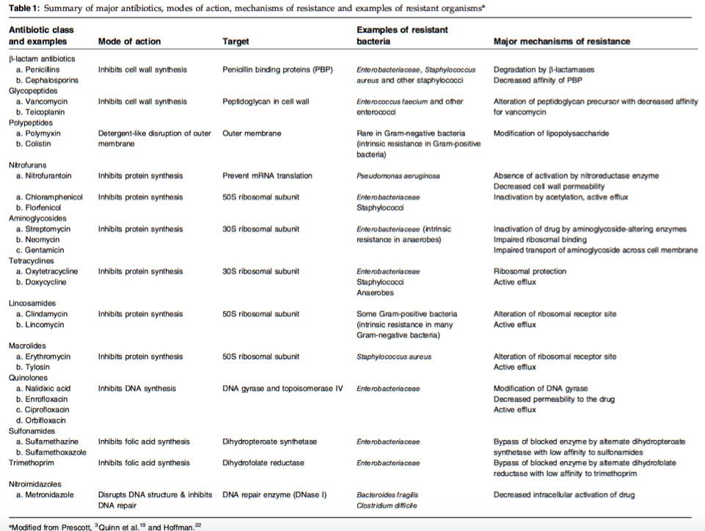
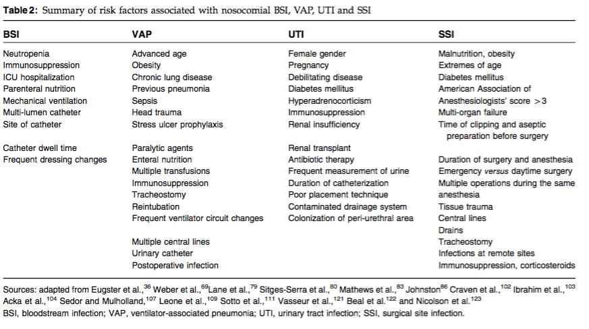
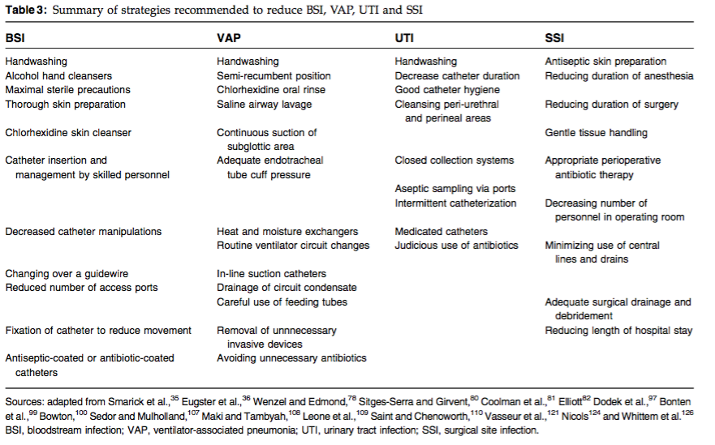
Ruple-Czerniak A, Aceto HW, Bender JB et al. Using Syndromic Surveillance to Estimate Baseline Rates for Healthcare-Associated Infections in Critical Care Units of Small Animal Referral Hospitals. J Vet Intern Med. 2013; 27: 1392-1399.

- Baselines of hospital-acquired infections have not been documented in veterinary med
- Concept of syndromic surveillance – measurement of nonspecific indicators of health or disease rather than measures of disease occurrence (i.e. lab tests)
  - Potentially less costly method of surveillance; used as screening test
- Multicentre study to evaluate baseline rates of healthcare associated infections among critically ill cats and dogs
- Methods
  - 4 veterinary referral hospitals; 12-week period in 2006
  - Animals hospitalized for >1 day in critical care unit
  - Identified:
    - demographic information
    - procedures/ treatments performed in hospital (i.e. catheter placement, surgery, intubation, endoscopy, antibiotic use, antiulcer medication use, lab samples)
    - occurrence of nosocomial syndrome unrelated to reason for hospital admission (IV catheter site inflammation, urinary tract inflammation, acute infectious respiratory tract disorders, acute GI disorders, surgery site inflammation/ infection, fever of undetermined origin, septicemia)
- Results
  - 1535 dogs and 416 cats; 41%, 53% admitted on emergency and 11%, 14.9% overall mortality rate
  - Table 2 & 3
- Conclusions
  - Positive association of risk of nosocomial syndromes:
    - increased duration of hospitalization
    - undergoing surgery
    - placement of a urinary catheter
    - use of antiulcer medications
    - receiving antimicrobial drugs (outside of perioperative use)
  - *Data collected retrospectively and therefore unsure if occurrences may have been reaction to nosocomial syndrome
  - Rate of nosocomial infections higher in dogs than cats
  - Easy and cost-effective way to collect information regarding nosocomial infections
  - High variability among institutions suggesting that a portion of the events are preventable
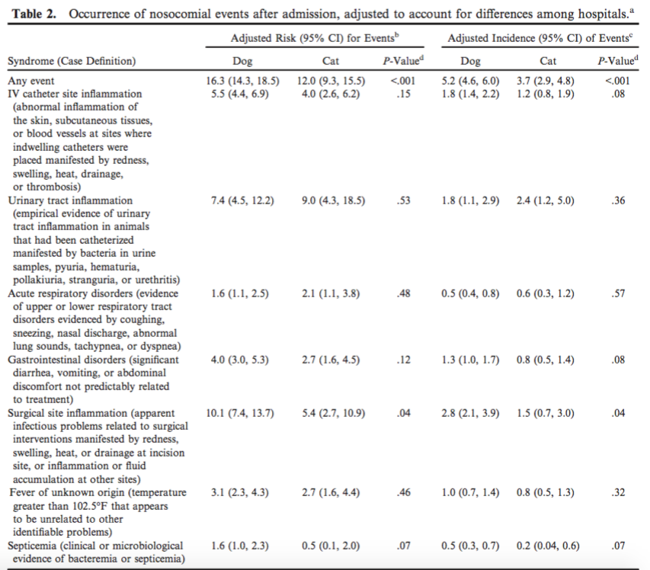

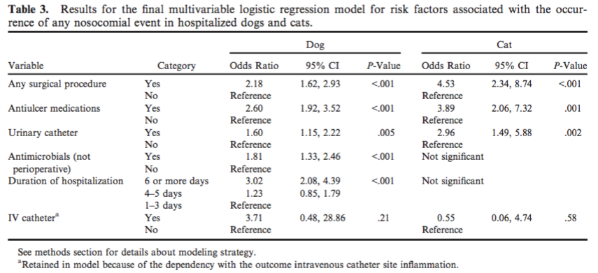
Black DM, Rankin SC, King LG. Antimicrobial therapy and aerobic bacteriologic culture patterns in canine intensive care unit patients: 74 dogs. J Vet Emerg Crit Care 2009; 19(5): 489-495

- Retrospective study of 74 canine ICU patients over 6 months in 2006
- Only collected information from patients with culture results (eliminating >80% of ICU population)
- Collected data regarding patient antimicrobial use, MIC results and clinical data
- 44% of cultures were positive
  - E. Coli 23%
  - Stapylococcus intermedius 10%
  - Acinetobacter baumannii 7%
- MDR pattern in 27% of isolates and was significantly more likely after 48 hours of hospitalization
  - More than half the C/S submitted after 48 hours were MDR
  - Speculate that patients with suspected gram neg sepsis >48 hours in-hospital empiric choices would include gentimicin, amikacin, imipenem (unless methicillin-resistant Staph, then TMS or doxycycline)
- Empiric antibiotics used in 57% of dogs before culture submission: enrofloxacin (55%), amoxicillin (48%), amoxicillin/clavulanic acid (19%)
  - Empiric choice was correct 30% of time
  - 49% of patients with negative cultures received antimicrobials prior to culture results – only 35% were managed moving forwards without antimicrobials
- Empiric antibiotics used in 94% of dogs while pending culture results: ampicillin(78%), enrofloxacin (73%), amikacin (13%)
  - appropriate 75% of time
- Post-MIC antimicrobials were correct 89% (17/19) of time
- 37% of dogs continued to receive antimicrobials despite negative cultures

Hamilton E, Kruger JM, Schall W et al. Acquisition and persistence of antimicrobial-resistant bacteria isolated from dogs and cats admitted to a veterinary teaching hospital .J Am Vet Med Assoc 2013; 243: 990-1000

- Prospective longitudinal study of 662 dogs and 92 cats with ICU stay >48 hours
- Rectal and nasal swabs collected at admission and discharge
- Enterococci, staphlylococci and E. coli tested via microbroth dilution
- Trends in antimicrobial resistance were tacked over the 3 year study period
- Results
  - Proportion of staphylococci with resistance increased by 225%; E. coli with resistance decreased; enterococcus was variable
  - MDR E Coli acquired by 8% of dogs and MRSA acquired by 1.4%
  - Hospitalization for >3 days was associated with development of MDR organisms
  - Antimicrobial administration did not affect acquisition of MDR organism

Traa MX, Barboza LB, Doron S et al. Horizantal infection control strategy decreased methicillin-resistant Staphylococcus aureus infection and eliminates bacteremia in a surgical ICU without active surveillance. Critical Care Medicine 2014.

- Historically human medicine has been focuses on active surveillance and a “search and destroy” model to handling hospital acquired infections (eg. Weekly nasal swabs); however this is an expensive and heavy workload model
- 6,697 patients; Retrospective observation study at Tufts Medical Centre
- Infection prevention strategies
  - Hand hygiene program with refresher education campaign (handwashing or handrub before every patient interaction)
  - Chlorhexidine oral hygiene program (6x daily for mechanically ventilated patients)
  - Chlorhexidine bathing (sponge-bathing 1-3x daily)
    - Has been showed to decrease MDR acquisition by 23% and MRSA acquisition by 32% (Climo Crit Care Med 2009)
  - Catheter-associated bloodstream infection program (sterile technique, antimicrobial-coated catheters, chlorhexidine-impregnanted central-catheter dressings)
  - Daily goal sheets
- MRSA infection rates decreased an average of 21% per year, which the biggest decline after the introduction of the catheter-associated bloodstream infection program
- Aggressive infection control is effective for eliminating MRSA in the ICU without the need for active surveillance
