Excitable Tissue – Nerve

Glial cells
- Undergo cell division in adulthood (unlike neurons)
- Two major types of glial cells:
  - Microglia: scavenger cells that remove debris from injury, infection and disease; resemble tissue macrophages
  - Macroglia:
    - Oligodendrocytes – involved in myelin formation
    - Schwann cells – involved in myelin formation
    - Astrocytes – found throughout brain; processes bind to blood vessels to form blood-brain barrier
      - Fibrous astrocytes – found primarily in white matter
      - Protoplasmic astrocytes – gray matter; take up K+ and neurotransmitters glutamate and gamma-aminobutyrate (GABA)

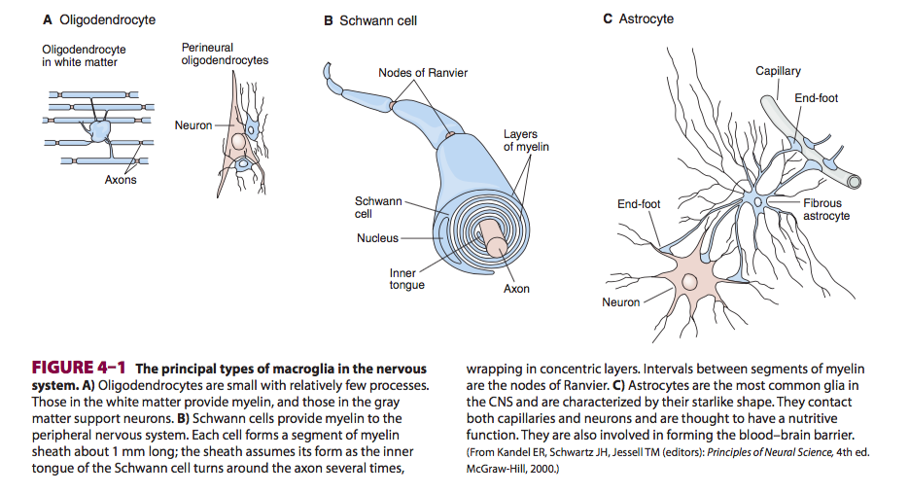

Neurons

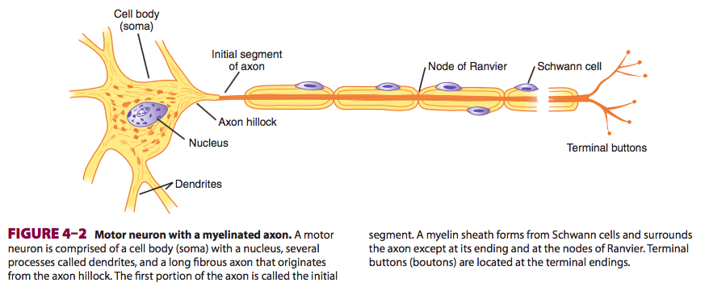

- 4 components to every neuron:
  - Receptor/ dendritic zone that integrates multiple local potential changes
  - Site where propagated action potentials are generated
  - Axonal process that transmits impulse to the nerve ending
  - Nerve ending where granules containing neurotransmitters are released
- Cell body is generally at the dendritic zone, but it can also be within the axon (eg. Auditory neurons) or attached to the side of the axon (eg. Cutaneous neurons)
- Some neurons have multiple processes – bipolar (eg. Retina), or multipolar (eg. Motor neurons)
- Most axons are myelinated (protein-lipid complex wrapped around)
  - Schwann cells wrap membrane around the neuron 100x in the peripheral nervous system
  - Neuron ending and Nodes or Ranvier are not myelinated
  - Unmyelinated neurons are surrounded by Schwann cells without wrapping around the axon
  - CNS –myelin formed by oligodendrocytes (emit multiple processes that form myelin on neighboring axons)

Axonal Transport
- Axoplasmic flow: transport of proteins from cell body to axonal ending
- Wallerian degeneration: if axon is cut, the part distal to the cut (not associated with the cell body) dies
- Orthograde transport:
  - From the cell body toward the axon terminals
  - Occurs along microtubules that run along the length of the axon
  - Requires dynein and kinesin
  - Occurs at 400 mm/day (fast) or 0.5-10 mm/day (slow)
- Retrograde transport:
  - Opposite direct (axon terminal to cell body)
  - 200 mm/day
  - Eg. Used synaptic vesicles or material taken up by endocytosis (nerve growth factor, viruses) may be carried back to the cell body and degraded by lysosomes

Excitation and Conduction
- Nerve cells respond to electrical, chemical and mechanical stimuli, creating:
  - Synaptic, generator or electrotonic potentials -- local, non-propagated signals
  - Action potentials/ nerve impulses – propagated potentials
- Impulses are actively conducted along axon
- Resting membrane potential -70 mV
  - Established by Na+/K+ ATPase
  - More open K+ channels than Na+ channels at rest and thus resting membrane potential is closer to equilibrium potential of K+ (-90 mV)
- Action potential
  - Resting state (RMP -70 mV)
  - Depolarization
    - Stimulus
    - Opening of voltage gated Na+ channels Na+ enters cell
    - Threshold potential entry of Na+ allows opening of more voltage-gated Na+ channels positive feedback loop
    - Rapid upswing in membrane potential towards equilibrium potential for Na+ (+60 mV); only reaches ~30 mV
    - Reversal of membrane potential
    - Na+ channels rapidly become inactivated then return to a resting state
    - Opening of voltage-gated K+ channels (slower and more prolonged than Na+)
  - Repolarization
    - Net movement of + out of cell allows for repolarization
    - (Na+ channels closed, K+ channels still open)
  - Hyperpolarization
    - Overshoot of membrane potential
    - Slow return of K+ channels to a closed state
  - Refractory period
    - Absolute refractory period: until repolarization is about 1/3 complete – no stimulus can excite the nerve
    - Relative refractory period: until the end – stronger than normal stimuli can cause excitation
  - Return to resting membrane potential
- Threshold potential – minimal stimulus that will produce an action potential (-55 mV)
  - Strength and duration of the stimulus are relevant
  - “all or none” - Action potential occurs with constant amplitude/ form regardless of the strength of the signal
  - Subthreshold stimulus can result in a localized depolarizing potential change

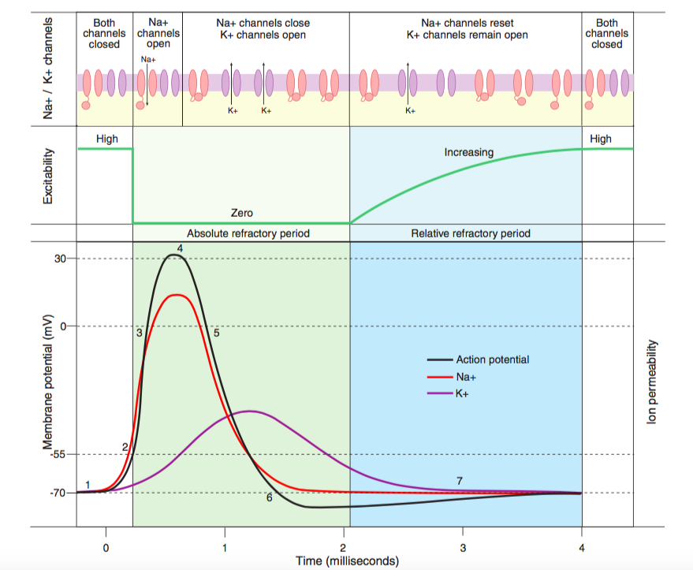

- Electrolyte changes
  - Hyperkalemia – resting membrane potential moves closer towards threshold to elicit action potential neurons become more excitable
  - Hypokalemia hyperpolarized neurons / decreased excitability
- Saltatory conduction: depolarization occurs from one node of Ranvier to the next
  - Voltage gated Na+ channels are highly concentrated in the initial segment and nodes of Ranvier
  - Allows myelinated axons to conduct up to 50X faster than unmyelinated fibers
- Depolarization can occur in either direction
  - Orthodromic condution: from synaptic junction along axons to termination
  - Antidromic conduction: conduction from middle of axon toward synapse, where impulse will die out

Mixed nerves
- Epineurium: bundles of axons together into a fibrous envelope
- Mammalian nerve fibers are classified into A, B and C groups
  - In general, the greater the diameter of a nerve fiber the faster its speed of conduction
  - Larger axons: proprioceptive sensation, somatic motor function, conscious touch, pressure
  - Smaller axons: pain, temperature sensation, autonomic function
  - Differ fiber types are more susceptible to hypoxia, pressure and local anesthetics
    - Eg. Local anesthetics will block pain fibers before group A touch fibers
    - Eg. Pressure will affect group A touch fibers before pain fibers
- Local anesthetics – blockade of voltage-gated Na+ channels causes gradual increase in threshold for excitability, a reduction in the rate of rise of the AP, slowing of axonal conduction velocity – eg. Ester-linked (Cocaine, procaine, tetracaine), amide-linked (lidocaine, bupivacaine)

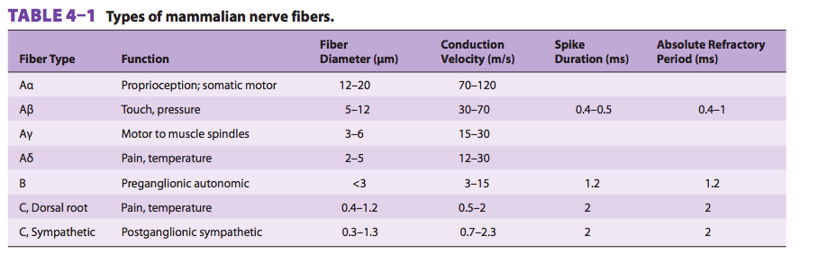
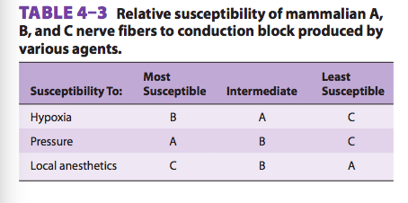

Axonal regeneration – peripheral nerve damage is often reversible. Axon will degenerate distal to the damage but axonal sprouting will occur from the proximal stump via growth-promoting factors. Conversely, in the CNS, distal stump recovery is rare partly because growth-promoting chemicals are not needed in the CNS. Additionally, CNS myelin is an inhibitor of axonal growth.
NSAIDs may overcome factors that inhibit axonal growth.

Neurotrophins
- Proteins needed for survival and growth of nerves
- Tyrosine kinase associated (Trk) receptors are at the end of neurons and bind neurotrophins
  - Dimerization initiates autophosphorylation
- Internalized and transported to neuronal cell body or produced in neurons and transported to the nerve ending
- Nerve growth factor (NGF) – necessary for growth and maintenance of sympathetic neurons and some sensory neurons
- Other factors important for neuronal growth: ciliary neurotrophic factor (CNTF), glial cell line-derived neurotrophic factor (GDNF), leukemia inhibitory factor (LIF), insulin-like growth factor (IGF-I), fibroblast growth factor (FGF), platelet derived growth factor (PDGF)

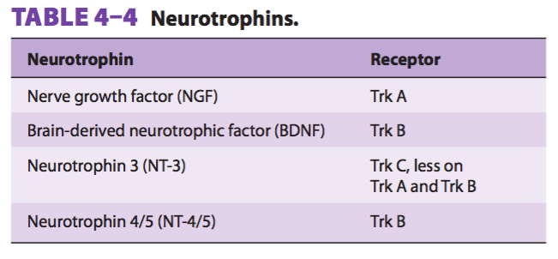

Excitable Tissue – Muscle

Skeletal muscle morphology
- Muscle fibers are arranged in parallel between tendinous ends
- Force of contraction of the units is additive
- Each muscle fiber is a single cell that is multinucleated, long, cylindrical
  - Surrounded by cell membrane called the sarcolemma
  - Muscle fibers are made up of myofibrils which are then grouped into myofilaments
- Contractile units skeletal muscle: myosin-II, actin, tropomyosin, troponin
  - Troponin: troponin I, troponin T, troponin C
- Striations visible in muscle are termed I band, Z line, A band, H band
  - Sarcomere: area between 2 adjacent Z lines
  - Thick filaments: myosin; lined up to form A band
  - Thin filaments: actin, tropomyosin, troponin; extends out into I band
  - H bands (lighter part in centre of A bands) - regions where when muscle is relaxed the thin filaments do not overlap with the thick filaments
  - Z lines – anchoring of the thin filaments; move closer together when the muscle contracts and further apart when it relaxes
  - M-line – site of reversal of polarity

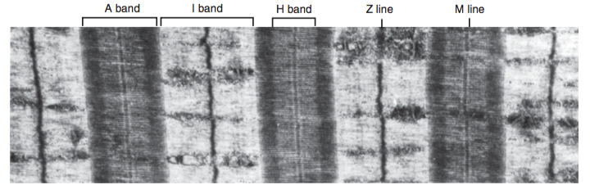

- Myosin-II has 2 globular heads and a long tail. Heads form cross bridges with actin
  - Heads contain actin-binding sites and catalytic binding site that hydrolyzes ATP
- Actin – formed thin filaments in a long double helix
  - Tropomyosin molecules are located in the groove between the actin chains
  - Troponin are located at intervals along the tropomyosin molecules
    - Troponin T - binds the troponin components to tropomyosin
    - Troponin I - covers sites where myosin heads interact with actin
    - Troponin C - contains binding sites for Ca++ that initiates contraction
- Other structural proteins
  - Actinin: binds actin to the Z lines
  - Titin: connects the Z lines to the M lines and provided scaffolding for the sarcomere
  - Desmin: binds Z lines to plasma membrane to create structure
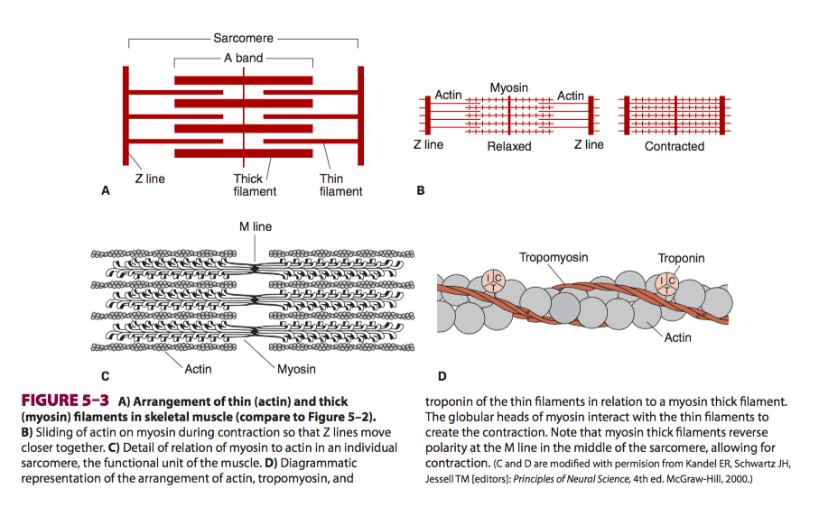

Sarcotubular system
- T system (transverse tubules) and sacroplasmic reticulum
- T-system is continuous with the sarcolemma of the muscle fiber
- Space between the 2 layers of the T system forms the sarcoplasmic reticulum – important store of Ca++
- Provides a path for rapid transmission of the action potential from the cell membrane to all the muscle fibrils

Electrical Characteristics of Skeletal Muscle
- Resting membrane potential of skeletal muscle -90 mV
- Excitation contraction coupling
  - Mechanical response (twitch) starts about 2ms after the chemical response (depolarization of the membrane)
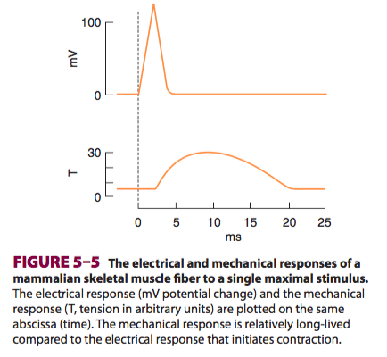

  - Discharge of motor neuron
  - Release of transmitter (acetylcholine) at motor end plate
  - Binding of acetylcholine to nicotinic acetylcholine receptors
  - Increased Na+ and K+ conductance in the end-plate membrane
  - Generation of AP in muscle fibers
  - Inward spread of depolarization along T tubules
  - Release of Ca++ from terminal cisterns of sarcoplasmic reticulum via dihydropyridine receptos (DHPR) and diffusion to thick and thin filaments
    - DHPR – voltage gated Ca++ channels in the T tubule membrane
    - DHPR unlock release of Ca++ from the sarcoplasmic reticulum via physical interaction with ryanodine receptor (RyR)
    - Ca++ is amplified through calcium-induced calcium release
  - Binding of Ca++ to troponin C, uncovering myosin-binding sites on actin
  - Formation of cross-linkages between actin and myosin and sliding of thin on thick filaments, producing movement
  - Relaxation
    - Sarcoplasmic reticulum Ca++ ATPase (SERCA) pumps calcium back into the terminal cisterns
    - Release of Ca++ from troponin
    - Cessation of interaction between actin and myosin
    - Contracture occurs if Ca++ cannot be transported back into the reticulum
- Sliding filament theory
  - Contraction is brought about by sliding of thick filaments over thin filaments, increasing overlap
  - Myosin heads bind firmly to actin, bend their “necks”, then detach
    - Requires hydrolysis of ATP
    - At rest myosin heads contain tightly bound ADP
  - AP increase in cytosolic [Ca++] free Ca++ binds to troponin C weakening of troponin I interaction with actin, exposing actin binding site for myosin to allow for formation of myosin/ actin cross-bridges
  - Formation of cross-bridge ADP release change in shape of myosin head to form cross-bridge ATP binds free site and is hydrolyzes Myosin neck bends
  - As long as Ca++ levels are sufficient, cycle repeats producing gross muscle contraction
- Isometric contraction: contraction without an appreciable decrease in the length of the whole muscle
- Isotonic contraction: contraction against a constant load with a decrease in muscle length
- Summation of contractions: contraction mechanism does not have a refractory period – tension will build

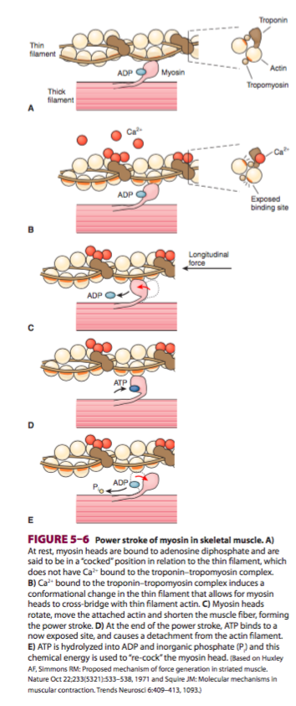

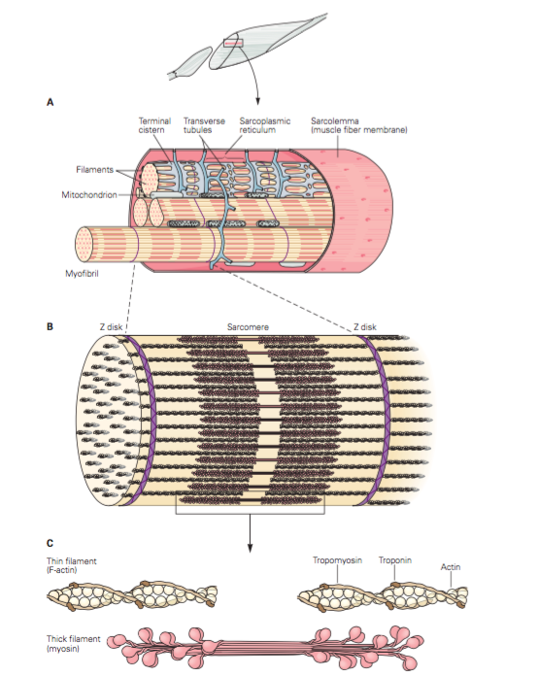

Skeletal muscle fiber types

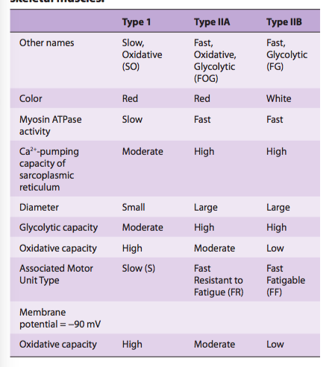

Energy sources
- ATP ADP
- Phosphorylcreatine is another energy-rich phosphate compound that can be used for short supplies of energy
  - Phosphorylcreatinine Creatine
- Free fatty acids primary course of energy at rest and light exercise
- CHO metabolism important with higher intensity of exercise
- When energy expended exceeds what is able to be met by aerobic metabolism, energy is created through the anaerobic breakdown of glucose to lactate
  - Anaerobic metabolism is limited by the reduction in pH that lactate causes, inhibiting enzymes
  - After exertion, extra O2 is consumed to remove excess lactate, replenish ATP and phosphorylcreatine stores
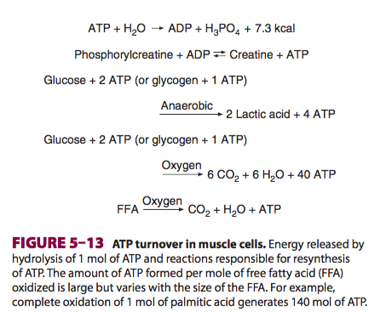

Motor Unit
- A single motor neuron and the muscle fiber it innervates
- The number of muscle fibers in a motor unit varies (eg. fewer in areas requiring precise movement)
- Each spinal motor neuron innervates one kind of muscle fiber
- Increased cell activity hypertrophy
- Inactivity atrophy

Electromyogram
- Small electrodes pick up activity of single muscle fibers
- Measured EMG depicts the potential difference between 2 electrodes

Cardiac muscle

- Each muscle fiber is a complete unit surrounded by a cell membrane
- Intercalated disks: Where one muscle fiber meets another, there is an area of extensive folds; maintain cell to cell cohesion
- Gap junctions form between adjacent fibers; providing low-resistance bridges for excitation of one fiber to another allow cardiac muscle to function as a syncytium
- T-system located at the Z lines rather than A-I junction (skeletal muscle)

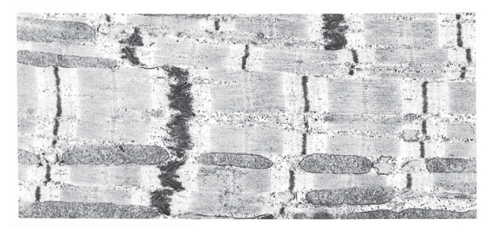
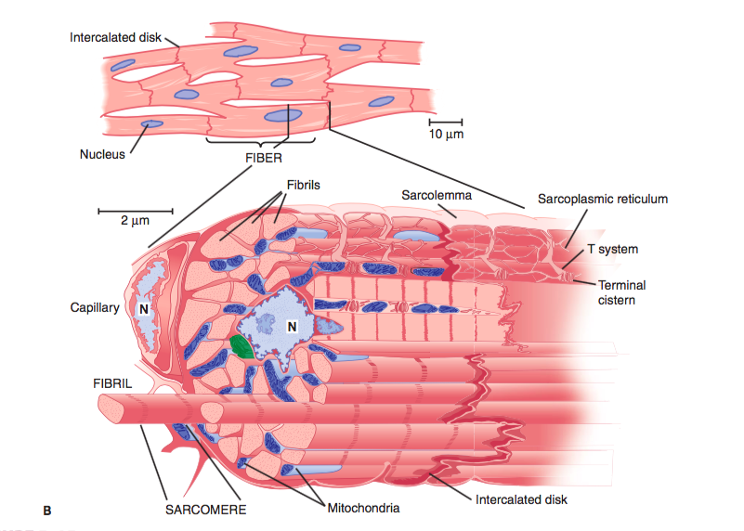

Electrical Properties
- RMP -80 mV
- Depolarization occurs, but then is followed by a plateau before the membrane potential returns to baseline. Repolarization is not complete until the contraction is half over
- Phase 0 –rapid depolarization and overshoot (opening of voltage-gated Na+ channels)
- Phase 1 – rapid repolarization (closure of Na+ channels and opening of one type of K+ channel)
- Phase 2 – prolonged plateau (slower but prolonged opening of voltage-gated Ca+ channels )
- Phase 3 – final repolarization (closure of the Ca++ channels and a slow, delayed increase of K+ efflux)
- Phase 4 – resting membrane potential
- Excitation contraction coupling
  - Similar to skeletal muscle, except influx of Ca++ through DHPR in the T system activates calcium-induced calcium release
- Absolute refractory period extends into phase 4 meaning that cardiac muscle cannot experience tetany
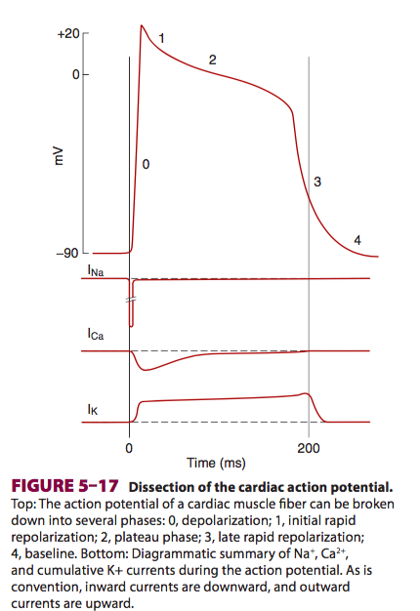

Smooth Muscle

- Lacks visible cross striations
- Troponin is absent
- Sarcoplasmic reticulum is less extensive
- Much fewer mitochrondia – relies on glycolysis
- Types
  - Visceral (unitary) – occurs in large sheets, has many low-resistance gap junctions between muscle cells, functions as synsytium, eg. Intestine, uterus, ureters
  - Multiunit – few gap junctions allowing for finely control, eg. Iris
- Electrical activity
  - Continuous, irregular contractions that are independent of nerve supply
  - Maintained state of partial contraction = tone
  - “resting potential” -20 to -65 mV
  - “sine” like waves; sometimes have prolonged plateau like cardiac muscle
- Contractions relaxation
  - Binding of acetylcholine to muscarinic receptors
  - Increased influx of Ca++ into the cell
    - Influx through voltage or ligand gated channels
    - Efflux from intracellular stores through RyR or inositol triphosphate receptor (IP3R) Ca++ channel
  - Activation of calmodulin-dependent myosin light chain kinase through Ca++ binding to calmodulin
  - Phosphorylation of myosin
  - Increased myosin ATPase activity and binding of myosin to actin
  - Contraction
  - Dephosphorylation of myosin by myosin light chain phosphatase
  - Relaxation, or sustained contraction due to the latch bridge

Synaptic and Junctional Transmission

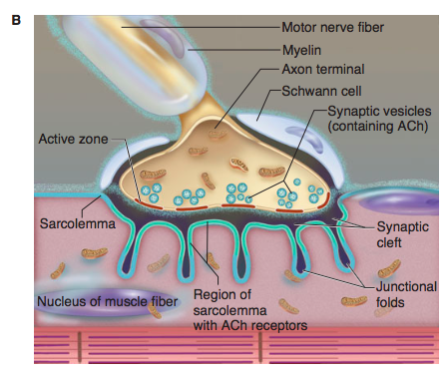

- Ends of presynaptic fibers are enlarged to formed terminal boutons or synaptic knobs
- Sometimes endings are at dendritic spines – especially in cerebral and cerebellar cortex
- Each neuron divides into ~2000 synaptic endings
- Pre-synaptic terminal is separated from the post-synaptic structure by a synaptic cleft (20-40 nm wide)
- Many neurotransmitter receptors in the postsynaptic membrane
- Postsynaptic density: postsynaptic thickening; ordered complex of specific receptors, binding proteins and enzymes
- Presynaptic terminal contains many mitrochrondia, and membrane-bound vesicles containing neurotransmitters
- 3 kinds of synaptic vesicles:
  - small, clear synaptic vesicle that contain acetylcholine, glycine, GABA, or glutamate
  - Small vesicles with a dense core that contain catecholamines
  - Large vesicles with a dense core that contain neuropeptides
  - These vesicles and proteins are synthesized in the cell body and transported by fast axoplasmic transport; small vesicles are recycled in the nerve ending
- Ca++ triggers exocytosis of transmitters; voltage gated Ca++ channels located close to release sites at active zones
- Neurexins: proteins bound to the membrane of the presynaptic neuron that bind neurexin receptors in the postsynaptic membrane to hold synapses together

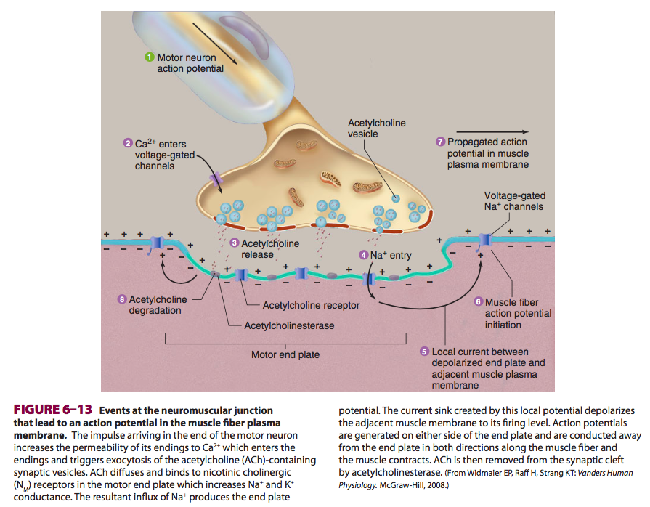

Clostridium tetani and clostridium botulinum – neurotoxins bind irreversibly to the presynaptic membrane of the NMJ and use retrograde axonal transport to the cell body of the motor neuron in the spinal cord. Presynpatic inhibitory interneurons pick up the toxin and the release of glycine and GABA is blocked activity of motor neurons is markedly increased spastic paralysis
Botulism toxin cleaves a presynaptic membrane protein needed for fusion of synaptic vesicles containing acetylcholine to the terminal membrane flaccid paralysis

Electrical events in postsynaptic neurons
- Synaptic delay: time it takes for the synaptic mediator to be released and act on the post-synaptic membrane receptor
  - Conduction is slower if there are many synapses
  - Can determine if a pathway is monosynaptic or polysynaptic by measuring the synaptic delay
- Excitatory postsynaptic potential (EPSP): depolarization of the post-synaptic cell membrane immediately under the pre-synapatic membrane; opening on Na+ and Ca++ channels in the post-synaptic membrane, producing an inward current in a very small area – not enough to depolarize the membrane but enough to created EPSP
  - Depolarizations in each active knob summate
  - During this phase – excitability of the neuron to other stimuli is increased
- Inhibitory postsynaptic potential (IPSP) – summation of hyperpolarizing responses – excitability of neuron is decreased
  - Eg. Localized increased in Cl- transport (opening of Cl- charge allowing influx of Cl-, increasing membrane potential)

Generation of AP in the post-synaptic neuron
- Constant activity of excitatory and inhibitory activity on the postsynaptic neuron produces a fluctuating membrane potential that is a sum of the hyperpolarizing and depolarizing activities
- Once depolarization threshold is reached, AP will be generated
- Motor neurons – portion of the cell with the lowest threshold for production of an action potential is the initial segment

Temporal and spatial summation of postsynaptic potentials
- Time constant: determines the time course of the synaptic potential
  - The longer the time constant, the greater the chance for summation to induce an AP
  - = temporal summation
- Length constant: determines the degree to which a depolarizing current is reduced as it spreads
  - If the neuron has a long length constant, the membrane depolarization induced by input arriving at two points on the neuron with minimal decrement
  - = Spatial summation

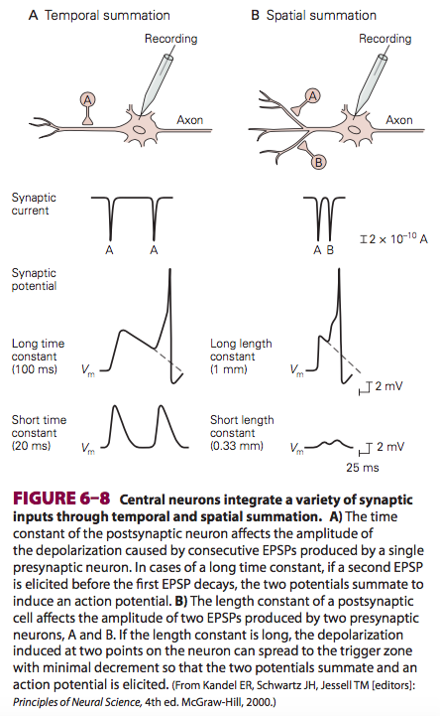

Inhibition and facilitation at the synapses
- Inhibition in the CNS can be postsynaptic or presynaptic
- Direct inhibition: inhibition that is not a consequence of previous discharges the postsynaptic neuron
- Indirect inhibition: inhibition due to the effects of previous postsynaptic neuron discharge. E.g. Postsynaptic cell may be refractory to excitation because it just fired and is in it refractory period
- Postsynaptic inhibition
  - Occurs when an inhibitory transmitter ( e.g. Glycine, GABA) is released from a presynaptic nerve terminal onto the postsynaptic neuron
- Presynaptic inhibition and facilitation
  - Process mediated by neurons whose terminals on excitatory endings, forming axoaxonal synpases
  - GABA was the first transmitter showing to produce presynaptic inhibition via an increase in chloride conductance
  - presynaptic facilitation occurs when the action potential is prolonged and the calcium channels are open for a longer period
- Inhibitory systems are usually stimulated by converging stimuli on the post synaptic neuron

Neuromuscular transmission
- Neuromuscular junction: acetylcholine is within small clear of vesicles of the terminal boutons
- Depressions in and the motor end plate are called junctional folds
- Motor end plate is the thicken portion of the muscle membrane at the junction
- Space between the nerve and motor end plate
- Only one nerve fiber ends on each end plate
- Transmission:
  - Similar to process at synapse
  - Increased permeability of nerve endings to calcium
  - Calcium enters neuron and triggers marked increase in exocytosis of acetylcholine containing vesicles
  - Acetylcholine diffuses to nicotinic cholinergic receptors (N_{M}) that are concentrated at the top the junctional folds the membrane of the motor and plate
  - Acetylcholine binds these receptors
  - Increases sodium and potassium conductance
  - Influx of sodium produces depolarization = end plate potential
  - Local change in potential depolarizes the adjacent muscle membrane
  - Acetylcholine is removed from the synaptic cleft buy acetylcholinesterase
- Small quanta of acetylcholine are released randomly from the nerve cell membrane at rest which produce a miniature end plate potential (minute depolarizing spike)
  - Size quanta released depends on calcium concentration and inversely with magnesium concentration at the end plate
- Myasthenia gravis - antibody to the muscle type of nicotinic cholinergic receptors
  - Neuromuscular transmission fails at low levels of acetylcholine release leading to muscle fatigue with sustained activity
  - Treatment: acetylcholinesterase inhibitor, e.g. Neostigmine or pyridostigmine

Nerve endings in smooth muscle
- Smooth muscle
  - Some of these nerve fibers contain clear vesicles under cholinergic
  - Some contain dense core vesicles that contain norepinephrine
  - No recognizable end plates
  - Excitatory junction potentials: stimulation of noradrenergic nerve produced discrete partial depolarizations that summate with repeated stimuli
  - Inhibitory junction potentials: tissues inhibited by noradrenergic stimuli, hyperpolarizing
- Cardiac muscle
  - Cholinergic and noradrenergic nerve fibers and on the sinoatrial node, the atrioventricular node and in the bundle of His
  - Noradrenergic fibers also innervate the ventricular muscle

Denervation hypersensitivity – when a motor nerve to skeletal muscle is cut and degenerates it gradually becomes extremely sensitive to acetylcholine.
- Marked proliferation of nicotinic receptors over wide region of the neuromuscular junction
- Also occurs in smooth muscle

