Chapter 6
Effects of Hormones on Renal Function

Mechanisms of Hormone Action: They activate specific cellular proteins via phosphorylation or by inducing the synthesis of new proteins. Hormones initiate these events by affecting:
- Adenylyl cyclase
- Guanylyl cyclase
- Phosphatidylinositol turnover
- RNA transcription

Adenylyl Cyclase
- Receptor on basolateral membrane of the tubular cell
- Stimulate:
  - Vasopressin (V²)
  - Parathyroid hormone
  - β-adrenergic
  - Prostaglandins (vascular effect)
- Inhibits:
  - Prostaglandins
  - α²- adrenergic
  - Angiotensin II (tubular effect)

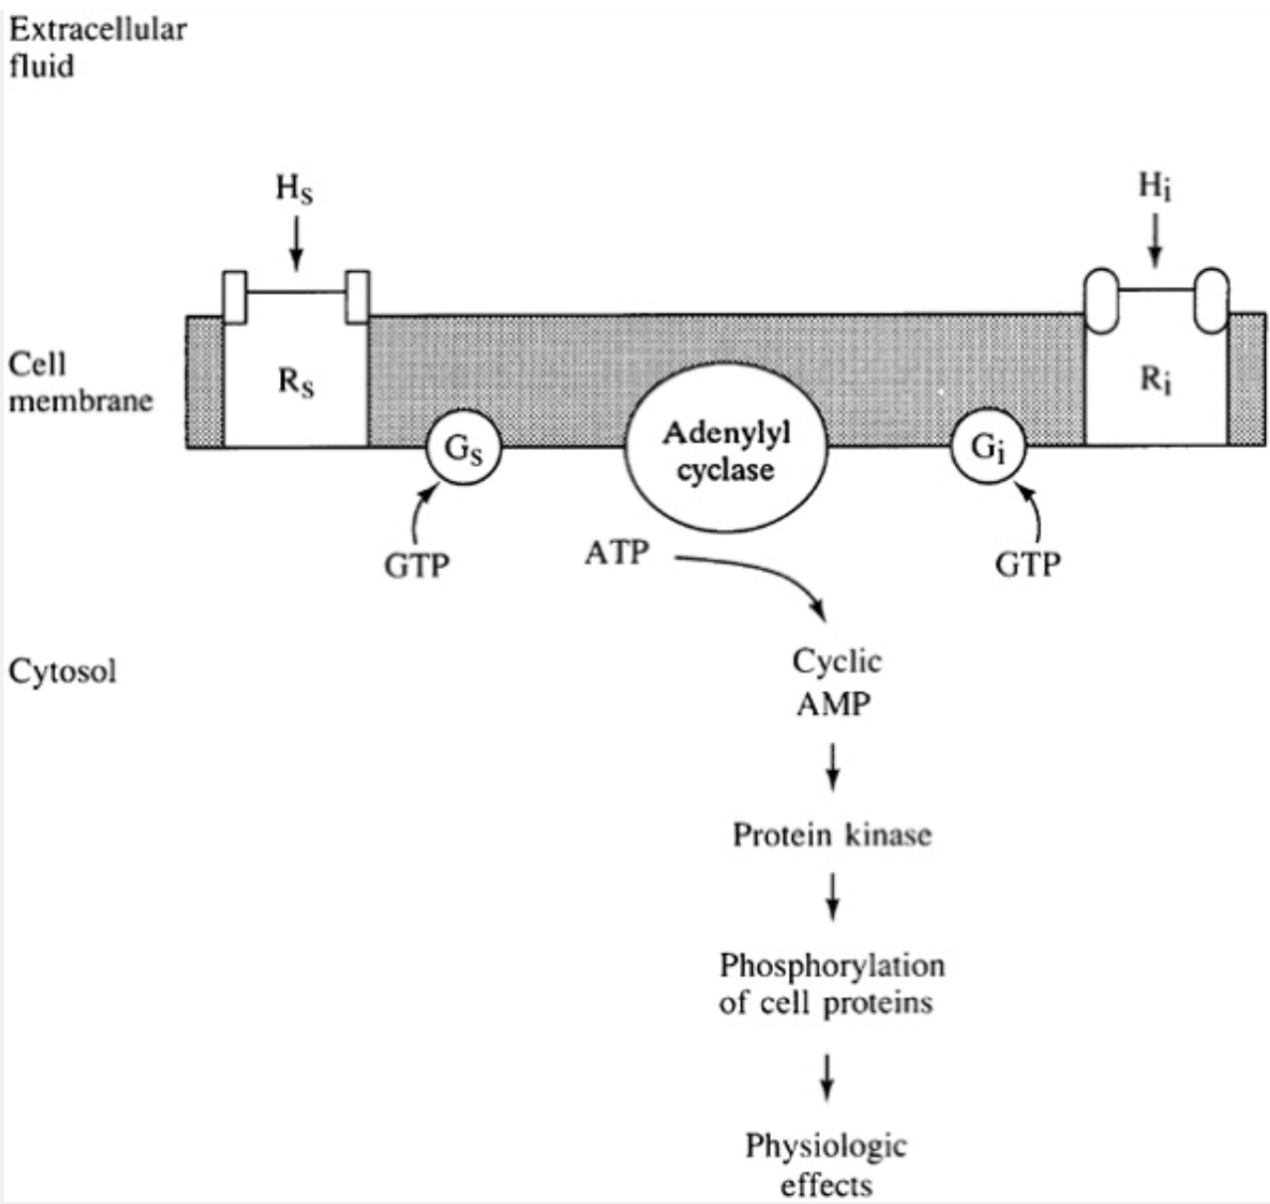

Guanylyl Cyclase:
- Leads to formation of GMP and phosphorylation of specific cell proteins
- Mediates actions of atrial natriuretic peptide, and of direct vasodilators (nitroprusside and nitroglycerin)
- There are no stimulatory or inhibitory regulatory proteins
- Binding of ANP induces conformational change, leading to generation of cyclic GMP

Phosphatidylinositol Turnover:
- Hormones bind to G protein activated receptors (Ang II and norepinephrine)
- Phospholipase is activated instead of adenylyl cyclase
  - Promotes breakdown of mb lipid into inositol and diacylglycerol, which increases the release of ca from endoplasmic reticulum and enhancing uptake of extracell Ca, this Ca binds to calmodulin, leading to phosphorylation of cell proteins and physiologic effects of the hormones

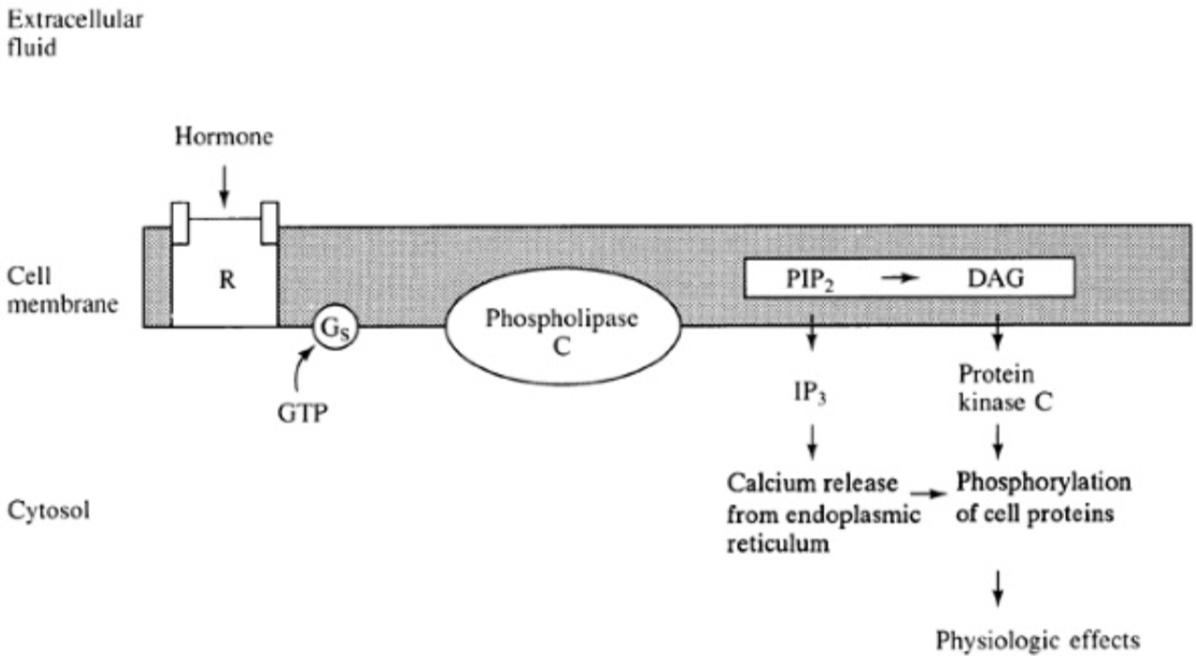

RNA Transcription:
- Steroid hormones (aldosterone, calcitriol and cortisol), produce new protein synthesis
- These hormones are lipid-soluble and diffuse through the mb and combine with receptors in the cytosol
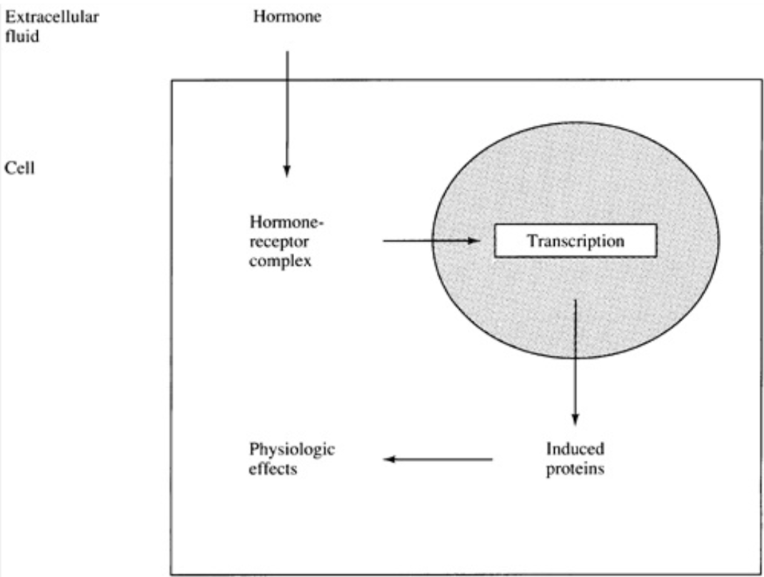

Antidiuretic Hormone and Water Balance

- Synthesized in the supraoptic and paraventricular nuclei in the hypothalamus
- Secretory granules with ADH migrate down the axons of the supra-optico-hypophyseal tract into the posterior pituitary, where they are stored till needed
- ADH is metabolized in the liver and kidney, half-life of 15-20 min
- Actions:
  - 1ary determinant of the rate of free water excretion
  - Increases water permeability of the luminal mb of the cortical and medullary collecting tubules in the principal cells
- Receptors:
  - V₁: induces vasoconstriction and enhancement of prostaglandin release
  - V₂: mediate the antidiuretic response, by moving aquaporin-2 to the luminal membrane, allowing water to be reabsorbed, water is then returned through the basolateral mb to circulation
  - V₃ or V_{1b}: mediates the effect of ADH on the pituitary, facilitating release of ACTH
- Nephrogenic diabetes insipidus: defect in ADH pathway, where there is resistance ot the action of ADH and an increase in urine output
  - Hereditary Nephrogenic DI X-linked fashion: genetic defect in the V₂ receptor that leads to decreased hormone binding, impaired intracellular transport or coupling to adenylyl cyclase system, diminished synthesis or receptor degradation
  - Hereditary Nephrogenic DI autosomal recessive form: mutations of the aquaporin-2 gene, lead to impaired trafficking of the water channels with lack of fusion with the luminal mb and/or decreased channel function
- Electrolyte handling:
  - ADH enhances Na reabsorption and K secretion
- Vascular resistance:
  - ADH increases vascular resistance (vasopressin)
- Renal prostaglandins:
  - ADH stimulates production of prostaglandins (prostaglandin E₂ and prostacyclin)
- Other extrarenal effects:
  - Regulates cortisol, factor VIII and vW factor release from endothelium
  - Promotes secretion of ACTH via V₃ receptors
  - Cortisol has an inhibitory effect on secretion of ADH and CRH (corticotropin releasing hormone)
- Control of ADH secretion:
  - Hyperosmolality – Na, respond to as little as 1% change
  - Effective circulating volume depletion
- Osmoreceptors:
  - Brain
- Role of thirst:
  - Centrally regulated
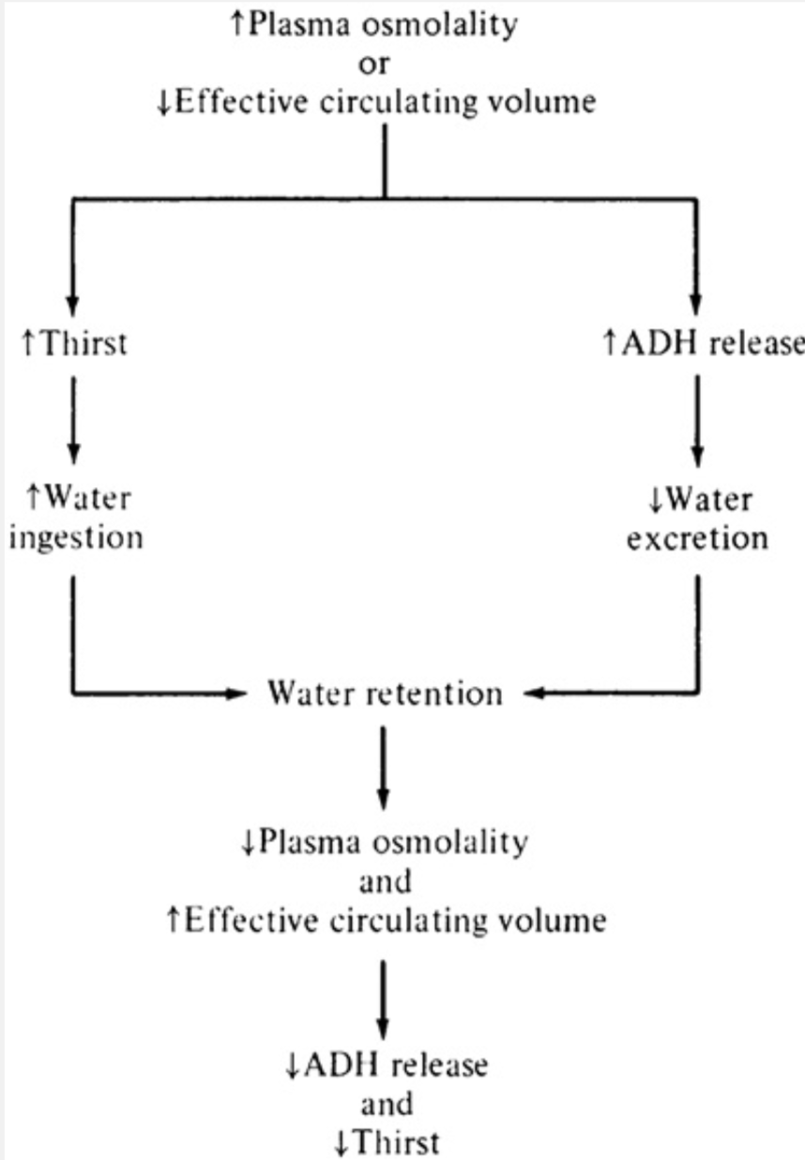

- Volume receptors:
  - Triggered from effective circulating volume depletion, even on the face of a low plasma osmolality
  - Parasympathetic afferents in the carotid sinus baroreceptors
- Other factors that affect ADH secretion:
  - Nausea – 500 fold rise in ADH
  - Surgery - mediated by pain

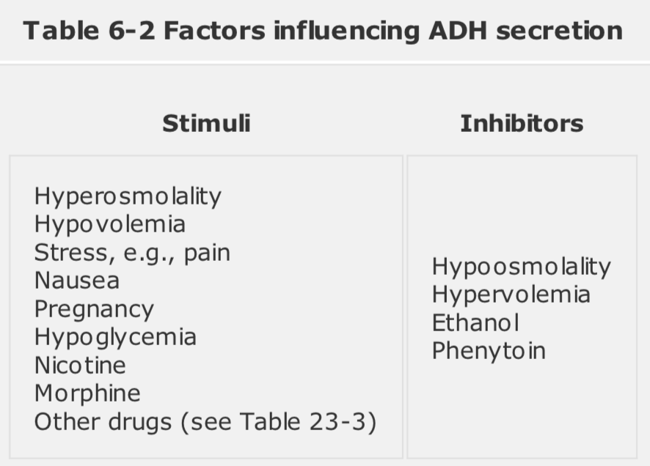

Aldosterone:
- Acts on distal nephron to increase Na reabsorption and secretion of K
- Diffuses into tubular cell then attaches to specific cytosolic receptors in collecting tubules and connecting segment
- Principal cells reabsorb Na and secrete K
- Papillary collecting tubule reabsorbs Na but does not secrete K
- Increases # of open Na/K channels on luminal mb and activity of Na/K/ATPase pump in the basolateral mb
- Stimulates H+ secretion in collecting tubular cells
- Extrarenal effects:
  - Reduced concentration of Na and increases K in colon, saliva and sweat
- Control of Aldosterone secretion:
  - Ang II and high K are the major stimuli
- Cortisol binds with the same affinity to aldosterone receptor
  - Normally cortisol is inactivated by 11β hydroxysteroid dehydrogenase
  - If this enzyme is inactivated, then cortisol can act as the 1ary mineralocorticoide
- Renin-angiotensin system:
  - Increase in Na intake, expands extracellular volume, and produces less renina and aldosterone, this allows excess Na to not be reabsorbed in the proximal tubule
  - Reduction in effective circulating volume will enhance secretion of renin and aldosterone
- Aldosterone secretion is stimulated y K, linear increase once K is above 3.5 meq/L
- If aldosterone is given to a healthy patient on normal salt intake, NaCl and water retention and K loss will be seen until there is a 3kg weight gain (people), then spontaneous diuresis ensues – this is called Aldosterone Escape, seen in 1ary hyperaldosteronism
- Hyponatremia increases aldosterone and vice versa with as little as 4-5 meq/L change of Na

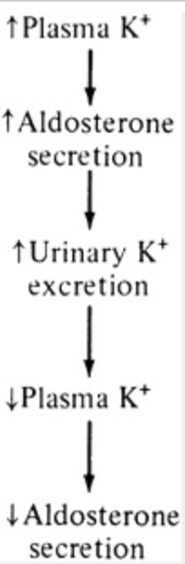

Clinical State | Aldosterone Secretion | Proximal or Loop Reabsorption | Distal Na Delivery | Δ Urinary Excretion  Na K
Hyponatremia | ↑ | ↑ | ↓ | ↓ | 0
Hypernatremia | ↓ | ↓ | ↑ | ↑ | 0
Hyperkalemia | ↑ | ↓ | ↑ | 0 | ↑
Hypokalemia | ↓ | ↑ | ↓ | 0 | ↓

ACTH:
- Released from the anterior pituitary, enhances adrenal glucocorticoid and androgen synthesis
- Causes transient rise in aldosterone
- Limited ACTH response can be due to 2 factors:
  - Overproduction of deoxycorticosterone, potent mineralocorticoid activity, leads to fluid retention and decreased renin and aldosterone secretion
  - Conversion of zona glomerulosa segment to cortisol production, which occurs in chronically critically ill patients

Atrial Natriuretic Peptide:
- Released from myocardial cells in the atria and sometimes ventricles due to wall stretch
- 2 major actions:
  - Direct vasodilator, lowers BP
  - Increases Na and water excretion, by directly increasing GFR and reducing Na reabsorption in medullary collecting tubule, and to a small degree in proximal tubule
- Reduces basal renin release, inhibits Ang II and K-induced aldosterone secretion
- ANP can also be produced in the vascular wall

Urodilatin:
- ANP-like hormone
- Produced in the kidney
- Produces natriuresis with same potency as ANP

Brain Natriuretic Peptide:
- Homologous to ANP, present in brain and heart
- May be responsible for cerebral salt wasting in TBI

C-Type Natriuretic Peptide:
- Similar to ANP and BNP
- Produced by vascular endothelial cells and in the kidney
- May be involved in regulation of local blood flow

Prostaglandins:
- Derived from arachidonic acid, catalized by COX enzyme
- Produced in various parts of the kidney (glomerular nad vascular endothelium, medullary and cortical collecting tubule and renomedullary interstitial cells)
- Tubules synthesize PGE₂, glomerulus produces PGE₂ and prostacyclin
- Most renal prostaglandins are vasodilators with the exception of PGF_{2α} and thromboxane
- NSAID induced AKI is related to the intensity of the renal vasoconstriction, patients with hypernatremia have a larger reduction in GFR if NSAIDs are given
- Natriuretic effect, reduces Na reabsorption at thick ascending limb and collecting tuules

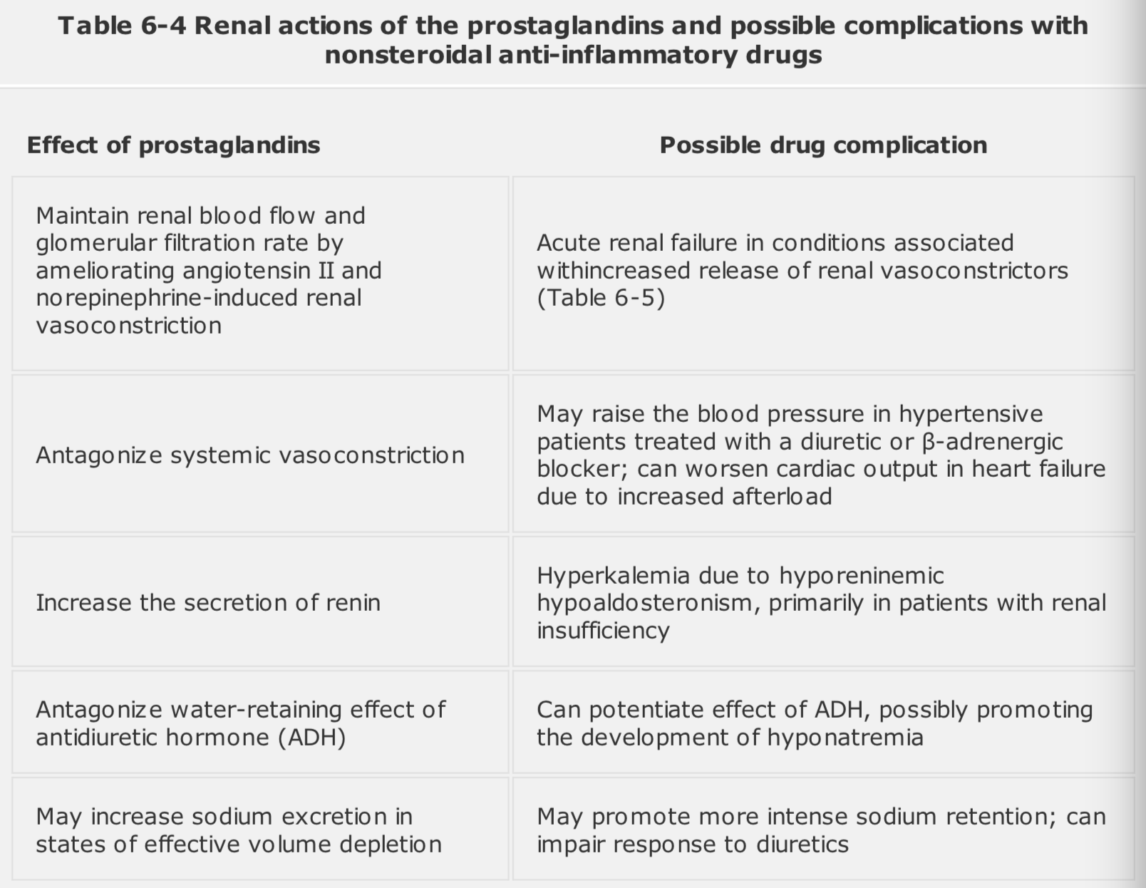

Renin:
- Stimulated by baroreceptor in the afferent glomerular arteriole and macula densa cells in the early distal tubule
- These stimuli can be blocked by NSAIDs

Hormonal Regulation of Calcium and Phosphate Balance

Parathyroid Hormone:
- Secreted from parathyroid glands in response to a decrease of plasmatic iCa
- PTH increases Ca by:
  - In the presence of Vit D, stimulates bone resorption, releasing Ca phosphate
  - Enhances intestinal Ca and phosphate absorption by promoting calcitriol formation in the kidney (major active metabolite of Vit D)
  - Increases active renal Ca reabsorption on early cortical distal nephron
- PTH affects P by:
  - Increases phosphate entry into the extracellular fluid by effects of bone and intestinal absorption
  - Reduces proximal tubular phosphate reabsorption, enhancing excretion by decreasing type II Na/phosphate cotransporter on the luminal membrane
- Small increases of plasma Ca lowers PTH secretion
- Activates Vit D in the kidney through enzymes in the proximal tubule
- Formation of calcitriol is 1arily stimulated by PTH and hypophosphatemia yo maintain Ca and phosphate balance

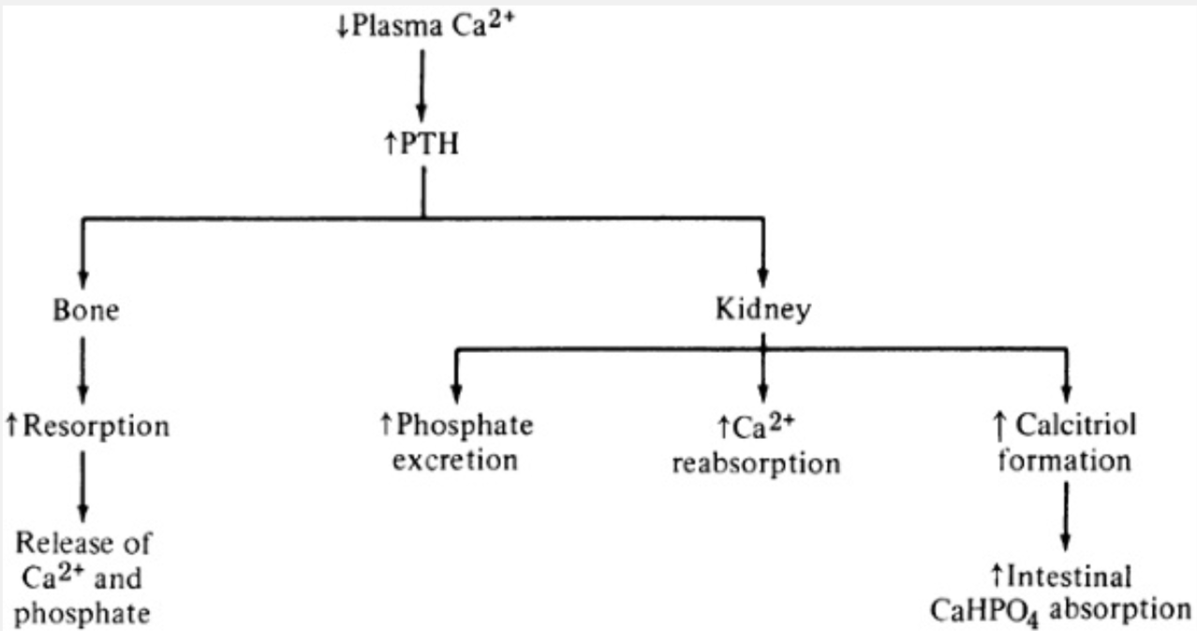

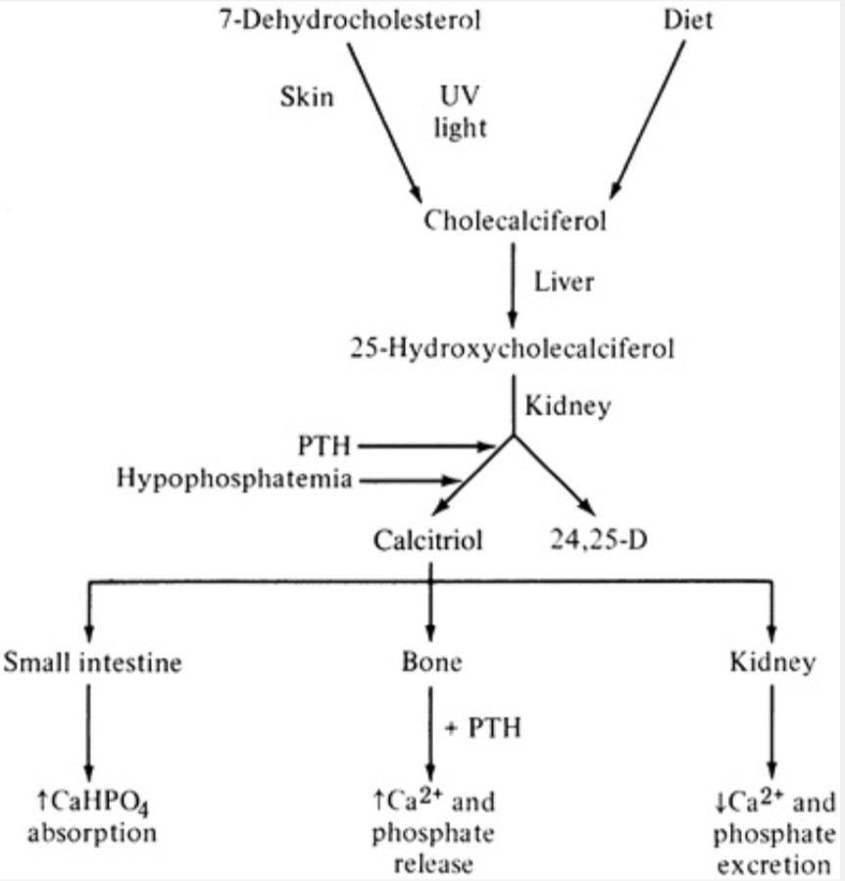

Calcium and Phosphate Metabolism in Renal Failure
- If intake remains the same, phosphate will be retained, this leads to secondary hyperparathyroidism
- There is an increase in circulating PTH levels that correlate with the degree of decline in GFR
- If phosphate intake is reduced 2ary hyperparathyroidism does not occur
- Calcitriol levels are reduced
- Phosphate intake restriction can reverse mineral metabolism: calcitriol increases and PTH decreases, intestinal Ca reabsorption is improved
- Administration of calcitriol can prevent or reverse 2ary hyperparathyroidism

Catecholamines
- Sympathetic activity increases Na reabsorption
- Norepinephrine
  - Direct stimulation of proximal and loop Na transport (α₁-adrenergic activation)
  - Altered peritubular capillary hemodynamics, from increased arteriolar resistance
  - Activation of the RAS system by β₁-adrenergic receptors
- Dopamine
  - Synthesized in proximal tubule from circulating L-dopa
  - Opposite effects than norepi
  - At low doses is a renal vasodilator acting at afferent and efferent arterioles
    - Results in a marked increase in renal blood flow with a much lesser or no elevation in GFR
  - At high doses can causes vasoconstriction, mediated by α-adrenergic receptors
  - Reduces proximal Na reabsorption Na/H exchanger activity decreases

Kinins:
- Kallikrein enzyme is produced in distal tubule and connecting segment
- Converts inactive kininogen to bradykinin
- Vasodilators
- May have an intraluminal effect on Na and water handling in collecting tubules

Erythropoietin:
- Primary stimulus for erythropoiesis
- Produced mostly by kidneys and to a lesser degree the liver
- Triggered by anemia or hypoxemia
- May need to be administered in CKD

Endothelin:
- Once secreted they bind to 2 classes of receptors:
  - Endothelin A (ETA) and endothelin B (ETB)
- Produced by most cells in the kidney (mostly collecting ducts)
  - Regulates vascular resistance – potent vasoconstriction
  - Modulate fluid and electrolyte transport
    - Suppresses Na/H exchanger and Na/K/ATPase pump
    - Antagonizes ADH and aldosterone
  - Regulate cell proliferation and ECM accumulation by increasing:
    - Release of tissue inhibitor of metalloproteinase
    - Release of cytokines that stimulate matrix accumulation
    - Production of renal cell fibronectin and collagen
- Have a role in glomerular sclerosis and interstitial fibrosis and irreversible renal damage

Nitric Oxide:
- Vasodilator
- Inner medullary collecting duct has the greatest enzymatic activity for NO production
- Most important actions in the kidney are:
  - Regulation of renal hemodynamics
    - Systemic BP is significantly affected by NO
    - Expressed in endothelial cells in afferent arteriole, glomerulus and efferent arteriole
  - Modulation of fluid and electrolyte transport
    - Intrarenal NO synthesis is increased when there is high salt intake, facilitating Na excretion
    - Inhibits Na entry in the cortical collecting duct, Na/H exchanger in the proximal tubule and Na/K/ATPase in varied areas
    - Impairs responsiveness of the collecting tubule to ADH, facilitating water excretion
  - Regulation of damage in response to injury
    - Inhibits platelet activation and adhesion which can minimize injury in glomerulonephritits

