Capnography Waveforms and Respiratory Monitoring

Causes of Hypoxemia (PaO2 < 80 mmHg)
- Hypoventilation
- VQ Mismatch
- Intrapulmonary Shunt
- Diffusion Impairment
- Low FiO2

Pulse Oximetry
- How much of the hemoglobin in blood is carrying oxygen (aka what is the oxygen saturation)
- Light is emitted from a light source (LED) > travels across probe > some of it is absorbed by tissue > rest is detected on other side (or reflected back)
- Uses a ratio of near infrared to red wavelengths of light to determine the percentage of hemoglobin present as oxyhemglobin
  - Red 660 nm wavelength (deoxyhemoglobin)
  - IR 940 nm wavelength (oxyhemoglbin)
  - MetHb absorbs at 660 and 940, shifts SpO2 to 80-85%
  - COHb absorbs at 940, falsely increases SpO2
- Functional SO2 = [(HbO2)/(HbO2 + HHb)] x 100
- The amount of light absorbed is proportional to:
  - Concentration of absorbing substance (Hgb) (Beers Law)
  - Length of light path in absorbing substance (vessel size) (Lamberts Law)
  - Differential absorption of red and infrared light by Hgb DHgb 660 (red), 940 (IR)
- Problems with Pulse Oximetry
  - Sensitive to motion
  - Optical Shunting
  - Ambient Light
  - Electromagnetic interference
  - Poor peripheral perfusion
  - Can’t detect hyperoxia
  - Calibration
  - Dyes (methylene blue)
  - Abnormal Hgb
- Factors interfering with pulse oximetry
  - Jaundice can interfere with red and infrared light
  - More difficult to obtain reading in obese or edematous animals
  - Vasoconstriction, vascular disease, low CO
  - Patients with SpO2 < 94% should have arterial blood gas values obtained because SpO2 is less reliable at values below the normal range and is inaccurate at less than 80%

Capnometry
  - Infrared waves measure CO2
  - Infrared is absorbed by gasses that have 2 or more different atoms, oxygen (O2) does not and therefore does not absorb infared. CO2 does!
  - Beer, Lambert Law applies here is it does to pulse ox
  - Detector puts out a signal that is proportional to the amount of waves falling on it.
    - More CO2 in sample chamber, more IR absorbed, less IR reaches detector > High CO2 display
    - Less CO2 in the sample chamber, less IR absorbed, more IR reaches detector > Low CO2 display
    - CO2 in the sample chamber during inspiration and expiration differ > CO2 tracing
- Carbon Dioxide Analyzers
  - Mainstream
    - Sample cell/cuvette IN the airway between ET tube and circuit
    - IR sensor fits over the sample cell and emits light through the cell
    - Light reaching the detector on the opposing side measures PCO2
    - PROS:
      - No need for scavenging
      - No need for sampling tubes
      - Crisp waveforms
      - No deformity due to dispersion of gases in lines
      - Real time CO2
    - CONS:
      - Thermal injury possible (heated to prevent condensation)
      - Bulky
      - Large internal volume
      - Increased risk of inadvertent extubation
      - Increased dead space
  - Sidestream
    - CO2 measuring unit remote
    - Small pump aspirated airway gas through sampling tube (ports present on ET tube, Y-piece or adaptors)
    - Delay in analysis as gas reaches monitor
    - PROS:
      - Can be used in non-intubated patients (nasal cannulas, feeding tubes)
      - Minimal to no apparatus dead space
    - CONS:
      - Waveforms not synchronous with breath (delay depends on length, diameter, aspiration rate)
      - Rounded/Slurred waveforms (gas mixing)
      - Need scavenger
      - Remove gas from breathing circuit
      - Gas may pass through conduits in analyzer that cannot be sterilized
      - Tubes can become obstructed with moisture or secretions
  - Transit Time: time for CO2 to reach the analyzer
    - Tube length
    - Tube diameter
    - Suction flow rate
  - Rise Time: time for analyzer to respond (time to rise from baseline to maximal value)
    - Size of measuring chamber

- Teixiera, F.J. et al. Comparison of a sidestream capnograph and a mainstream capnograph in mechanically ventilated dogs. 2002 JAVMA Vol 221 (11):1582-1585.
  - 6 normal dogs
  - Arterial catheter in the femoral artery for BP and ABG.
  - Polyethylene tube in trachea to level of distal end ET tube for sidestream ETCO2
  - Mainstream ETCO2 between ET tube and breathing circuit
  - Linear relationship between both methods and PaCO2 (sidestream r²=0.922 and mainstream r^{r}= 0.936).
  - Mean bias values for sidestream (5.65 +/- 5.57 mmHg) higher than mainstream (3.15 +/- 4.89 mmHg)
  - Both ETCO2 monitors underestimated degree of hypoventilation when PaCO2 > 60 mmHg

- Kelmer, E.K. et al. Agreement between values for arterial and end tidal partial pressures of carbon dioxide in spontaneously breathing, critically ill dogs. JAVMA 2009 Vol 235 (11): 1314-1318.
  - 26 dogs admitted to ICU with nasal oxygen catheter and arterial catheter. Excluded if panting.
  - 30 consecutive PetCO2 measurements over 1 minuted taken and averaged. Concurrent arterial blood gas for PaCO2. A-a gradient calculated. Values off of oxygen supplementation taken as well, when patient status allowed.
  - Mean difference between PaCO2 and PetCO2 significantly higher when supplemental oxygen administered. (3.95 +/- 4.92 mmHg).
  - Mean difference between PaCO2 and PetCO2 significantly higher in dogs with a condition affecting respiratory system (8.55 +/- 5.43 mmHg vs. 3.28 +/- 3.23 mmHg)
  - There was a strong significant linear correlation between PaCO2 and PetCO2 both when oxygen was administered and when it was not.
  - 6 of the 7 dogs with the highest difference between PaCO2 and PetCO2 had pleural space disease.
- Naeik et al. Needle Decompression of Tension Pneumothorax with Colorimetric Capnography. CHEST 2017; 152 (5): 1015 – 1020
  - Custom needle trocar based device with a side stream chamber for a colorimetric capnography indicator to be exposed to escaping gas.
  - 3 normal domestic healthy swine in induced tension pneumothorax group and single negative control
  - lower lateral thoracic incision to visualize and injure the pulmonary parenchyma with laparoscopic scissors. Video thorascope inserted without CO2 insufflation to visualize chest wall.
  - Development of tension pneumothorax monitored based on femoral arterial line pressure (< 90 mmHg systolic), HR (>140 bpm) – allowed to develop with PPV
  - Needle thoracostomy with standard of care using 8 cm long 14 gauge angiocatheter by expert and novice. Similarly performed with needle capnography.
  - Operator assessment of success both subjectively and as visualized with thoracoscope
  - Decompressions detected in 15 of 15 needle capnography attempts (100% success rate) and 9/15 standard of care attempts (60% success rate)
  - Actual decompression as visualized by thoracoscopy occurred 15/15 (100%) times for needle capnography and 12/15 (80%) times for standard of care.

Techniques
- IR absorption
  - Polyatomic gases (CO2) have specific and unique absorption spectra of IR light
  - Amount of light absorbed in a specific spectrum is proportional to concentration of absorbing molecule
  - Concentration can be determined by comparing to a standard
  - Water vapor absorbs IR light and can increase measured CO2
- Ramen Scatter
  - Gas is sampled in a a chamber where it is illuminated bu high intensity monochromatic argon laser beam.
  - Molecules with interatomic bonds absorb a fraction of the energy and reemit energy at various wavelengths characteristic of the absorbing molecule.
- Mass Spectrometry
  - Electron beam ionizes and fragments components of gas sample
  - Ions are accelerated through a magnetic field and separated based on mass to charge ratio
- Phase I
  - Baseline
  - Inspiration is occurring
  - At the very end of this phase, the direction of gas flow reverses as expiration beings
  - During early expiration, expired gas is from the anatomic dead space > no gas exchange > CO2 free
  - Abnormal
    - Fails to return to baseline during inspiration
      - Slow response time with high respiratory frequencies (sine wave)
      - 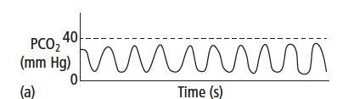
      - CO2 in inspired gas (exhausted CO2 absorber, malfunctioning inspiratory valve, inadequate fresh gas flow)
      - 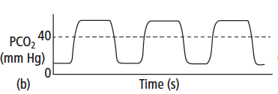
      - External pressure applied to chest during inspiration
      - 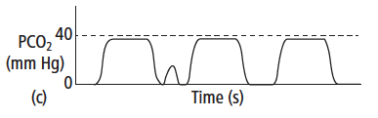
- Phase II
  - Upstroke of capnogram
  - CO2 containing alveolar gas is exhaled in a mixture with CO2 free gas from dead space
  - As expiration proceeds the expired gas is composed of increasing amounts of CO2
  - Abnormal
    - Slow sampling rates decrease slope of II and IV, shorten plateau
    - Slow expiration (sloped alveolar plateau as well, increased alpha angle and normal beta angle) > airway narrowing, obstruction, kinked ET tube
    - 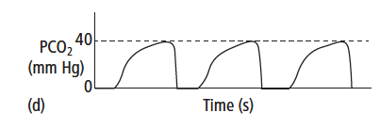
- Phase III
  - Plateau
  - PCO2 almost constant as alveolar gas is expired
  - Expiration ends and is followed by a pause, CO2 remains constant as CO2 from alveolar gas is stationary in the breathing circuit where gas is sampled.
  - Alpha angle is between phase II and III and is 100-110 degrees.
  - Abnormal
    - Elevated alveolar plateau: hypoventilation
    - Lower alveolar plateau: hyperventilation, reduced CO production (hypothermia), reduced delivery of CO2 to lungs (low CO)
    - Decreased in alveolar plateau: PTE, leak in gas sampling line
    - 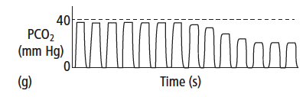
    - Slanted plateau phase: uneven filling and emptying of the alveoli (VQ mismatch)
    - 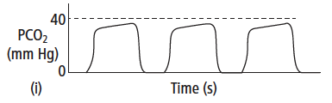
    - Artifactual dips and bumps in the plateau: pushing on chest, spontaneous ventilator efforts in a ventilated patient (insufficient anesthetic depth, inadequate ventilation, hypoxemia, inadequate analgesia, hyperthermia)
    - 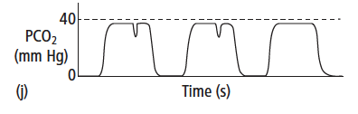
    - Cardiogenic oscillations: contraction of right ventricle and filling pulmonary vasculature expels small vlume of gas from lungs with each beat. (Inconsequential)
    - 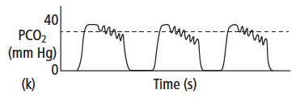
- Phase IV
  - Rapid down stroke with inspiration)
  - Fresh non CO2 gas passes the sampling port as it is inspired
  - Beta angle between III and IV and is ~ 90 degrees
  - Abnormal
    - Reduced slope of phase IV (increased beta angle): slow inspiration or CO2 in inspired gas (inadequate fresh gas flow or malfunctioning inspiratory valve)
    - 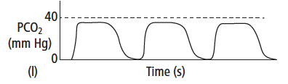

Blood Gas Assessment of Hypoxemia
- PCO2
  - When CO2 production increases, increases in respiratory rate and or tidal volume will normalize PCO2 in a healthy animal
  - Increased PCO2 diffuses into CSF and lowers the pH > stimulates chemoreceptors > increases ventilation
- PaO2
  - Can also trigger ventilation when PaO2 < 60 mmHg
  - Portion of gas dissolved in the blood (2-3% of total arterial blood oxygen content)
- Arterial blood is a mixture of blood from two sources
  - PcO2: Oxygenated blood leaving functional alveolar-capillary units and entering arteries (95% of arterial blood)
  - PvO2: Mixed venous blood entering arterial circulation via normal anatomic shunt (5% of arterial blood)
  - PaO2 = 100 mmHg
  - PAO2 = 105 mmHg
  - PvO2 = 40 mmHg
  - 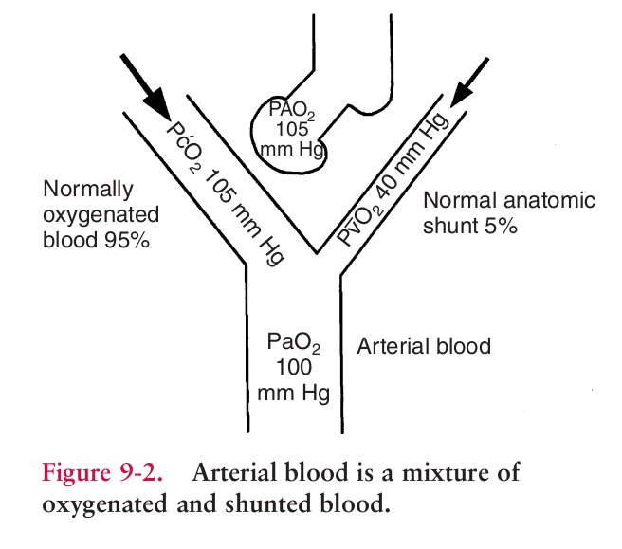
- Decreased cardiac output with a normal shunt
  - If oxygen consumption constant, ↓ CO leads to ↓ PvO2
  - Tissues exposed to less blood > extract more oxygen from available blood
  - Shunted blood entering circulation has lower PvO2 than shunted blood when cardiac output normal
  - So PaO2 slightly lower (PvO2 only 5% of PaO2)
  - 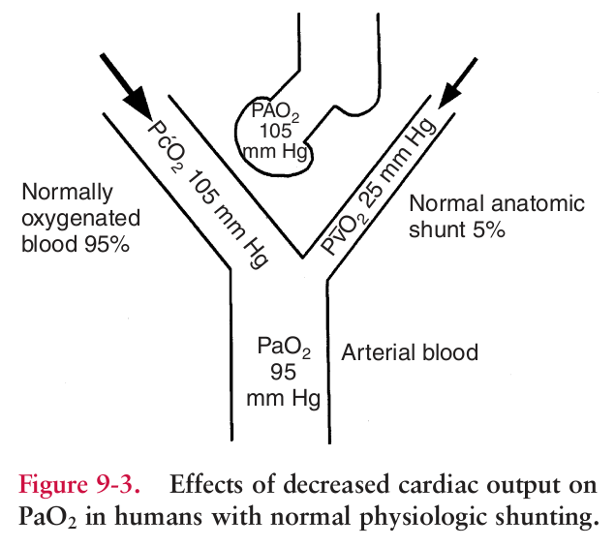
- Increased shunting
  - Abnormally high shunt > larger impact on PaO2 (large percent of venous blood from shunt enters circulation)
  - CO and PvO2 still normal
  - 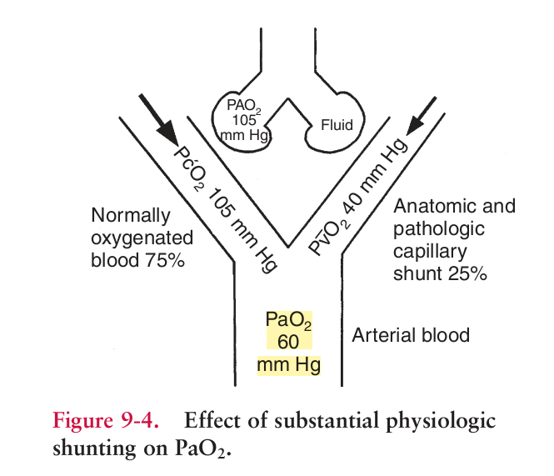
- Decreased CO + Increased Shunt
  - CO more profound effect on PaO2 because changes in CO affect PO2 of shunted blood
  - Larger shunt = greater percentage of shunted blood entering circulation
  - 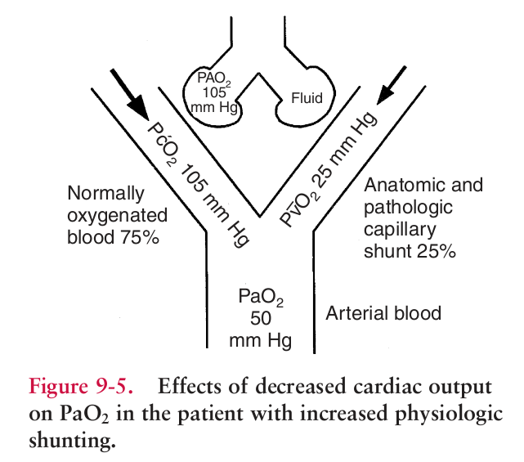
- Increased CO + Increased Shunt
  - Increased CO enhances tissue oxygenation bu increase in blood reaching tissues and increase in PaO2 (via increase in PvO2)
  - 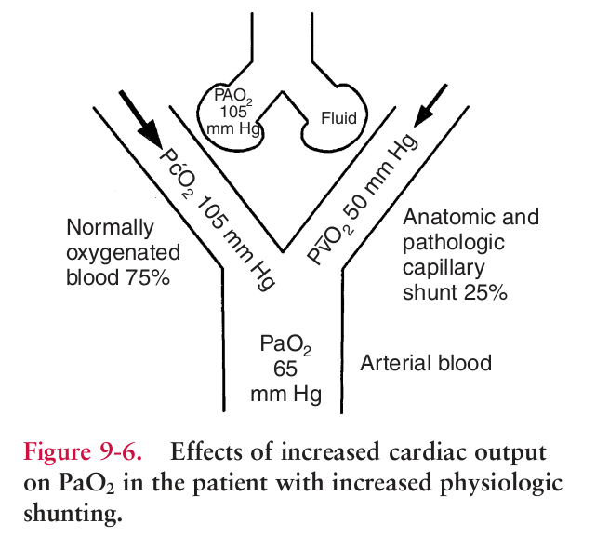
- When FIO2 constant
  - ↑ PaO2 interpreted as improvement in lung function
  - ↓ PaO2 interpreted as deterioration in lung function

Assessment of Physiologic Shunting
- Physiologic shunt = % of venous blood that remains unoxygenated after travelling from right side of heart to left side of heart
  - Absolute shunts: Anatomic shunts, capillary shunts
  - Relative shunts: low VQ
  - Can be used to quantitate efficiency of oxygen uptake via the lungs
- Classic Shunt Equation: Qsp/QT = [CcO2 –CaO2] / [CcO2 – CvO2]
  - Qsp is volume of blood shunted past physiologic shunt each minute
  - QT total cardiac output
  - CcO2 is oxygen content of ideal capillary blood
  - CaO2 is oxygen content of arterial blood
  - CvO2 is oxygen content of mixed venous blood
  - Need PaO2, SaO2, PvO2, SvO2 and [Hb]
  - 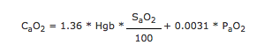
  - For CvO2 substitute SvO2 and PvO2
  - In the ideal capillary saturation is 1 and CcO2 is derived from the alveolar gas equation (PcO2 = PAO2)
  - Normally ~3% of CO
  - Only way to measure physiologic shunting when CO unstable
  - Swan Ganz Catheter
  - Gold Standard
  - Need mixed venous blood sample (pulmonary artery catheter)
  - Depends on FIO2
    - Pulmonary shunt ↓ as FIO2 0.21 > 0.40
    - Pulmonary shunt constant FIO2 0.40 – 0.70
    - Pulmonary shunt ↑ as FIO2 > 0.70
- PaO2/PAO2
  - What percentage of PAO2 delivered to alveoli actually reaches arterial blood (percentage of successful oxygen transfer)
  - Assuming constant lung function the percentage of PAO2 transferred should be constant regardless of FIO2
    - Can use at varying FIO2
    - Progressive evaluation of lung function
    - In patients with constant cardiopulmonary status can use to guide FIO2 selection
  - Lower limit of normal = 0.75 (75%)
  - Most stable when FIO2 > 0.3 and PaO2 < 100 mmHg, and for patients with large shunts (<0.55 ratio)
- Alveolar to arterial gradient (A-a gradient)
  - The small amount of blood that returns to the left heart deoxygenated (from bronchial and Thebesian circulations) mixes with arterialized blood returning from pulmonary capillaries and drops the PaO2 below the PAO2. Normally this A-a gradient should be < 15 mmHg (physiologic shunting)
  - If venous admixture or intrapulmonary shunting cause more deoxygenated blood to reutnr to the LA, the gradient will be increased.
  - A-a gradient = PAO2 – PaO2 = [FiO2(Pb-PH20) – PaCO2/RQ] – PaO2
  - Works for room air or 100% oxygen (where A-a should be < 150 mmHg), otherwise the expected gradient is not established
- The 120 rule
  - Estimate the PaO2 to expect based on PaCO2
  - At sea level on room air PaCO2 + PaO2 = 120 – 160 mmHg
  - When PaCO2 + PaO2 < 120, pulmonary dysfunction is present
- PaO2/FiO2
  - Can be used at any FiO2
  - PaO2/FiO2 should be greater than 500 mmHg
    - 300-500 mild dysfunction
    - 200-300 moderate dysfunction (mild ARDS)
    - < 200 severe pulmonary dysfunction (moderate to severe ARDS)
      - PaO2/FIO2 < 200 mmHg indicates shunt > 20%
  - Or use the oxygenation ratio (%FIO2 in denominator, normal 4-5.0)
  - May be more accurate than PaO2/PAO2
  - Low PaO2 on high FIO2 is evidence of poor response to oxygen therapy and presence of absolute shunt
  - PaO2/FIO2 Limitations
    - Does not take into account changes in PaCO2 (hypoventilation can make it look like intrinsic ability of lungs to transfer air is compromised)
    - Should not be used with low FIO2 levels (< 0.3) where changes in PaCO2 can have large effects on ratio
    - Changes in PaCO2 also change CO and PaO2
      - ↓ PaCO2 causes ↓ CO
      - Alters oxygen loading efficiency
- SpO2/FiO2
  - Calabro et al. Preliminaary evaluation of the utility of comparing SpO2/FiO2 and PaO2/FiO2 ratios in dogs. JVECC. 23(3) 2013; 280-285
    - Prospective, observational pilot study
    - 38 client owned dogs requiring assessment of oxygenation
    - Exclusions: COHgb-emia, MetHgb-emia, SpO2 < 80% or > 97%, coagulopathy, severe respiratory destress, right to left shunt
    - Arterial blood sample and SpO2 within 15 minutes, all on room air
    - SF and PF were correlated (rho 0.618, P < 0.01)
  - Carver et al. Evaluation of PaO2/FiO2 and SaO2/FiO2 ratios in postoperative dogs recovering on room air or nasal oxygen
    - Retrospective
    - 19 female dgs admitted for routine OHE
    - Exclusions: cardiac or respiratory disease, < 10 kg
    - Arterial blood gas 1 hour after induction and during procedure, and 10, 60 and 120 minutes post op
    - 2 recovery groups: room air vs 2 hours nasal O2 insufflation (100 mL/kg/min) (estimates 37% FiO2)
    - PF higher in dogs recovering on supplemental oxygen, SaO2/FiO2 lower in dogs recovering on room air
    - PF and SaO2/FiO2 had excellent correlation at all times points with Pearson correlation coefficients of 0.9, 0.95 and 0.93 at 10, 60 and 120 minutes post o for room air and 0.94, 0.93 and 0.90 for oxygen.
- FiO2 x 5
  - PaO2 on room air should be 100 mmHg (5 x FiO2)
  - Extrapolate out to estimate PaO2, if < Fi)2 x 5 indicates dysfunction
- Total Oxygen Content
  - CaO2 = (SaO2 x Hgb x 1.34) + (0.003 x PaO2)
  - Normal O2 content is 16.9-18.0 mL/dL
  - Red blood cell mass has much greater effect than does PO2
- Venous PCO2 (PvCO2)
  - Arterial – venous gradient for PCO2 = 5 mmHg
  - Arterial to venous PCO2 gradient increases
    - Anemia: decreased ability to buffer
    - Venous stasis
- Venous PO2 (PvO2)
  - Used to determine the oxygen extraction ratio (OER)
    - Compares oxygen delivery with oxygen consumption
    - Blood from PAC or central venous line
    - Normal PvO2 40-50 mmHg
    - PvO2 < 30 mmHg indicates decreased oxygen delivery

Blood Gas Assessment of Hypoxia
- Evaluate the 3 essential components of oxygen supply
  - Arterial oxygenation assessment (SpO2, PaO2)
  - Blood hemoglobin concentration
  - Circulatory Status (BP, HR, Arrhythmias, Blood Volume, Vascular Tone)
- Arterial oxygenation
  - PaO2
    - Partial pressure of oxygen dissolved in plasma
    - Measure of ability of lungs to move oxygen from the atmosphere to the blood
    - Normal PaO2 at sea level ranges from 80-110 mmHg
    - PaO2 is better indicator of pulmonary deterioration, mild hypoxemia, hyperoxemia than SaO2 (normal individuals have SaO2 on flat portion of oxyhemoglobin dissociation curve so large changes in PaO2 results in minimal changes in SaO2)
  - SaO2 (SpO2)
    - Percentage of hemoglobin that is carrying oxygen in the arterial blood
    - 98% of oxygen in arterial blood is combined with Hgb
    - Measurement may be by nomogram, co-oximetry or pulse oximetry
      - Nomogram
        - Predicts (calculates) SaO2 based on PaO2 and pH
        - Does not account for factors other than pH that can alter HbO2 affinity
        - Assumes no abnormal forms of PaO2 are present (HbCO2, MetHb)
        - May be labeled as SO2 when calculated
      - Oximetry (Pulse oximetry)
        - 2-wavelength spectrophotometer
        - Abnormal forms of Hb cannot be detected
        - SaO2 measured this way is percentage of HbO2 compared with the sum of HbO2 and desaturated Hb only (functional SaO2)
        - Cannot distinguish between HbO2 and HbCO so SpO2 = HbO2 + HbCO
      - CO-oximetry
        - Uses between 4-8 wavelengths of light
        - Uses conductimetry to estimate a samples hematocrit (HCT)
          - Whole blood conducts an electrical current due to electrolytes in plasma, but erythrocytes, leukocytes and platelets do not
          - Alterations in conductivity of blood correlate to approximate cell counts (decreased electrical conductivity indicates an increase in the ratio of nonconductive cells to conductive plasma i.e. a higher HCT)
          - Leukocytes and platelets don’t have enough mass to effect conductimetry so its estimated based on electricity transmitted through sample
          - tHb is then calculated from the HCT
        - Most still do not detect sulfhemoglobinemia
          - Falsely elevated MetHb
          - Falsely decreased COHb
        - Can measure HbCO and MetHb
        - SaO2 is % of HbO2 compared to all forms of Hb (fractional SaO2)
        - Fractional SO2 = [(HbO2)/(HbO2 + HHb + COHb + MetHb)] x 100
    - SaO2: better indicator of arterial oxygen content than PaO2 (98% of oxygen in blood carried in combined state)
    - PO2 of 60 mmHg = SO2 90%
    - PO2 of 40 mmHg = SO2 75%
- Hb concentration
  - Absolute quantity Hb must be sufficient to carry and deliver O2
  - Hb responsible for 98 % of oxygen transport
  - Anemia can impact
    - Only about 25% of oxygen in arterial blood is extracted by tissues, so mild anemia does not substantially affect tissue oxygen supply
    - Body responds to anemia by increasing CO and 2,3-diphosphoglycerate (2,3-DPG) levels
      - CO increases by up to 50% in acute phase
      - Within 2 weeks, CO returns to pre-anemic levels and increase in DPG accounts for compensation
  - Read et al. Validation of noninvasive hemoglobin measurements using co-oximetry in anesthetized dogs. Cav Vet J 2016; 57: 1161-1165.
- Circulatory Status
  - Measurement
    - Fick Equation with pulmonary artery catheter
      - Ficks law: the diffusion of a gas across a membrane is directly proportional to the area of the tissue membrane and the pressure gradients, and inversely proportional to the thickness of the membrane.
    - Indirectly
      - UOP, Neurologic status, BP, pulse, CRT, cyanosis, extremity temperature
  - Complete CV assessment must include
    - The pump (the heart)
      - CO = HR x SV
    - The fluid (the blood)
      - Blood volume
        - CO cannot exceed venous return
        - Hypovolemia
          - Absolute
          - Relative
        - Measure: Low central venous pressure
          - CVP in superior vena cava or right atrium, reflects right atrial pressure. N
          - Normal 2-10 mm Hg
          - High CVP > CHF or fluid overload, low CVP hypovolemia
    - The tubules (blood vessels)
      - Vascular tone: neurogenic shock, psychogenic shock, septic shock, anaphylactic shock

Key Indicators of Hypoxia
- Indices of oxygenation failure and tissue hypoxia
  - Lactate accumulation, decreased mixed venous oxygenation, oxygen uptake and utilization, gastric mucosal acidosis
- Lactate
  - Immediate response of cell to hypoxia is onset of anaerobic metabolism > glycolysis and creatinine kinase reaction
    - In glycolysis pyruvate becomes the terminal electron receptor and is reduced to lactate > lactic acid accumulates
    - Hyperlactatemia is most often the result of tissue hypoxia
    - Not highly sensitive indicator because:
      - Lactic acid levels rise rapidly in the first few minutes of hypoxia then falls off as energy stores are depleted
      - Can be 10 times higher inside the cell than in the blood outside the cell
      - Normal liver takes up lactate quickly with normal perfusion and can remove lactate much faster than tissues can produce it – elevated blood lactate is transient unless circulatory failure or liver impairment are present
    - Arterial blood better than venous blood as measure of whole body hypoxia
    - HCO3 should decrease by 1 mEq/L for every 1 mEq/L lactate concentration
    - Not specific
      - Will increase with any rise in blood pyruvate (infusion of pyruvate, glucose, bicarbonate)
      - Increase independent of pyruvate hypoxia, liver disease, exercise
- Mixed venous oxygenation indices
  - More global picture of oxygenation that peripheral venous blood (local)
  - Average of all venous blood returning to the heart
  - Pulmonary artery catheter
  - Normal Values
    - PvO2 35-45 mmHg
    - SvO2 75%
    - CvO2 15vol%
    - pH 7.38
    - PvCO2 46-48 mmHg
  - Mixed venous oxygen saturation (SvO2)
    - Potential sources of decreased SvO2
      - Increased oxygen consumption (VO2)
      - Decreased arterial oxygen saturation (SaO2)
      - Anemia
      - Decreased CO
  - Mixed venous oxygen partial pressure (PvO2)
    - Mixed venous blood reflects interaction of pulmonary and CV systems (supply and demand)
    - Represents average end capillary oxygen driving pressure
    - Shortcoming: venous blood is heterogeneous and mixed venous blood depends on Depends on distribution of cardiac output
    - Weather a cell in the body receives enough oxygen to meet metabolic requirements depends on two factors:
      - Driving pressure propelling oxygen from capillaries to cells
        - Difference between the capillary PO2 and the cellular PO2
        - Because precapillary PO2 is 100 mmHg and post capillary PO2 is 40 mmHg, the oxygen driving pressure is lowest at the end of the capillary
      - Distance of the cell from the capillary itself
        - PO2 lowest in cells farthest from the capillary
        - If these cells are just oxygenated at normal PvO2, any decrease in PvO2 will lead to hypoxia of those cells. Further decreases in PvO2 lead to more cells being affected.
        - Hypoxia is probable when PvO2 < 35 mmHg
    - Clinical oxygenation disturbances and PvO2
      - Hypoxemia
        - Body responds to hypoxemia by increasing CO to maintain PvO2 (tissue oxygenation preserved despite fall in oxygen content)
        - Patients unable to increase CO may have decrease in PvO2
      - Decreased CO and Anemia
        - Circulatory shock, anemia, CO poisoning > PaO2 normal but PvO2 decreased
      - High PvO2 and Hypoxia
      - Septic shock, cyanide poisoning > hypoxia not due to oxygen driving pressure but rather shunting of blood past tissues or cellular metabolic dysfunction
      - PvO2 increased but still hypoxic
      - May still recognize short term instability by acute declines in mixed venous oxygenation from baseline

