Abdominal and Thoracic Trauma

Types of trauma:
- Penetrating
  - Most common type of trauma 50.2% (20,250 trauma cases, 83% dogs, 17% cats, Hall et al, 2017, VetCot registry)
    - Bite wounds 69%, most common
  - Bite wounds (185 dogs, 11 cats, Shamir et al 2002)
    - Males, <10kg dogs most common to have multiple injuries
    - 35% thoracic trauma (31% penetrating trauma)
    - 24% abdominal trauma (79% penetrating trauma, 65% organ injury)
    - 7% mortality
    - Coyote attacks (145 dogs, Frauenthal et al 2017)
      - 16% mortality
      - Rib fractures 25%, and are associated with mortality
      - Pulmonary contusions 20%
      - Tracheal tear 12%
      - Pneumothorax 10%
      - Abdominal wall hernia 6%
      - Abdominal penetrating wounds 5%
  - Gunshot wounds (29 dogs, Baker et al, 2013)
    - 38% survival, of dogs that made it to a vet facility
    - Thorax is the most common site of injury (50%)
      - Tension pneumothorax most common
    - None received IV fluids before getting to a vet, “permissive hypotension”?
  - Impalement/Stabbing
  - Evisceration
- Blunt:
  - 2nd most common type of trauma 47% (20,250 trauma cases, 83% dogs, 17% cats, Hall et al, 2017, VetCot registry)
    - HBC 41%
  - Blunt trauma, 235 dogs (UPenn, Simpson et al 2009)
    - Motor vehicle accidents 91%
    - 72% thoracic trauma
      - Pulmonary contusions 58%
      - Pneumothorax 47%
      - Hemothorax 18%
      - Rib fractures 14%
    - 50.2% abdominal trauma
      - Hemoperitoneum 23%
      - Abdominal hernias 5%
      - Urinary tract ruptures 3%
    - 20.4% both thoracic and abdominal trauma
  - Motor vehicle trauma, 239 dogs (Tufts, Streeter et al 2009)
    - >50% young dogs
    - Most common injuries were long bone fractures, pulmonary contusions, soft tissue injury, pelvic fractures and hemoabdomen
    - Dogs that did not survive to discharge had a higher ATT score and more expensive bills
    - Older age, high ATT score, abnormal temp, neuro deficits, hyperglycemia and hypoproteinemia at presentation are neg prognostic indicators in dogs (140 dogs, Klainbart et al 2018)
  - High-rise syndrome
    - Cats (132 cats, Vnuk et al, 2003)
      - 97% survived
      - 34% thoracic trauma (more likely if > 7 story fall)
        - Pneumothorax 60%
        - Contusions 40%
        - Hemothorax 10%
      - 7% abdominal trauma (land on feet? limb injuries)
      - Pancreatic rupture (4 cats, Liehmann, et al 2012)
    - Dogs (81 dogs, Gordon et al ,1993)
      - 75% jumped
      - Thoracic trauma more common than abdominal
      - 15% abdominal trauma
      - More likely to have abdominal trauma if > 3 story fall and if accidental fall
  - Human abuse (243 dogs, 182 cats, Munro et al 2001)
    - Kicking most common
    - 6% dogs had a ruptured organ (spleen, liver, bladder, kidney)
    - Cats tend to have abdominal muscle rupture

Diagnostics:
- Bloodwork:
  - Mild hyperglycemia, mild hyperlactatemia, mild metabolic acidosis, mild hypoalbuminemia, mild thrombocytopenia, moderate increase in ALT are commonly found in blunt trauma
  - Elevated ALT, AST, GGT, ALKP – r/o biliary trauma and leakage
  - Azotemia – r/o uroabdomen
  - Acute traumatic coagulopathy is extremely rare
    - ATT is significantly associated with PT, aPTT, MA in dogs, this score does not predict ATC in cats (18 dogs, 19 cats, Gottlieb et al, 2017)
  - Troponin elevations may be seen in cardiac contusions and ischemia
  - iCa (88 dogs, Holowaychuk and Monteith 2011)
    - 16% ionized hypocalcemia
    - iHypoCa on admission also had higher HR, lower BP and metabolic acidosis
    - Dogs with abdominal trauma were > likely to have iHypoCa – traumatic pancreatitis?
    - iHypoCa ocurrs most frequently in severely injured patients
  - Blood typing and crossmatching

- ECG: (30 dogs, Snyder et al 2001)
  - 62% had VPC’s
  - 16% developed frequent arrhythmias (>4000 VPC/day)
  - All within the 1st 24hr of trauma
  - 43% developed at least 1 episode of vtach

- Imaging:
  - Thoracic radiographs (Sigrist et al 2004)
    - 49% dogs and 63.5% cats have radiographic evidence of thoracic trauma
    - Abn auscultation is correlated with injury on rads, RR is not
    - 72% w/ no other injuries had signs of thoracic trauma on rads
    - Radiographic findings were not associated with outcome
    - Look for evidence of contusions, hemothorax, pneumothorax, diaphragmatic hernia
  - tFAST (145 dogs, Lisciandro et al 2008)
    - 4-point FAST protocol compared to thoracic rads within 24hr trauma for evaluating fluid
      - Sensitivity 78%
      - Specificity 93%
      - Accuracy 90%
      - Higher in penetrating trauma + experienced user
    - 23% pneumothorax
    - 72% pulmonary contusions on rads
    - 44% had tFAST abnormalities

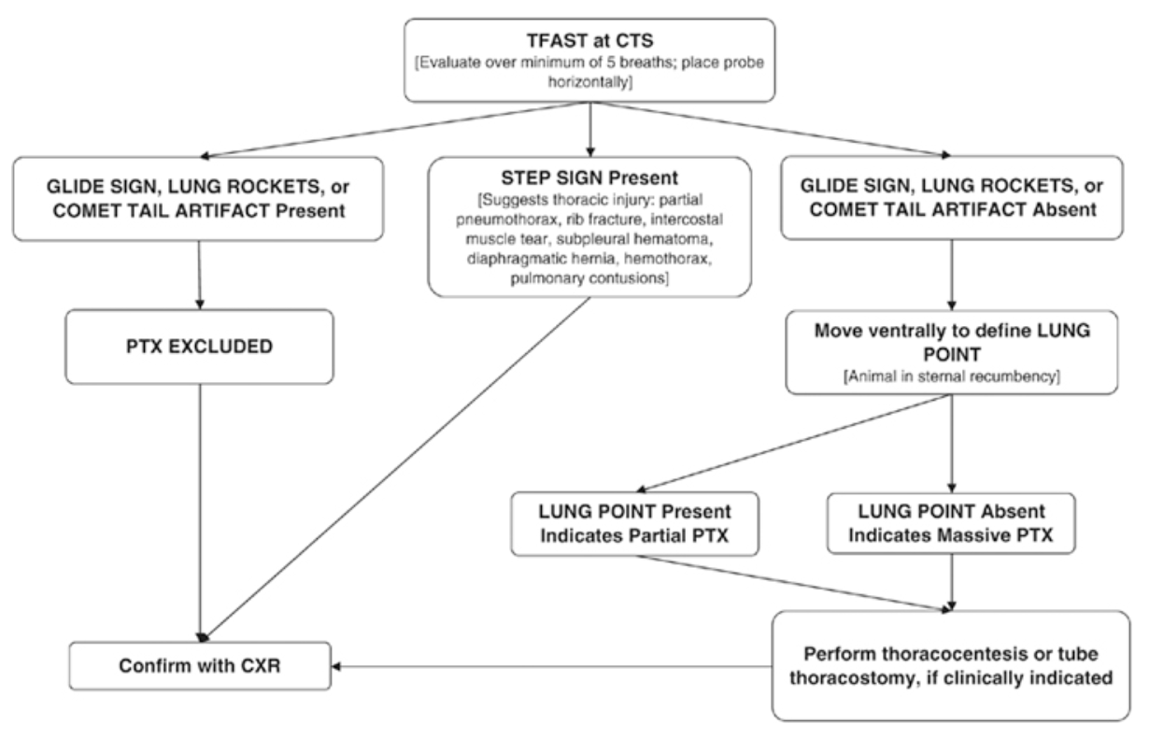

  - Abdominal radiographs
    - Free gas – abdominal wall or organ perforation
    - Loss of serosal detail – free fluid r/o blood, urine, bile, sepsis
    - Wispy retroperitoneal space – retroperitoneal fluid, r/o urine
  - aFAST:
    - 45% dogs have free fluid post trauma (Boysen et al 2004)
  - Abdominal ultrasound:
    - Diaphragmatic hernia 93% successful diagnosis (Spattini et al 2003)
    - Look for free gas, free fluid, body wall ruptures, urinary tract defects, etc.

- Fluid Analysis:
  - PCV/TS
    - Similar to peripheral usually indicates acute or ongoing bleed
    - Hemorrhagic effusion: at least 10-25% of peripheral PCV
    - Erythrophagocytosis – seen in chronic hemoabdomen
  - Bilirubin
    - 2 times abdominal to serum is consistent with bile peritonitis
    - Yellow-green to brown colored effusion
    - Bilirubin crystals
    - May be septic
  - Creatinine and K
    - 2 times abdominal to serum creatinine is consistent with uroabdomen
    - 1.4 times in dogs and 1.9 times in cats abdominal to serum K is consistent with uroabdomen
  - Chyle
    - Milky effusions
    - Triglycerides > 100 mg/dL
    - Cytology is predominantly lymphocytes, may be inflammatory too if chronic
  - Sepsis
    - Glucose/Lactate differential
    - Intracell bacteria

Treatment:

- Medical:
  - Fluids: (Driessen and Brainard, 2006) – probably outdated!
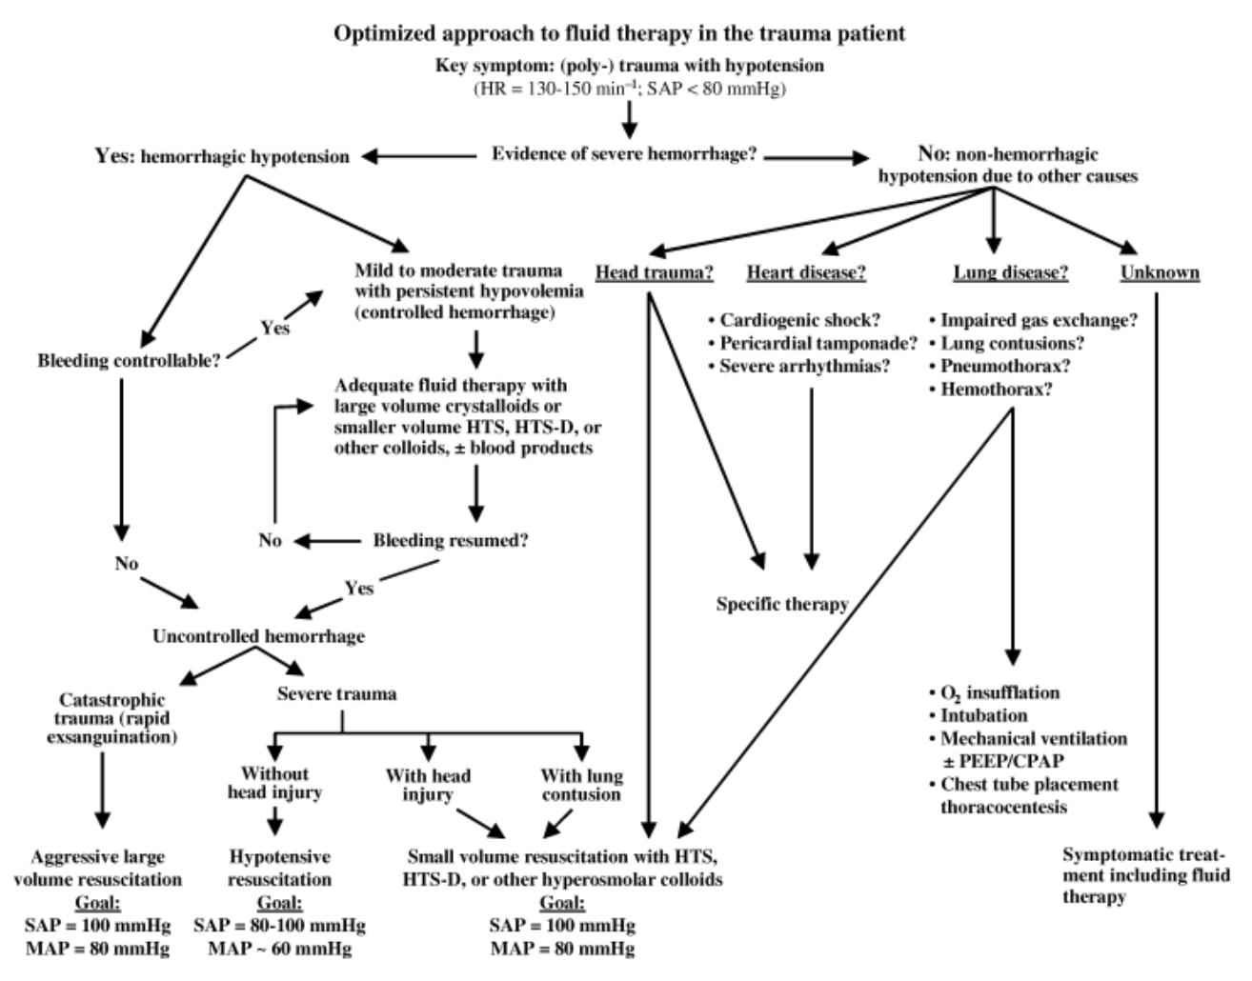

Also outdated, more likely to avoid colloids in trauma patients based on human guidelines and providing early blood products
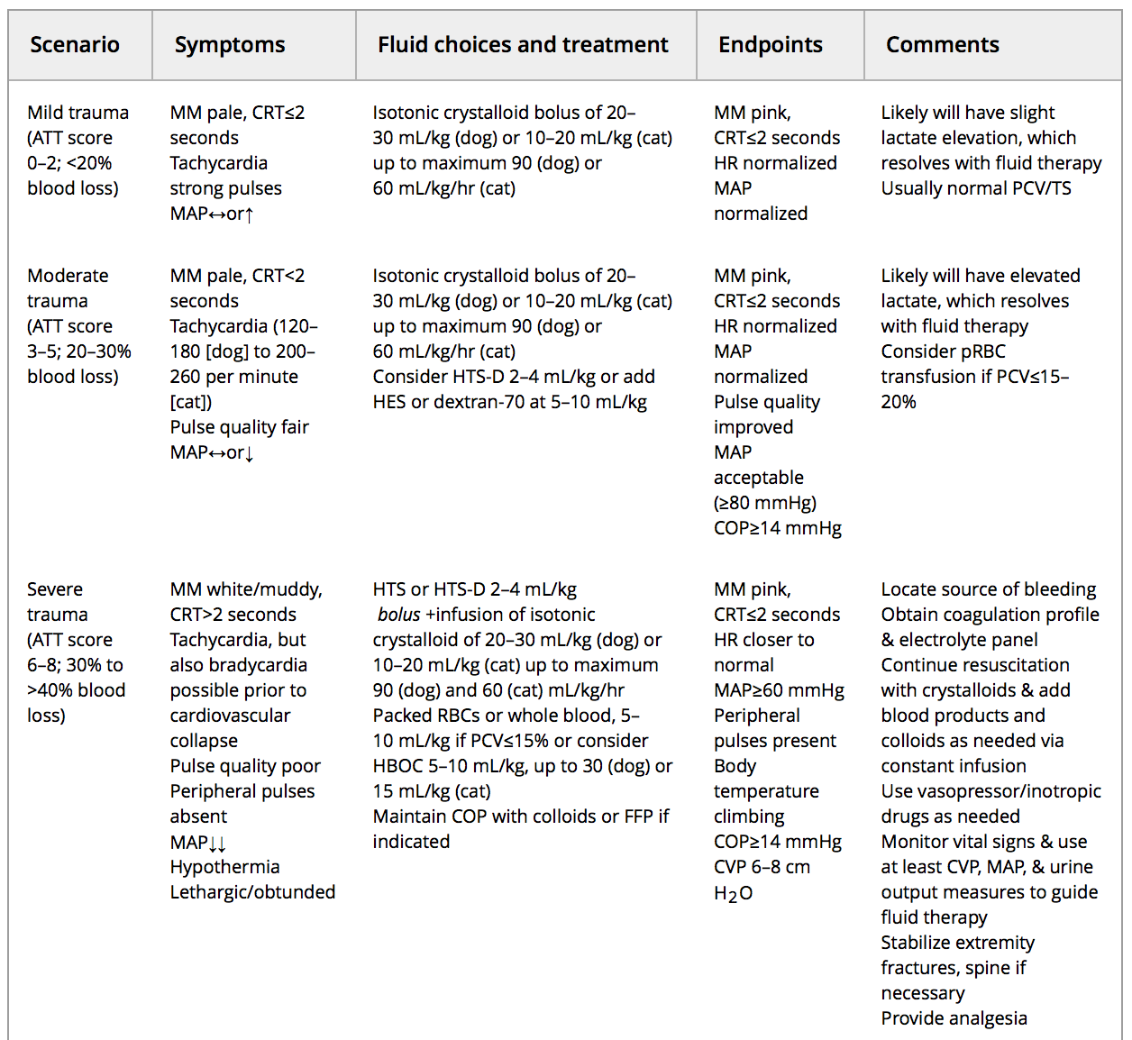
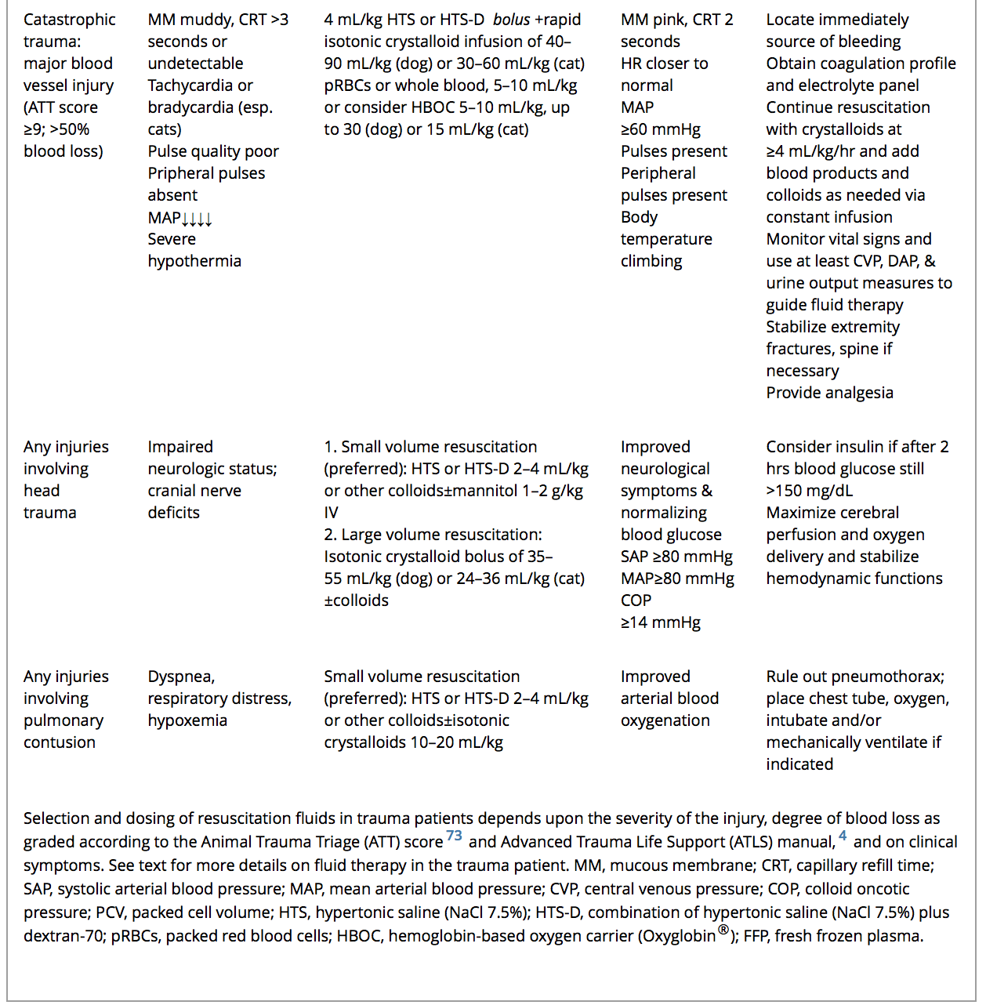

    - Crystalloids are preferred to colloids
    - Hypotensive resuscitation is controversial in vet med
    - In head trauma MAP should be > 80 mmHg
    - Use caution with pulmonary trauma as lungs can be leaky
    - Individualize therapy

  - Transfusions:
    - 36% traumatized dogs received transfusions, of those 93% were pRBC, most were for perioperative hemodynamic stabilization, survival rate was 78% (125 dogs, Lynch et al 2015)
    - Plasma or whole blood if coagulopathic
  - Antibiotics
    - All cavity penetrating injuries should have broad spectrum antibiotics
    - Extent of injury to skin, SQ and muscle determine use
  - Antifibrinolytics
    - Within the first 3 hours
    - Can also use locally
    - For how long?
  - Respiratory support
    - Oxygen
    - MV
    - HFNC
  - Pain management

- Surgical:
  - Up to 50% of cases may need surgical interventions (Hall et al, 2014)
  - When should surgery occur? (Peterson et al, 2015)
    - Dipahragmatic hernias
      - Only Sx emergency if stomach is involved
      - Stabilization should be performed before sx no matter time it takes
      - Mortality 18%
    - Uroabdomen
      - 69% animals can urinate or have a palpable bladder
      - 85% are due to blunt trauma
      - Medical management can be long 2-4 weeks
      - Ureteral rupture should have immediate repair
      - Septic uroabdomen should have sx immediately
      - Sx timing has not been evaluated in animals
    - Hemoabdomen
      - Sx is necessary if bleeding is uncontrolled despite medical management
      - Most common sites of bleeding spleen 58%, liver 50%, kidney 23%
    - Bile/septic peritonitis
      - Immediate sx
    - Penetrating injuries
      - Thoracic GSW are usually medically managed
      - All other penetrating injuries should be surgically explored
    - Body wall rupture/evisceration
      - Immediate sx
      - 73-80% survival

Prognosis:
- VetCOT registry (20,250 trauma cases, 83% dogs, 17% cats, Hall et al, 2017)
  - ATT (median 1, 0-18)
  - MGCS (median 18, 3-18)
  - 14% TBI
  - 6.5% spinal trauma
  - Surgery performed on 43%, 62% performed in the ER vs OR38%
  - 90% survived to discharged
  - 8.3% euthanized
  - 1.3% died
- MV and vasopressors have been significantly associated with non-survival (Simpson et al 2009)
- 10% mortality with severe blunt trauma, excluding euthanasia due to $ (Simpson et al 2009)
- 90% survival regardless of blunt or penetrating trauma (Hall et al, 2014)
- ATT, MGCS at time of admission may be predictive of outcome (Hall et al, 2014)
- Concurrent head trauma, hematochezia, ARDS, MODS, pneumonia, DIC, vasopressor use, MV and CPR can negatively affect survival (Simpson et al 2009)

VetCOT Registry
- (20,250 trauma cases, 83% dogs, 17% cats, Hall et al, 2017)
- Grants access to 4 applications a year for research
- Certifies facilities as Type I, II and II Trauma Centers

References:

Boysen SR, Rozanski EA, Tidwell AS, et al. Evaluation of focused assessment with sonography for trauma protocol to detect free abdominal fluid in dogs involved in motor vehicle accidents. J Am Vet Med Assoc 2004; 225:1198–1204.

Driessen B, Brainard B. Fluid therapy for the traumatized patient. Journal of Veterinary Emergency and Critical Care. 2006 Dec 1;16(4):276-99.

Gordon LE, Thacher C, Kapatkin A. High-rise syndrome in dogs: 81 cases (1985-1991). Journal of the American Veterinary Medical Association. 1993 Jan;202(1):118-22.

Hall KE, Holowaychuk MK, Sharp CR, Reineke E. Multicenter prospective evaluation of dogs with trauma. Journal of the American Veterinary Medical Association. 2014 Feb 1;244(3):300-8.

Hall KE, Sharp CR. The American College of Veterinary Emergency and Critical Care Veterinary Committee on Trauma (ACVECC-VetCOT) Registry Data Summary – All Cases to March 2017. Abstract presented at IVECCS Nashville, TN 2017.

Klainbart S, Bibring U, Strich D, Chai O, Bdolah-Abram T, Aroch I, Kelmer E. Retrospective evaluation of 140 dogs involved in road traffic accidents. The Veterinary record. 2017 Dec.

Lisciandro GR, Lagutchik MS, Mann KA, Voges AK, Fosgate GT, Tiller EG, Cabano NR, Bauer LD, Book BP. Evaluation of a thoracic focused assessment with sonography for trauma (TFAST) protocol to detect pneumothorax and concurrent thoracic injury in 145 traumatized dogs. Journal of veterinary emergency and critical care. 2008 Jun 1;18(3):258-69.

Lynch AM, O'Toole TE, Respess M. Transfusion practices for treatment of dogs hospitalized following trauma: 125 cases (2008–2013). Journal of the American Veterinary Medical Association. 2015 Sep 15;247(6):643-9.

Munro HM, Thrusfield MV. Battered pets ‘: non‐accidental physical injuries found in dogs and cats. Journal of Small Animal Practice. 2001 Jun 1;42(6):279-90.

Peterson NW, Buote NJ, Barr JW. The impact of surgical timing and intervention on outcome in traumatized dogs and cats. Journal of Veterinary Emergency and Critical Care. 2015 Jan 1;25(1):63-75.

Shamir MH, Leisner S, Klement E, Gonen E, Johnston DE. Dog bite wounds in dogs and cats: a retrospective study of 196 cases. Transboundary and Emerging Diseases. 2002 Mar 1;49(2):107-12.

Sigrist NE, Doherr MG, Spreng DE. Clinical findings and diagnostic value of post‐traumatic thoracic radiographs in dogs and cats with blunt trauma. Journal of veterinary emergency and critical care. 2004 Dec 1;14(4):259-68.

Simpson SA, Syring R, Otto CM. Severe blunt trauma in dogs: 235 cases (1997–2003). Journal of veterinary emergency and critical care. 2009 Dec 1;19(6):588-602.

Snyder PS, Cooke KL, Murphy ST, Shaw NG, Lewis DD, Lanz OI. Electrocardiographic findings in dogs with motor vehicle-related trauma. Journal of the american animal hospital association. 2001 Jan 1;37(1):55-63.

Streeter EM, Rozanski EA, Laforcade-Buress AD, Freeman LM, Rush JE. Evaluation of vehicular trauma in dogs: 239 cases (January–December 2001). Journal of the American Veterinary Medical Association. 2009 Aug 15;235(4):405-8.

Vnuk D, Pirkić B, Matičić D, Radišić B, Stejskal M, Babić T, Kreszinger M, Lemo N. Feline high-rise syndrome: 119 cases (1998–2001). Journal of feline medicine and surgery. 2004 Oct;6(5):305-12.

