American Journal of Veterinary Research

Associations between gastric dilatation-volvulus in Great Danes and specific alleles of the canine immune-system genes DLA88, DRB1, and TLR5. Harkey MA, Villagran AM, Venkataraman GM et al. Am J Vet Res 2017;78:934–945
- Is there a genetic predisposition for GDV?
- Method
  - 42 Great Danes and 39 Great Danes with at least one episode of GDV
  - Gene sequencing from 2 of the most polymorphic MHC genes (DLA88 and DRB1), as well as regions of innate immunity genes (TLR5, NOD2, and ATG16L1)
- Results - Specific alleles of DLA88, DRB1 and TLR5 were significantly associated with GDV
- Conclusions - Could these genes serve as markers for Great Danes at risk for GDV?

Odunayo A, Tobias KM, Okafor CC, Flatland B. Ammonia concentrations in canine whole blood, EDTA- anticoagulated whole blood, and plasma measured by use of a point-of-care ammonia meter. Am J Vet Res 2017;78:1239–1244
- 40 client-owned dogs; ammonia levels tested on ammonia meter from whole blood, EDTA blood, and plasma. Plasma sample also sent to lab for ammonia measurement
- Ammonia levels were the same from whole blood and EDTA blood; however plasma samples are significantly higher – possibly due to longer processing time
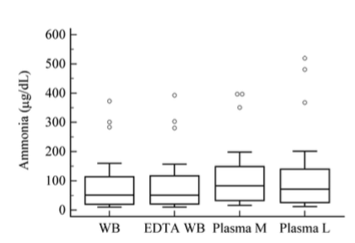

JAAHA
Lawson C, O’Brien M and McMichael M. Upper Airway Obstruction Secondary to Anticoagulant Rodenticide Toxicosis in Five Dogs. J Am Anim Hosp Assoc 2017; 53:236–241
- Case series of 5 dogs presenting for signs of acute upper airway obstruction – coughing, gagging, stridor, stertor, resp distress - 3 of the cases referred for suspected esophageal FB
- 2/5 cases had other signs of bleeding – mild serosanguinous nasal discharge and ecchymosis; other 3 cases did not have signs of external hemorrhage
- Radiographs: soft tissue opacity in the pharynx, larynx or trachea +/- narrowing of the tracheal lumen – however tracheal narrowing was static (not dynamic) in al cases
- All dogs had prolonged clotting times
- Outcome: 4/5 treated for coagulopathy presumed secondary to rodenticide and all survived to discharge
- Conclusion: upper airway obstruction is unusual presentation of anticoagulant rodenticide toxicosis

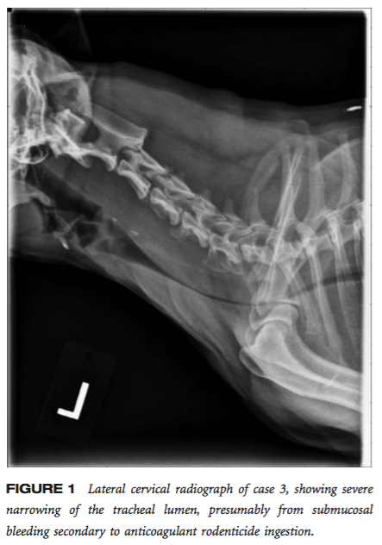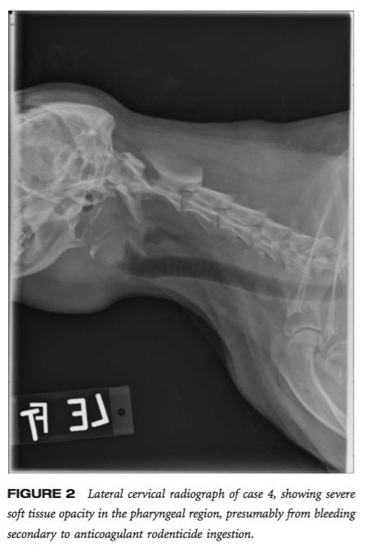

Veterinary Surgery

Spillebeen AL, Robben JH, Thomas R, et al. Negative pressure therapy versus passive open abdominal drainage for the treatment of septic peritonitis in dogs: A randomized, prospective study. Veterinary Surgery. 2017; 46:1086–1097.
- Randomized prospective clinical trial
- 16 dogs with septic peritonitis
- 2 treatment groups: negative pressure abdominal drainage (ABThera system with continuous abdominal drainage at 125 mmHg) versus passive open abdominal drainage (abdomen left partially open with sterile tie-over bandage) – surgeon decided if drainage was indicated and then patient was randomized to one of the two groups
- Comparison of outcome and complications, including histopath of omentum and abdominal wall at time of initial surgery and time of closure
- Patients closed once drain production did not increase or decrease, and no degenerated/ toxic neutrophils and/or intracellular bacteria were seen on cytology
- Results:
  - Overall survival of 81%.
  - Operating time, drainage time, survival, costs, complications, and loss of total protein were similar between groups.
  - Histopath – neutrophilic inflammation, necrosis and edema increased over time in negative pressure
  - Bandage changes more frequent and more fluid leakage in passive
- Conclusion: Negative pressure drainage reasonable alternative to passive open drainage, but did not improve outcome (as seen in humans)

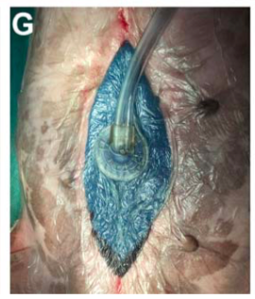

Plavec T, Rupp S, and Kessler M. Colonic or ileocecocolic volvulus in 13 dogs (2005-2016). Veterinary Surgery. 2017;46:851–859.
- Retrospective case series of 13 dogs with colonic or ileocolonic volvulus
- Signalment: all large-breed (22-58 kg) dogs, 8 male, 5/13 GSD, 4/13 Labs
- Clinical signs: vomiting, depression, inappetence, diarrhea +/- tenesmus
- All presented in shock with abdominal distension and/ or abdominal pain
- Outcome: 3/13 euthanized at surgery, 10/3 survived surgery and alive at follow-up (6 to 70 months)
- Conclusions:
  - Consistent results with previous studies
  - Favorable prognosis in comparison to that seen with mesenteric volvulus

Journal of Feline Medicine and Surgery

Yozova ID, Howard J and Adamik KN. Effect of tetrastarch (hydroxyethyl starch 130/0.4) on plasma creatinine concentration in cats: a retrospective analysis (2010–2015). Journal of Feline Medicine and Surgery 2017, Vol. 19(10) 1073–1079
- Retrospective of 93 criticall ill cats with normal creatinine at admission and a repeat creatinine following admission
- Groups: crystalloids (62) only versus Hetastarch + crystalloids (31)
- Results
  - Heatstarch group: longer length of hospitalization, lower albumin, higher APPLE scores, higher incidence of SIRS and/or sepsis
  - No significant difference in change in creatinine concentrations or mortality
- Conclusions: more studies needed …

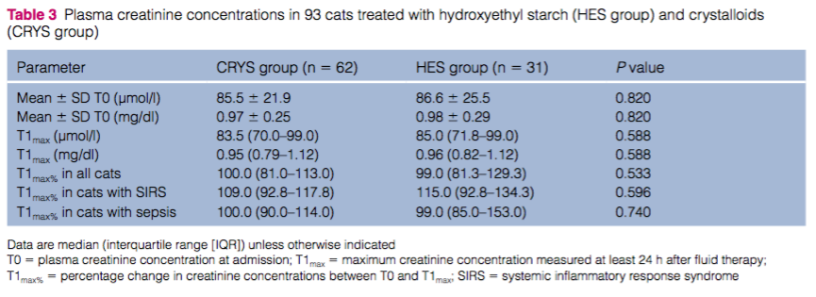

Ho KK, Abrams-Ogg AGG, Wood RD et al. Assessment of platelet function in healthy cats in response to commonly prescribed antiplatelet drugs using three point-of-care platelet function tests. Journal of Feline Medicine and Surgery 2017, Vol. 19(6) 638–647
- 36 healthy cats randomly assigned to one of three treatments – (1) aspirin 5 mg PO q72hr; (2) aspirin 20.25 mg PO q72; (3) Clopridogrel 18.75 mg PO q24. Cats in aspirin group treated with clopridogrel on days 4 to 8
- Platelet function assessed by three methods: Multiplate (impedence), Platelet Function Analyzer 100 (by mechanical aperture closure) and Plateletworks (by platelet counting).
- Results
  - Aspirin: only effect seen with Plateletworks (with collagen) at 20.25 mg
  - Clopidogrel: effects detected by Platelet Function Analyzer 100 (by mechanical aperture closure) and Plateletworks (by platelet counting).
- Conclusion
  - Aspirin is either not as effective as clopidogrel or the tests used could not identify the effect

