Jan. 19, 2017 - Finding Email (folders and mailboxes)
29 November 2016
- Quick Search & Search Options:

To make the Search Tools appear in the ribbon, click on the "search" box. These tools allow you to narrow your search results.
-Scope allows you to search the entire mailbox, current folder or all subfolders.
-Refine allows you to add criteria such as only search messages that have an attachment, are marked important, or are Categorized.
-Options allows you to see recent searches and select locations to search. There is also an "Advanced Find."

Searching Your Mailboxes:
Click in the search area at the top of the folder
Type a keyword for the message you are looking for
Use the Search Tools in the Ribbon to narrow your results

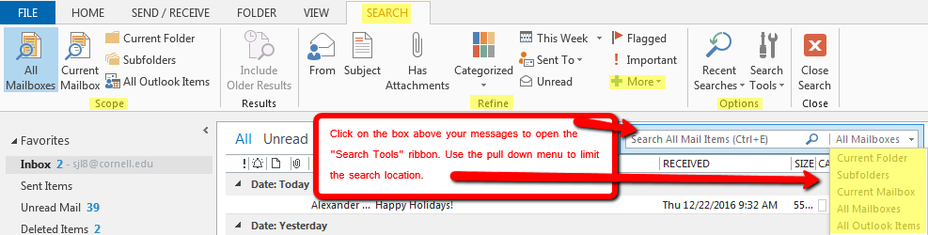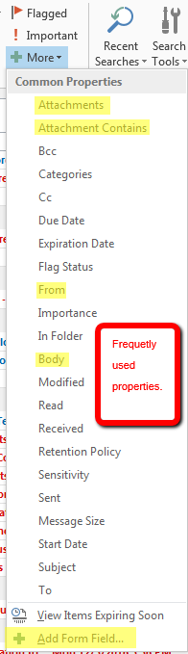
Click on the + More tab to open a list of common sorting properties.

Clutter helps filter low-priority email. It keeps track of the email you read and the ones you don't. Once turned on, Clutter is automatic. As new email comes in , it sorts the messages you're most likely to ignore and puts them in the "Clutter" folder. As your reading habits change, Clutter learns and adapts.
https://support.office.com/en-us/article/Use-Clutter-to-sort-low-priority-messages-in-Outlook-7b50c5db-7704-4e55-8a1b-dfc7bf1eafa0

If you prefer, you can easily turn off Clutter.
"How to turn off Microsoft Office 365 Clutter Feature - Vital Network Solutions" https://youtu.be/_0p4QqRpKOM

