Basic OCLC Searching

The search box in OCLC is divided into 2 main sections: the Command Line Search and the Keyword/Numeric Search. Both can be useful, depending on the resource(s) you’re working on. Both options share many of the same search commands, but the Command Line requires you to be familiar with searching abbreviations and/or punctuation, whereas the Keyword/Numeric search allows you to select your search parameters from pop-down menus.

1. One of the most common searches we use is a title seach in the Command Line, using the sca ti= search parameter (Title Phrase). This will search the complete phrase, in order, exactly as it appears on the resource. The results list from a sca ti= search allows you to see the closest similar titles to yours: very handy if you make a typo! NOTE: make sure there’s no space before the equal sign (=), or the search won’t work.

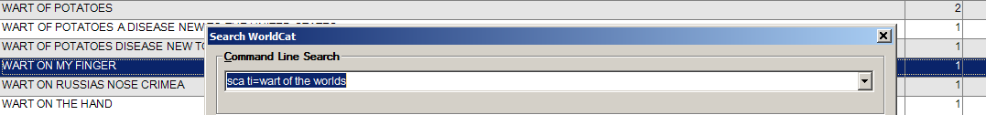

TIP: We have a macro that allows you to search whichever title you’ve just searched in Voyager: simply type jjj from the search box in Voyager, wait for the macro to switch you to OCLC, and then type sss in the Command Line Search. The sca ti= command will appear automatically, and the title will be pasted automatically to complete your search command! NOTE: BOTH programs have to be open for the macro to work!

2. The Command Line Search can be used for many other searches, including by ISBN (just type in the number, with nothing in front of it), or by OCLC number, if it’s available to you (use the pound sign (#) in front of the number, e.g. #8314566)

3. Without opening the main search box at all, you can use Command Line searches right in the Toolbar Search Window at the top of the OCLC window.


4. In addition to Title Phrase searching (sca ti=), other options for title searching include ti: (title keyword) or tiw= (title whole phrase). The ti: search is a Title Keyword search, so it doesn’t require that you enter the title in exact order, but it may yield more results than you’d like. Similarly, the Title Whole Phrase search (tiw=) will search only the words as they occur in a single subfield in a 245.
5. The Command Line can also be used to search things other than title, such as author (au:), personal name (pn:), and many others, but instead of memorizing the correct abbreviations and punctuation, you may prefer to use the Keyword/Numeric secion of the box instead:

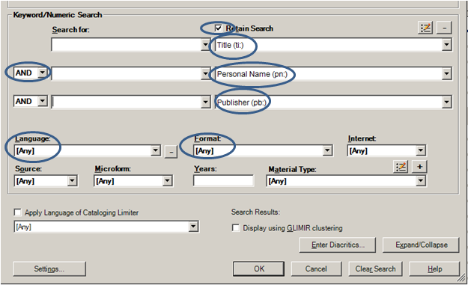

In this box, your searches can be combined to group titles, names, publishers, and even languages and formats into a single search. This is especially handy when you are searching a work by a well-known author that may have been published in many editions, or works with brief or vague titles (e.g. “Complete Works”), or works which may have been released as both a book and a film (e.g. “Gone with the Wind”, the Harry Potter books, etc.).

Note: You can check the Retain Search box so that your last search will appear again, in case you need to refine or add to it, and you can also use the pop-down menus in the “Search For” boxes to see your previous searches for that session, in case you need them again.

6. Search Results: If your search yielded only a few results, you can often get a sense of which record is the best candidate for your needs before you look at any individual records, because the results will show you not just the basic bibliographic information (Author, Title, ISBN), but also who created it (e.g. DLC), and even what the Language of Cataloging is.
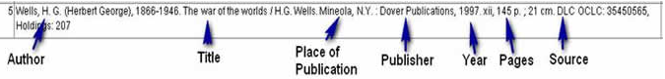Language of Cat.

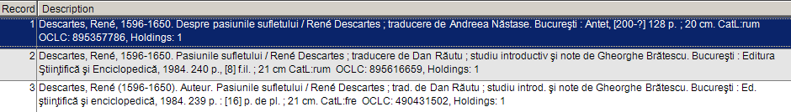

Finally, one of the most useful searches is back in the Command Line, and it’s the Keyword Search. In this search, we can enter any number of keywords from the resource in hand, without any abbreviations or punctuation for the search commands. OCLC will find and display results where those words appear anywhere in the record. For example, the Romanian version of Plato’s works is called “Opere” by “Platon”, and these words are the same in Italian as they are in Romanian. Plugging in Platon and Opere in the Command Line will therefore yield way too many records, but adding just a single word from the publisher (stiintifica) will narrow it down considerably.
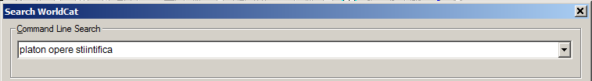
You can also put phrases in quotes, and OCLC will treat them as a single “word”.
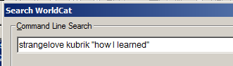

We’ve only scratched the surface, but it’s very important to keep in mind that different searches will suit different resources. Feel free to experiment and ask questions!

