Connecting Point Grey Camera to Computer using GigE on NIC
If using GigE with the USB adapter: make sure you install the driver for the adapter. EITHER the adapter will come with a CD or internet link where you can install the driver OR when you connect the adapter, the computer will automatically find the driver and load it. After the driver is installed, continue with the following directions.

- Make sure you have Vision Acquisition Software on the computer. Check this by searching NI License Manager and checking that Vision Acquisition is ‘Activated’ (Figure 1). If it doesn’t show up in the tree to the left, it needs to be installed. If the software is not listed as ‘Activated’, select ‘Activate’ in the upper left corner and follow the directions. If it prompts you for a NI User account, Cameron or Monroe can supply this to you.
Once you have Vision Acquisition installed, close the License Manager.

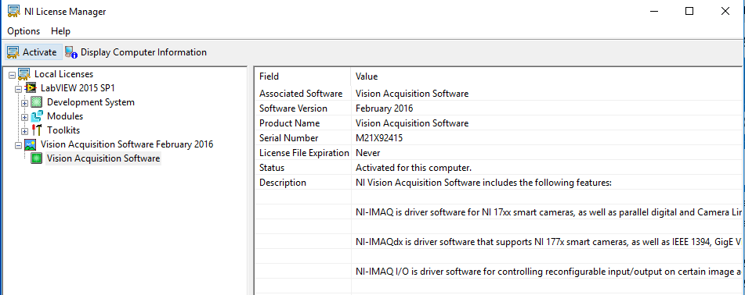
Figure 1. NI License Manager Screenshot
- Install the following drivers from Point Grey’s website. You’ll need to create an account. https://www.ptgrey.com/downloads/getsecuredownloaditem/10700
Printed on the side of the camera is the name. Using the pull down menus, find the downloads that correspond to your camera and operating system
  - Download two items (Figure 2):
    - Under ‘Software’ download: FlyCap2 SDK Version
    - Under ‘Firmware’ download: the camera firmware (the name will change depending on the camera you have. Flea3 is used in this example)
  - Run the FlyCap executable and follow the instructions. (you don’t need to supply user info, just skip it) VERY IMPORTANT: SELECT ALL THE INTERFACE DRIVER YOU NEED FOR YOUR CAMERA. IF YOU DON’T KNOW IT, LOOK IT UP OR ASK. IF YOU DON’T HAVE THE RIGHT DRIVERS, THE CAMERA WILL NOT WORK.
  - Unzip the camera drivers to a known location on the computer.
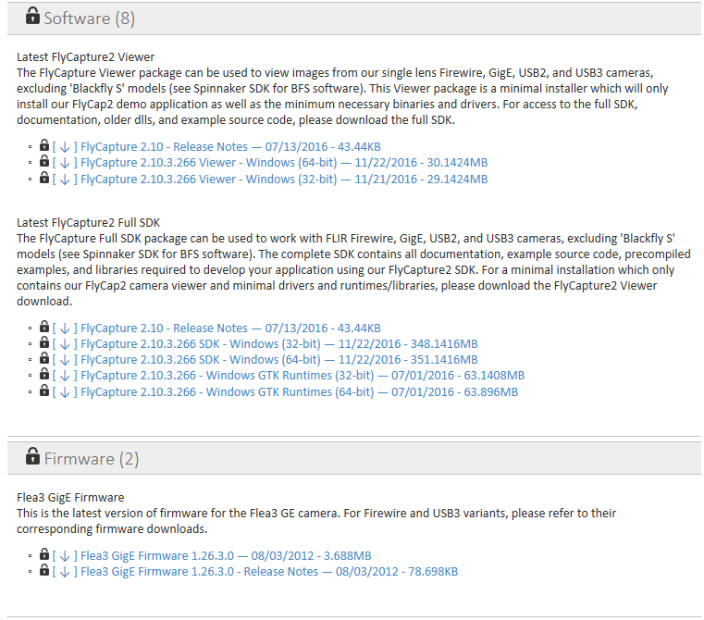
Figure 2. Point Grey downloads page populated after selecting camera and operating system.
  - Once FlyCapture is installed, GigE Configurator will automatically launch.
  - Under Network Adapters on the left panel, select Ethernet (Figure 3). MTU value should read 9000 but if it doesn’t, select Open Network Connections, go to the Advanced tab, highlight Jumbo Packets, and select the value (to the right) to be 9014 bytes and select OK at the bottom of the window.
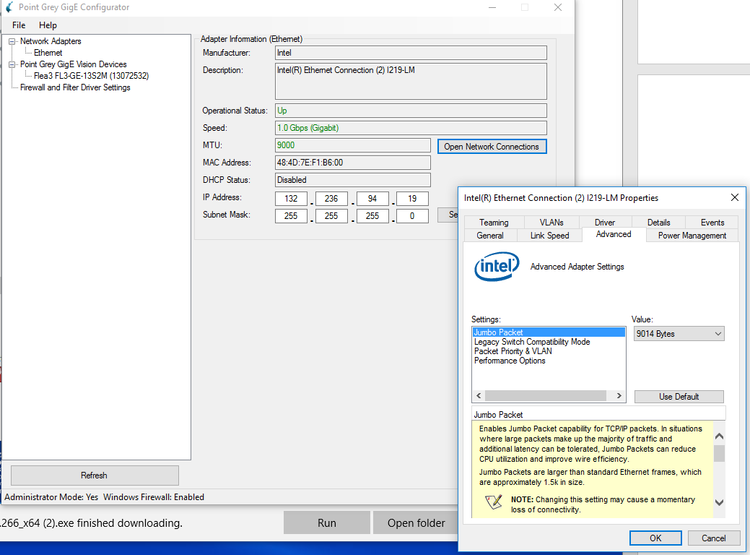
Figure 3. GigE Configurator, setting network packet size
  - If camera says (BAD) next to the name, select the camera in the left panel, and select ‘Automatically Force IP’ (Figure 4). The program will refresh, populate with camera information and not say (BAD) anymore. Close GigE Configurator.

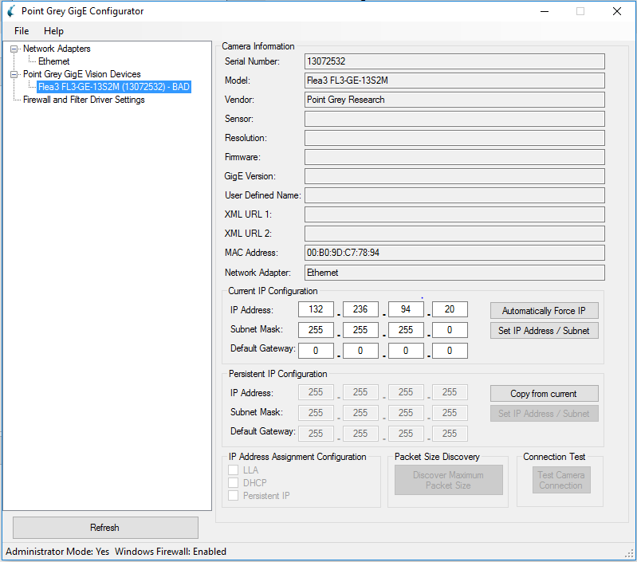
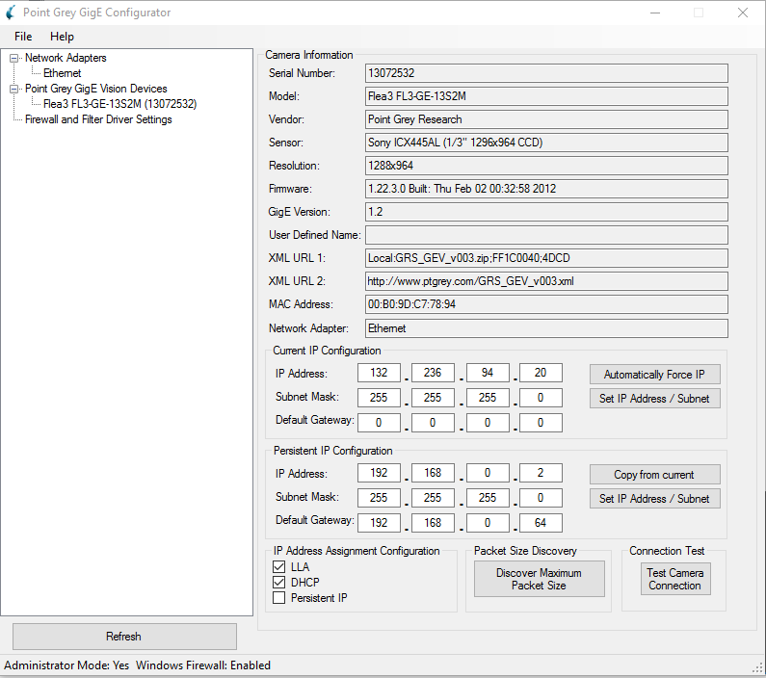
Before refresh
After refresh

Figure 4. Camera properties before and after IP address is forced and program refreshes.

  - Open UpdatorGUI3. The camera should appear in the top box (Figure 5). Once you have unzipped the folder containing the camera firmware, select Open in the middle of the window. Navigate to the unzipped firmware folder and select the *.ez2 file. Select Open and then Update. The progress bars should go wild as well as the indicator light on the camera. Select Quit when the update finishes.
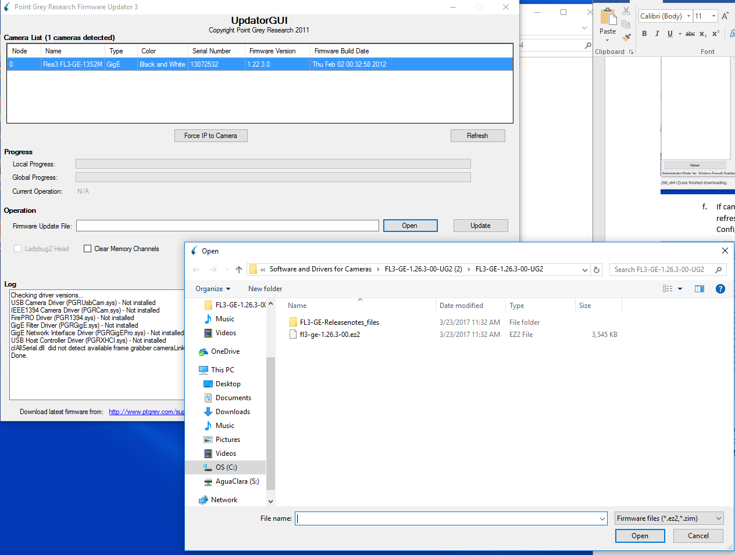
Figure 5. UpdatorGUI3 to update camera firmware.
- Open up NI-MAX. In the left panel (Figure 6), navigate to My System->Devices and Interface->Point Grey Research *camera name*. If the camera doesn’t show up, something went wrong. Test the camera by clicking Snap or Grab to get images from the camera. If the camera is working in NI-MAX, LabVIEW will be able to find and use the camera in software.
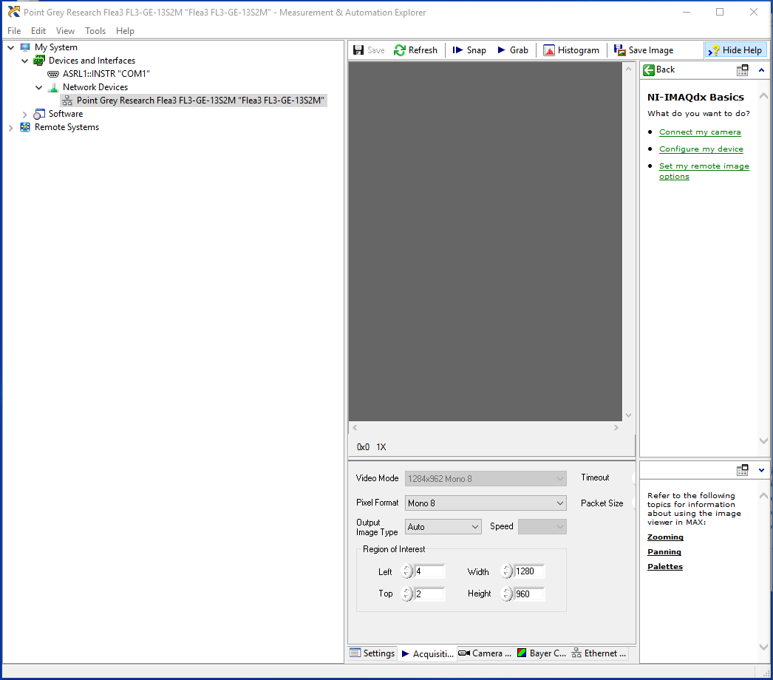
Figure 6. NI-MAX will confirm that LabVIEW can use the camera.

