Directions for entering CLIQ paper surveys into Excel.
- Find and open the Excel file “DataEntry_Template.xlsx” from Box: https://cornell.app.box.com/files/0/f/16293932980/CUL_Instruction_Assessment_Data_Fall_2016
- Save the file to your local computer by renaming it following the naming convention: COURSE1010_PROFESSOR_SEMESTER_YYYY.
- Use one excel file per class.
- The Excel file has a worksheet example that looks like this:

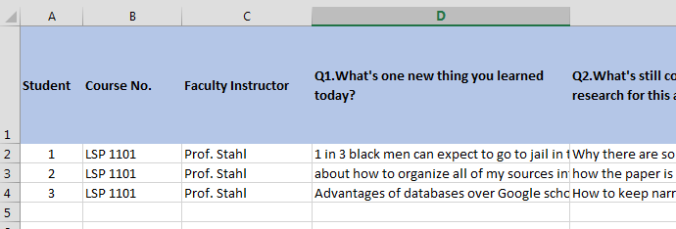
The top row of the spreadsheet (in blue) contains the labels/questions for the data you need to enter. Each column corresponds to a data point relevant to your class, such as the student in class, the instructor (Faculty member), and each of the seven questions, plus the library (your unit).
Each row corresponds to one questionnaire/survey. For example, student no. 1’s responses to the questionnaire will all be in that same row, with the responses to each question under the corresponding column.

- Before entering data, label each paper survey from your class consecutively starting with No. 1.
- In Excel:
  - Erase the sample data contained in the first three rows; keep the blue row intact. Or, if you want to keep it as a reminder, just start your data entry below it and after completion, erase it.
  - Columns B (Course No.) and C (Faculty instructor) will be the same for all the students in your class you can add those now or later.
  - In the second row, start with number 1 (Column A), and enter the information from your first paper survey labeled No.1. Type that student’s responses to question 1, question 2, etc. under the corresponding column (moving horizontally to the right).
  - Multiple Choice Question 4. Type the corresponding answer: Strongly Agree, Agree, Neither Agree nor disagree, etc. Type No Answer if it was left blank.
  - Multiple Choice Question 5. Type Yes, No or No Answer (if it was left blank).
  - Multiple Choice Question 7. Type Yes, No, Not sure, or No Answer (if it was left blank)
  - Column K (Library). Enter your unit’s name. This will be the same for your class.
- Save to your computer.
- Save a copy of this file to the Box Folder “CUL Instruction Assessment Data Fall 2016” and your corresponding library with the same file naming convention:
File Name: COURSE1010_PROFESSOR_SEMESTER_YYYY.
Box File:
https://cornell.app.box.com/files/0/f/16293932980/CUL_Instruction_Assessment_Data_Fall_2016
- You’re done!

Thank you for participating in the CUL-wide assessment program!
Assessment Sub Team

