how to ODBC to A&S’ SQL server

Instructions for Chem IT

the first two steps assume that the computer is installed as a 64 bit OS… if not, skip to third step

first, determine if the FM you are using is 32 or 64 bit… this appears to involve finding the “FileMaker Pro.exe” file and noting whether the folder is in “C:\Program Files\” or “C:\Program Files (x86)\”. (x86 is the 32 bit version)

second, find the correct ODBC. see https://support.microsoft.com/en-us/kb/942976 for assistance... essentially, each version is lying about how many bits it is… go figure!

third, open* the ODBC Data Source Administrator (whichever is appropriate…), choose “User DSN”
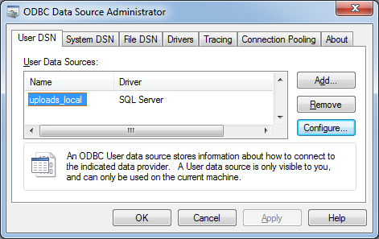

fourth, if a new computer, choose “Add”, otherwise, select the correct DSN and hit Configure, then skip down to the sixth step and double-check the details

fifth, choose SQL Server and hit Finish
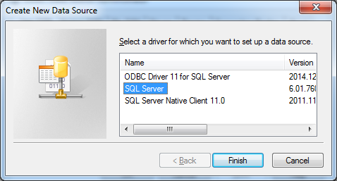

sixth, fill in correct DSN name, any description you wish, and the SQL Server IP address, and click Next
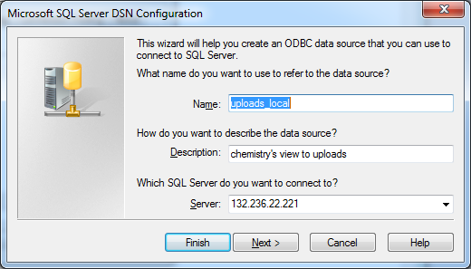

seventh, choose “With SQL Server Authentication…”, be sure the “Connect to SQL Server…” box is checked, and fill in the username and password
(contact Dani and/or Tu for this information, if you need to)
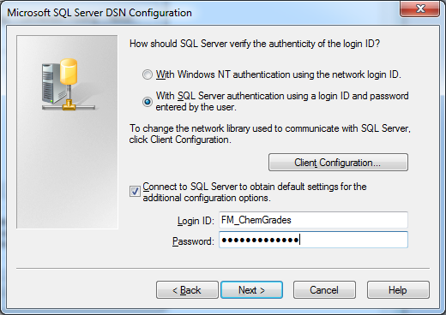

eighth, on a new DSN, you will likely need to change the default database… check “Change the default database to:”, and change as necessary, click Next
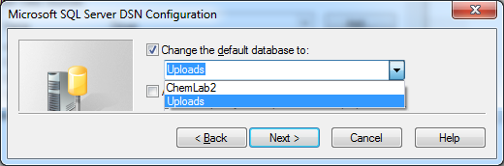

ninth, click Finish then Test Data Source, and you should see a success page! click two oks and you’re done!
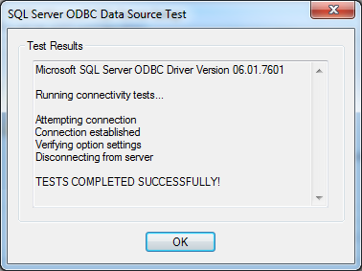

this information compiled by Dani Rotach, dmr22, college of arts and sciences, 9/23/2016
win 7
FileMaker 11
MS SQL Server 2014

propagate changes to FileMaker file: Chem Grades Uploads: layout ODBC

* if you need to locate the ODBC Data Source Administrator(s), you might be able to find them in the Control Panel’s Administrative Tools, or you could search (in the start menu search box) for ODBC, or you can go to the link in step 2 to find the locations of the executables, because not all versions appear on all searches! sigh. you’d think they’d make this easier, but, no.

