Hi All:)

Great meeting with you all today!

The minutes can be found in the Attachments section of our wiki. Please feel free to edit as needed.

All - The following are the action items from our meeting. Please send me an email with the following information. Thanks to those who already answered my questions:) Please do so by COB Monday, September 13th.
- Equipment – Are you in need of a camera? Headset? (Please note that the audio is much better, on both ends, if you use a headset)
- Teams – Which topic (CUL or Cornell) would you like to work on?

Erin and Gaby – Xin mentioned that you both worked on mapping instruction. Can you share any processes/lessons learned, etc… that might be helpful to this team?

Sarah and Patrick – I have contacted you to learn more about any videoconferencing needs you may have. Please respond back so we can make sure this mode of communication will work for you.

Sarah – Please send me your picture again.

All – Please share any thoughts on how to make our meetings or the task force better.

Discussion topics
There are a few things we need to discuss and I thought we could start the discussion over email. Please feel free to reply all, so we can make a decision as a team. The ideas below are just suggestions. I am looking forward to hearing your thoughts.

Meeting / Team / Communication Norms
It seems that we will need to meet as a task force to make larger decisions. When we split into working teams, they can decide how often to meet.

I suggest we schedule a meeting once a month on our calendars to hold the space since our schedules won’t be easy to coordinate. If we need to meet, we will use that time to do so. If we do not need to meet as a team, we can cancel the meeting.

We can also decide to meet as a task force as needed, when an issue comes up that needs to be addressed.

Is the team comfortable rotating minute taking?

Is the team comfortable using the wiki as our space? Should we also create a Box folder so we can edit documents as a team? What else do we need to succeed?

Proposed Process
Are these phases complete?
Do we need more phases?
What is missing?

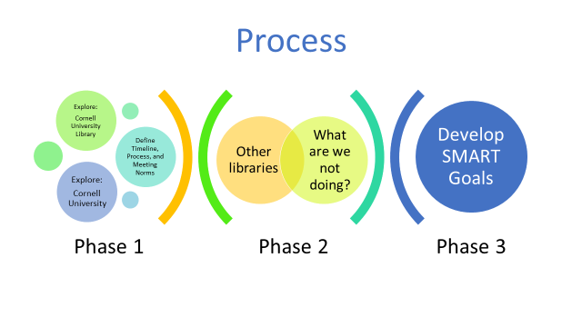

Proposed workflow timeline
Do these dates make sense?
What is missing?
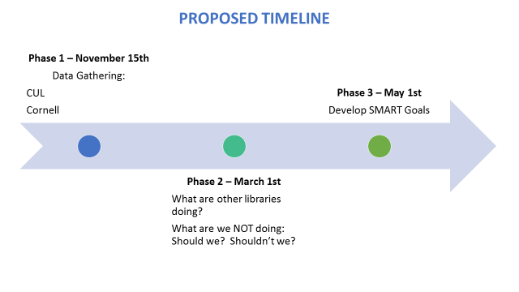

Prioritization and Developing Guidance
As I stated in the meeting, it might be helpful for us to understand what our priorities are as we start our work. Once we have our priorities in place, we can then develop a guiding question that might help us decide what is in scope/out of scope as we move through our deliverables.

Do you all think we can figure this out over email OR would it be better to schedule a meeting in the next two weeks?

That’s it! Thanks for reading through this entire email!

Have a great rest of your day,
Neely

