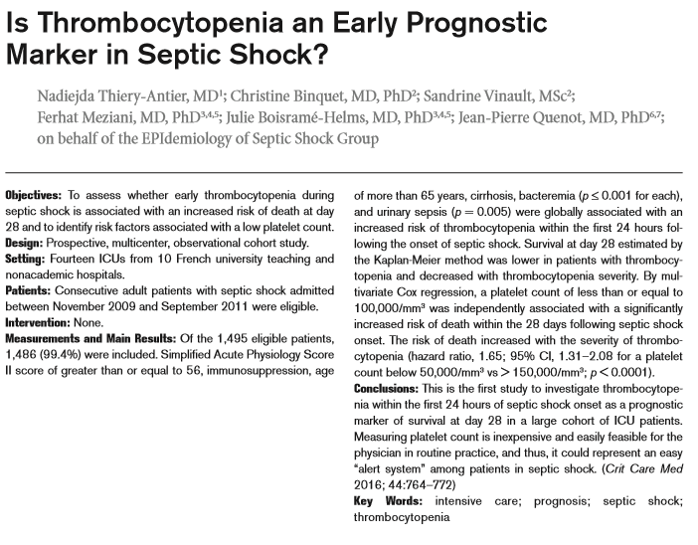

TAKE HOME
- Thrombocytopenia <100,000 in the 1st 24 hr of septic shock is associated with increased risk of death at 28 days
- Cirrhosis, immunosuppression, and bloodstream infection were found to be risk factors for thrombocytopenia

