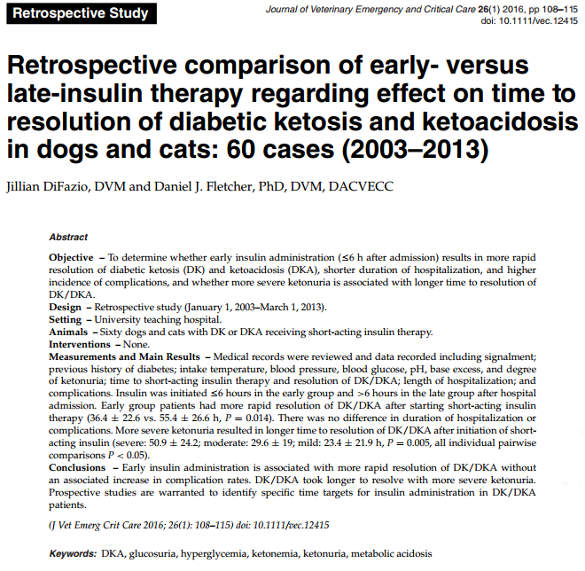
- Recommendations for timing if insulin initiation are more based on expert opinion rather than evidence
- Justification for delaying insulin administrations and waiting till rehydration and sampling lines
  - BG decreases with fluid therapy alone
    - reduces insulin resistance
    - decreases concentrations of counterregulatory hormones
    - increases insulin availability to peripheral tissues
    - dilute the BG
    - increases glomerular filtration rate, thereby increasing urinary glucose loss
  - Concerns of metabolic complications of insulin therapy
    - Significant decrease in BG → decrease in osmolality → cerebral edema
      - May not be as important as regularizing Na as BG drops which can also lead to cerebral edema
      - serum osmolality does not correlate with BG in dogs and cats with DK and DKA, and is more closely associated with changes in Na, suggesting that the concern over rate of BG normalization is unwarranted
    - Electrolyte derangements
      - Decreased K, P, Mg
- Insulin is required to stop ketogenesis, increase ketone body metabolism, decrease gluconeogenesis, promote glucose utilization
- In people recommendation is start insulin therapy after 1st hr of resuscitation pending K+ ≥ 3.3

Study:
- Retrospective study
- Inclusion criteria: DK or DKA with ketonuria (acidemia wasn’t required)
- Exclusion criteria: died/euthanized before insulin administration, long-acting insulin prior to resolution, ketonemia without ketonuria (ketonuria was used to evaluate resolution), unavailable records
- Early administration: ≤ 6 hrs; Late administration ≥ 6 hrs
- Evaluated:
  - Time to resolution DK/DKA
  - Complications: (worsening or development hypoK, hypoP, hypoMg, hypoglycemia, declining mentations, seizures)
Results:
- Ketonuria resolved quicker in early insulin group, 19 hours earlier
- No differences in complications between early and late
- LOH not associated with time of administration (comorbidities?)

