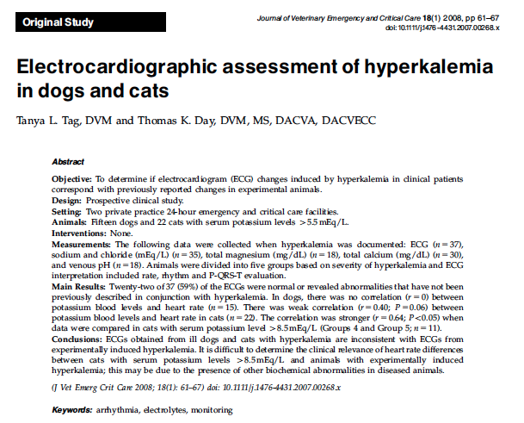

- Why did they do the study?
  - ECG alterations were found when hyperkalemia was induced in healthy animals, which correlated to the degree of hyperkalemia:
    - 5.5 – 6.5 mEq/L: increase in T wave amplitude
    - 6.6-7.0 mEq/L: decrease in R wave amplitude, prolonged QRS and P-R intervals and S-T segment depression
    - 7.1-8.5 mEq/L: decrease in P wave amplitude, increase in P wave duration and prolonged Q-T interval
    - 8.6-10 mEq/L: lack of p waves (atrial standstill) and sinoventricular rhythm
    - > 10.1 mEq/L: widening of QRS complex, replacement of QRS with smooth biphasic waveform, ventricular flutter, fibrillation or asystole
  - However critically ill patients have other electrolyte/biochemical abnormalities that affect the ECG.
- Materials/Methods
  - Study population: 37 dogs (15) and cats (22) from 2 private practice ECC facilities
  - Inclusion: non-anesthetized dogs and cats with serum K+ > 5.5 mEq/L AND an simultaneous ECG recorded before therapy
  - Exclusion: known or induced cardiac disease, exposure to CV toxins
  - Data: K+, Cl-, Na+, Ca2+, Mg2+, blood gas, ECG rhythm strip for minimum 15 seconds
  - Separated into 5 groups based on severity (as above)
  - ECG analyzed without knowledge of group: rate, rhythm, P wave size and duration, P-R interval, QRS complex configuration and duration, Q-T interval and T wave configuration
- Results
  - 59% of the ECG changes were not consistent with the previously reported changes based on degree of hyperkalemia
    - Groups 1 and 2: no ECGs consistent with previously reported changes
    - Group 3: 75% not consistent
    - Group 4: 43% not consistent
    - Group 5: 27% not consistent
    - Each group had patients with NSR
  - Other lab abnormalities
    - Hyponatremia
    - Hypochloridemia
    - Hypermagnesmeia
    - Hypocalcemia
    - Venous academia
  - No correlation between K+ blood levels and heart rate in dogs OR cats overall
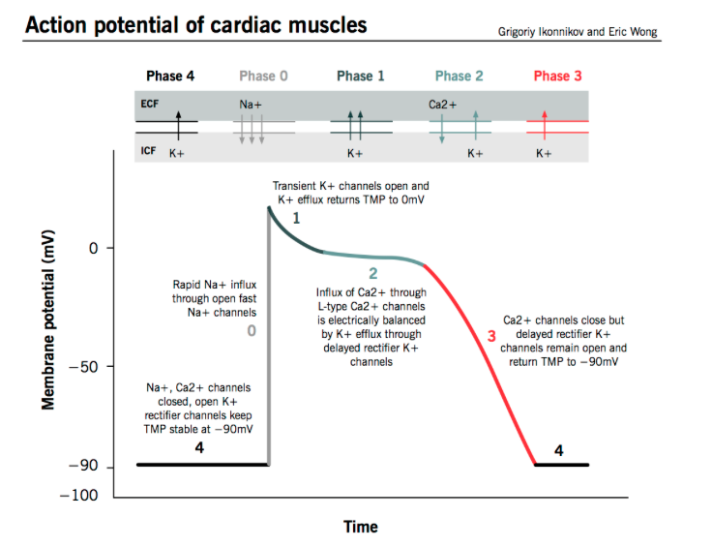
    - Correlation was significant in cats with serum K+ > 8.5 mEq/L
- Physiology Review
  - In-cell to ex-cell K+ ratio determines cardiac resting membrane potential because K channels open at rest
    - When serum K+ increases the concentration gradient decreases >> less negative RMP (closer to threshold, should increase excitability) BUT
      - Also inactivates Na-K channels so cells are slower reaching threshold potentials
      - SLOWS efflux K+ out of cell during phase 3, prolonging muscle recovery
  - Body mechanisms to protect against hyperkalemia:
    - Insulin, beta adrenergic R’, K+ >> in cell shift K+
    - Increased renal excretions K+ (increased activity of K+ channels in principal cells
      - Increased serum K+ on protein components of channels
      - Increased aldosterone release
  - Changes affecting ECG
    - Calcium moves into c ell during phase 2
      - Hypocalcemia prolongs phase 2, lowers threshold potential, downregulates myocardial b R’ >> weakens cardiac muscle
      - Prolongs ST segment, QT interval
    - Venous academia
      - Ex cell pH affects cell membrane excitability by decreasing beta adrenergic R’ on cardiac nodal tissue, also causes K+ to shift ex-cell
    - Hypermagnesemia
      - Prolog s QRS shortens QT and prolongs PR

