Vet J. 2010 Jul; 185(1):28-35
Prognostic and predictive biomarkers of canine osteosarcoma.
Canine osteosarcoma (OS) is an aggressive tumour that accounts for approximately 90% of primary bone tumours in the dog. Although the standard treatments (including limb amputation/sparing, chemotherapy and palliative radiotherapy) have significantly increased survival rates, almost 90% of animals will eventually develop predominantly pulmonary metastases. Despite advances in various therapies, prognosis remains poor, with median survival times ranging from 3 months to 1 year and <20% of dogs survive for >2 years following diagnosis. Various clinical and epidemiological markers have facilitated decision-making with respect to therapy but no single molecular biomarker has been shown to enhance prediction of disease progression. The publication of the canine genome in 2005 raised the possibility of increasing understanding of the genetic mechanisms underpinning canine OS. This review explores the use of biomarkers within the multi-disciplinary management of dogs with OS, and highlights the few known, potential prognostic/predictive molecular markers including their potential value as 'bridging biomarkers' for human OS. Although high-throughput profiling of canine OS remains in its infancy, research within the next decade using leading-edge screening technologies has the potential to identify biomarkers that may enhance diagnostic and prognostic accuracy and result in more effective, individually tailored, treatment and management protocols for affected dogs.

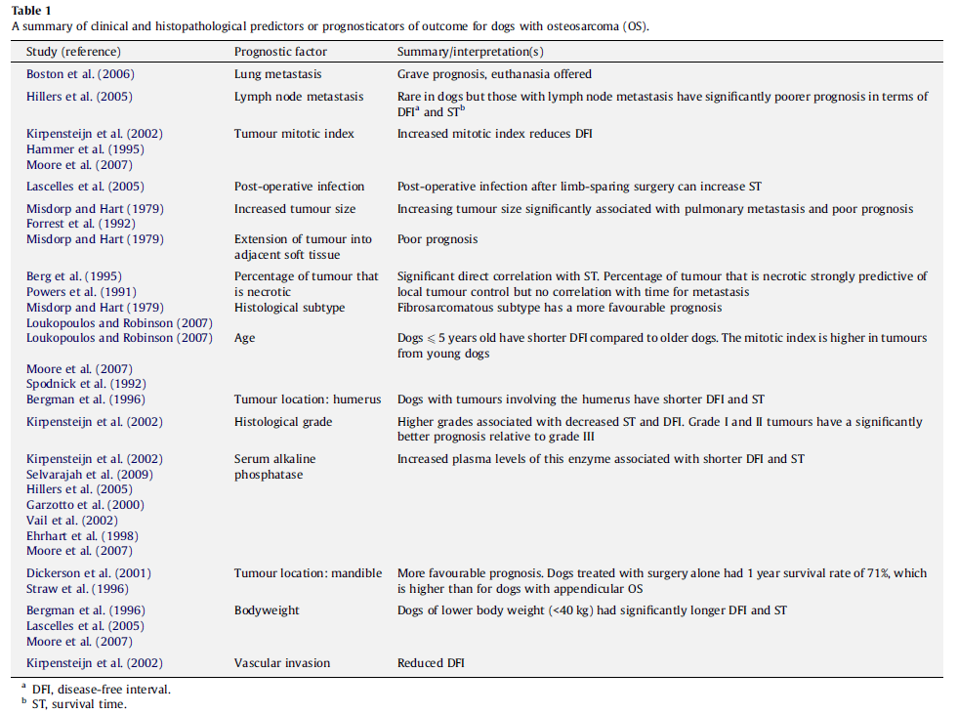
Description | Malignant neoplasm; mesenchymal origin. Production of osteoid. Local skeletal destruction.
Frequency | Most common primary bone tumor (approximately 90%).
Location | Away from elbow, near stifle. 25% in axial skeleton (skull, ribs, vertebrae, sternum, pelvis). Sometimes extra-skeletal sites.
Behavior | Aggressive and invasive. Highly metastatic. Hetergoneous (locatrion, met sties, xrays signs, histopath, progression, response to Tx)
Age at presentation | Median age: 8-10 y; subset of tumor arising in younger dogs. Males may be predisposed.
Clinical signs | Lameness or even fracture
Diagnostics | Xrays: osteolytic and osteoproductive lesions.  Histopath: osteoid matrix with osteoblastic, fibroblastic, chondroblastic and telangiectic subtypes. Mets histopath: more necrosis
Mets | Lungs*, distant bones, regional LN, soft tissues. Less than 15% have xray detectable lung or bone mets at presentation. 90% of them die w/in 1 y with met disease if only amputation.
Treatment | Amputation or limb-sparing (when neuro, ortho disorders, owner does not want amput; risk of infection, implants failure, recurrence (in 15-25%)
Prognosis | Histopathological grading system for appendicular tumor: grade III = poorer (75% of cases)  Amputation alone: < 3-6mo in 90% (mets)  Chemotx (cisplatin, carboplatin, doxorubicin) – single or multi-agent regimes.  Bisphosphonates  With chemo: MST = 10-12mo  <10-20%: survive > 2y

- Types of biomarkers
  - Prognostic
  - Diagnostic
  - Predictive biomarker (to predict responsiveness to tx)
  - Therapeutic biomarkers/toxicity biomarkers (monitoring/responsiveness to Tx)
- ALP
  - Total and bone associated
  - Prognostic in dogs
  - Normal pre-Tx: survived longer
  - Discrepancies as to its use post-op in predicting mets or recurrence
- TP53 tumor suppressor
  - Tumor suppressor genes encode PT that prevent or retard cell division – and they are mutated development/progression of cancer
  - TP53 mutation may be independent prognostic indicator and predictor of more malignant phenotype
- Vascular endothelial growth factor – regulator of angiogenesis
  - Associated with more aggressive tumors in dogs
  - Poorer prognostic
- Mesenchymal-epithelial transition factor
  - Protooncogene – activates oncogenic pathways and participates in angiogenesis and mets
  - Predictor for mets vis lymphatics
- COX-2 – regulator of angiogenesis
  - Involved in apoptosis, angiogenesis, immune-surveillance, production of PGs
  - Prdictor of mets and survival – debatable
- Ezrin – cytoskeletal linker protein
  - Physical and functional anchor site for cytoskeletal F-actin fibers
  - Associated with mets
  - Predictor of poor outcome
- Metalloproteinases – MMP
  - Predictor of shorter survival
  - Correlate with invasive and metastatic forms in humans
- Therapeutic and toxicity markers
  - CtnI – Sn and Sp; doxorubicin toxicity

Questions
- Prognosis in dogs with OSA that receive amputation and chemotherapy
  - < 3 mo
  - 6-9 mo
  - 10-12 mo
  - 2 years
- Which % of dogs have mets detectable on chest xrays at the time of diagnosis of OSA?
  - 10%
  - 25%
  - 50%
  - 75%
- Which of the following has been associated with poorer outcome in dogs with OSA
  - Elevated pre-treatment ALP
  - Elevated ALP post-treatment
  - Worsening ALP following initiation of treatment
  - ALP is not associated with survival in dogs with OSA
- Which tumor location has been associated with better prognosis
  - Humerus
  - Femur
  - Mandible
  - Rib
- TP53
  - Prevents or retards cell division
  - Regulates angiogenesis
  - Is a cytoskeletal linker protein
  - Is a predictor for metastasis via lymphatics

Questions & Answers
- Prognosis in dogs with OSA that receive amputation and chemotherapy
  - < 3 mo
  - 6-9 mo
  - 10-12 mo
  - 2 years
- Which % of dogs have mets detectable on chest xrays at the time of diagnosis of OSA?
  - 10% (< 15%)
  - 25%
  - 50%
  - 75%
- Which of the following has been associated with poorer outcome in dogs with OSA
  - Elevated pre-treatment ALP
  - Elevated ALP post-treatment
  - Worsening ALP following initiation of treatment
  - ALP is not associated with survival in dogs with OSA
- Which tumor location has been associated with better prognosis
  - Humerus
  - Femur
  - Mandible
  - Rib
- TP53
  - Prevents or retards cell division
  - Regulates angiogenesis – VEGF and COX-2
  - Is a cytoskeletal linker protein - Ezrin
  - Is a predictor for metastasis via lymphatics - MET

