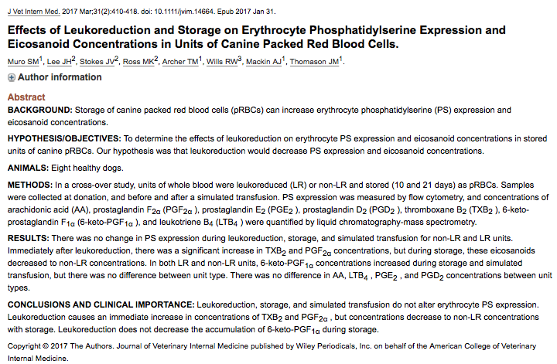

- Humans: increase in PS expression on RBC surface recognized storage lesion
  - Signals need for cell removal, potential to decrease lifespan of transfused cells
- Accumulation of eicosanoids (PGF_{2α}), (LTB₄), (TXB₂), (6-keto-PGF_{1α}) in canine pRBC during storage and transfusion
  - Vascular and bronchial tone, platelet aggregation, GI motility, renal blood flow, inflammation (via interaction with signaling molecules, cytokines and chemokines), potential to increase transfusion reactions
  - RBCs contain AA but not the enzymes need to make eicosanoids
  - Leukocytes and platelets probably contribute the most in pRBCs
- Healthy research colony dogs (Walker Hound Dogs)
  - LR and non-LR groups
  - 28 day recovery period and then switch groups
  - PS assessed at collection, day 10 and day 21 via flow cytometry
  - Eicosanoids assessed at collection, day 10 and day 21 via mass spec
- PS no significant difference in expression between groups or within groups for different times.
  - Microparticle formation possible
- Also no difference in concentration of AA, PGE₂, PGD₂, LTB₄
  - At time of collection PGF_{2α} and TXB₂ concentrations higher in LR units but decreased with storage so no difference in any other time point.
  - Significant increase in 6-keto-PGF_{1α} concentration LR and non-LR on days 10 and 21

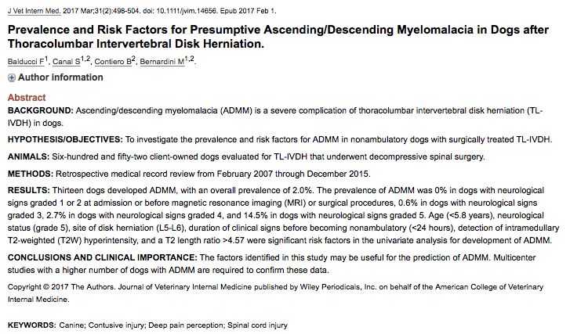

- Diagnosis of ADMM (presumptive)
  - Progression of clinical signs from initial UMN to LMN paresis/paraplegia to flaccid paraplegia
  - Total areflexia of the pelvic limbs, tail and anus
  - Loss of DPP caudal to site of spinal cord injury
  - Cranial migration of CTM reflex
  - Tetraparesis
  - Loss of thoracic limb reflexes
  - Respiratory difficulty
- Study population
  - 652 dogs (complete PE, NE, MRI revealing IVDH T3-L6, hemilam or mini hemilam)
  - 13 with ADMM (2%)
    - neuro grade 1 (spinal hyperesthesia only) 0%
    - neuro grade 2 (neuro defecits but ambulatory) 0%
    - neuro grade 3 (paraplegia with motor) 0.6% (1/173)
    - neuro grade 4 (paraplegic with DPP) 2.7% (4/148)
    - neuro grade 5 (paraplegia without DPP) 14.5% (8/55)
- Risk Factors ADDM
  - Chondrodystrophic breeds 69.2%
  - < 5.8 years old (not sig in multivariate)
  - neuro grade 5 (not sig in multivariate)
  - herniation L5-L6
  - duration CS to becoming non ambulatory
    - < 24 hrs 3.54 times more likely than > 24 hrs
  - intramedullary T2W hypersensitivity
    - T2W length ratio > 4.57 => 17.2 x more likely to develop ADMM
    - Edema, inflammation, hemorrhage, gliosis, necrosis, myleomalacia

