J Am Vet Med Assoc. 2008 Jul 1;233(1):87-95
Pituitary-adrenal function in dogs with acute critical illness

OBJECTIVE: To evaluate pituitary-adrenal function in critically ill dogs with sepsis, severe trauma, and gastric dilatation-volvulus (GDV).

DESIGN: Cohort study.

ANIMALS: 31 ill dogs admitted to an intensive care unit (ICU) at Washington State University or the University of Pennsylvania; all dogs had acute critical illness for < 48 hours prior to admission.

PROCEDURES: Baseline and ACTH-stimulated serum cortisol concentrations and baseline plasma ACTH concentrations were assayed for each dog within 24 hours after admission to the ICU. The change in cortisol concentrations (Delta-cortisol) was calculated for each dog. Morbidity and mortality data were recorded for each patient.

RESULTS: Overall, 17 of 31 (55%) acutely critically ill dogs had at least 1 biochemical abnormality suggestive of adrenal gland or pituitary gland insufficiency. Only 1 (3%) dog had an exaggerated response to ACTH stimulation. Dogs with Delta-cortisol < or = 83 nmol/L were 5.7 times as likely to be receiving vasopressors as were dogs with Delta-cortisol > 83 nmol/L. No differences were detected among dogs with sepsis, severe trauma, or GDV with respect to mean baseline and ACTH-stimulated serum cortisol concentrations, Delta-cortisol, and baseline plasma ACTH concentrations.

CONCLUSIONS AND CLINICAL RELEVANCE: Biochemical abnormalities of the hypothalamic-pituitary-adrenal axis indicative of adrenal gland or pituitary gland insufficiency were common in critically ill dogs, whereas exaggerated responses to ACTH administration were uncommon. Acutely ill dogs with Delta-cortisol < or = 83 nmol/L may be more likely to require vasopressors as part of the treatment plan.

Hypothesis:
- Pituitary-adrenal insufficiency exists in CC dogs
- Dogs with pituitary-adrenal insufficiency have higher morbidity (LOH, hypotension) and mortality
Methods:
- n= 31 dogs (13 sepsis, 10 trauma, 8 GDV) and 10 healthy dogs
- Measurement of baseline cortisol
- Measurement of baseline ACTH
- Measurement of post ACTH stim cortisol and ∆ cortisol
Results:
- No correlation between ACTH and baseline cortisol in sick dogs (positive correlation in healthy)
- No difference in baseline cortisol/ACTH and ∆ cortisol between group of sick dogs
- 17/31 (55%) had at least one value suggestive of relative adrenal insufficiency (no electrolytes abnormalities)
  - No response to ACTH
    - And all dogs had high baseline cortisol (reserve depletion?)
  - Post cortisol less than RI
  - ACTH less than RI
- 19/31 (61%) had at least 1 value consistent with adrenal over reactivity
- ∆ cortisol ≤ 83 nmol/L associated with increased likelihood of receiving vasopressors
- Outcome – NSD between dogs w/ vs w/out values consistent with adrenal insufficiency

Eur J Endocrinol. 2016 Jul;175(1):R1-9
Mechanisms in endocrinology: New concepts to further unravel adrenal insufficiency during critical illness

The concept of 'relative' adrenal insufficiency during critical illness remains a highly debated disease entity. Several studies have addressed how to diagnose or treat this condition but have often yielded conflicting results, which further fuelled the controversy. The main reason for the controversy is the fact that the pathophysiology is not completely understood. Recently, new insights in the pathophysiology of the hypothalamic-pituitary-adrenal axis response to critical illness were generated. It was revealed that high circulating levels of cortisol during critical illness are explained more by reduced cortisol breakdown than by elevated cortisol production. Cortisol production rate during critical illness is less than doubled during the day but lower than in healthy subjects during the night. High plasma cortisol concentrations due to reduced breakdown in turn reduce plasma ACTH concentrations via feedback inhibition, which with time may lead to an understimulation and hereby a dysfunction of the adrenal cortex. This could explain the high incidence of adrenal insufficiency in the prolonged phase of critical illness. These novel insights have created a new framework for the diagnosis and treatment of adrenal failure during critical illness that has redirected future research.
Key Points
- High circulating levels of cortisol during critical illness may be explained more by reduced cortisol breakdown than by elevated cortisol production
- High plasma cortisol concentrations (due to reduced breakdown) reduce plasma ACTH concentrations via negative feedback
- Reduced plasma ACTH concentrations may lead to an understimulation and dysfunction of the adrenal cortex
- Currently recommended hydrocortisone dose (SCC: intravenous hydrocortisone to treat septic shock patients if adequate fluid resuscitation and vasopressor therapy are not able to restore hemodynamic stability – weak recommendation, low quality of evidence) may be too much due to decreased breakdown of cortisol
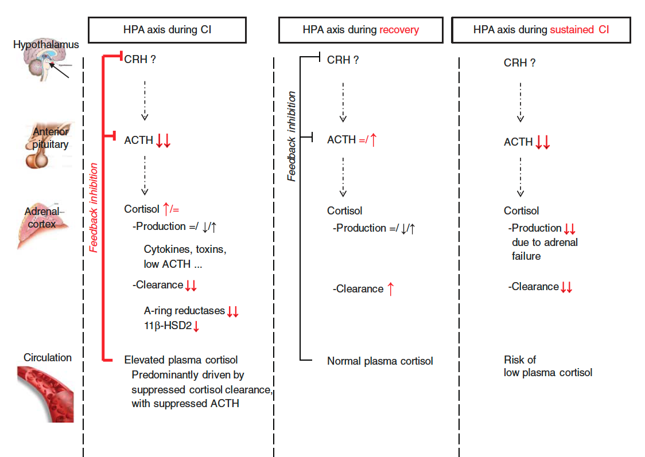

- Absolute vs relative adrenal insufficiency
  - Absolute: failing cortisol production
    - Primary, secondary, tertiary
    - Addisonian crisis
    - Adrenal hemorrhage
    - Adrenal thrombosis
    - Drugs that influence HPA axis: etomidate, phenoB, ketoconazole, rifampin…
    - Low cortisol, w/ or w/out low ACTH, suppressed cortisol response to ACTH stim
  - Relative: functional, transient deficiency acquired during critical illness; insufficiently activated adrenal cortex relative to the degree of stress – CONTROVERSIAL!
    - Critical illness-related corticosteroid insufficiency
    - Underlying mechanisms:
      - Cytokines: induction of tissue resistance; inhibition of ACTH function
      - Decreased ACTH secretion (ischemia, necrosis, NO)
      - Suppression of cortisol synthesis (oxidative stress, low cholesterol, low cortisol precursor, altered BF)
      - Decreased GC cellular uptake
      - Decreased #, expression, fct of GC-receptors
      - Low corticosteroid binding globulin (CBG) levels and decreased affinity impaired transport
- Normal response (vital) to stress
  - Activation of the HPA increased cortisol
- HPA-axis regulation during critical illness
  - A study showed that trauma/sepsis patients only had transient elevation of ACTH (after a few days, ACTH dropped), cortisol remained high - Why?
    - Non-ACTH mediated mechanisms regulate cortisol availability during illness? (cytokines, neuropeptides)
    - Increased sensitivity of ACTH (so does not need as much to produce high cortisol) NO: increment cortisol response to ACTH stim is never increased and often low
    - Decreased breakdown of cortisol
      - By suppressed expression and activity of A-ring reductases (liver) and suppressed activity of 11beta-hydroxysteroid dehydrogenase type 2 (kidney) = 5x longer ½ life!!!
        - ** 24h cortisol production rate in many CC patients with high cortisol levels may not be much higher compared with healthy controls
          - HIGH cortisol (from decreased breakdown) negative feedback inhibition of ACTH stim
    - Decreased ACTH:
      - Adverse consequences for the integrity of adrenal cortex (PROLONGED illness)
        - Depletion of cholesterol esters (cholesterol needed for cortisol production)
        - Suppressed expression of ACTH-regulated genes
- Relative adrenal insufficiency
  - IS NOT primary adrenal failure
    - If it was primary adrenal failure, we would expect a HIGH ACTH (not been reported)
  - Patients with LOW cortisol response to ACTH stim also have the MOST REDUCED cortisol BREAKDOWN
    - ACTH stim test may give little information about the adequacy of cortisol production but may reflect the degree of reduced cortisol metabolism (leading to increased cortisol levels which exerts negative feedback on ACTH production)
  - ACTH stim response is poorly reproducible in CC patients – adrenal function during critical illness is DYNAMIC
    - The use of repetitive measurement of plasma cortisol over time WITH repetitive ACTH stim could potentially provide more information on the nature of adrenocortical dysfunction
      - **Cortisol responsiveness to ACTH restores after illness
      - **Decreasing cortisol response during repetitive ACTH stim associated with poor Px
- When to treat? And how?
  - Mouse model of absolute adrenal insufficiency showed that admx of corticosteroid to septic mice with absolute adrenal insufficiency was beneficial but caused harm to mice w/out adrenal insufficiency
  - If there is a decrease in cortisol breakdown, the recommended hydrocortisone dose of 200 mg/day might be too much

QUESTIONS

- In a study evaluating adrenal function in dogs with sepsis, trauma or GDV, a ∆ cortisol < 83 nmol/L was associated with:
  - Higher mortality rates
  - Longer stay in hospital
  - Higher SOFA score
  - Need for vasopressor

- In critical illness, cortisol levels are increased due to
  - Increased ACTH
  - Increased CRH
  - Decreased clearance
  - Adrenal hyperplasia

- Which of this patient is most likely suffering from critical illness-induced adrenal failure
  - Patient A has a plasma cortisol incremental response of 4 mcg/dL
  - Patient B has a plasma cortisol incremental response of 10 mcg/dL
  - Patient C had a plasma cortisol incremental response of 9 yesterday, and of 6 today

QUESTIONS & ANSWERS
- In a study evaluating adrenal function in dogs with sepsis, trauma or GDV, a ∆ cortisol < 83 nmol/L was associated with:
d) Need for vasopressor

- In critical illness, cortisol levels are increased due to
c) Decreased clearance

- Which of this patient is most likely suffering from critical illness-induced adrenal failure
c) Patient C had a plasma cortisol incremental response of 9 yesterday, and of 6 today

