Vet Clin North Am Small Anim Pract. 2004 May; 34(3): 707-23.
Nonsteroidal anti-inflammatory drugs in veterinary ophthalmology
KEY POINTS
- NSAIDs used for: prevention intraop miosis, control post-op pain/inflammation, allergic conjunctivitis, uveitis, reduce doses (and side effects) associated with steroid admx
- NSAIDs used when diseases preclude use of steroids: DM, systemic infection
- Topical NSAIDs side effects: local ocular irritation, direct corneal cytopathy, decreased AH outflow; also possible to induce systemic side effects (GI, renal, liver…)
- MOA: Inhibition of COX (-1 and/or -2) inhibition of production of PGs, TXA₂

- Inflammation in eye can keratitis sicca, corneal neovascularization/pigmentation, fibrosis, cataract, synechiae, glaucoma, optic nerve atrophy, retinal degeneration/detachment, phthisis bulbi, blindness
- After cell membrane damage, membrane phospholipid is release and hydrolyzed by phospholipase A₂ arachidonic acid metabolized by cyclooxygenase and lipoxygenase pathways TXA₂, PGE₂, PGF_{2α}, PGI₂, LTs
- PGs = main substances that inflammation, potentiate the effects of other inflammatory mediators, cause breakdown of BAB, exacerbate photophobia, lower ocular pain threshold
- Constitutive COX-1: endoplasmic reticulum of all cells: plts, GI mucosa, vascular endothelium, renal medullary collecting ducts, interstitium, pulmonary, hepatic, splenic sites – important for normal physiologic function
- Inducible COX-2: synthesized by macrophages and inflammatory cells stimulated by cytokines, other inflammatory mediators; inflammation and pain
- NSAIDS may also exert anti-inflammatory actions other than COX-inhibition; suppression of PMN cell locomotion and chemotaxis, decrease expression of inflammatory cytokines and mast cell degranulation, free radical scavengers
- Systemic NSAIDs in uveitis often use when cortico are CI (infectious disease, DM), and before cataract surgery (maintain mydriasis)
- Side effects of NSAIDS:
  - GI - MOA?
    - Some are weak acids: easily transported into GI epithelial cells (non-ionized and lipophilic state in intraluminal gastric pH; once incorporated into cells ionized; injure mitochondrial direct toxicity)
    - Impair PG-dependent mucosal protective mechanisms through non-selective COX inhibition reduced bicarbonate secretion, mucus formation, vascular effects
    - Even highly COX-2 selective still have some COX-1 (GI side effects never totally eliminate though can be reduce)
  - Blood dyscrasias
  - HypoPT
  - BronchoC
  - Hepatopathy
    - Idiosyncratic cytotoxic hepatocellular drug reaction with carprofen in dogs (evaluate renal and liver function prior?)
  - Nephrotoxicity
  - Fetal abnormalities
  - Cellulitis, thrombophlebitis, tissue necrosis (IM, perivascular admx)
  - Monitor for: hematochezia, melena, vomiting, increased water consumption, non specific changes in demeanor
  - If chronic use: monitor ALT and creatinine
  - Topical admx can systemic effects
    - From systemic absorption through nasal mucosa (rare)
  - Topical admx side effects
    - Local ocular irritation: hyperemia, burning, stinging, anesthesia
    - Direct corneal cytopathy: corneal infiltrates, epithelial defects, superficial punctuate keratitis, melting (diclofenac)
      - Some contain preservative agents, cytotoxic agents, solubilizers
      - Inhibition of PGE promotion of MMP activity affect corneal healing and collagen remodeling
    - Decrease AH outflow: use with caution with very inflamed eye increase IOP; can evaluate angle with gonioscopy prior to tx; uveoscleral outflow is mediated by PGs (that ouflow can be reduced with NSAIDs)
- Topical NSAIDs in ophthalmology
  - Reduction of post-op inflammation and photophobia (cataract sx)
  - Control symptoms of allergic conjunctivitis
  - Alleviate pain after refractive surgery
  - Pre-op to prevent PG-induced ocular inflammation and intra-op miosis
    - Ketorolac (w or w/out preservative), diclofenac, flurbiprofen, suprofen
  - Vs corticosteroids: more prudent when infectious ocular diseases
    - They can be use together to improve control of ocular inflammation; NSAID will reduce need of cortico and associated side effects
  - Topical NSAIDS q6-12h
- Mediators of BAB breakdown: PGs, LTs, PAF, neuropeptides: substance P and calcitonin gene-related peptide, IL, bradykinins
  - BAB stabilizers: diclofenac > flurbiprofen > suprofen
- Trigeminal nerve stimulation of the cornea and 2nd axonal stimulation of inflammatory mediators is a well known cause of uveitis 2nd to ulcerative keratitis
  - PGs are more important mediators of the ocular irritative response in the dogs than are sensory neuropeptides (which are blocked by proparacaine)
- NSAID inhibition of corneal pain is mediated by a reduction of corneal nerve activity (direct effect on the excitability of polymodal nerve endings)
- Posterior uveitis: need topical AND systemic; not enough concentration in retina, choroid with topical only

Vet Clin North Am Small Anim Pract. 2004 May; 34(3): 693-705.
The use of corticosteroids to treat ocular inflammation
KEY POINTS
- Mechanism of action of steroids
- Topical admx
  - Indications: conjunctivitis, dacryocystitis, episcleritis, keratitis, anterior uveitis
  - NOT for eyelid, posterior segment, orbit
  - Decrease healing, phagocytosis, intracellular killing of bacteria, increase collagenase activity (not if ulceration, not if infectious)
  - Acetate and alcohol preparation penetrates more than phosphate preparation
  - Can be absorbed (1-35%) systemically and cause HAC signs
  - Do not inhibit protein exudation completely
- Other routes of admx: subconjunctival (bulbar conjunctiva, as an adjunct/to decrease frequency of topical applications: dexamethasone: 2d); systemic (for posterior segment, eyelid, orbit disorder, anterior uveitis: as an adjunct to topical or instead of topical in case of ulceration)

- Ocular inflammation mediated by cytokines, neuropeptides, lipid-derived substances
  - *Metabolites of AA called eicosanoids
  - Hydroxy-eicosatetraenoic acids and LTs are chemoattractants, also increase permeability
  - PGs = predominant metabolites in ocular tissues during inflammation; breakdown BOB
    - PGs normally removed by active transport by ciliary body (saturable, sodium-dependent, impaired with inflammation) and degradation by PG15-dehydrogenase (little amount in eyes)
- Signs of inflammation: miosis, decreased IOP, exudation of PT (aqueous flare); more chronic sequelae: corneal/uveal scarring, synechia formation, cataract formation, vitreous liquefaction, glaucoma, retinal detachment, retinal degeneration, optic nerve degeneration, phthisis bulbi
- Corticosteroids are lipophilic 21-carbon proteins derived from cholesterol
- Receptor is INTRACYTOPLASMIC
  - Corticosteroid binds to IC receptor
  - The complex then translocates into nucleus where it binds to specific DNA sequences (called glucocorticoid response elements)
  - This leads to alteration in cell gene expression protein synthesis
    - Some genes inhibited, most upregulated (like lipocortin)
    - Lipocortin inhibits proinflammatory substances such as PAF and PLA₂
    - This leads to decreased extubation of cells and fibrin, inhibition of fibroblastic and collagen-forming, retardation of epithelial and endothelial regeneration, stabilization of lysosomal membranes, reduced neovascularization, stabilization of BOB
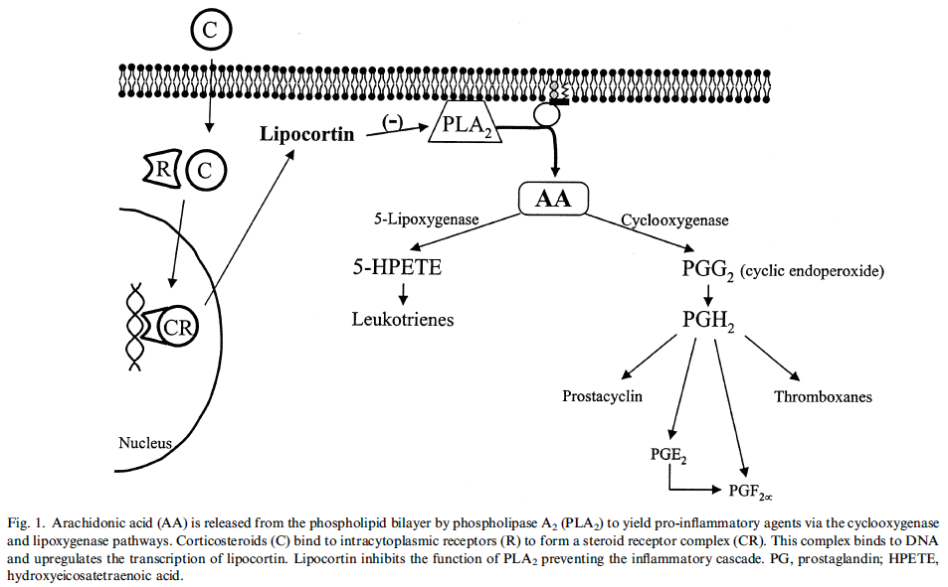
- Before initiation of GC consider: cause, severity, site of inflammation
- Routes of admx: topical, subconjunctival, systemic, retrobulbar, intravitreous
- TOPICAL
  - Severe inflammation treated aggressively (at least q4-6h then tapered)
  - Solution: the most rapid uptake and highest peak; duration is limited by rapid clearance; pumped out through nasolacrimal apparatus
  - Contact time (and therefore concentration and therapeutic effect) increased by using suspensions or ointments (exception: dexamethasone ointment because lipid-based ointment vehicles retain the drug and decrease its bioavailability)
  - Suspension: deliver higher concentrations than solutions
  - **Hydrophobic epithelium and hydrophilic stroma**
  - Lipophilic acetate and alcohol preparations penetrate cornea up to 20 fold greater than water-soluble phosphate preparations
  - Hydrocortisone DOES NOT penetrate cornea (but would be ok for conjunctivitis unless immune-mediated conjunctivitis – CAREFUL with feline conjunctivitis: invariably infectious –feline herpes, Chlamydophila, Mycoplasma)
  - Indications: conjunctivitis, dacryocystitis (nasolacrimal cannulation and flushing, ATBs, GC – no ointment), episcleritis, keratitis (goal: maintenance of optical clarity through retardation or prevention of corneal neovascularization, scarring, melanosis), anterior uveitis
    - DO NOT ACHIEVE therapeutic concentrations in: eyelids, posterior segment, orbit
    - DO NOT inhibit protein exudation completely because other nonarachidonic acid cascade inflammatory factors are also involved
  - Acts locally but also absorbed systemically through the conjunctiva and nasal or oral mucosa (1-35% absorbed signs of HAC)
  - Ocular side effects: glaucoma, cataract (rare in clinic, though experimental report), corticosteroid keratopathy, mild increase in IOP in cats and glaucomatous dogs (decreased outflow)
  - Decreased phagocytosis and killing of microorganisms, increased collagenase activity (worsening ulceration, decreased healing), decreased wound strength (reduced keratocyte proliferation and migration, impaired collagen production), exacerbation of infectious disease
- SUBCONJUNCTIVAL
  - Advantage: reduced reliance on frequent topical application and possibly greater IO concentration
  - Less effective to suppress corneal inflammation
  - Adjunct to topical therapy
  - Most of the drug is believed to reach ocular surface by leakage back out the needle tract and into the tear film
  - Some drug also absorbed by conjunctival and episcleral blood vessels and dissipated w/in systemic circulation
  - Small amount also directly absorbed through sclera
  - Injection under bulbar conjunctiva, 3-4 mm behind corneoscleral limbus – proparacaine to numb eye, 0.25-0,5 ml, 25-27G, mild pain for 12 hours (people)
  - SHOULD NOT be injected under palpebral conjunctiva (absorption largely systemic)
  - Complications: globe perforation, retinal detachment, granuloma formation, extraocular muscle paralysis, periocular atrophy or fibrosis
  - Sometimes have to remove the corticosteroid depot and associated conjunctival and subconjunctival tissues
  - Dexamethasone 1-2 d; bethamethasone and triamcinolone: up to 3 w; NOT methylprednisolone (associated with notable and sometimes uncomfortable subconjunctival plaques that need to be removed)
  - DO NOT use topical preparation (preservatives)
- SYSTEMIC
  - To achieve therapeutic concentrations in the adnexa, posterior segment, orbit
  - Anterior uveitis may also be treated with systemically administered corticosteroids either to augment topically admx corticosteroid agents or because presence of corneal ulcer prohibits topical use of such agents

Questions
- Name indications for the use of NSAIDs in ophthalmology

- Which of the following is the main substance that results in clinical manifestations of ocular inflammation?
  - Prostanglandins
  - Leukotrienes
  - Thromboxane
  - Substance P

- What side effects are associated with administration of topical NSAIDs?

- Explain why steroids have a slow onset of action

- True or False – Hydrocortisone 1% with neomycin- polymyxin-bacitracin is an appropriate choice for the treatment of anterior uveitis.

Questions & Answers
- Name indications for the use of NSAIDs in ophthalmology
Prevention of miosis, control inflammation/pain in post-op, allergic conjunctivitis, uveitis, when corticosteroids can’t be used (DM, systemic infection)…

- Which of the following is the main substance that results in clinical manifestations of ocular inflammation?
- Prostanglandins vascular permeability changes, vasodilation, miosis, BAB breakdown, intraocular pressure changes
- Leukotrienes
- Thromboxane
- Substance P

- What side effects are associated with administration of topical NSAIDs?
Direct ocular irritation, corneal cytopathy, decreased AH outflow (and increased IOP), systemic side effects through nasal mucosa absorption

- Explain why steroids have a slow onset of action
Most of the actions of glucocorticoids commence with their binding to specific receptors within the cytoplasm of targeted cells. The receptor-steroid complex then migrates into the nucleus, where it binds to DNA and alters genetic synthesis of proteins. Any number of cellular functions are thereby modified, including the production of enzymes that regulate myriad metabolic processes and those that regulate synthesis of inflammatory autacoids and immune-related cytokines. This mechanism is time consuming and accounts for a delayed onset of effect

- True or False – Hydrocortisone 1% with neomycin- polymyxin-bacitracin is an appropriate choice for the treatment of anterior uveitis.
Hydrocortisone does not penetrate cornea – not effective for IO inflammation

