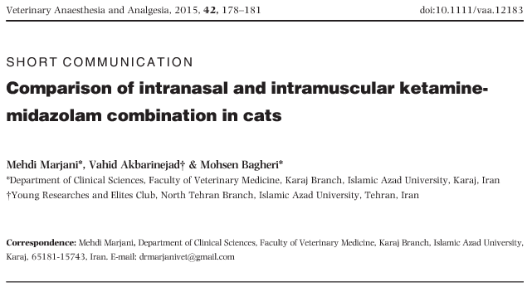
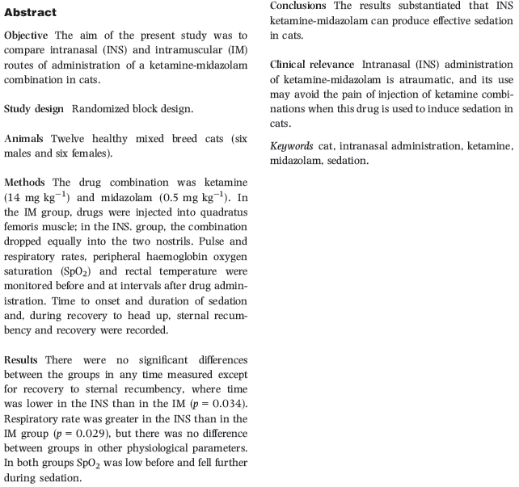
- Intranasal ketamine-midazolam has also been used for sedation in rabbits
- Ketamine 14 mg/kg + Midazolam 0.5 mg/kg IV diluted with saline to a volume of 1 ml
- No vocalization noted with IN vs IM
- No difference in time to onset or recovery
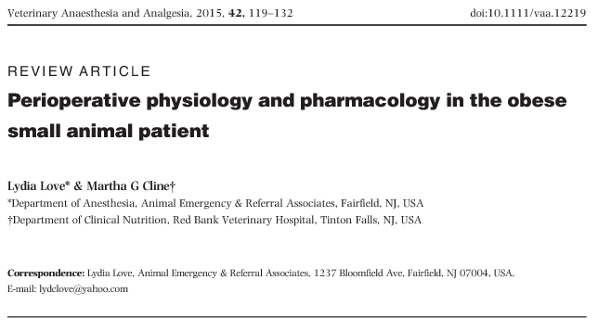
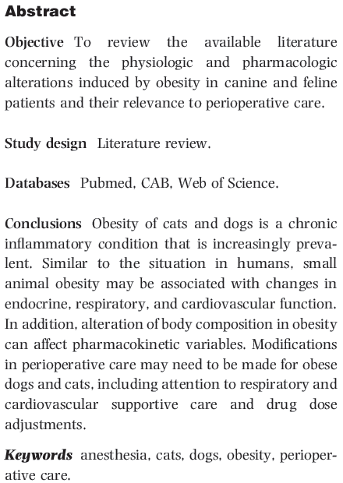
- Cats weighing more than 6 kg are nearly three times as likely to die in the perioperative period as those weighing between 2 and 6 kg
- Dogs diagnosed with chronic renal failure, survival was positively correlated with increasing BCS
- Adipose tissue hypoxia leads to the increased secretion of proinflammatory adipokines underlying the chronic inflammatory state of obesity, including leptin, interleukin- 6 (IL-6), and tumor necrosis factor-a (TNF-a)
- Respiratory: difficult airway management, more tracheal collapse and laryngeal paralysis, decreased pulmonary compliance, increased atelectasis
- Cardiovascular: increased HR and BP after induction
- Increased metabolic oxygen requirements due to the increased body mass of obesity result in increased total blood volume and CO
- Binding of drugs to albumin appears to be unchanged in obesity
- Suggestions have been made for alteration of loading doses in obese humans, including using IBW for hydrophilic drugs, TBW for dosing of lipophilic drugs and, for drugs that are partially distributed to adipose tissue, using an adjusted body weight of IBW + 20%

