VASODILATORS IN SEPTIC SHOCK RESUSCITATION: A CLINICAL PERSPECTIVE

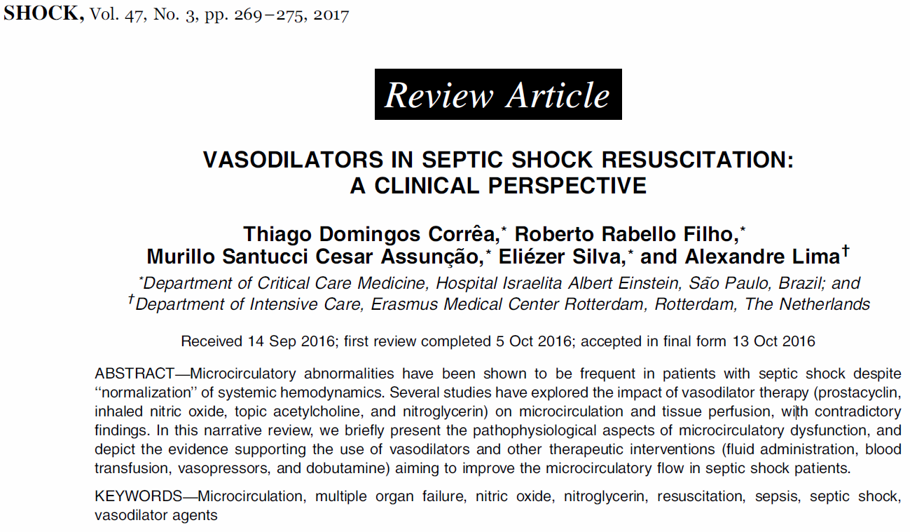
- Microcirculation
  - Arterioles, capillaries, venules
    - Primary site of oxygen exchange between RBC and tissue
  - Disturbed in sepsis
    - Associated with poor outcomes
  - Poiseuille’s law
    - Blood flow is determined proportionally by pressure gradient between post-arteriolar and venular pressures
      - Microcirculatory driving pressure
- And directly related to radius^4 and inversely related to capillary length
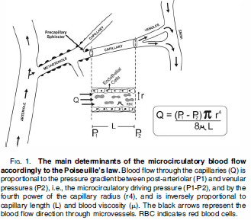
- Vasodilators
  - Acetylcholine, NO donors, Nitroglycerin
  - Could increase precapillary inflow pressure while maintaining venular outflow pressure
- Sepsis and microvascular circulation
  - Heterogeneous inducible NO synthase cause microvascular abnormalities
  - Reactive oxygen species can consume NO leading to NO deficiency
  - Glycocalyx
    - Thin layer of glycosaminoglycan that covers endothelial surface
      - Sepsis – thickness is reduced
        - Increased WBC and platelet adhesion
        - Increased blood viscosity
- Microcirculatory abnormalities in sepsis
  - Decreased perfused capillary density
  - Decreased proportion of perfused capillaries
  - Heterogeneous capillary perfusion within organs
  - Intermittent capillary perfusion
    - Can change second to second
  - Associated with non-survival
- Vasodilators
  - Clinical and experimental studies show administration of NO donors could recruit sublingual capillaries
  - Conflicting clinical trials since regarding benefits of this therapy
- Fluid Therapy
  - Main determinants of oxygen transport to the tissue cells are:
    - Convection
      - Convective transport of oxygen carrying RBC through capillaries
      - Determined by
        - Rate at which RBC enter capillaries
        - SpO2
        - Oxygen carrying capacity of RBC at SpO2 of 100%
          - 0.0362 pl O2/RBC
    - Diffusion
      - Diffusion of oxygen from RBC to tissue cells mitochondria
      - Determined by Fick’s law of diffusion
        - Gradient of O2 in RBC to mitochondria (pO2Grad)
        - Diffusion coefficient
        - Exchange surface
        - Diffusion distance
  - Fluid therapy can
    - improve convection
    - decreased blood viscosity and improve flow
    - decrease release of endogenous vasoconstrictors
  - Volume overload (too much fludis)
    - Increased CVP and decreased microcirculatory driving pressure and increase diffusion distance between capillary RBC and mitochondria
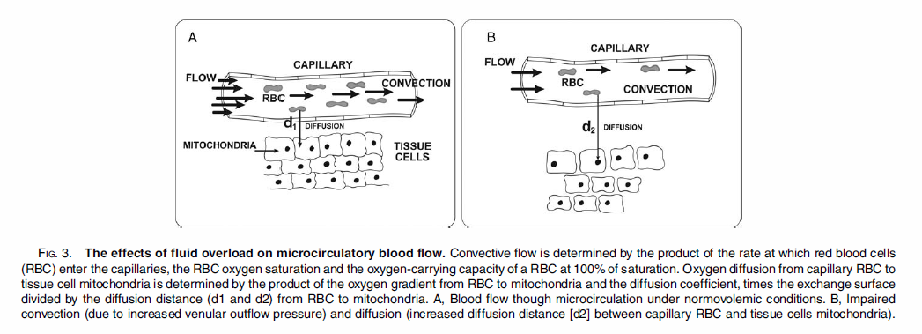
- Dobutamine and vasopressors
  - Dobutamine is primarily beta-adrenergic agent but has mild vasodilatory effects
    - May improve microvascular blood flow by increasing driving pressure and increased cardiac output
  - Studies on increasing MAPs from 60-90 did not show effects on sublingual microvascular blood flow in septic shock patients
- Blood transfusion
  - Increasing hemoglobin concentration from 7-8g/dL did not appear to affect microvascular circulation
- Conclusions – We still don’t know what to do!!!

