Main points
- Cats have limited causes of uveitis which are:
  - FIP
  - FIV
  - FeLV
  - Toxo
  - Fungal (blaso, histo, crypto)
  - Lymphoma
- Uveitis is treated with topical steroids as long as there are no ulcers
- Aqueous flare is hallmark of anterior uveitis and the amount indicates severity
- Dogs can get uveitis from anything causing systemic inflammation

Main signs of uveitis (all species)
- **Aqueous flare is hallmark of anterior uveitis**
- Ocular discomfort
  - Photophobia
  - Blepharospasm
  - Pain
    - Sometimes anorexia or depression
  - Epiphora
- Other uveitis signs
  - Episcleral injection
  - Corneal edema
  - Keratic precipitates
    - Inflammatory cells adherent to corneal endothelium
    - Small and scattered is often suggestive of FIP
      - Image 1 arrows
      - Image 2
    - Usually with FIP, Neoplasia, Fungal, or foreign bodies
  - Hypopyon
  - Hyphema
    - Systemic hypertension
    - Intraocular neoplasia
    - Coagulopathy
    - Tick-borne disease
  - Miosis
    - Can be even resistant to dilation
  - Lowered IOP
    - Normal IOP =
      - Dogs 15-25 mmHg
      - Cats 15-30 mmHg
    - Early phase of uveitis
    - Can become “normal” or increased = glaucoma
      - Inflammatory cells/debris or synechiae can block outflow
  - Anterior synechiae
    - Attachments between iris and cornea
      - Can lead to glaucoma by reducing drainage angle
  - posterior synechiae
    - Attachments between iris and lens
      - Can lead to 360’ attachment (iris bombe) and glaucoma
  - Dull iris
  - Swollen iris
  - Retinal detachment
    - Inflammatory cells accumulate behind retina
Categorization of Uveitis
- Infectious
- Immune mediated
- Neoplastic/paraneoplastic
- Metabolic
- Traumatic
- Toxic
- Reflex
- idiopathic
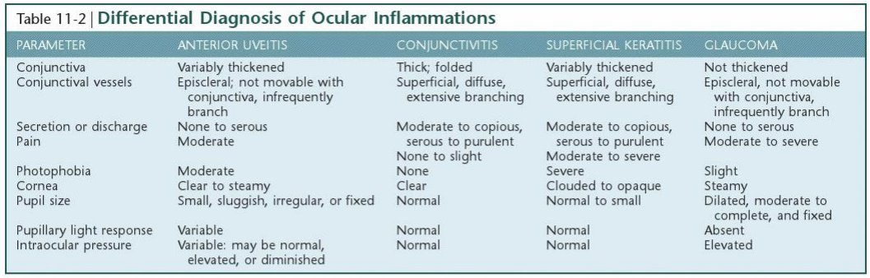
Treatment
- Treat underlying cuase
- Corticosteroids
  - Topical preferred, but must be fluorescein stain negative!
  - After addressing possible infectious causes
  - Mild uveitis
    - Dexamethasone 0.1% or pred acetate 1% q6-12
  - Moderate (easily detectable flare)
    - Dexamethasone 0.1% or pred acetate 1% q4-6
    - Consider systemic pred 0.25mg/kg/day in addition
  - Severe (marked flare, fibrin, hypopyon)
    - Dexamethasone 0.1% or pred acetate 1% q1-4
    - Systemic pred 1mg/kg/day
    - Triamcinolone acetonide 1-2mg per eye subconjunctivally (see ophthalmologist)
  - Mydriatics
    - Prevent synechia and reduce pain
    - Atropine
    - Can decrease drainage angle and cause increased IOP
  - Antiglaucoma drugs
    - If IOP is increased or “normal’ despite uveitis
  - Systemic pain meds

Specific types of uveitis
- Infectious
  - Can be systemic or ocular
  - In dogs, blasto, histo, coccidio -mycoses and erlichiosis
  - In cats, toxo, cryptococcosis, FIP
- Immune mediated
  - Can be 1’ immune mediated uveitis (idiopathic)
    - Diagnosis of exclusion
- Uveodermatologic syndrome
  - Akita, Old English Sheepdog, Golden retriever, Husky, Irish setters are overrepresented
  - Immune mediated destruction of melanin
  - Depigmentation of mucocutaneous junctions, eyelids, haircoat
- Lens-induced
  - Lens proteins induce uveitis when they escape capsule
  - Any disease of lens can induce uveitis if capsule breaks down
    - FBs or cataracts
- Golden retriever uveitis (image 3)
  - AKA pigmentary uveitis of golden retrievers
  - Associated with pigment deposition everywhere
  - Usually leads to vision loss
- Feline uveitis (%s are from study of seroprevalence in colorado)
  - FIP (27%)
  - Lymphoma
  - Retroviruses (28%)
  - Toxoplasma (78.5%)
  - Cryptococcus
  - histo/blasto/coccidio
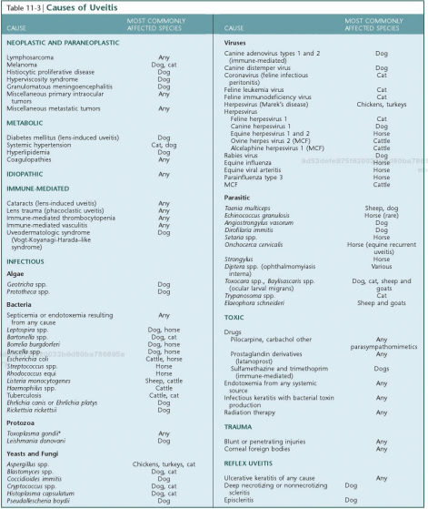
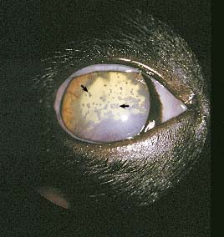image 1
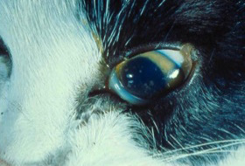image 2

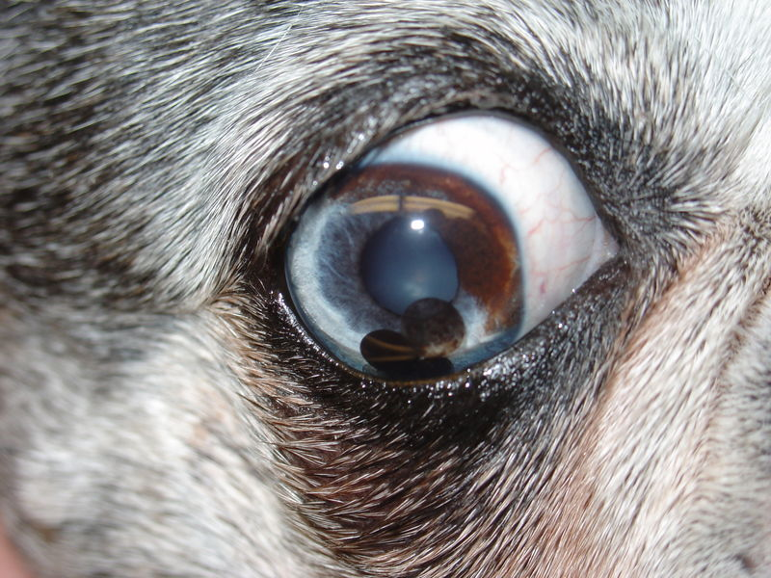image 3

Questions
- True/False: Uveitis in dogs and cats should always be treated with topical steroids +/- addition of systemic steroids
- Which of the following dog breeds is overrepresented for uveodermatologic syndrome
  - Cocker-spaniel
  - Shiba Inu
  - German Shepherd
  - Siberian Husky
- Fill out the following table:
Diagnostic test in work-up for canine uveitis | Rationale
1.
2.
3.
4.

- Which of the following clinical signs is considered more suggestive of the diagnosis of FIP
  - Aqueous flare
  - Keratic precipitates
  - Decreased IOP
  - Anterior synechia
  - Hypopyon
- Give a reason for and against the use of atropine for treatment of uveitis

Answers
- True/False: Uveitis in dogs and cats should always be treated with topical steroids +/- addition of systemic steroids
Only if NO ulcers

- Which of the following dog breeds is overrepresented for uveodermatologic syndrome
  - Cocker-spaniel
  - Shiba Inu
  - German Shepherd
  - Siberian Husky
- Fill out the following table:
Diagnostic test in work-up for canine uveitis | Rationale
1. See chart for information
2.
3.
4.

- Which of the following clinical signs is considered more suggestive of the diagnosis of FIP
  - Aqueous flare
  - Keratic precipitates
  - Decreased IOP
  - Anterior synechia
  - Hypopyon
- Give a reason for and against the use of atropine for treatment of uveitis
For: can reduce pain, can decrease likelihood of synechia
Against: Can lead to decreased drainage angle and glaucoma

