Toxicokinetics and toxicodynamics

KEY POINTS
- Toxicodynamic is what the toxin does to the body and toxicokinetic is how the body handle the toxin (how ADME occurs)
- Absorption:
  - Bioavailability
  - Enterohepatic recirculation
- Distribution
  - Storage
  - V_{d}: total amount of chemical divided by concentration in blood
    - Low V_{d}: primarily w/in plasma vs high V_{d} widely distributed
  - Barries
- Metabolism
  - Phase I metabolism: oxidation, hydrolysis, reduction; CYP450
  - Phase II metabolism: conjugation
- Excretion
  - Mostly renal, other routes possible
  - Clearance: volume of blood/plasma cleared from the toxin per unit of time
  - First-order kinetic
    - Non saturable processes, rate of elimination at any given time point is proportional to the amount of compound that remains in the body at that point in time; 5 x ½ lifes = 97% eliminated
  - Zero-order kinetic
    - Saturable processes
    - Rate of elimination is independent of amount of toxin remaining in body
    - Only a finite amount of xenobiotic can be eliminated per unit time

- Dispostion of a xenobiotic = what the body does to it – ADME
- Toxicokinetics: quantitation and determination of time course of disposition (ADME)
- Toxicodynamics: what a toxicant does to the body
- Absorption
  - Involved crossing cellular membrane (phospholipid bilayers, various sized pores, PT)
  - Routes of exposure: oral (GI), dermal, inhalation; iatrogenic: SQ, IM, IP, IV
  - Bioavailability: fraction of total dose that is absorbed
    - 100% when IV
    - Gases, vapors: depends on blood-to-gas partition coefficient; size (particles > 5 microns: NP, <1 micron : alveoli)
    - Dermal: stratum corneum, keratin. Lipid-soluble vs hydrosoluble
    - Ingestion: digestion; transit time, hepatic biotransformation, biotransformation in GI cells – first-pass effect (presystemic elimination), enterohepatic recirculation
  - Mechanisms
    - Energy-independent (passive transport: simple diffusion or filtration) or energy-dependent (active transport, facilitated transport, pinocytosis)
    - Passive
      - Simple diffusion and filtration – non saturable
        - Concentration gradient – Fick’s law (rate of transport proportional to difference in chemical’s concentration between 2 sides of membrane)
        - Uncharged (non ionized), lipid-soluble molecules, especially if small, more readily diffusible (ionized = less lipid soluble)
        - Henderson-Hasselbalch equation can be used to predict whether a particular xenobiotic
          - Difference between the association constant (pKa) which is equivalent to pH at which equal amounts are nonionized and ionized states
      - Filtration – involves passage of xenobiotics through pores; determined by sizes
    - Active
      - Saturable process
      - Against electrochemical or concentration gradients
      - Different transporters
    - Facilitated (carrier-mediated transport)
      - Not against concentration gradient
    - Pinocytosis
      - Cellular engulfment of small amounts of xenobiotics and transfer of this amount of chemical through the cellular membrane
- Distribution
  - Translocation from site of absorption to organs/tissues (involves transport w/in circulation and cellular uptake)
  - Rate of transfer into organ/tissue depends on properties of xenobiotics (lipid solubility, MW), BF, rate of diffusion across endothelial walls into cells
  - V_{d}: total amount of chemical divided by the concentration of chemical w/in blood = used to describe extent to which a xenobiotic is distributed w/in body; relevant indicator as to whether chemical is primarily w/in plasma (low V_{d}) vs widely distributed in ITS or ICS (high V_{d})
  - Storage
    - Protective mechanism or potentiates effects
    - Example:
      - Plasma PT (salicylates, barbiturates, cardiac glycosides, steroids, vitamins, essential minerals) – change in PT can increase amount of unbound toxins
      - Liver/kidneys, fat, bones
  - Barriers
    - BBB
      - Nonporous CNS capillary endothelium
        - Contains MDR-protein
        - Surrounded by glial cells
      - Very low PT content of ITS also contributes to apparent inability of many PT-bound toxins to reach clinically relevant concentration in the brain
      - BBB not fully formed at birth; less –developed in some breeds
    - Other barriers in eyes, testes, prostate, joints, placenta – only small nonionized, lipid-soluble molecules …
- Metabolism and biotransformation
  - Metabolism = fate or disposition of xenobiotic or sum total of chemical transformations of normal body constituents
  - Biotransformation = general term; refers to metabolic conversion into more water-soluble forms
  - Phase I
    - Enzymes with broad substrate specificity
      - Oxidation, hydrolysis, reduction
      - Apolar, lipophilic toxins metabolites with greater polarity and hydrophilicity
      - CYP450
  - Phase II
    - Conjugation with functional group – glucuronide, sulfate, amino acids, glutathione, acyl or methyl groups increased water solubility, less toxic metabolites (except acetaminophen, aflatoxin B₁)
    - Some instances of metabolic activation, bioactivation, toxication or lethal synthesis (any factors that increase biotransformation enhanced amount of toxic metabolite to which animal is exposed
- Excretion
  - Removal of toxins and metabolites from the body
  - Renal*, also in feces (biliary or unabsorbed), saliva, sweat, CSF, milk
  - Exhalation
  - Clearance: volume of blood that is cleared of chemical per unit of time; indicator of ability to eliminate the toxin by metabolism, excretion, exhalation
  - Can be used to predict duration of toxicosis or when samples would be the most useful for diagnosis.
  - One-compartment model: first-order kinetics, non saturable processes, rate of elimination at any given time point is proportional to the amount of compound that remains in the body at that point in time; elimination ½ life can be calculated using V_{d} and clearance (1/2 life = time required for blood or plasma concentration of toxin to be reduced by ½; 5 x ½ lifes = 97% eliminated; assumes that changes in toxin in the blood/plasma = reflection of what is occurring in tissues
  - Zero order kinetics = processes involved in elimination are saturable and rate of elimination is independent of amount of toxin remaining in body; only a finite amount of xenobiotic can be eliminated per unit time

Toxicodynamics
- = what the toxin does to the body
- Ultimate toxicant = the parent toxin, its metabolite ou generated ROS that actually causes cellular damage
- Target = a molecule that interacts with the ultimate toxicant resulting in adversely affected biologic processes: cells, organs, tissues
- Disposition can be protective: storage (so no access to target), metabolism (so more water-soluble and eliminated), first-pass effect
- Distribution and biotransformation can also increase likelihood of adverse effects: enterohepatic recirculation increases bioavailability, metabolism into more dangerous compounds or production of free radical, ROS
- Basis for most toxicoses = cellular damage; often most dramatic in cells with high rates of metabolism and replication
  - Alterations in pH, mimic actions of normal nutrients, endogenous hormones, NT, alterations of receptors, ROS, alteration of membrane integrity, impaired cellular synthesis of ATP, uncoupling of OP, inability to regulate IC calcium…

Questions
- A drug X is administered by mouth to a patient. Below is a graph showing its concentration over time. This drug is eliminated by ________ order elimination kinetics.
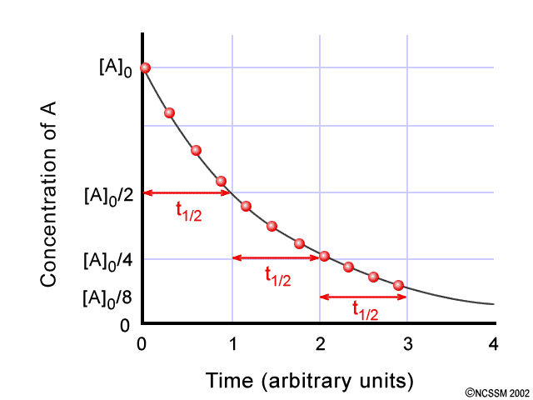

- Drug X has a Vd of 2L and a drug Y has a Vd of 3L. Which drug is mostly distributed into the plasma?

- Drug X has elimination ½ live of 6 hours. After how long will this drug be almost completely eliminated from the organism?
  - 6 hours
  - 12 hours
  - 24 hours
  - 30 hours
  - 36 hours

Questions & Answers
- A drug X is administered by mouth to a patient. Below is a graph showing its concentration over time. This drug is eliminated by FIRST order elimination kinetics.

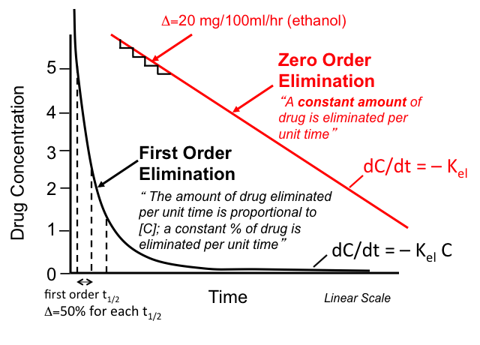
- Drug X has a Vd of 2L and a drug Y has a Vd of 3L. Which drug is mostly distributed into the plasma?

- Drug X has elimination ½ live of 6 hours. After how long will this drug be almost completely eliminated from the organism?
  - 6 hours
  - 12 hours
  - 24 hours
  - 30 hours – 97% eliminated
  - 36 hours

