J Am Vet Med Assoc. 2004 Jul 15; 225(2): 242-50.
Evaluation of complications and prognostic factors associated with administration of total parenteral nutrition in cats: 75 cases (1994-2001).

OBJECTIVE: To determine frequency and types of complications, prognostic factors, and primary diseases affecting clinical outcome associated with administration of total parenteral nutrition (TPN) in cats.

DESIGN: Retrospective study.

ANIMALS: 75 cats that received TPN for > or = 12 hours.

PROCEDURE: Medical records were reviewed, and information was obtained on signalment, history, problems at initial evaluation, physical examination findings, weight and changes in weight while receiving TPN, duration in the hospital before initiation of TPN, the type of TPN catheter used, duration of TPN administration, and final diagnosis. Laboratory results obtained immediately prior to TPN and at 24 and 96 hours following initiation of TPN administration were compared.

RESULTS: Reports of weight loss at initial evaluation, hyperglycemia at 24 hours, or diagnosis of chronic renal failure were significantly associated with increased mortality rate. Greater serum albumin concentrations prior to and at 96 hours following TPN administration were significantly associated with decreased mortality rate. Mechanical and septic complications were infrequent and not associated with increased mortality rate. Most cats had multiple diseases. The overall mortality rate was 52%; among 75 cats, 36 recovered, 23 were euthanatized, and 16 died as a result of their primary illness or complications associated with their illness.

CONCLUSIONS AND CLINICAL RELEVANCE: Results indicated high mortality rate in cats maintained on TPN that had multiple concurrent diseases associated with a poor prognosis. Indicators of poor prognosis included a history of weight loss, hyperglycemia at 24 hours following TPN administration, hypoalbuminemia, and chronic renal failure.
_________________________________________________________________________________________________________
Why did they do the study? Limited information on the use of TPN in cats WRT risk factors or variables to predict outcome. Previous study on healthy cats receiving TPN showed development of hematologic abnormalities (unknown significance of those changes in clinically ill cats)

Material & Methods: Retrospective study; 75 cats that received TPN; recorded history/ PE and lab data. Evaluated various risk factors and their effects on survival/probability of being weaned from TPN

Results: Increased mortality rate in cats that had previous weight loss, hyperglycemia (T24) or CKD. Decreased mortality rate in cats with higher albumin prior and during TPN. High mortality in cats with multiple concomitant diseases. 21% of cats had at least 1 mechanical complication. Frequent metabolic complications include: hyperglycemia, hyponatremia, hypokalemia.

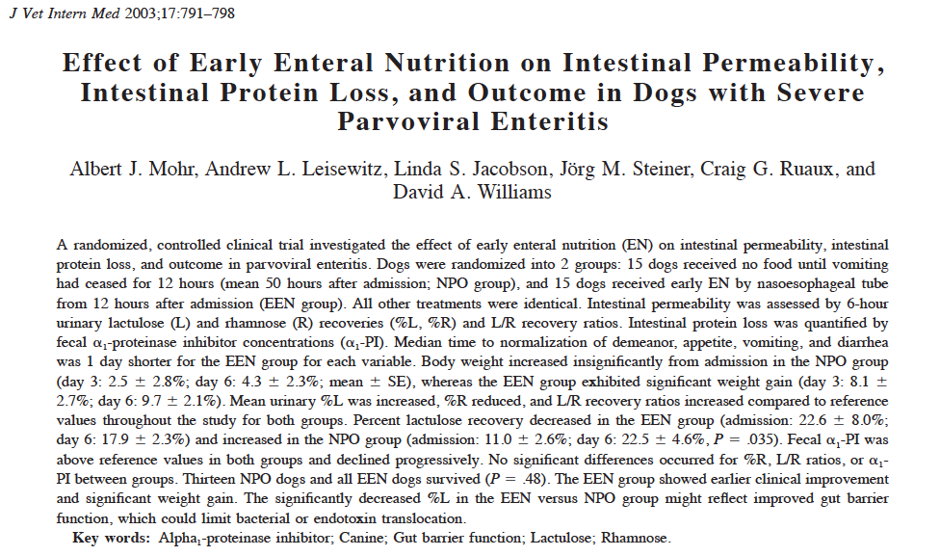

Why did they do the study? The efficacy of the old school advised strategy of initial starvation in dogs with parvo has never been investigated. Most important stimulus for intestinal growth, repair and integrity is the presence of nutrients. No nutrient mucosal atrophy, no proliferation of crypt cells, reduction in GALT cells, increased permeability, increased cytokines and APPs. Benefits of early EN: decreased permeability, increased weight, increased motility, attenuation of AP response, improved immunological status, reduced catabolism and preservation of positive nitrogen balance. Intestinal permeability and epithelial integrity evaluated by sugar intestinal permeability tests (lactulose and rhamnose). Fecal loss of protein: alpha-1 proteinase inhibitor

Material & Methods: Prospective RCT; 15 dogs NPO group received nothing until no vomit for 12h, if not eating for 12h force-fed. ; 15 dogs EEN group received NE feeding 12h post admission, used an illness factor, removed feeding tube when no vomit for 24h, then free food, if not eating for 12h force-fed.

Results: Appetite improved faster in EEN, normalization of appetite/attitude + resolution of vomiting/diarrhea 1 day faster with EEN. Increased BW with EEN. Same albumin between groups over time. Progressive decrease in %L in EEN (might reflect improvement in tight junction integrity; maybe also earlier repair of intestinal epithelial necrosis and improvement of flora since bacterial overgrowth promotes increase in permeability) and increase in NPO (with the decreased alpha-1 PI may indicate that increased lactulose permeation might be due to altered tight junctions rather than through disrupted epithelim which should lead to loss of PT and therefore alpha-1 PI). Rhamnose recovery decreased progressively over time in both groups (maybe consistent with villus atrophy, intestinal ischemia/congestion, or indicative of altered immature enterocytes membrane phospholipid composition and transcellular membrane pores). *The precise transepithelial permeation pathways of probes used for intestinal permeability not been established precisely. Rhamnose (monosaccharide) permeates transcellularly (small aqueous pores) – can be affected by mucosal factors not directly related to intestinal integrity; Lactulose (disaccharide) permeates paracellulary via larger aqueous channels in the region of intercellular tight junctions. Highest L/R ratios at the time of discharge (when integrity of intestines should be maximal)- maybe ratio does not reflect accurately the severity of intestinal epithelial disruption in parvo. Enteral feeding not associated with lot of complications. Some studies suggested that at least 25% of RER to prevent mucosal atrophy.

J Vet Emerg Crit Care (San Antonio). 2012 Aug; 22(4): 453-9
Early nutritional support is associated with decreased length of hospitalization in dogs with septic peritonitis: A retrospective study of 45 cases (2000-2009)

OBJECTIVE: To determine whether the timing and route of nutritional support strategy affect length of hospitalization in dogs with naturally occurring septic peritonitis.

DESIGN: Retrospective study encompassing cases from 2000 to 2009.

SETTING: University teaching hospital.

ANIMALS: Forty-five dogs that survived septic peritonitis.

INTERVENTIONS: None.

MEASUREMENTS AND MAIN RESULTS: Nutritional strategy for each dog was categorized as either enteral nutrition (EN: free choice voluntary eating or assisted tube feeding) or central parenteral nutrition (CPN). Early nutritional support was defined as consistent caloric intake initiated within 24 hours postoperatively. Consistent caloric intake occurring after 24 hours was defined as delayed nutritional support. Data reflective of nutritional status included body condition score, serum albumin concentration, and duration of inappetence before and during hospitalization. Body weight change from the beginning to the end of hospitalization was calculated. A modified Survival Prediction Index 2 score was calculated for each dog at admission. Additional clinical data recorded for comparison of illness severity included indicators of severe inflammation (eg, presence of toxic changes in neutrophils and immature neutrophils), coagulopathy (eg, prolonged prothrombin time and activated partial thromboplastin time), the use of vasopressors and blood transfusions, and presence of concurrent illnesses. Nutrition-related complications were classified as mechanical, metabolic, or septic complications. Multivariate linear regression analyses were used to determine the relationship of nutritional strategy with hospitalization length, while considering the presence of nutrition-related complications, the nutritional status- and illness severity-related variables. While controlling for other variables, dogs that received early nutrition had significantly shorter hospitalization length (by 1.6 days). No statistically significant association was found between route of nutrition and hospitalization length. The presence of concurrent illnesses and nutrition-related metabolic complications were also associated with longer hospitalization length (by 2.1 and 2.4 days, respectively).

CONCLUSION: Early nutritional support in dogs with septic peritonitis is associated with a shorter hospitalization length.

Why did they do the study? The optimal time frame and route of admx have not been identified in vet patients.

Material & Methods: Retrospective study; 45 (?) dogs with septic peritonitis; EN or CN (central PN vs TPN because optimal PT requirement protein-caloric and micronutrient requirements unknown). Multivariate linear regression (nutritional strategy (early vs delayed; EN vs PN) vs LOH).

Results: Exact calorie intake not quantified (retrospective). Tubes = gastroS. Early = w/in 24 h post surgery. Final model: timing, concurrent illnesses, nutrition-related metabolic complications. Longer hospital if delayed nutrition, multiple concurrent diseases, development of metabolic complications (hyperglycemia, hypoMg, hypoK, hypoP). Parvoviral infection – nutrition w/in 12h of admission = faster improvement. Early nutrition reduces LOH by hormonal modulation attenuation hypermetabolic response? By preservation of hepatic antioxidants? By prevention of protein-caloric malnutrition? By maintaining gastrointestinal barrier?

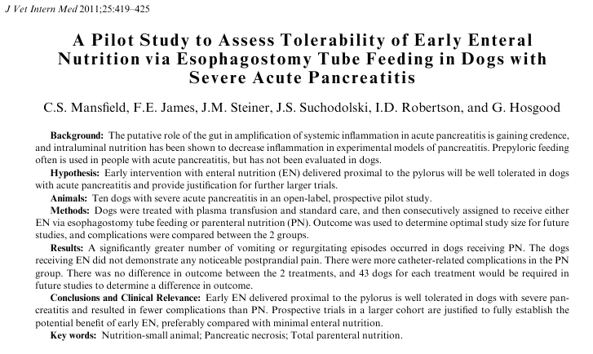

Why did they do the study? EN is beneficial: maintains mucosal integrity (stimulation of growth factors and BF). Pancreatic secretions actually decreased during pancreatitis (especially if severe). Moving from strict pancreatic rest to early EN/PN in pancreatitis. Unknown when. Unknown which is better between EN/PN. Unknown if it is ok to feed proximal to pylorus.

Material & Methods: Prospective, RCT (consecutive assignment to EN (n=5) or PN (n=5)). Fed with a diet that was demonstrated to induce minimal pancreatic secretions in healthy dogs (low-fat, supplemented with enteric-coated pancreatic enzymes, medium chain TG oil). EN provides through E-tube. Scope to look for esophagitis (as a cause for regurgitation). All dogs received IVFT, analgesia, metoclopramide, FFP. They measured a bunch of parameters (cTLI, s-CPL, CRP, gastrin, pancreatic elastase-1) – only mentioned that were not different between groups. Fed to reach 100% RER w/in 3 days. Monitored PE, clinicopathological values, BW, pain, pancreatic scores.

Results: EN was well tolerated. High # of complications with PN (institutional vs true tx effect – mostly catheter sepsis related). Less V+/R+ in EN vs PN. Need to avoid stimulus of the duodenum in acute pancreatitis appears does not appear to be upheld. Do not know if this specific diet made a difference.

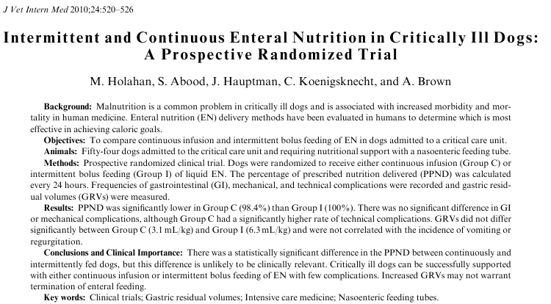

Why did they do the study? Unknown: what to feed, when, which route, how much. GRV associated with gastric reflux/aspiration pneumonia or not. Continuous feeding or intermittent bolus (amount of calories prescribed actually delivered, complications…)?

Material & Methods: Randomized, prospective. NE or NG tube (NG tube recorded GRV q4h; volume returned back). 1/3 RER to reach 100% by day 3. Intermittent (n=26): q4h, over 30 minutes or Continuous (n=28). PPND: number of calories delivered over 24 hours / total calories prescribed. Noted complications. Clinicare or Clinicare RF

Results: Yes difference in the PPND (more in group I) though clinically significant? Also NSD between groups by day 3 (same in people – one study more with boluses, another more with continuous infusion; though after some time no difference). Rescue protocol if 2 vomit/regurgitations w/in 24h (not just 1) and tolerance of high GRV (high GRV defines as > 5 ml/kg over 4 hours in very young infant; 150-200 ml in 4 hours in adults)= maybe explanation for achievement of median PPND of 100% (higher than previous studies: 91-97%). More hours of feeding lost in group C (which accounted for less PPND). No difference in mechanical complications, no difference in GI complications. No correlation between GRV and complications; no difference in GRV between groups.

J Vet Emerg Crit Care 2010 Apr 1;20(2):232-6
Continuous versus intermittent delivery of nutrition via nasoenteric feeding tubes in hospitalized canine and feline patients: 91 patients (2002-2007).

OBJECTIVE: To compare continuous to intermittent feeding at delivering prescribed nutrition in hospitalized canine and feline patients. (and also complications)

DESIGN: Retrospective clinical study.

SETTING: University teaching hospital.

ANIMALS: Fifty-four cats and 37 dogs.

MEASUREMENTS AND MAIN RESULTS: Twenty-four-hour periods of prescribed and delivered nutrition (kcal) were recorded, and the percentage of prescribed nutrition delivered (PPND) was calculated. If the patient received nasoenteric feeding for >1 day, then the average PPND per day was calculated. Frequency of gastrointestinal complications (vomiting, diarrhea, and regurgitation) was calculated per patient for each group. The PPND was not significantly different between patients fed continuously (99.0%) and patients fed intermittently (92.9%). Vomiting affected 29% of patients (26/91), diarrhea affected 26% of patients (24/91), and regurgitation affected 5% of patients (5/91). There was no significant difference in incidence of gastrointestinal complications between the patients fed continuously and the patients fed intermittently. There was a significantly higher incidence of diarrhea and regurgitation in dogs than in cats.

CONCLUSIONS: PPND was not significantly different for continuous versus intermittent feeding via nasoenteric tubes. Frequencies of gastrointestinal complications were not significantly different between patients fed continuously and patients fed intermittently. Enterally fed dogs had a significantly higher frequency of regurgitation and diarrhea than enterally fed cats. Prospective studies are warranted to investigate causes for these potential inter-species differences.

Why did they do the study? Is one method of delivery better than the other in terms of providing prescribed calories/frequency of complications? Maybe more interruptions with continuous (for Dx, Tx, walks, visits)? Prescribed and actually given not matched because of vomiting, high GRV, interruption for Dx/Tx. Conflicting results in people.

Material & Methods: Retrospective. Dogs and cats fed with NG/NE tube. Intermittent vs continuous. PPND. Complications

Results: 37 dogs, 54 cats. Median PPND in dogs = 91.7%; in cats = 100%; overall 97.1%. Some of the patients that had GI complications had the same GI signs (vomiting or diarrhea – not regur.) prior to EN. Continuous vs intermittent; no difference in complications; no difference in PPND. Regurgitation and diarrhea appear to be more frequent in dogs than in cats. Nutrition stopped for several reasons: vomiting, regurgitation, diarrhea, tube failure, Dx, surgery, high GRV, blood transfusion, dyspnea, hypersalivation.

Hepatobiliary Pancreat Dis Int. 2002 Feb; 1(1): 150-4.
Early intrajejunal nutrition: bacterial translocation and gut barrier function of severe acute pancreatitis in dogs.

OBJECTIVE: To evaluate the effect of early intrajejunal nutrition in attenuating bacterial and/or endotoxin translocation and improving gut barrier function of severe acute pancreatitis (SAP) in dogs.

METHODS: 15 dogs were divided into parenteral nutrition (PN) group (7 dogs) and early intrajejunal nutrition (EIN) group (8). EIN was delivered nutrients via a needle jejunostomy catheter feeding at 48 h after operation. SAP model was induced by injecting 1 ml/kg of combined solution of 5% sodium taurocholate and 8000-10 000 BAEE units trypsin/ml into the pancreas via the pancreatic duct. Systemic blood samples were obtained before and 1, 3, 5, 7 d following SAP, and cultured by aerobic as well as anaerobic bacterial growth. Systemic plasma and portal vein endotoxin levels were quantified by the chromogenic limulus amebocyte lysate (LAL) technique. Portal vein blood and specimens of tissue from the mesenteriolum and mesocolon lymph nodes, lung, pulmonary portal lymph nodes, pancreatitistissue and periopancreas tissue were adopted before the experiment was finished. Aliquots of the homogenata were cultured as blood mentioned above to determine the magnitude of the bacteria. DNA, protein and the villi, the thickness of mucosa, and the whole bowel wall of the ileum and transverse colon were measured.

RESULTS: The study showed that the levels of systemic plasma endotoxin and the magnitude of bacterial translocation to the portal and systemic blood and distant organ were reduced significantly in the EIN group as compared with the TPN group. The contents of Protein and DNA, the height of villi, the thickness of mucosa and whole bowel wall of the ileum and transverse colon in the EIN group were higher than those in the PN group.

CONCLUSION: Our results suggested that EIN is safe and effective to be adopted by intrajejunal delivery of nutrients in SAP, decreases the occurrence of gut bacterial translocation, and improves the gut barrier function.
__________________________________________________________________________________________________________________

Why did they do the study? Pathogenesis of severe acute pancreatitis unclear; microorganisms that cause pancreatic infection and sepsis often common enteric bacteria. Coming from the gut? Bacterial and/or endotoxin translocation may be modulated by nutrition.

Material & Methods: n=15; experimental SAP. Instrumentation (jug cath, jejunostomy tube
n=7 PN and n=8 EIN.

Results: No worsening of pancreatitis with EIN. All bacterial species collected at MLNs and distant organs were common enteric bacteria – suggesting that they were coming from the gut. Lower serum endotoxin after day 5 in EIN. Less bacterial load in distant organ with EIN (less translocation? Better clearance? Less persistence?) With EIN: increased mucosal protein, DNA contents and villus height, mucosal thickness and bowel thickness.

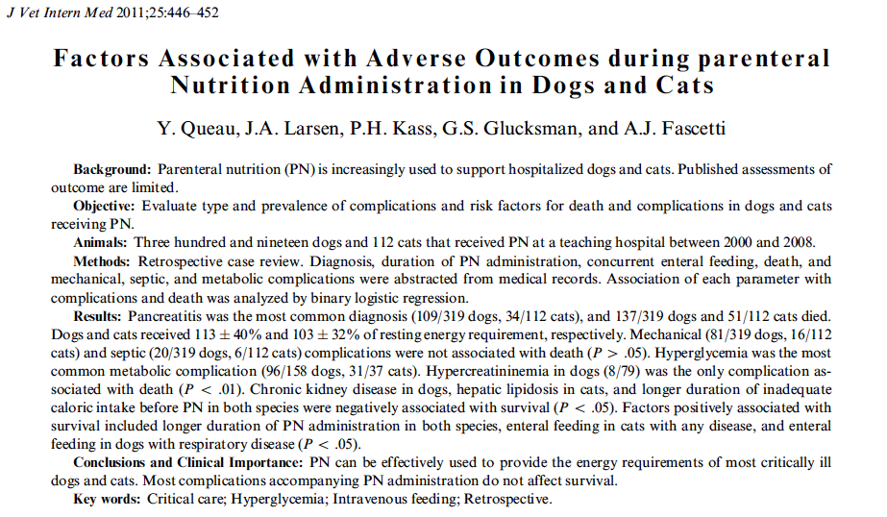

Why did they do the study? Not a lot of info of PN in dogs/cats. In some studies complications = hyperglycemia, electrolyte disturbances, hyperlipidemia. Some mechanical complications too that affected delivery. Don’t know complication types and incidences, risk factors for complications, if with more experience less complications…

Results: PN could be used to provide nutrition to most animals. Frequent complications, most do not affect outcome. Pancreatitis often dx in those patients started on PN. 81% dogs and 63% cats received at least RER. Amount of calories provided decreased over the 9y period. CPN provided more calories than PPN (only in dogs). Osmolarity of PPN kept lower than CPN (by diluting with water or decreasing dextrose (adding more lipids to compensate) decreased calories). Mechanical complications common (but less then previously reported) 25% in dogs, 14% in cats. . More complications in dogs with IV placed in saphenous. Septic complicatons 6% dogs 5% cats (maybe overestimated because not a lot confirmed with culture). More septic complications with PPN in dogs. Septic complications not associated with worse outcome. Metabolic complications prevalent: especially hyperglycemia 61% dogs 84% cats (many patients were however hyperglycemic (and non DM) before initiation of PN) If previously hyperglycemic: further rise in BG after starting PN 10% in dogs, 32% in cats- amount of dextrose or calories not associated with hyperglycemia. Many other metabolic complications – none associated with survival. EXCEPT for development of hypercreatininemia in dogs independently of CKD – only 8 dogs developed this complication. Better outcome if combined with EN in all diseases in cats; respiratory diseases in dogs. Longer PN better outcome (maybe because survived long enough to survive PN for longer time). Increasing # of patients receiving EN with PN over 9 year period (trickle feeding and enteral health). Complications although not necessarily affecting outcome may still interfere with PN delivery.

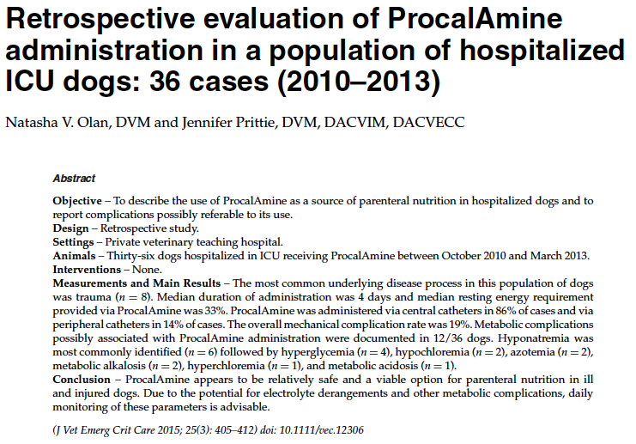

Why did they do the study? Not a lot of info of PN in dogs/cats. In some studies complications = hyperglycemia, electrolyte disturbances, hyperlipidemia. Some mechanical complications too that affected delivery. Don’t know complication types and incidences, risk factors for complications, if with more experience less complications…

Results: PN could be used to provide nutrition to most animals. Frequent complications, most do not affect outcome. Pancreatitis often dx in those patients started on PN. 81% dogs and 63% cats received at least RER. Amount of calories provided decreased over the 9y period. CPN provided more calories than PPN (only in dogs). Osmolarity of PPN kept lower than CPN (by diluting with water or decreasing dextrose (adding more lipids to compensate) decreased calories). Mechanical complications common (but less then previously reported) 25% in dogs, 14% in cats. . More complications in dogs with IV placed in saphenous. Septic complicatons 6% dogs 5% cats (maybe overestimated because not a lot confirmed with culture). More septic complications with PPN in dogs. Septic complications not associated with worse outcome. Metabolic complications prevalent: especially hyperglycemia 61% dogs 84% cats (many patients were however hyperglycemic (and non DM) before initiation of PN) If previously hyperglycemic: further rise in BG after starting PN 10% in dogs, 32% in cats- amount of dextrose or calories not associated with hyperglycemia. Many other metabolic complications – none associated with survival. EXCEPT for development of hypercreatininemia in dogs independently of CKD – only 8 dogs developed this complication. Better outcome if combined with EN in all diseases in cats; respiratory diseases in dogs. Longer PN better outcome (maybe because survived long enough to survive PN for longer time). Increasing # of patients receiving EN with PN over 9 year period (trickle feeding and enteral health). Complications although not necessarily affecting outcome may still interfere with PN delivery.

