Focused Ultrasound Technique for the Small Animal Practitioner
TFAST part 2

Summary
- TFAST should be used as a first-line screening test for both blunt and penetrating trauma for rapid detection of pneumothorax, pleural and pericardial effusions, as well as other trauma sequelae.
- TFAST should be used as a first line screening test in non-trauma subsets of patients with respiratory distress, collapse, and unexplained hypotension.

Wet Lung vs Dry Lung Concept
- In people, lung ultrasound is superior to chest auscultation and supine chest radiography in detecting interstitial syndrome and lung consolidation
- Wet lung > b-lines
- Dry lung > a lines and glide sign
Subcutaneous Emphysema
- Ultrasound does not transit (image) through air
- Gator sign orientation is almost always possible by applying sufficient probe pressure to displace the SQE
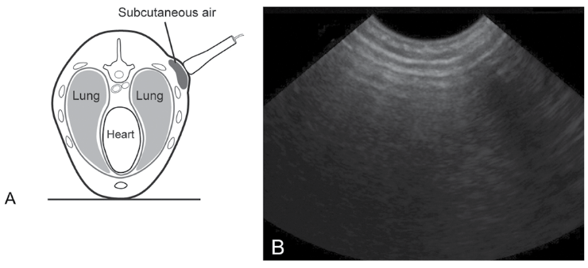

Pericardium
- 3-5th intercostal spaces
- Marker towards the elbow (short axis of <3), then rotate marker toward spine (long axis of <3)
- Right lateral recumbency is preferred, due to the cardiac notch providing a better acoustic window (less lung)

Diaphragmatico-Hepatic (DH) View
- Image is the gallbladder “kissing” the diaphragm
- Subxiphoid or paracostal view

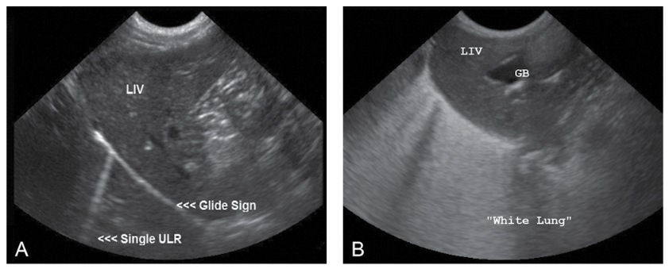

Findings at the TFAST Pericardial Site
- Can also evaluate contractility and volume status via the left ventricular short axis mushroom view
- Dry lung strategy high sensitivity and specificity (>98%) in people for ruling out cardiogenic pulmonary edema > can be used to guide diuretic usage in heart failure management
Determining Pleural from Pericardial Effusion
- Bull’s eye sign is created by the apex of the heart in the center of the pericardial fluid
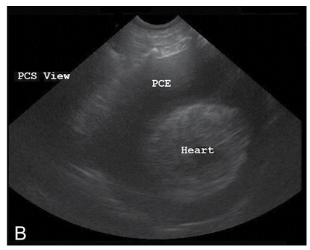
Cardiac Tamponade
- Waving or collapse with diastole of the right ventricular or right atrial free wall
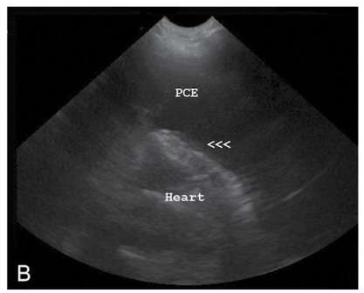

Use of M-mode for Lung Ultrasound
- Dry lung is represented by the seashore sign (graininess of sand along the shoreline)
- Pneumothorax will produce a stratosphere sign or bar code sign
- Wet lungs will produce a rain sign
- Power slide: glide sign with doppler

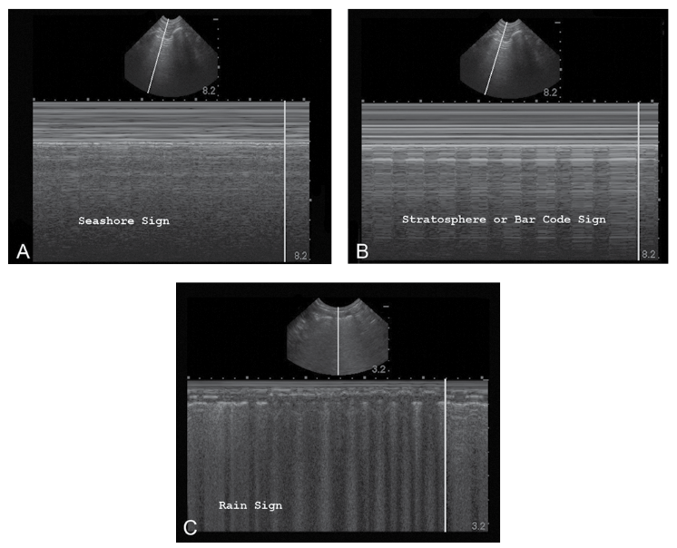
Questions:
- T or F: Subcutaneous emphysema enhances TFAST

- Explain what a bull’s eye sign is?

- T or F: Waving or collapse with diastole of the left atrial free wall can be seen in cardiac tamponade

Answers:
- T or F: Subcutaneous emphysema enhances TFAST worsens

- Explain what a bull’s eye sign is?

Apex of the heart in the center of the pericardial fluid

- T or F: Waving or collapse with diastole of the right atrial free wall can be seen in cardiac tamponade

