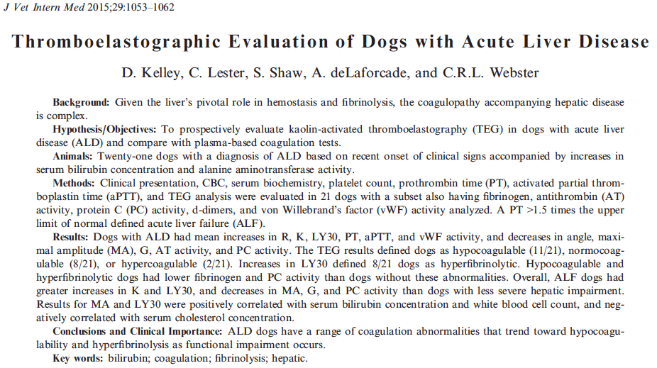

What do we know? – Liver plays central role in coagulation (production and clearance of procoagulants, anticoagulants, regulators of fibrinolysis). In people with ALD, prolongation of PT/aPTT (unless marked), are not considered predictors of bleeding tendencies. Basing our clinical decisions (to admx blood product for example) on PT/aPTT may overestimate bleeding risk (and admx of blood products that are not necessary). TEG tracings of people with ALD are compatible with normal coagulation or hypercoagulability.

Why did they do the study? – To evaluate TEG profile in dogs with ALD. To compare TEG results with clinical presentation, biochemistry and PT/aPTT.

What did they do? - Prospective study. Acute (< 1 mo) liver disease. NO medications that affect coagulation. NO comorbidities that affect coagulation. NO Greyhounds. ALD defined as at least 3x >ALT and elevated bilirubin. ALF defined as > 1.5 PT. CBC, chem, TEG, PT/aPTT, fibrinogen, AT activity, PC activity, d-dimers, vWf activity. TEG: blood collected from peripheral vein; vacutainer needle, 3.2% sodium citrate; hold 30 min at room temperature; kaolin-activated TEG.

Results:
- n =21 dogs
- Causes of ALD: idiopathic, toxicity, neoplasia, infectious, IM
- Outcome: 29% did not survive (6/21)
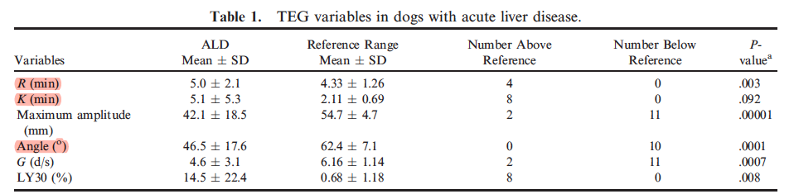
- Based on G value
  - 52% hypocoagulable (11/21)
    - 9/10 had prolonged PT
    - 7/8 had prolonged aPTT
    - 1 had normal PT/aPTT
    - Lower PC activity
    - Lower fibrinogen concentration
  - 38% normocoagulable (8/21)
    - 4/8 had prolonged PT and/or aPTT
  - 10% hypercoagulable (2/21)
    - Normal PT/aPTT
    - 1 was anemic (33%)
- Based on LY30
  - 38% hyperfibrinolytic (8/21)
    - More likely to be hypocoagulable (7/8) and to have ALF (6/8)
    - Decreases in angle, MA, G
    - Lower fibrinogen
    - Lower PC (not seen in any nonhyperfibrinolytic dog)
    - Higher WBC
    - 4/8 had SIRS (similar to the non hyperfibrinolytic group)
    - Degree of hyperfibrinolysis positively correlated with PT ,aPTT, bilirubin, WBC
    - Degree of hyperfibrinolysis was negatively correlated with cholesterol and PC
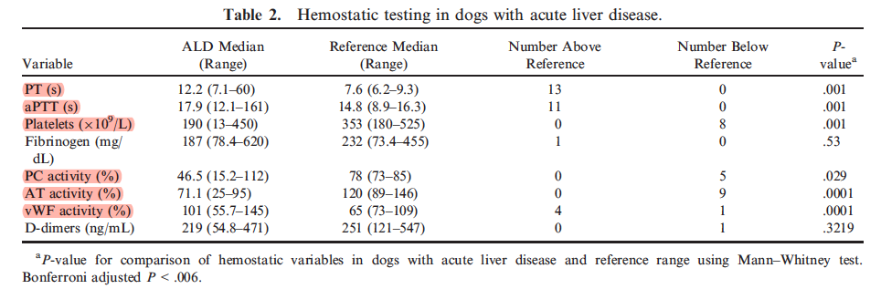
- 38% were anemic
- 29% had elevated WBC
- 38% were hypoalbuminemic
- 19% were hypoglycemic
- 18% were hypercholesterolemic
- 10 dogs in ALF (> 1.5 prolongation PT)
  - Longer K times, LY30, PT, aPTT
  - Significant decreases in angle, MA, G, fibrinogen, PC
  - Higher WBC
  - Lower cholesterol

Summary
- Most dogs with ALD were hypo or normocoagulable on TEG
- Hyperfibrinolysis and hypocoagulability more common in dogs with ALF
- Important inconsistencies between TEG and PT/aPTT/platelets – TEG discordant with conventional testing 25% of the time
  - 4 classified as hypo based on PT/aPTT were normo on TEG
  - 1 classified as normo based onPT/aPTT were hypo on TEG
- None of the dogs with low AT/PC (loss of anticoagulant) were hyper
- Conclusion: TEG analysis suggested that conventional plasma-based coagulation testing may overestimate decreased functionality of the coagulation system in dogs with early ALD; but as severe functional hepatic impairment ensues, both conventional coagulation testing and TEG indicate onset of hypocoagulable state.

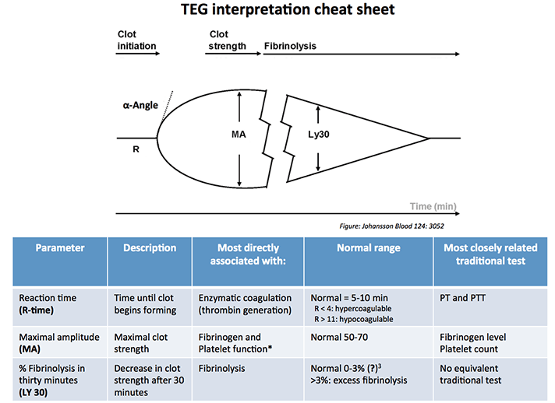

Questions
- In this study, dogs were more likely to be… (based on TEG)
  - Normocoagulable
  - Hypocoagulable
  - Hypercoagulable
  - Hyperfibrinolytic
  - Hypofibrinolytic

- In this study, dogs with ALF were more likely to be… (based on TEG)
  - Normocoagulable
  - Hypocoagulable
  - Hypercoagulable
  - Hyperfibrinolytic
  - Hypofibrinolytic

- In this study, results of MA and LY30 were positively correlated with…
  - Bilirubin
  - ALT
  - ALP
  - Cholesterol

- Complete:
Parameter | Description | Most directly associated with | Most closely related traditional test
R time
MA
LY30

Questions & Answers

- In this study, dogs were more likely to be… (based on TEG)
  - Normocoagulable 8/21
  - Hypocoagulable 11/21
  - Hypercoagulable 2/21
  - Hyperfibrinolytic
  - Hypofibrinolytic

- In this study, dogs with ALF were more likely to be… (based on TEG)
  - Normocoagulable
  - Hypocoagulable
  - Hypercoagulable
  - Hyperfibrinolytic
  - Hypofibrinolytic

- In this study, results of MA and LY30 were positively correlated with…
  - Bilirubin
  - ALT
  - ALP
  - Cholesterol negative correlation with

- Complete:
Parameter | Description | Most directly associated with | Most closely related traditional test
R time | Time until clot begins forming | Thrombin generation | PT/aPTT
MA | Maximal clot strenght | Fibrinogen and platelets | Fibrinogen level and platelet count
LY30 | Decrease in clot strength after 30 minutes | Fibrinolysis (plasmin) | none

