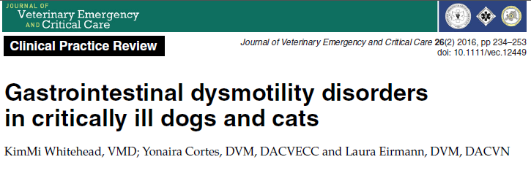
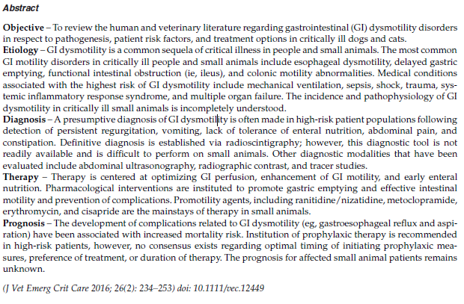
Take-Homes:
- Manifestations and Complications of GIDM include Ingesta or food bolus stasis and Disruption of absorption, which leads to GERD, Esophagitis, Aspiration, Bacterial overgrowth, abdominal distention, fluid shifts, and delayed nutrition
- Treatment of GIDM include early enteral nutrition, fluid therapy aimed at avoided hypo or hypervolemia, correction of systemic abnormalities, and pharmacotherapies

- The most common GI motility disorders in critically ill human and small animal veterinary patients:
  - esophageal dysmotility
  - delayed gastric emptying
  - functional intestinal obstruction (ie, ileus)
  - colonic motility abnormalities
- GI tract excitatory neurotransmitters
  - **Acetylcholine**
    - Primary neurotransmitter of parasympathetic system
  - Substance P
  - Neurokinin A
  - Serotonin
- GI tract inhibitory neurotransmitters
  - Vasoactive intestinal peptide (VIP)
    - Very inhibitory peptide
  - Somatostatin
    - somato-Stasis
  - Nitric oxide
    - NO movement
  - GABA

- Esophagus
  - Dogs - all skeletal muscle
  - Cats - distal smooth muscle
- Average small intestinal transit time of
  - 3–5 hours in healthy dogs
  - 2–3 hours in healthy cats

GIDM

- Complications
  - aspiration pneumonia
  - Esophagitis
  - feeding difficulties
  - increased risk of bacterial translocation and sepsis
  - increased intraabdominal pressure (IAP)
- Drugs that induce esophageal inhibition
  - Ketamine
  - Benzodiazepines
  - Opioids
- Delayed gastric emptying theories
  - Decreased motor activity “pump failure”
  - Increased inhibitory input “Excessive feedback”
    - Appears to be gaining support
- Risk Factors
  - Primary GI disease
  - Secondary
    - Peritonitis
    - Pancreatitis
    - Stress
    - Electrolyte derangements
    - Metabolic/endocrine disturbances
    - Drugs
      - Opioids
      - Alpha-2s
      - Vasopressors
    - Diabetes
    - Hypoperfusion
    - Hypoxemia
    - Obesity
    - SIRS/Sepsis
    - Neoplasia
    - TBI
- Manifestations and Complications of GIDM
  - Ingesta or food bolus stasis
    - GERD
    - Esophagitis
    - Aspiration
    - Bacterial overgrowth/translocation
      - In people with SIRS,investigators found that GIDM was associated with altered gut flora as well as with higher septic mortality
    - Bloat/distention
  - Disruption of absorption
    - Fluid sequestration
      - Hypovolemia
    - Delayed nutrition
- Diagnostics
  - Nothing very good, many things have been studied
  - Tends mostly to be clinical suspicion
- Treatment
  - Treatment of underlying condition
  - Early nutrition
    - Improving blood flow to the gut
    - protecting the GI mucosa
    - reducing the risk of translocation of intestinal bacteria
    - stimulating motility
    - promoting secretion of various gut hormones and growth factors
  - Judicious fluid therapy
    - Minimize gut edema
  - Early ambulation
    - No supporting evidence
  - Correction of metabolic derangements
  - Normothermia
  - Multimodal pain management
  - Pharmacological intervention
